Chapter 29
Penetrating trauma
Michelle Welsford and Alim Pardhan

Introduction
Trauma is the leading cause of death for North Americans aged 1–34 years, only surpassed by cancer and cardiovascular disease in older adults. Penetrating trauma has significant morbidity and mortality and is a common cause for activation of EMS. Injuries due to firearms are particularly lethal and require rapid assessment and decision making in the field to mitigate injury. In 2009, approximately 700 deaths in Canada were associated with firearms, 75% of which were intentional self-harm [1]. In 2010 there were approximately 31,000 firearm-related deaths in the United States, of which approximately 61% were suicides [2].
Other potential causes of penetrating trauma include knives, arrows, nails, glass, wood, and wire. Penetrating trauma can also occur with shrapnel from explosions as well as with foreign objects flying in motor vehicle collisions. The types of weapons/projectiles, the way in which the object imparts its energy, as well as the location of impact, dictate the type and severity of injury.

Physics and mechanics of penetrating trauma
Two physical concepts explain injury associated with penetrating trauma. The energy associated with a moving object is defined by: kinetic energy = ½ mass × velocity². Kinetic injury explains why a small and light projectile (e.g. a bullet) can result in devastating injury. Because the projectile energy is related to the velocity squared, doubling the velocity results in a four-fold increase in kinetic energy; if velocity increases by a factor of 4, kinetic energy increases by a factor of 16. In penetrating trauma, the projectile imparts kinetic energy to the victim’s body, resulting in injury.
The second concept is the Law of Conservation of Energy: Energy cannot be created or destroyed but only transferred from one form to another. When a projectile enters the body and remains there, it can be inferred that all the projectile’s kinetic energy has been transferred to the body. Where the projectile travels through the body and exits, the energy transferred to the body is equal to the kinetic energy of the object before entering minus its energy on leaving the body.
Weapons can usually be classified based on the amount of energy carried by the projectile.
- Low energy: knives, hand-launched missiles
- Medium energy: handguns, smaller bullets, lower velocities (200–400 m/s)
- High energy: military or hunting rifles, larger bullets, higher velocities (600–1000 m/s) [3]

Ballistics
Ballistics, the study of projectiles as they move and hit their target, includes trajectory (the path that that an object follows after launch) and terminal ballistics, a more clinically relevant measure which reports how the projectile acts when it hits its target. Several factors affect terminal ballistics, including missile size, velocity, missile shape, deformity, and stability.

Size
As a general rule, the larger the missile, the more damage caused by direct contact between the missile and tissue. Larger missiles generally have a greater surface area and impart more energy faster. Bullet size is measured by the inside diameter of the gun barrel either in millimeters (e.g. 9 mm) or hundredths of an inch (e.g. 44 caliber). Magnum rounds refer to those with more gunpowder than a normal round, which increases the muzzle velocity and thus the bullet energy by 20–60% [3,4] (Figure 29.1).
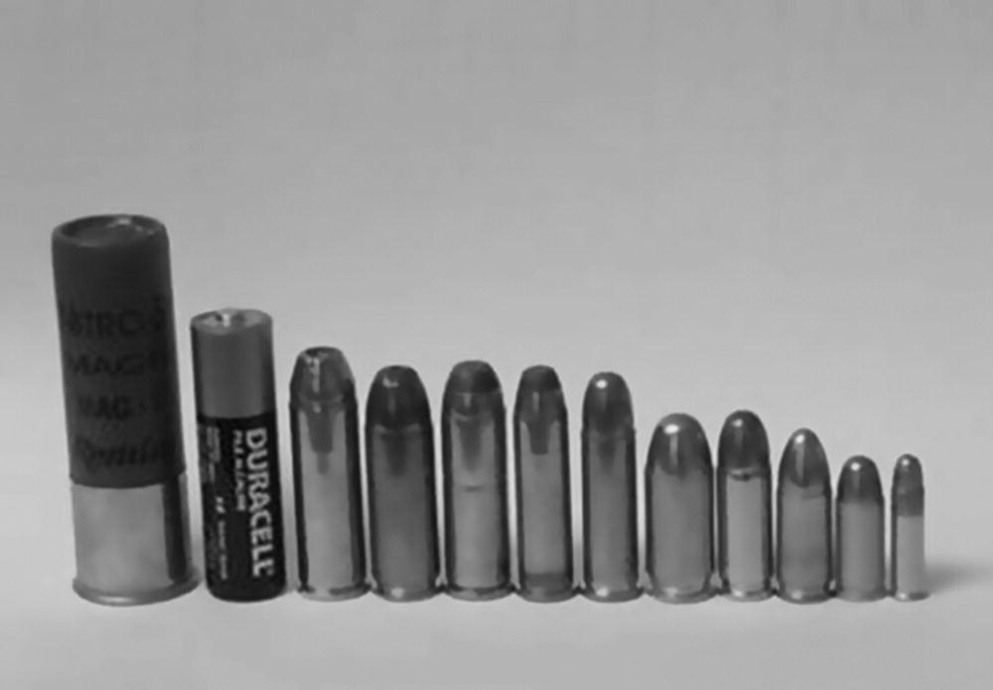
Figure 29.1 Bullets of various lengths and diameters, compared with an AA battery.
Source: Reproduced with permission of Robert R. Bass.

Velocity
Missiles traveling through air encounter resistance or drag. Drag increases exponentially with velocity and is inversely proportional to mass. Clinically, this implies that the damage caused by a missile at short range will be greater than one fired at longer range and that heavier missiles are able to maintain their velocity better than light ones. For practical purposes, the impact velocity of bullets will be the same as the muzzle velocity at 45 meters for low-energy firearms, such as handguns, and 90 meters for higher velocity weapons, such as rifles [4].
Slower-moving missiles such as knives or arrows have less kinetic energy and cause injury only where in contact with tissue. Higher energy missiles, such as rifle bullets, create a shockwave and a cavity in the body tissues. This process is known as cavitation (Figure 29.2).

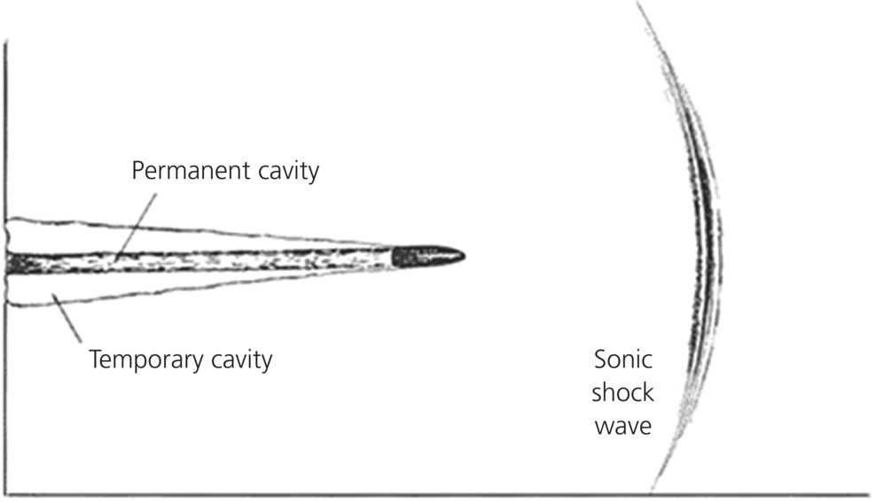
Figure 29.2 Sonic wave and cavitation produced by a high-velocity bullet in tissue.
Source: Reproduced with permission of Robert R. Bass.

Shape and deformation
The energy imparted by a missile is related to its shape. Missiles that are blunt (i.e. have a higher cross-sectional area) experience more resistance and impart energy to tissues quickly, whereas sharper missiles cut through tissues more effectively and release energy over a longer period of time and distance.
Projectiles may deform on impact, increasing the bullet’s cross-sectional area. This mushrooming effect raises the resistance between the missile and tissues, thus increasing the energy transfer rate. Some missiles may fragment on impact, increasing the rate of energy exchange because the total surface area of the fragments is greater than that of the original missile (Figure 29.3).

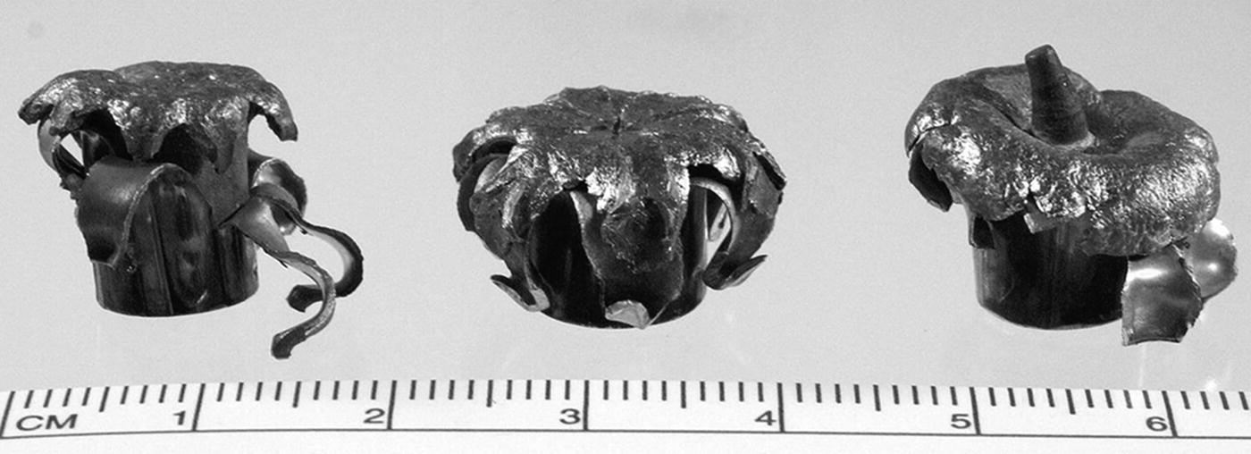
Figure 29.3 Examples of bullet shapes and deformity designed to inflict tissue damage.
Source: Reproduced with permission of Robert R. Bass.

Stability
Contrary to popular belief, bullets often do not travel in a direct line and may tumble or wobble (yaw) in their course, often decreasing the velocity and accuracy of the missile. If it tumbles or yaws after hitting tissue, the bullet’s surface area with respect to tissue is increased, thereby increasing the amount and rate of energy transfer [4] and thus the extent of injury (Figure 29.4).
Figure 29.4 Effect of yaw in creating a larger surface area of effect.
Source: Reproduced with permission of Robert R. Bass.

Types of weapons

Knives and arrows
Knives and arrows are considered to be low-energy weapons. Although the projectile’s weight may be significantly higher, the velocity is generally much lower. Tissue damage is typically restricted to direct contact between the projectile and tissue. The extent of tissue damage can be extremely difficult to estimate because the projectile’s trajectory cannot be determined based on external injury appearance. The entrance wound will not predict whether the object moved around within the body or what organs it came into contact with. It is, however, useful to know the blade length; to a certain degree this can predict the maximum depth of penetration.

Handguns
Handguns are typically short-barreled, medium-energy weapons with small bullets. As a medium-energy weapon, a handgun’s damage-causing potential is more limited than that of higher energy firearms. Handgun bullets tend to have a blunter shape, causing early release of energy. Despite their shape and composition of softer metal (lead), handgun bullets tend not to deform due to their lower energy. As such, the bulk of the injury is caused in tissues damaged by the bullet’s passage.

Rifles
Rifles are named for the rifling in the barrel, which causes the bullet to spin. The spin of the bullet improves accuracy and range due to the conservation of angular momentum. Rifle bullets are larger, retain more kinetic energy, and travel much further with greater accuracy than do handgun projectiles. They are able to transfer significant energy with damage extending outside the bullet’s immediate track. Hunting ammunition is designed to expand dramatically (up to three times) on impact [4], increasing the speed of energy delivery and the wound pathway. Military ammunition is fully jacketed so it does not deform, which decreases the energy delivery rate [4].

Shotguns
While shotguns can fire single bullets (slugs), in general they fire a collection of spherical pellets, called shot, which radiate from the muzzle of the gun in a conical distribution. Typical muzzle velocity is 360 m/s [3]. Shot have a high drag coefficient so they lose velocity quite rapidly. At short range, they can be devastating but at longer range they lose much of their destructive potential (Figures 29.5, 29.6).

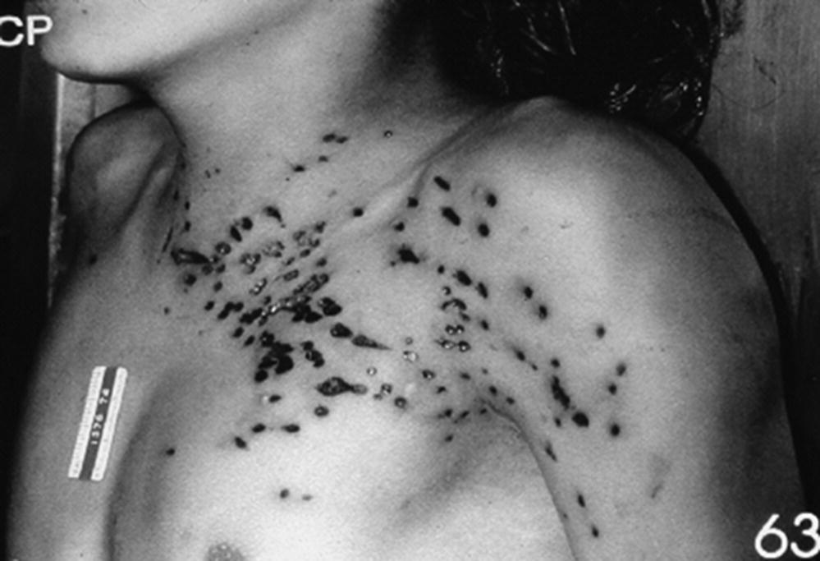

Figure 29.5 Shotgun injuries to chest.
Source: Reproduced with permission of Robert R. Bass.
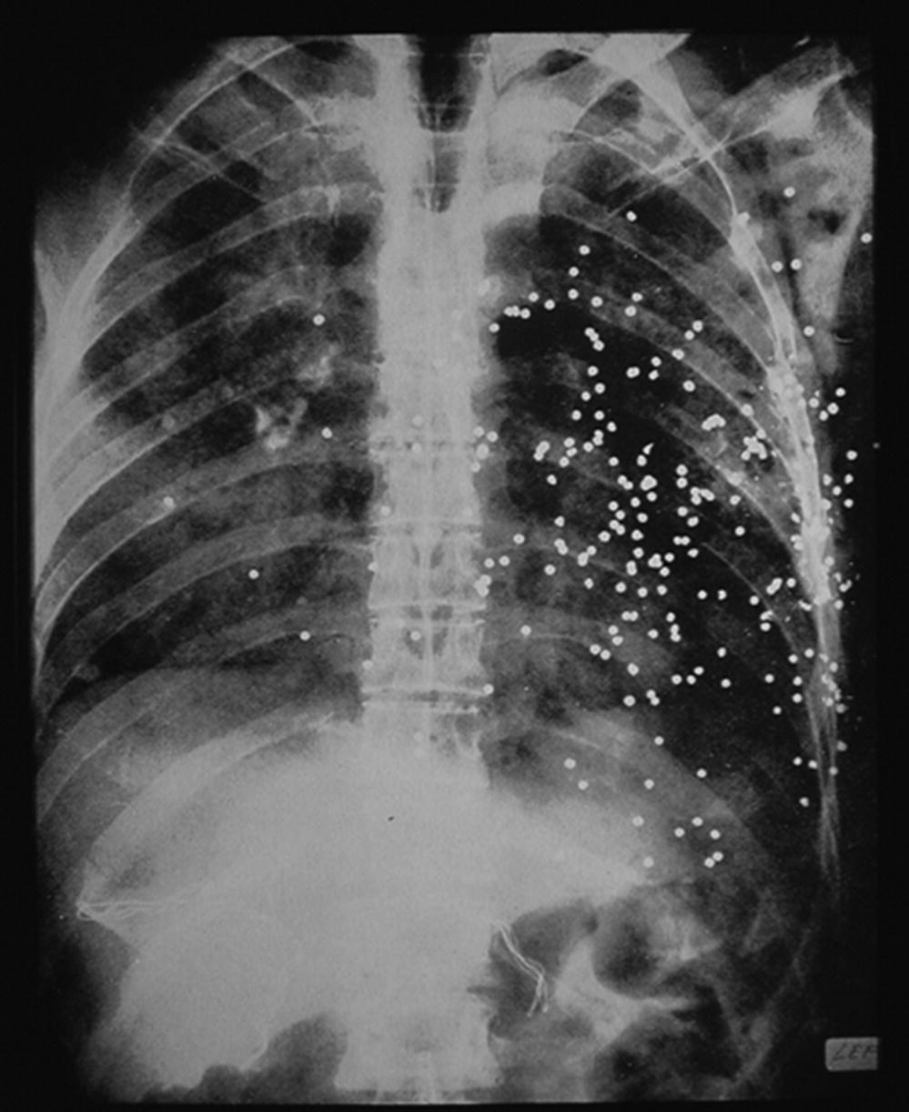

High-velocity projectile injury
While low-velocity projectiles inflict injury by direct cutting or tearing of tissues, higher velocity projectiles inflict injury in three ways: direct, pressure wave, and cavitation.

Direct injury
Direct injury is caused by a projectile’s impact including crushing and lacerating tissues. Direct injury is based on the projectile size, although this may be modified by any deformation and bullet instability as it travels through the body. Crushing and laceration cause serious injury only if the bullet strikes organs or blood vessels [4].
Body armor protects the wearer by spreading the energy of impact over a larger area. Although this means that the projectile is prevented from hitting the body, the kinetic energy strikes a larger area, which can cause significant injury, such as fractured ribs and cardiac contusions.

Pressure wave
When a high-velocity projectile (greater than 750 m/s) hits human tissue, a high-pressure wave moves outward from the missile track in all directions. Caused by the compression ahead of the bullet, the pressure wave moves faster than the bullet itself. The faster and blunter the projectile, the greater the effect. Pressure from higher velocity bullets can exceed 1,000 pounds per square inch. Pressure waves travel better through fluids, higher density tissues, and organs, causing tearing and crushing of tissues. Blood vessels and solid organs (e.g. liver or spleen) can be injured or in some cases fractured. Hollow organs (e.g. large bowel) can rupture, and bones can be broken by the pressure wave (see Figure 29.2) [4].

Cavitation
High-velocity projectiles create a temporary cavity behind the missile path as tissues move away from the track. Cavity size is dependent on energy transferred during the bullet’s journey and may be 30–40 times the diameter of the bullet [4]. The cavity will have a lower pressure than the air outside the body, causing air and potentially debris to be pulled in through the entrance and exit wounds. After the bullet has passed, the elasticity of the surrounding tissues tends to collapse the temporary cavity (see Figure 29.2).

Entry and exit wounds
Bullets often have both entry and exit wounds. In general, the exit wound is the same size or larger than the entrance wound but this is not always the case. Although bullets typically follow the path of least resistance, they may not travel in a straight line. Projectiles may have an unpredictable path within body tissues, including rotation or ricochet and deflection off bony structures. Two injury sites do not always represent an entry and an exit wound as they may represent two different entry wounds.
Entrance wounds can be deceptively small. A very small entrance wound can hide a devastating injury, and EMS providers should not be lulled into a false sense of security by a small entrance wound.

Resuscitation and initial assessment
Although the standard approach to patient assessment is described elsewhere, there are several unique considerations in the patient who has suffered a penetrating injury.

Scene safety
Although a thorough assessment of scene safety is always a priority, it takes on particular importance when dealing with penetrating trauma. Almost all potential causes of penetrating trauma harbor risks to the unwary EMS provider, and these must be considered before scene entry.
When penetrating trauma is a result of assault, the prehospital provider must ensure the perpetrator is no longer in the immediate area or has been apprehended or restrained by police. On other scenes where penetrating trauma is a possibility, such as explosions or motor vehicle collisions, the EMS personnel must examine the scene before entry to ensure there is no undue risk. When the scene is unsafe, the provider should withdraw to a safe distance and summon the appropriate assistance, such as police or fire services.

Spine immobilization
Assessment for possible spinal cord injury is important. Numerous case series have challenged the need for spinal immobilization in penetrating trauma patients [5–7]. It is well accepted that cervical spine (c-spine) immobilization is not required for penetrating firearm injuries to the head [8]. Similarly, immobilization for penetrating injuries to the neck and torso is likely only required when there is a high suspicion in an obtunded patient or obvious neurological compromise [9–11].

Extremity bleeding
Most bleeding from extremities, including arterial bleeding and amputations, can be controlled with direct pressure and elevation of the wound. When extremity bleeding persists despite these maneuvers, it may be necessary to apply a tourniquet [12]. Persistent bleeding when constant direct pressure cannot be maintained, such as military-casualty incidents or tactical environments, may also necessitate a tourniquet. Military use of tourniquets has undoubtedly saved lives in combat situations. Similarly, tourniquet use during the Boston Marathon bombing in 2013 allowed over 200 injured patients to be promptly treated and transported to area hospitals [13]. This is discussed more fully in Volume 1, Chapter 35. The letters TK and the time the tourniquet was applied should be written on the patient’s limb or forehead.

Permissive hypotensive resuscitation
In managing penetrating trauma patients, IV fluid therapy is controversial. Permissive hypotensive resuscitation advocates that only patients without radial pulses or with a systolic blood pressure (SBP) of <70 mmHg receive fluid resuscitation in the field [14]. IV access should rarely be obtained on scene and should be reserved for en route in the upper extremities if possible. IV or IO access in the lower limbs is relatively contraindicated because abdominal vascular injuries may lead to direct extravasation rather than reaching the central circulation.

Impaled objects
In general, impaled objects are not removed in the field as the object may be providing tamponade to bleeding soft tissues and blood vessels, and removal could cause exsanguination. Because movement of the object may cause further injury, the object should be well stabilized with bulky dressings and tape. Occasionally this will require cutting the object to a shorter length on scene if it impedes extrication and transportation. Care should be taken to ensure minimal movement of the object during this process. The exceptions are removal of an object that impedes CPR in a pulseless
patient or impedes airway management where airway control is required (Figure 29.7).

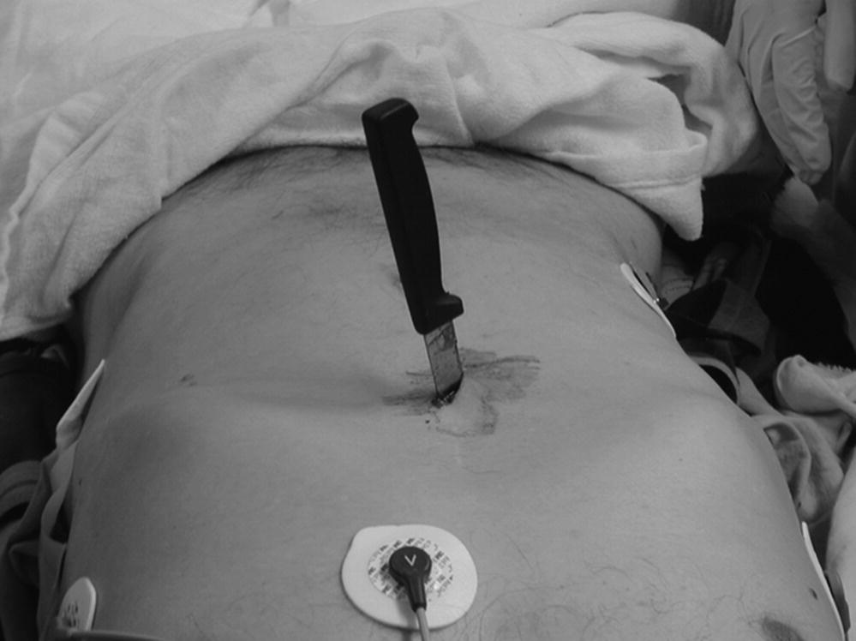
Figure 29.7 Knife left in situ in the wound for removal in the operating room.
Source: Reproduced with permission of Robert R. Bass.

Transport issues

“Scoop and run” versus “stay and play”
An optimized and efficient trauma system is required to deliver a patient from injury location to definitive care through a coordinated system of public access (9-1-1), EMS care, trauma triage, and trauma center. The corollary to the “golden hour” for the trauma system may be called the “platinum 10 minutes” for EMS, where the goal is to begin transport of the patient within 10 minutes of arrival on scene, barring extrication or other logistical issues that prevent prompt transport.
The platinum 10 minutes, or “scoop and run,” is important in penetrating trauma patients who meet trauma triage criteria in which surgical management is likely. The term refers to the strategy of rapid assessment and transport. Interventions such as IV cannulation should be initiated en route to the hospital except in extenuating circumstances, such as a prolonged extrication. Conversely, the term "stay and play" refers to on-scene stabilization and initial management, which is rarely indicated in penetrating trauma.
For the penetrating trauma patient in cardiac arrest, emergency department thoracotomy may be useful if performed within 15 minutes of loss of circulation [15–17]. EMS providers should focus on maintaining the airway, good CPR, and correcting reversible causes of arrest, specifically hypoxia, tension pneumothorax, and hypovolemia, while transporting the patient to the hospital. Communication with the receiving ED or trauma center to notify them of the incoming patient, relevant injuries, and an estimated time of arrival is essential.

Penetrating chest trauma
The consequences of penetrating trauma depend on the mechanism and location of injury, the path of the projectile, and the underlying health of the patient. All patients with penetrating intrathoracic injury are at risk for intraabdominal or neck injury, depending on the entry point and path of the projectile. It is also true that a penetrating traumatic injury to the neck or abdomen can have associated chest injuries. When patients have been stabbed, it is useful to know the approximate length of the blade to understand what structures may have been injured. In the setting of a gunshot wound, any entry wound that does not have an exit wound should be considered to have retained bullet fragments.

Lungs and bronchial tree
Penetrating injury to lungs or bronchial tree can lead to escape of air or blood into the thoracic cavity, resulting in simple pneumothorax, tension pneumothorax, or hemothorax. Treatment for simple pneumothorax is supportive, for tension pneumothorax chest decompression may be required, and hemothorax should be treated with fluids, oxygen, and transport.

Heart and great vessels
Penetrating injury to the “cardiac box” increases the likelihood of myocardial and great vessel injury. The cardiac box is a rectangular shaped area of the anterior chest bounded superiorly by the clavicles, laterally by the midclavicular lines, and inferiorly by the costal margins [18]. It should be noted that the cardiac box includes the epigastric area.
Pericardial tamponade is a potentially rapidly life-threatening condition resulting from accumulation of fluid in the pericardial sac. It occurs more frequently in stab than gunshot wounds: 60–80% of stab wounds involving the heart develop tamponade [19]. Only a small amount of blood (50–100 mL) is necessary for pericardial tamponade to develop. Signs and symptoms of pericardial tamponade are hypotension, tachycardia, muffled heart sounds (Beck triad), dyspnea, cyanosis, and distended jugular veins. These signs may be followed by cardiac arrest with pulseless electrical activity. The treatment for pericardial tamponade is pericardiocentesis (potentially performed by the EMS physician in the field, particularly if ultrasound guidance is available) as a temporizing measure, followed by surgical repair.
Any penetrating thoracic or abdominal trauma can cause a diaphragmatic injury. Because diaphragmatic injuries can result in significant respiratory compromise, respiratory distress associated with injuries to the chest or abdomen should prompt EMS personnel to consider the possibility of a diaphragmatic injury.

Penetrating abdominal trauma
Gunshot wounds to the abdomen most commonly injure the small and large bowel because of the large space they occupy. A projectile passing through a gas-filled bowel will often cause compression of that gas, which may limit the pressure wave and injury. However, a projectile passing through a solid organ, such as the liver and spleen, causes cavitation and more widespread injury. Penetrating abdominal trauma may cause devastating injury to the large vessels (i.e. aorta, inferior vena cava, iliac vessels), leading to immediate exsanguination and death.
Due to the relative lack of skeletal protection and highly vascular structures, penetrating abdominal trauma has a high mortality. As opposed to blunt trauma in which force is more diffuse, transmitted across the abdomen, and leads to primarily solid organ injury, penetrating trauma is often a locally applied force affecting the hollow organs and mesentery. Solid organ injuries are less common with penetrating than blunt trauma, but they can occur, especially in stab wounds, with devastating consequences.
Penetrating wounds should be covered to decrease infection and observed for ongoing bleeding. Any intraabdominal organs visible (evisceration) should simply be covered with sterile saline-soaked dressings and in turn covered with an occlusive dry or plastic dressing.

Penetrating neck trauma
Penetrating neck wounds can be immediately fatal, and seemingly “innocuous” wounds can suddenly become life-threatening. Even the seemingly “benign” penetrating injury to the neck should be treated with careful and expectant management.
Injury to the major blood vessels of the neck may rapidly lead to exsanguination or delayed hemorrhage. Because of the thin overlying muscles and subcutaneous tissue, airway injuries to the larynx or trachea are common and may be devastating. Although somewhat protected by other structures, deeper injury can lead to pharyngeal and esophageal injuries. Lastly, neurological injury can occur to the spinal cord posteriorly, the cranial nerves superiorly, or the brachial plexus inferiorly.
Common carotid injuries occur in approximately 10% of all penetrating neck trauma. Significant carotid artery injuries are usually rapidly fatal, but may occasionally tamponade briefly to allow transport and assessment. History of significant blood loss either at the scene or ongoing is evidence of a major vascular injury. Similarly, expanding hematomas may initially be subtle, but are signs of vascular injury and may lead to airway compromise from direct compression. Hematomas are often visible when the patient’s head is in a neutral position and the patient is examined from the feet.
Jugular vein injuries may also be fatal, but they may be successfully managed with direct pressure in the field to allow transport to an operative setting. Venous injuries may be complicated by entrainment of air leading to air emboli, a potentially fatal complication.
Neurological deficits should be carefully documented and relayed to the receiving facility. Unilateral stroke symptoms may be related to carotid artery injury and subsequent brain ischemia. Additionally, unilateral cranial nerve and brachial plexus injuries may also be apparent as facial or arm weakness respectively. Spinal cord injury may result in unilateral or bilateral motor deficits of the arms and legs.
Penetrating neck trauma can lead to airway anatomy distortion due to either a primary direct airway injury or secondarily via compressing hematomas and bleeding. Signs of an expanding hematoma, hoarse voice, stridor, airway compromise, or blood in the airway are warning signs of impending airway compromise and require quick action. Airway compromise should be anticipated, intubation should occur early rather than late, and in most cases, rapid transport should be initiated to a trauma center with basic airway maneuvers if airway intervention is not immediately required.
Although prehospital providers are accustomed to considering a potential spinal injury and providing immobilization to the majority of blunt trauma patients, this is not always required in penetrating injury. Based on case reviews, many have advocated against immobilizing patients with penetrating neck injuries unless neurological signs or symptoms are apparent [6,7]. Isolated stab wounds to the neck are unlikely to cause unstable cervical spine injuries. Although gunshots can lead to cervical spine injury, most spinal cord injuries are complete and obvious on initial evaluation, prompting immobilization. The provider should follow local directions regarding spinal immobilization with the understanding that if no spinal involvement is likely, the patient may be better managed without immobilization.
Penetrating neck injuries should be covered with an occlusive dressing if possible, to reduce the chances of an air embolism if bleeding is minimal. If ongoing bleeding is present, direct manual pressure can be used on one side of the neck. Obvious brisk bleeding from the neck may be best controlled with direct pressure above and below the bleeding site with the provider’s two thumbs. Gauze under each thumb may assist with traction on the skin. If this is required to control significant bleeding, care should be taken not to change providers or stop the pressure to inspect the wound until arrival at the trauma center. Bilateral compression and circumferential dressings should be avoided because these may lead to cerebral hypoxia and infarction from bilateral carotid artery compression.
Lastly, IV cannulation, if performed, is preferentially performed on the upper limb opposite the side of neck injury. Because the subclavian vessels may be involved, it is best to avoid infusing fluid that will travel through an injured vessel leading to clot disruption, greater exsanguination, and local hematoma formation.

Penetrating head and facial trauma
The prehospital approach and management of penetrating head trauma is similar to that for head injuries in general and is discussed in Volume 1, Chapter 30. However, the airway management of facial trauma deserves special consideration.
Facial wounds that are otherwise survivable may lead to death due to airway compromise. Penetrating wounds or impaled objects may lead to significantly distorted airway anatomy and blood and foreign bodies in the airway. Any patient with penetrating facial injuries should be carefully considered for airway control. In addition to oral airway and oral endotracheal intubation, surgical airways, such as cricothyrotomy, may be required. Nasal airways should be avoided in patients with significant facial trauma.

Penetrating extremity trauma
Penetrating injury to the extremity can disrupt blood vessels, bones, nerves, muscles, and other soft tissues. This section will focus primarily on vascular and bony injuries.
Vascular injuries are either higher pressure arterial injuries or low-pressure venous injuries, both of which can bleed profusely. Arterial injuries tend to be more serious and should be identified and acted on promptly to prevent further morbidity or mortality. Arterial bleeding is often a brighter red and spurts with each heartbeat. Venous bleeding tends to be darker and tends to flow as opposed to spurt. The majority of active bleeds, including arterial bleeding, can be managed with direct pressure. When these strategies fail, the application of a tourniquet can be considered. Details on indication and use of tourniquets and other modalities may be found in Volume 1, Chapter 35.
Penetrating trauma can also cause bony injuries such as fractures or dislocations. These injuries should be considered open injuries because the penetrating object pathway will have exposed the injury to the outside. They should be treated as other fractures or dislocations by immobilization in the position found and dressing open wounds.

Prevention and public health issues
There are approximately 7.2 million registered firearms in Canada [20], and 223 million registered firearms in the United States [21]. US statistics indicate that approximately 40% of households have access to firearms. EMS personnel face a high probability of responding to locations where firearms may be readily accessible to the occupants. This presents both a challenge and an opportunity. The challenge is that EMS providers must be aware of their surroundings and ensure that the scene is safe to enter before beginning patient care.
Emergency medical services providers also have an opportunity to recognize safety concerns in the home that are not seen by traditional hospital-based health care providers. An example of this would be a home where children are present and a firearm is seen within easy reach of the children. Although it may or may not be appropriate to educate the parents about the dangers of this circumstance at the time, it is an observation that can be relayed to hospital personnel or to the relevant child protection agency. Where children are felt to be at imminent risk, EMS providers may have a legal obligation to report this to the child protection agency (as do other health care providers).

Medicolegal issues
Most jurisdictions require reporting of certain types of injuries. Many require hospitals to notify the police of all patients who present to the ED with gunshot wounds. The role of EMS will vary between jurisdictions. Providers should be familiar with the specific legislation in their jurisdiction and what (if any) requirements exist for reporting gunshot or stab wounds.
Emergency medical services providers should carefully document historical or physical findings. Patient care records are legal documents and can be used as evidence in a court of law. Unless a criminal act is witnessed, EMS providers should document what is seen and heard as opposed to what they are told or what they perceive may have happened. Examples of this include: “The patient states he was shot by his father” rather than “The patient was shot by his father.” EMS providers should not make suppositions about which wound is the entrance versus exit, but simply document the locations and descriptions of the two penetrating wounds.

Forensic issues
Emergency medical services often responds to crime scenes or to patients who are the victims or perpetrators of crime. As such, providers need some understanding of forensics and evidence preservation. Wherever possible, the provider should ensure that neither the scene nor evidence is disturbed.
- When a crime is suspected, notify the police immediately. When the police are already on scene, follow the instructions of the officer in charge, especially with respect to scene security and safety. When there is disagreement between law enforcement and EMS, the EMS provider should notify the appropriate supervisor and document all discussions.
- When arriving on scene, ambulances should be parked to allow safe and rapid access to the patient, where possible without being on the immediate crime scene.
- Gloves should be worn at all times.
- Use the minimum number of providers needed.
- Use the same route to get to and from the patient; avoid walking through fluids and other debris.
- Try not to disturb physical evidence
- Do not move or touch anything unless necessary to do so for patient care.
- When it is necessary to move something, document it and notify law enforcement officials.
- Do not cut through or near holes in patient clothing; they may be bullet or knife holes.
- Any removed clothing and any personal articles should be left in the possession of law enforcement.

Prehospital termination of resuscitation in penetrating trauma
Up to one-third of all traumatic deaths occur before arrival at hospital, and prehospital traumatic cardiopulmonary arrest is associated with very poor survival (0–5%). Of patients who sustain traumatic cardiopulmonary arrest, isolated penetrating trauma (stab wound) to the thorax is the most salvageable subset of patients and any signs of life at the time of EMS arrival may reflect a potential survivor if transport time to a trauma center capable of ED thoracotomy is less than 15 minutes. In these very specific circumstances, ED thoracotomy may have up to a 25% survival rate [22]. The higher survival is seen in those patients who did not arrest until after arrival in the ED, but there have been a few survivors where the arrest occurred up to 15 minutes before arrival. Thus, this group of patients requires the most rapid transport with no delay on-scene for additional procedures.
“Futility” of prehospital medical resuscitation has been defined as less than a 1% chance of survival to hospital discharge and this is used to determine guidelines for ceasing resuscitation for non-traumatic cardiac arrest [23]. Using the literature, and a similar definition for “futility,” NAEMSP and ACS-COT prepared a joint guideline for termination of resuscitation in prehospital traumatic cardiopulmonary arrest [24].

Conclusion
Trauma is the leading cause of death between the ages of 1 and 34 years in North America. Those penetrating trauma patients who are alive on arrival of EMS providers have a better chance of survival if they are transported rapidly to a designated trauma center. EMS providers should not be fooled by seemingly innocuous penetrating injuries. They can use their knowledge of anatomy and physiology to anticipate potential injuries and intervene before cardiovascular collapse or airway compromise ensues.

