Chapter 37
Ocular trauma
Eric Hawkins and Michael D. Mills

Introduction
Traumatic eye injuries are extremely common in the prehospital setting, and may occur as isolated injuries or as part of more extensive maxillofacial or multisystem trauma. These injuries may range from the minor to the sight threatening, and EMS physicians must be prepared to rapidly identify serious problems that could result in permanent blindness or further complications. Once significant eye injuries are recognized, it is important that the patient is stabilized, appropriately treated, and evaluated by a hospital or physician with adequate access to full ophthalmological services to provide definitive care.

Epidemiology
Ocular trauma is common; in the United States an estimated 2–3 million people seek medical attention for eye injuries each year [1,2]. Among many risk factors, the most significant seem to be male sex and age under 30 [3]. Most injuries are not significant, and many never need treatment for minor eye problems [2]. Of those with more serious injuries, 16% have ocular or orbital damage and over 50% of patients with significant facial trauma have associated sight-threatening eye injuries [4]. Trauma is the second most common cause of monocular blindness, trailing only cataracts [5]. Each year, eye injuries are the number 1 cause of ophthalmological hospital admissions in the United States [5].

Evaluation: history and physical exam
Initial assessment and treatment should focus on the ABCs of trauma resuscitation, and any life-threatening injuries should be addressed first, as with any trauma patient [6,7]. Eye injuries can be distracting, and it is important not to divert attention from other sources of serious injury early in the trauma survey process. It is also critical to recognize that associated facial trauma and swelling may affect airway patency, and this should be secured before further examination of the orbit if needed.
After initial stabilization and primary survey, attention can be focused on the ocular injury and a thorough evaluation should be performed. In the case of known or suspected chemical contact to the face and eye, immediate irrigation with normal saline or clean water should be performed during this evaluation process
The key components in the evaluation of traumatic eye injuries are a thorough history and careful eye examination. The history focuses on key points surrounding the event and should note the type of injury, the time of onset, and any specific symptoms reported by the patient [6]. Mechanism of injury is also recorded and may include blunt or penetrating trauma and thermal or chemical burns to the eye or periorbital areas of the face. Other important points include the patient’s visual acuity before the injury, if known, the presence or absence of contact lenses, any past medical history of eye disorders, and any history of ophthalmological surgical or medical treatment [7].
The physical examination of the eye begins with evaluation of visual acuity, establishing a baseline level of function and providing functional assessment of possible damage to the eye [7,8]. In the field, this can be performed using a hand-held Snellen chart to document the smallest objects or letters identifiable at a specific distance from the eye. Visual acuity is recorded for each eye individually and then using both eyes simultaneously [7]. If no chart is available, a newspaper or other source of small print is useful to estimate visual acuity. Patients who normally wear prescription glasses for reading should perform this with those same glasses if available, but those who use contact lenses should not have those replaced for this examination. If the patient’s glasses are unavailable, it is possible to use a piece of paper with a small pin-sized hole through which the patient can view the chart and complete the examination [6,7]. This “pin-hole test” corrects for the refractive error of the patient’s eyes and should allow completion of the examination. For those who cannot read the Snellen chart due to injury or underlying ocular disease, other options include assessing the patient’s ability to count fingers, detect hand motions, or perceive the presence or movement of light [6]. The method of testing and patient performance should be documented for each eye.
After rapid evaluation of visual acuity, attention shifts to the external assessment of the eye and surrounding structures. Each globe is examined for protrusion or proptosis and for external signs of penetration or damage from a foreign body (Figures 37.1–37.3). Ocular movement in the cardinal directions of gaze (vertical up-down, horizontal right-to-left, and diagonal left-to-right and right-to-left) is also tested and any deficit or entrapment recorded. The pupil and iris are then inspected for size, shape, and reaction to light and results compared between eyes. The presence or absence of a hyphema (blood in the anterior chamber that may obscure the iris or pupil) is especially important to assess (Figure 37.4). Finally, the conjunctivae are inspected for erythema, subconjunctival hemorrhage, chemosis, conjunctival swelling, or subconjunctival emphysema. If the patient reports a foreign body sensation in the eyelid (Figure 37.5) or if there is any concern for an intraocular foreign body or a punctured globe (Figure 37.6), it is best to end the examination at this point. The affected eye should then be covered with an eye shield or improvised protective device to protect the globe from external pressure before transport for more definitive evaluation and care [7]. The EMS physician should not remove a protruding foreign body (such as a nail) lodged in the globe. A cup or shield may be used to cover the eye with the foreign body in place.
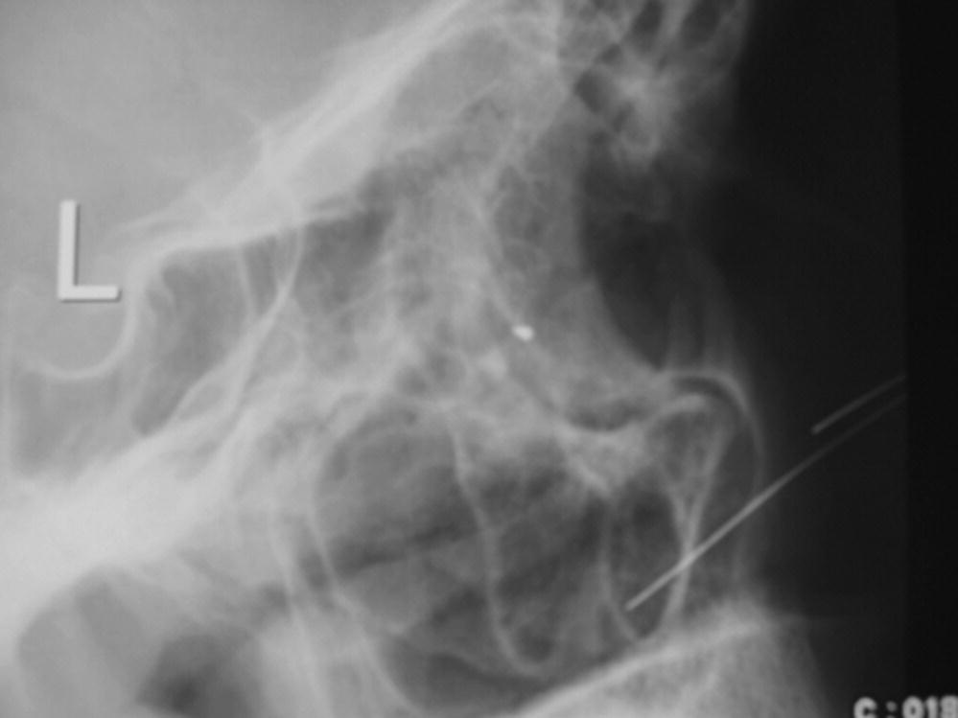
Figure 37.1 Intraocular foreign body x-ray (lateral view).
Source: Michael Mills. Reproduced with permission of Michael Mills.
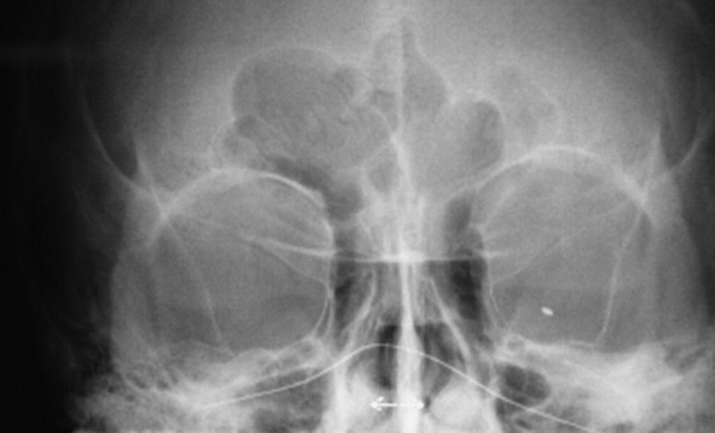
Figure 37.2 Intraocular foreign body x-ray (anterior-posterior view).
Source: Michael Mills. Reproduced with permission of Michael Mills.
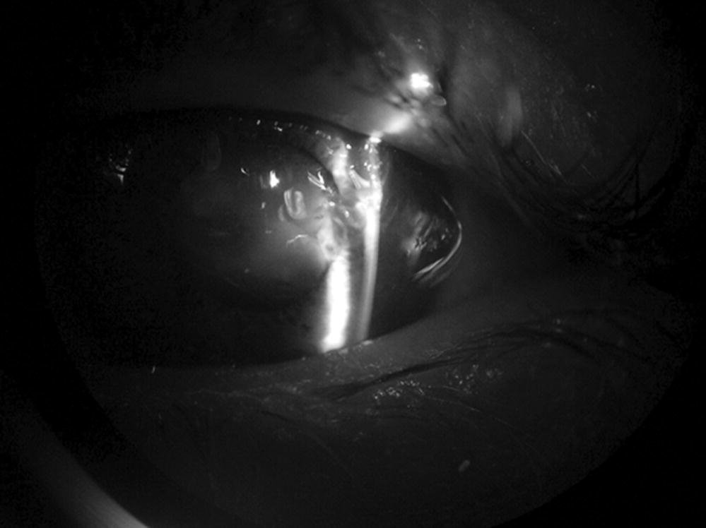
Figure 37.3 Intraocular foreign body on slit lamp.
Source: Michael Mills. Reproduced with permission of Michael Mills.
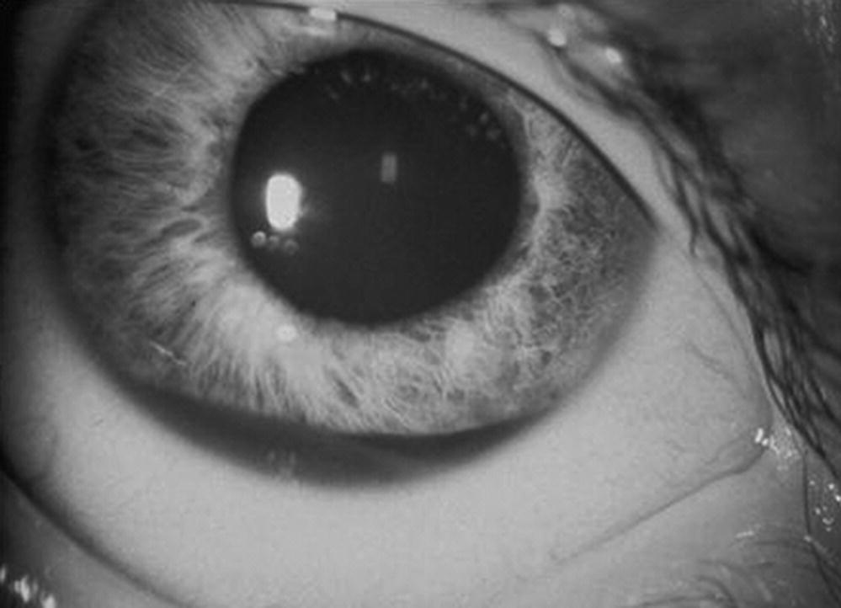
Figure 37.4 Hyphema from air bag injury.
Source: Michael Mills. Reproduced with permission of Michael Mills.

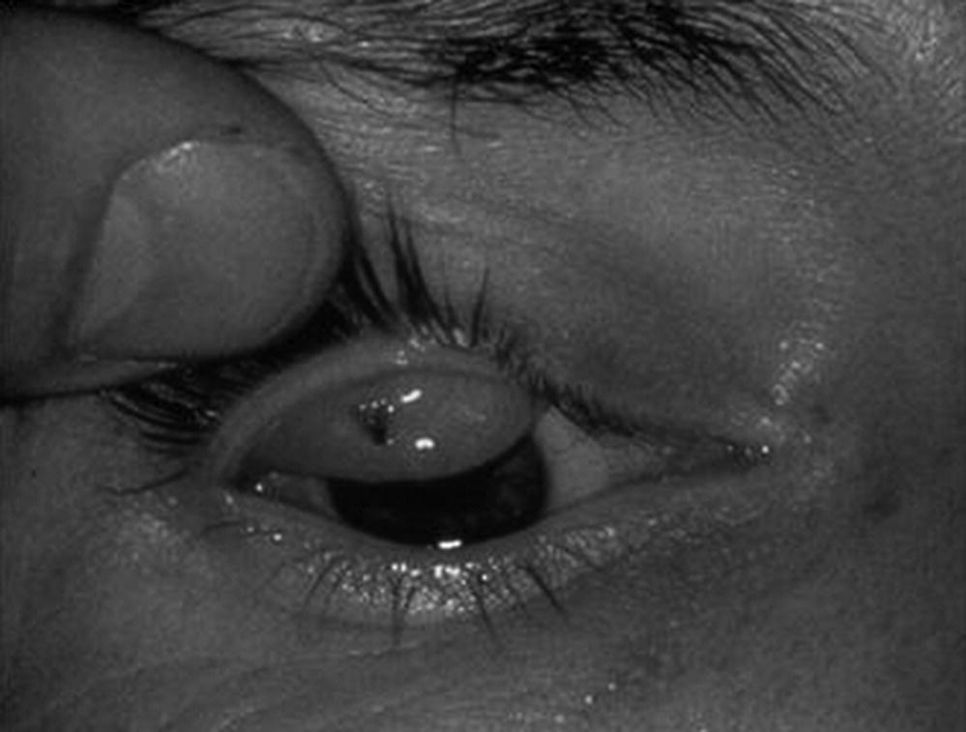

Figure 37.5 Foreign body in eyelid.
Source: Michael Mills. Reproduced with permission of Michael Mills.
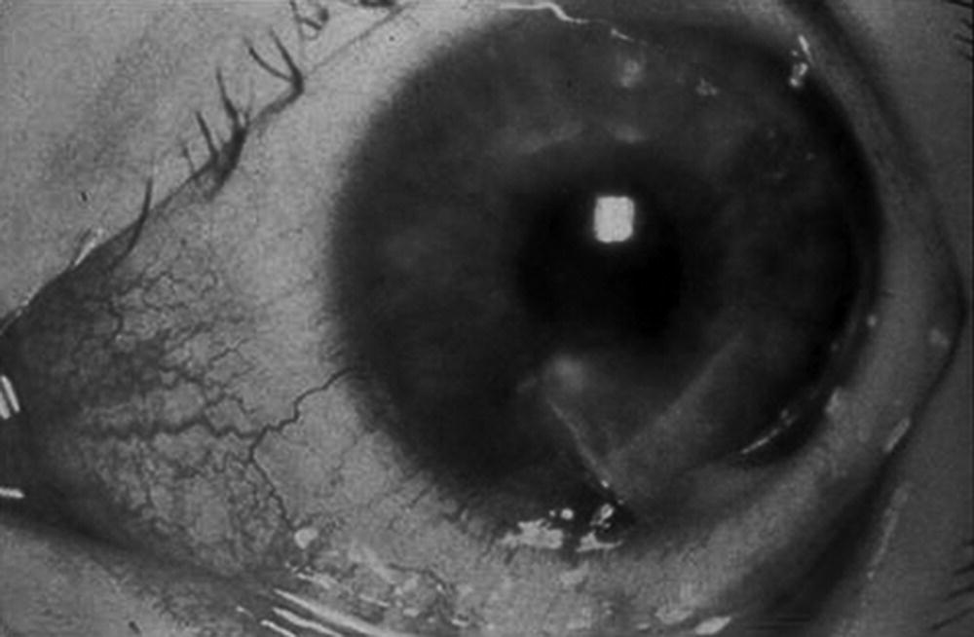
Figure 37.6 Ruptured globe.
Source: Michael Mills. Reproduced with permission of Michael Mills.
Finally, examination of the surrounding structures of the eye focuses on associated maxillofacial trauma or related complications. The eyelids and periorbital soft tissues are inspected for lacerations, ecchymosis, edema, foreign bodies, and cutaneous evidence of thermal or chemical burns. The orbital rims are similarly inspected and palpated for signs of crepitus or obvious bony deformities. If injuries are unilateral, comparisons are made between the eyes because normal foramina of the surrounding eye rim may be mistaken for fractures. If the patient has obvious periorbital trauma, an orbital blowout fracture is concerning, especially if there is associated diplopia (double vision) or inability to move the eye superiorly. Finally, the patient should have a sensory examination of the skin around the eye. Any numbness or paresthesias could indicate damage to the infraorbital nerve.

Specific eye injuries

Ocular burns
Ocular chemical burns are true ophthalmic emergencies and are best treated in the field with copious irrigation with water. Delays in irrigation have been associated with increased risks to visual acuity and higher rates of subsequent complications when compared with immediate irrigation of the eye [9]. Tap water and normal saline work equally well initially, with the keys being the volume of the fluid and duration of irrigation rather than the type of fluid [10]. Irrigation should continue during transport for a minimum of 30 minutes for significant exposures. Important historical information to obtain includes the duration of exposure, type of chemical, and the pH of the substance if known. If the chemical is an industrial source, a Material Safety Data Sheet (MSDS) is particularly helpful to identify and categorize the substance in question [10]. Injuries from acid exposures tend to be less serious than alkali substances [11] but this varies by the particular type of chemical involved. In addition to irrigation, proper prehospital management includes pain control and transport to an appropriate center for immediate ophthalmological consultation and evaluation.

Ocular trauma
Direct trauma to the eye can be divided into open or closed globe injuries. Open globe injuries have full-thickness defects in the ocular wall and include lacerations, intraocular foreign bodies, and rupture of the globe from blunt trauma [12]. These signify high-energy mechanisms of injury and are frequently associated with other ocular or periorbital injuries. Symptoms include decreased visual acuity, difficulty with ocular motility, and abnormal or absent pupillary reflexes. On examination, open globe injuries may be evident on gross inspection, as with a visible foreign body, a large scleral laceration with clear penetration, or an obvious deformity of the eye or pupil. However, penetrating injuries may cause negligible external damage to the sclera or globe and a small intraocular foreign body may cause minimal pain after the initial event [13]. The key point for the prehospital physician is to consider an open globe, especially if there is associated significant head injury, periorbital damage, or hyphema. Once an open globe is suspected, all further evaluation of the eye should be postponed until definitive care is available [7]. The eye should be protected with a hard eye shield and the patient should be transported for further emergency evaluation and potential surgical repair by an ophthalmologist. Other appropriate prehospital care includes pain control, elevation of the head of the bed to 30–45°, and antiemetic medication to reduce potential increased intraocular pressure during vomiting.
Closed globe injuries occur when there is partial penetration of the eye and include hyphema, damage to the retina, superficial abrasions and lacerations, and non-penetrating foreign bodies. These can cause significant eye pain, loss of visual acuity, and decreased ocular function, but they vary by the type and location of injury.

Traumatic hyphema
A traumatic hyphema is a collection of blood in the anterior chamber of the eye caused by blunt or penetrating injury. The highly vascular ciliary body or iris is usually the source of bleeding for a hyphema and is often associated with head trauma or other eye injuries to the cornea, iris, lens, or globe [14–16]. Signs include decreased direct visualization of blood in the anterior chamber, poor visual acuity, and decreased pupil reactivity. Hyphema severity is graded on a scale of 1–4 based on the amount of blood that collects in the anterior chamber when the patient is in a upright position, ranging from a minimal layering (grade 1) to a complete filling of the anterior chamber with blood (grade 4) [14,16]. This classification is important because higher-grade hyphemas have an increased risk of complications and are a threat to permanent damage or loss of visual acuity [17]. Complications include rebleeding into the hyphema, corneal blood staining, and damage of the optic nerve or retina from increased intraocular pressure [15–17]. Prehospital care focuses on pain management, elevation of the head of the bed from 30–45° if possible, covering of the eye with a protective shield, and prompt transport to a medical facility for further ophthalmological evaluation and management [15,16].

Corneal injuries
Corneal injuries are extremely common and may present with ocular pain, sensations of a foreign body in the eye, blepharospasm, or tearing [18]. Decreased visual acuity, blurred vision, and photophobia are also common initial symptoms. Corneal abrasions often result from a direct blow to the eye or a foreign body under the eyelid that irritates the corneal surface. These may be visible on gross exam, but often the lesion can only be seen on slit-lamp examination after staining with fluorescein dye. Similarly, corneal foreign bodies may be seen on visual inspection of the eye and should be suspected in any patient with eye pain associated with high-risk activities like use of power tools, grinding, hammering, or sanding objects with or without use of protective eyewear [11]. If an object is visualized in the eye it should be flushed with saline or removed by a skilled practitioner unless there is concern that it has penetrated the globe, in which case the eye should be covered or patched and the object left in place until appropriate evaluation by a physician.
Prehospital care of corneal injuries focuses on a thorough history, pain management, and transport to a center with appropriate specialty care. Most superficial corneal injuries heal within 24–72 hours, but the prognosis and potential for further complications depend on the depth and overall size of the lesion [18].

Retinal injuries
Trauma of the retina and posterior segments of the eye is less common than injuries to anterior eye structures, but carries a higher risk of blindness and irreversible loss of vision [19]. Common presentations include decreased visual acuity or a sensation of “flashing lights” or “floaters” in the visual field of the affected eye [20]. Retinal injuries require a complete fundus examination for definitive diagnosis, and these techniques are beyond the scope of this review. For the EMS physician, it is important to remember the signs of retinal and posterior segment injury and to obtain a focused eye history and examination, including visual acuity, before transporting the patient for ophthalmological evaluation and treatment.

