Chapter 15
Cardiac procedures and managing technology
T.J. Doyle

Intraaortic balloon pump
The intraaortic balloon pump (IABP) is a mechanical device used in the stabilization of an acutely ill cardiac diseased patient. The EMS physician or critical care transport team will most commonly encounter the device during a patient transfer from a facility with limited or unavailable cardiac surgery capabilities to a tertiary care center. The role of the IABP is to provide cardiac stabilization until definitive care can be obtained. Goals of IABP therapy include decreasing cardiac afterload, augmenting diastolic perfusion pressure, and increasing coronary artery perfusion [1]. These efforts help to improve cardiac output that can in turn improve tissue perfusion. The decrease in afterload reduces the workload on the heart, and the improved coronary artery circulation can increase oxygen supply to the myocardium.
Indications for IABPs most commonly encountered by EMS physicians are acute myocardial infarction, cardiogenic shock, ventricular aneurysm, left ventricular failure, valve or papillary muscle rupture, or a combination of these factors [2]. The patient is most commonly found in a catheterization lab, operating room, or coronary intensive care unit.
The IABP catheter is placed via an incision in the lower extremity, inserted in the femoral artery, and then advanced into the thoracic aorta. The balloon should be placed 1–2 cm distal to the beginning of the subclavian artery, and must be above the branches of the renal arteries. If the balloon is not placed correctly, occlusion of coronary, subclavian, or renal arteries could occur [1]. On a chest x-ray, the tip of the catheter should be visible between the second and third intercostal spaces. When inflated, the balloon should not completely occlude the aortic lumen, as this can damage the aortic wall and blood components [1]. Most devices have different sized balloons for patients based on weight or height. It is important to ensure the appropriate balloon volume is being used.
Absolute contraindications for an IABP include aortic dissection, abdominal aortic aneurysm, and aortic valve incompetence. Relative contraindications include bleeding disorders and atherosclerosis [1].
A patient with an IABP who requires interfacility transportation must be attended to by a specially trained team. In some cases, critical care paramedics, nurses, or physicians are trained to address IABP complications. Otherwise, it is vital that the transport team include a perfusionist or biomedical engineer.
Intraaortic balloon pump function is critically dependent on timing. The balloon is cycled in conjunction with the cardiac cycle. It is important to remember that the balloon is inflated during diastole and deflated just prior to systole. While the balloon is inflated, blood is pushed both back toward the heart, as well as further down the aorta. The result is increased blood flow to coronary and carotid arteries, and increased systemic perfusion. The balloon is deflated very rapidly, and this rapid loss of volume reduces the pressure in the aorta. The result is that the left ventricle does not contract as hard as it would otherwise. Cardiac workload and myocardial oxygen demands are reduced. If the timing is not correct, these advantages are lost, and further harm to the patient may occur [1].
The IABP can use several different triggers for the inflation and deflation cycle. The most common modalities use the ECG or the arterial pressure waveform as a trigger. The IABP may also have an internal trigger in the event of cardiac arrest. Using arterial pressure as a trigger requires the patient to have an arterial catheter placed and connected to the balloon pump. Some IABP devices may have specialized fiberoptic connectors to measure arterial pressures. It is important to note that once a fiberoptic connector is placed and zeroed, it cannot be removed and connected to a different transport IABP. Another trigger modality needs to be used, such as ECG. Most devices have an “automatic” trigger mode, where the pump automatically switches between trigger modes if needed. An example would be a switch between ECG and arterial pressure modes if the ECG signal is lost. Most modern pumps can also compensate for arrhythmias such as atrial fibrillation and pacing modes [1].
With the trigger mode established, attention should focus on timing. Most patients are transported with a 1:1 frequency, where each cardiac cycle is assisted. In order to assess timing, it may be helpful to place the device in a 1:2 frequency to get a better picture of the arterial pressure waveform landmarks. For transport, the operator should ensure that the balloon is set to inflate at the dicrotic notch, and to deflate during the next isovolumetric contraction (IVC) phase. The dicrotic notch phase on the arterial pressure waveform represents aortic valve closure and diastole. Once the timing is correct, the device can be placed back into a 1:1 frequency and put in the “automatic” mode if available [1]. Potential complications include limb ischemia, compartment syndrome, aortic dissection, bleeding, thrombocytopenia and red blood cell destruction, gas embolus, infection, and cardiac decompensation from incorrect timing [1].
Special care must be taken when transferring a patient from one brand of IABP to another to enable transport. There may be a difference in the balloon size, and an adapter may be needed to connect a “Brand D” catheter to a “Brand A” IABP. The balloon size should be noted and adjusted on the pump if necessary.
On arrival to a patient's side, the transport team should examine the patient paying particular attention to the insertion site, as well as to the distal extremity. The insertion site should be examined for bleeding or protruding balloon. The catheter tubing should be examined for any blood or blood flecks. The distal extremity should be examined for ischemia. Catheter tubing should be examined for kinking. Any positive findings noted above should delay the transport until the situation can be corrected. Fresh ECG leads should be applied to the patient. The referring hospital balloon pump should not be disconnected or shut off until the transport pump is connected and tested. The transport balloon pump should be plugged into an outlet during this time and not run on battery power. The pump should also be plugged into an aircraft or ambulance power inverter during transport. Pure battery operation should be used only to transport the patient from the vehicle to his or her hospital destination.

Special circumstances
In the event of cardiac arrest, the IABP will lose all trigger modes, give a “trigger arrest” alarm, and then stop counterpulsation. If left unchanged, this could result in a thrombus formation. When cardiopulmonary resuscitation (CPR) is initiated, the IABP should be switched to “arterial trigger.” Effective CPR should allow for the IABP to function off the arterial pressures. In the event that arterial pressures are not sufficient, the IABP should be switched to an “internal trigger.” This last resort trigger provides asynchronous counterpulsation and will help prevent clot formation. “Internal trigger” mode should be stopped if there is a return of circulation and the ECG or arterial pressure mode is restarted [2].
In the event of IABP failure during transport, a large Luer-Lok syringe should be attached to the quick connector to aspirate the balloon for blood. If no blood is found, use air to inflate the balloon to the volume capacity of the balloon. Then quickly aspirate the air and deflate the balloon. Repeat 4–5 times every 5–10 minutes until the pump is repaired or replaced [1].

Ventricular assist device
Ventricular assist devices (VAD) are surgically implanted pumps that are intended to assist one or both ventricles of the heart to pump when disease has diminished the heart’s native ability to do so. They are most often placed in patients with severe congestive heart failure. Devices include left ventricular assist devices (LVAD), right ventricular assist devices (RVAD), and biventricular assist devices (BIVAD). The most commonly placed device is the LVAD. The LVAD will have a cannula placed in the apex of the left ventricle with blood flow to the pump and a cannula placed into the ascending aorta with blood flow from the pump. Thus the device assists the ventricle in moving blood through the circulatory system [2].
Ventricular assist devices were first developed in the 1960s and the technology progressed during the 1970s and 1980s. Advances made them more portable, but the patient was still confined to the hospital. In the 1990s fully portable devices were developed that, for the first time, allowed VAD patients to be discharged from the hospital [3,4]. The devices are most commonly used as a bridge to cardiac transplantation, but they also may be used as a bridge to a reversible cardiac condition, or as a permanent therapy. There are two types of VAD patients: those with non-portable VADs, who would require critical care transport with a perfusionist, and those with portable VADs who may be living at home or in an assisted living facility. It is the second group of patients who are potentially encountered by EMS.
Currently, there are four generations of VADs with features that can vary based on the generation and the particular device (Box 15.1). First-generation devices mimic the pumping action of the left ventricle via the use of diaphragms or pusher plates that cause blood to be sucked into the left ventricle and expelled into the aorta. This mechanism results in pulsatile blood flow. The patient will have a pulse and blood pressure that can be measured [4]. The pumps are powered by electricity and can be either electromechanical or pneumatic. Electromechanical pumps use an electromagnetic pusher plate to drive the blood, whereas pneumatic devices use air pressure to move the blood. Both devices require electrical power to function. Pneumatic devices may come with a hand pump in case of device failure [3].

Box 15.1 Generations of Left Ventricular-Assist Devices
- First Generation
  - Berlin Heart ECXOR (Berlin Heart AG)
  - HeartMate XVE (Thoratec)
  - Novacor LVAS (World Heart Corp.)
  - Thoratec PVAD (Thoratec)
- Second Generation
  - HeartMate II (Thoratec)
  - Jarvik 2000 (Jarvik Heart)
  - MicroMed DeBakey VAD (MicroMed Cardiovascular)
- Third Generation
  - Berlin Heart INCOR (Berlin Heart AG)
  - CentriMag (Levitronix)
  - CorAide (Cleveland Clinic Foundation)
  - DuraHeart LVAS(Terumo Somerset, USA)
  - HeartMate III (Thoratec)
  - HeartQuest (WorldHeart)
  - HVAD Pump (HeartWare)
  - Levacor (World Heart Corp.)
  - VentrAssist (formerly Ventracor)
- Fourth Generation
  - MAGNEVAD (Gold Medical Technologies)
  - Heart Assist 5 (MicroMed Cardiovascular)
Source: Mechem CC. Prehosp Emerg Care 2013;17(2):223–9. Reproduced with permission
Second-generation LVADs have continuous-flow rotary pumps. If the device only assists with the work of the left ventricle, the underlying function may result in a palpable pulse. If the LVAD is fully replacing the function of the ventricle, there may not be a palpable pulse. As with other technology advances, these devices offer advantages in size, ease of implantation, and durability. The number of moving parts has been reduced to one: the impeller. Second-generation LVADs are subdivided into devices with axial pumps and those with radial (centrifugal) pumps [3] (Figure 15.1). 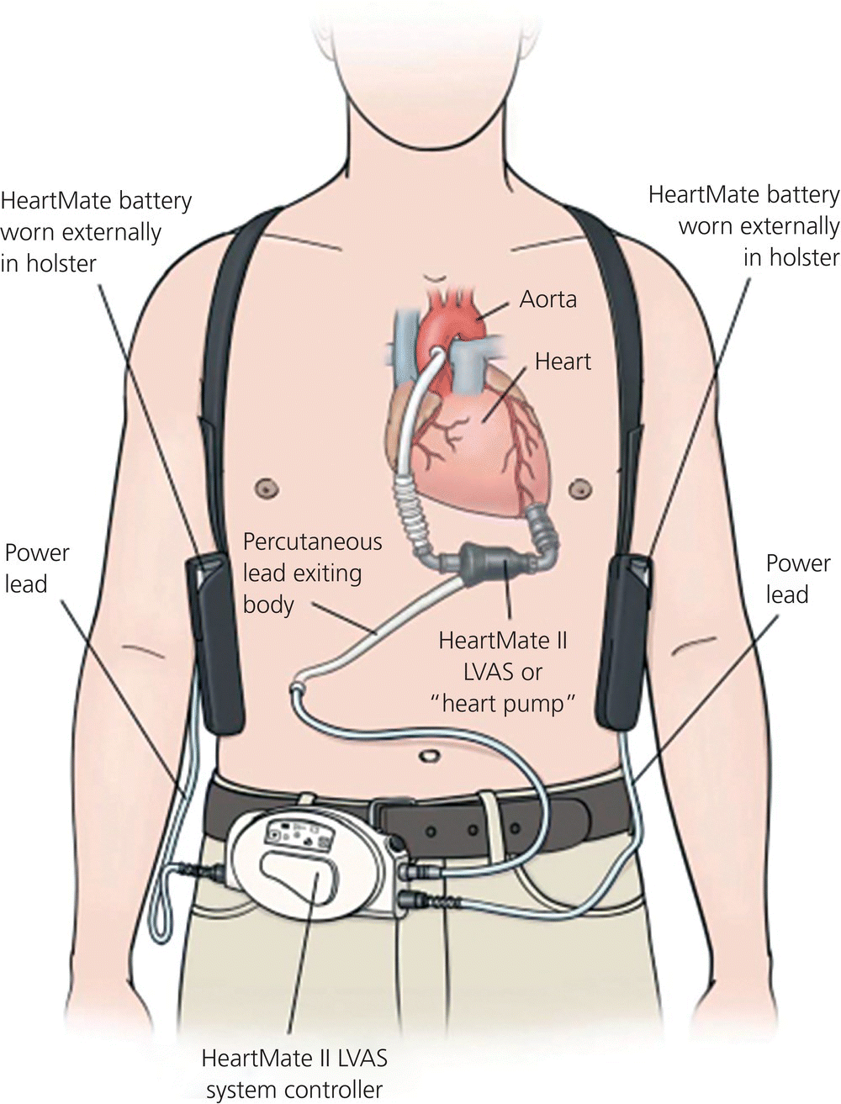

Figure 15.1 HeartMate II left ventricular assist device (LVAD). LVAS, left ventricular assist system.
Source: Thoratec Corporation. Reproduced with permission of the Thoratec Corporation.
Axial pumps use a corkscrew and the Archimedes principle against gravity. The inflow and outflow pumps are in line with the impeller, resulting in a smaller size pump. In contrast, centrifugal pumps have the inflow and outflow cannulas at right angles to the flow. Right angles allow for less suction, which can decrease the risk of the ventricle collapsing around the inflow cannula or distortion of the interventricular septum. Both can result in right ventricular failure [3]. One study found 58% survival rates for continuous-flow devices versus 24% for pulsatile flow devices. They also have a lower rate of complications. As continuous-flow pumps are valveless, there is an increased risk of blood flow back into the aorta if the pump stops [5].
Third-generation LVADs represent a further technology step forward. They can use continuous-flow, axial flow, or centrifugal pumps. The impeller is suspended by magnets and driven by electromagnets. This results in no contact between the impeller and the sides of the pump. Benefits include less trauma to blood components and less thrombus formation. The devices are also quieter and can last longer [3].
Fourth-generation LVADs, currently in testing and trials, are exploring further advances in technology, including wireless monitoring and elimination of the driveline. This would remove the cabling from the pump, which must travel through the skin in order to connect to the power source. As driveline infections are a major source of LVAD complications, driveline removal could result in significantly less morbidity [3].
The results of these advances are devices that allow the patient to leave the hospital and function either at home or in an assisted living facility. Prior to discharge, the patient and family are given extensive training on the operation and maintenance of the device, and how to troubleshoot problems and alarms. The patient is followed by a hospital team, and is given written instructions for EMS providers, which outline the device, emergency interventions, and hospital contact information [6].

Left ventricular assist device complications
Left ventricular assist device complications can be divided into two categories: device problems and patient problems. The most common problems consist of neurological events, bleeding, and cardiac arrhythmias. Neurological events include acute strokes and transient ischemic attacks. Thrombotic and hemorrhagic events can occur. The incidence of stroke has been reported ranging from 8% to 25%. The risk is increased for patients with stroke histories and those who have had device-related infections [3].
The most commonly experienced forms of bleeding include epistaxis, gastrointestinal bleeding, and hematoma formation. Bleeding can result from trauma to blood components, from acquired von Willebrand disease, or from iatrogenic anticoagulation [7]. Most patients are given anticoagulants and/or antiplatelet drugs to reduce the risk of thrombus formation [3,8]. LVAD patients are also at increased risk of arrhythmias. Patients may have atrial fibrillation, often as a result of underlying disease. The LVAD will provide left ventricle support, but the loss of atrial “kick” may affect right ventricular function. LVAD patients may also suffer from ventricular arrhythmias. These arrhythmias may result from underlying disease, from irritation of the myocardium by the device, or from ventricular collapse or septal deviation from excessive pump function. Some patients may require an implanted cardioverter-defibrillator (ICD) [3,8].
Infection is the most common complication, with infection rates ranging from 18% to 59% among LVAD patients. Infection is second only to heart failure as a cause of mortality in these patients. Infections can present at the surgical site, the driveline, the pump pocket, or the pump itself in the form of endocarditis [3,9].
Device-specific problems can manifest as device failure (fortunately rare) or from battery or cable connection issues. Suction events can occur when there is not enough volume in the left ventricle to support the speed of the pump. This causes the intake cannula to collapse and subsequent ventricular arrhythmias [3]. LVADs in place for a long time can become dislodged, resulting in incomplete left ventricle emptying , right ventricular failure, and arrhythmias. LVAD placement may also result in thrombosis [10]. The patient might then suffer symptoms ranging from dyspnea to cardiogenic shock [11] (Box 15.2).

Box 15.2 Complications Encountered in Left Ventricular-Assist Device Patients
- Infection
  - Bleeding
  - Stroke/transient ischemic attack
  - Hemolysis
  - Arrhythmias
  - Volume overload
  - Dehydration
  - Hypertension
  - Hypotension
  - Cardiac tamponade
  - Recurrence of heart failure
  - New right ventricular failure
  - Aortic insufficiency
Source: Mechem CC. Prehosp Emerg Care 2013;17(2):223–9.Reproduced with permission

Prehospital encounters
Balloon pump patients are not routinely encountered by EMS providers except during critical care interfacility transports. In contrast, a patient with a portable LVAD could be at home, have an event, and summon EMS. It is beneficial for EMS services to be aware of LVAD patients in their service area, and have device information and contact information accessible. Hospital policies may dictate that a perfusionist or pump technician be sent to the scene to evaluate the device in the event of a problem. This situation then could result in a delay in patient transport while the perfusionist is in transit. If the patient is having a medical issue not related to the device, a medical oversight decision may need to be made regarding transport. For example, a portable LVAD patient is having an acute stroke or gastrointestinal (GI) bleed, and no LVAD issues. The perfusionist can arrive in 45 minutes. The patient can be transported by helicopter to the tertiary care center in 15 minutes. The crew is not familiar with the LVAD. The medical oversight physician will need to weigh the risks of delay to care in waiting for the perfusionist versus the risk of an LVAD complication during the 15-minute flight.
The LVAD patient in distress might be having an issue with the device, an exacerbation of the underlying cardiac disease, or an unrelated medical event. The intial EMS assessment should be to determine if the issue is LVAD related or not (Figure 15.2). If the event does not seem to be LVAD related, then local protocols and/or medical oversight should be consulted for further guidance. The next step would be to determine the type of LVAD involved. The patient and caregiver should have device information available. This information should include whether the patient can receive electrical therapy, and whether or not CPR can be performed. Obviously, these questions need immediate answers [3].

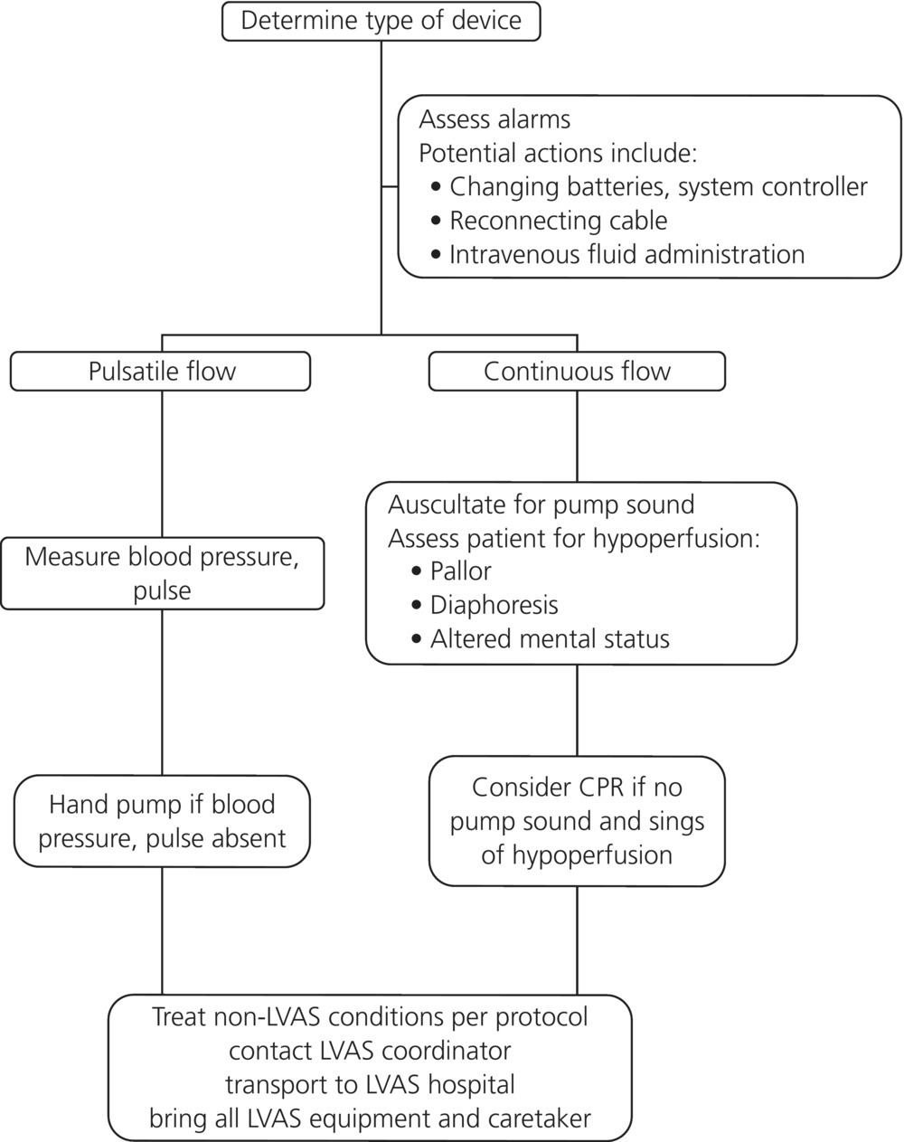

Figure 15.2 Emergency assessment of a patient with a left ventricular assist system (LVAS). CPR, cardiopulmonary resuscitation.
Emergency medical services personnel must determine if the device provides pulsatile or continuous flow. A patient with a pulsatile flow device should have a palpable pulse and blood pressure. Pulsatile pump LVAD failure requires the use of a hand pump to continue flow. A patient with a continuous-flow device will have no detectable pulse. A functioning pump should make a humming sound on auscultation [3].
In the event of device malfunction, the LVAD should generate a series of auditory and visual alarms. These alarms will be device and manufacturer specific. The patient, caregiver, and device literature should be used to determine alarm causes. Power alarms may be triggered by low voltage in the batteries, necessitating battery changes, or, in the case of a pulsatile device power failure, hand pumping. Low-flow pump alarms most likely result from hypovolemia, which would indicate the need for IV fluids or blood products. Other alarms may indicate cable disconnections which will require troubleshooting. Transport should not be delayed to perform these interventions [3].
As with all patients, the initial assessment should consist of airway, breathing, and circulatory assessments. Patients with continuous-flow devices may not have reliable pulse oximetry readings due to low pulse pressures. Furthermore, a continuous-flow device will not produce a palpable pulse or a measureable blood pressure. The EMS provider will need to then use other signs to assess perfusion, such as pale skin, diaphoresis, or mental status changes. The patient should be placed on a cardiac monitor and a 12-lead ECG should be performed if possible. Patients showing signs and symptoms of another illness, such as stroke, should be assessed in the usual fashion, regardless of the assist device. LVAD patients should also be exposed to examine for cable disconnections. The driveline skin site should not be routinely examined unless absolutely necessary, due to risk of infection. Clothes should not be cut with shears as there is risk of cutting the cables with disastrous results. For the same reasons the patient should be moved carefully to prevent dislodgment [3].
Patients with evidence of hemodynamic compromise and/or hypoperfusion should have large-bore IV access, and be volume resuscitated. Vasopressors are not generally a good initial therapy, as many problems are volume related, and vasopressors will increase afterload, which can worsen pump flow [3].
Arrhythmias should only be treated if they are symptomatic. An LVAD patient with full left ventricle support may be able to tolerate ventricular tachycardia or fibrillation. If the arrhythmia requires treatment, the usual therapies can be used for rate control and rhythm conversion. The patient can also receive electrical therapy [3]. Defibrillator pads should not be placed over the device. Some devices may require that the system controller cables be disconnected prior to defibrillation to prevent damage to the electronics. The patient should also be examined for the presence of an ICD, which would provide the appropriate treatment [12].
The decision on when to perform CPR can be a major conundrum in treating these patients. Knowledge of the device type and function is crucial. First-generation LVADs with pulsatile flow should not get chest compressions. Instead, the hand pump should be used. Second-generation and later continuous-flow devices will not have a hand pump. Chest compressions carry the risk that they may dislodge the device, resulting in exsanguination and death. On the other hand, if the LVAD is not pumping, the underlying left ventricle will not have the ability to maintain perfusion of organ systems. Patient survival is not likely. Lack of compressions may also result in a thrombus formation in the pump, resulting in obstruction to pump flow and potential downstream embolic events. EMS awareness of the patient’s advance directives regarding resuscitation may be important, as these patients have chronic severe disease and may wish to not be resuscitated [3].
Ideally, device information, patient wishes and treatment plans, and contact information should be prepared prior to initial discharge from the hospital. In the event of an EMS contact with a patient who is hypoperfused and has a non-functioning pump, an attempt may be made to contact the LVAD coordinator for further recommendations. If the coordinator cannot be reached, and the patient is to be resuscitated, compressions should be started and transport initiated [3].
The LVAD patient should be transported to the hospital that placed the device. These hospitals are usually tertiary care centers, and should be capable of managing not only LVAD complications but also other issues such as stroke or GI bleeding. If there are distance issues, air medical transport should be considered. This can shorten time and also provide critical care services. Regardless of transport mode, the LVAD patient should be transported with all device equipment, batteries, controllers, documentation, and caregivers (if possible).

Implanted cardiac devices
Emergency medical services personnel may also encounter patients in the field with implanted cardiac devices, such as pacemakers and ICDs. The approach to a patient with an implantable device who is suffering from a medical condition is to determine if the problem lies with the device or the underlying medical condition.

Pacemakers
Cardiac pacemakers are implanted devices used in patients suffering from bradyarrhythmias. If the patient’s intrinsic rhythm falls below a set target, the pacemaker will provide an electrical stimulus to the myocardium. There are a variety of pacemaker manufacturers and pacing modes, depending on the needs of the patient. The device will be palpable within the patient’s chest wall.

Pacing modes
Pacemakers are designated with a five-letter code; the first three letters are referred to most often [14]. The first letter indicates the chamber paced, the second letter indicates the chamber sensed, and the third letter the response after sensing [13].
- AOO Atrial pace; no sense, no inhibitions
- AAI Atrial pace; atrial sense, inhibited by atrial beat
- VOO Ventricular pace; no sense, no inhibitions
- VVI Ventricular pace; ventricular sense, inhibited by ventricular beat
- DOO Dual chamber pace; no sense, no inhibitions
- DVI Dual chamber pace; ventricular sense, inhibited by ventricular beat
- DDD Dual chamber pace; dual chamber sense, inhibited by either chamber
The EMS physician who responds to a pacemaker patient with a clinical issue first needs to determine if the device is the problem. Vital signs and cardiac monitoring are the best tools to identify the problem. The first determinant is the heart rate. If the patient is markedly bradycardic, the pacemaker should be presumed to have failed. The patient will require hemodynamic support, which may include external cardiac pacing. If external pacing is indicated, care should be taken to not cover the implanted device with the external pads. If the patient is tachycardic, the physician will need to determine if the pacer is firing inappropriately, or if there is another medical cause. The presence of pacer spikes prior to every tachycardic beat is the best indicator of a pacer issue.
The next step is to determine what therapy is needed. Optimally, the patient can be transported to a facility where the implanted device can be interrogated by an electrophysiologist, preferably at the hospital where the device was implanted. If the patient’s clinical condition requires more urgent intervention, a special magnet can be placed to suspend inappropriate pacing. The magnet will not turn the pacer off, rather it will trigger the device to pace at an asynchronous (fixed) rate depending on the device and manufacturer [15]. A DDD pacemaker will pace at DOO, a VVI device will pace at VOO, and an AII device will pace at AOO [15]. Magnet therapy is only effective when the magnet is on the skin over the pacemaker. In the event that magnet therapy is ineffective, it is theoretically possible to cut the pacer wires, but this would be difficult in the field, may permanently damage the device, and should only be performed as a last resort.

Implantable cardioverter-defibrillators
Implantable cardioverter-defibrillators are a first-line therapy for many patients at risk for sudden cardiac death. ICDs are usually implanted in the left infraclavicular region and are typically palpable. All patients with the device get an ID card that notes the manufacturer and device model. ICDs have four main functions:
- sensing atrial and ventricular signals
- classification of those signals into programmable heart rate zones
- administration of electrical therapy to terminate ventricular tachycardia or ventricular fibrillation
- pacing for bradycardia and/or cardiac resynchronization therapy (equivalent to a standard pacemaker) [16].
If ventricular fibrillation or ventricular tachycardia is detected, high-energy shocks of 1–40 J can be delivered [16]. Although this is less energy than external defibrillation or cardioversion, the shock can be painful to the patient.
The EMS physician will most likely encounter one of three possible scenarios in an ICD patient who is suffering from an ICD-related cardiac event. The first is device failure in the event of a ventricular arrhythmia. The second is an appropriately functioning device in the setting of a ventricular arrhythmia. The third possibility is the ICD delivering shocks inappropriately in the absence of a ventricular arrhythmia. The first step in all cases is assessment of mental status, vital signs, and cardiac monitoring. If the patient has an unstable ventricular arrhythmia and the ICD does not fire, it should be assumed the device is non-functional and ACLS protocols should be followed. If external defibrillation is needed, the defibrillator pads should not be placed over the implanted device.
If the patient has a ventricular rhythm and the ICD is giving appropriate shocks, care should be focused on additional treatment of the arrhythmia, as well as rapid transport to the hospital. The patient may benefit from analgesia and possibly sedation in the event of multiple shocks. External electrical therapy should not be needed.
In the third scenario, the ICD is giving inappropriate shocks in the absence of a ventricular arrhythmia. As with pacemaker malfunctions, ideally the device can be interrogated by an electrophysiologist at the receiving hospital. If the patient’s condition requires emergency intervention to stop inappropriate shocks, a special magnet can be placed over the device. The magnet will suspend detection of ventricular fibrillation and ventricular tachycardia and should stop the shocks. The magnet will not stop the pacemaker function of the ICD, nor place the pacer in asynchronous (fixed) mode [16]. In the event of magnet placement, cardiac monitoring is required because the ICD will no longer be able to sense nor shock arrhythmias. Magnet therapy is only effective while the magnet is secured to the skin over the device. It may also be prudent to apply external defibrillator pads during transport. As with a pacemaker, cutting the lead wires of an ICD will most likely permanently damage the device, is difficult to perform in the field, and is not recommended short of a dire last resort.

Pericardiocentesis
Pericardiocentesis may be indicated in the ACLS algorithm for pulseless electrical activity (PEA) in the event of cardiac arrest. If the PEA is the result of cardiac tamponade, pericardiocentesis may reverse the condition. The prehospital provider should use the subxiphoid approach, inserting a needle to the left of the xiphoid and aiming at the left shoulder at a shallow angle. An 18 gauge spinal needle or 3” IV catheter may be used. Aspiration of blood that does not clot indicates removal from the pericardial space, as opposed to intraventricular blood. This procedure is more difficult to perform in the prehospital environment where ultrasound guidance is typically less available. It should be used as a final resort when all other therapies have failed [17].

Conclusion
Only critical care teams with extensive additional training should attempt to transport patients with IABPs, unless they are accompanied by a perfusionist. Such patients are not generally encountered by the EMS system except to facilitate interfacility transportation. Careful attention must be paid when transitioning a patient from one pump to another, and proper timing of inflation is crucial.
Patients in the community with VADs are growing in prevalence. Preplanning for potential emergencies, including awareness by the EMS system, is an important aspect of ensuring an appropriate response when complications or unrelated medical events arise. A coordinated exchange of information between the VAD hospital team and surrounding EMS agencies is key to the safe and effective treatment and transfer of these patients. Depending on the brand and type of VAD, the patient may or may not have a palpable pulse or blood pressure. Most pump flow alarms occur because of low volume and require volume resuscitation. Vasopressors in these patients may do more harm than good.
The prehospital provider may also encounter patients with implanted cardiac devices. Assessment of these patients will determine if the clinical condition is due to a device malfunction or not. While not routinely carried or used by EMS personnel, the EMS physician may want to have access to a special magnet used to turn off an ICD, or reset a pacemaker to asynchronous pacing.

References
- 1 Anon. An Introduction to Intra-Aortic Balloon Pumping. Reading, PA: Arrow International, 2005.
- 2 York-Clark D, Stocking J, Johnson J. Mechanically assisted cardiovascular transport. In: Flight and Ground Transport Nursing Core Curriculum. Denver, CO: Air and Surface Transport Nurses Association, 2006, pp.205–10.
- 3 Mecham CC. Prehospital assessment and management of patients with ventricular assist devices. Prehosp Emerg Care 2013;17:223–9.
- 4 Myers TJ, Dasse K, Macris M, et al. Use of a left ventricular assist device in an outpatient setting. ASAIO J 2001;47:590–5.
- 5 Fukamachi K, Smedira N. Smaller safer, totally implantable LVADs: fact or fantasy? Am Coll Cardiol Curr J Rev 2005;14:40–2.
- 6 Hoshi H, Shinshi T, Takatani S. Third-generation blood pumps with mechanical non-contact magnetic bearings. Artif Organ 2006;30:324–8.
- 7 Geisen U, Heilmann C, Beyersdorf F, et al. Non-surgical bleeding in patients with ventricular assist devices could be explained by acquired von willebrand disease. Eur J Cardiothorac Surg 2008;33:679–84.
- 8 Kato TS, Schulze P, Yang J, et al. Pre-operative and post-operative risk factors associated with neurologic complications in patients with advanced heart failure supported by a left ventricular assist device. J Heart Lung Transplant 2012;31:1–8.
- 9 Califano S, Pagani F, Malani P. Left ventricular assist device associated infections. Infect Dis Clin North Am 2012;26:77–87.
- 10 Kiernan MS, Pham D, DeNofrio D, Kapur N. Management of HeartWare left ventricular assist device thrombosis using intracavitary thrombolytics. J Thorac Cardiovasc Surg 2011;142:712–14.
- 11 Felix SE, Martina J, Kirkels J, et al. Continuous flow left ventricular assist device support in patients with advanced heart failure: points of interest for daily management. Eur J Heart Fail 2012;14:351–6.
- 12 Boyle A. Arrhythmias in patients with ventricular assist devices. Curr Opin Cardiol 2012;27:13–18.
- 13 Pacemakers: Nomenclature. Available at: www.unc.edu/~rup/old/RP_Anesthesia/Basics/Pacers/html
- 14 Wallace A. Pacemakers for Anesthesiologists Made Incredibly Simple. Available at: www.cardiacengineering.com/pacemakers-wallace.pdf
- 15 Jacob S, Panaich S, Maheshwari R,et al. Clinical applications of magnets on cardiac rhythm management devices. Europace 2011;13(9):1222–30.
- 16 Stevenson W, Chaitman B, Ellenbogen K, et al. Clinical assessment and management of patients with implanted cardioverter-defibrillators presenting to non-electrophysiologists. Circulation 2004;110:3866–9.
- 17 Thomson D, Cooney D. Procedures. In: Krohmer JR, Sahni R, Schwartz B, Wang HE (eds) Emergency Medical Services: Clinical Practice and Systems Oversight, Volume 1, Clinical Aspects of Prehospital Medicine. Lenexa, KS: National Association of EMS Physicians, 2009.

