Chapter 42
Care in the wilderness
Seth C. Hawkins, Michael G. Millin, and William ”Will“ R. Smith

Introduction
Although there may be many ways to define wilderness, for the purposes of this chapter a wilderness setting includes any geographic area where typical medical resources are not adequate or available for the management of an injured or sick patient. Such settings may include deserts, mountains, rivers, oceans, space, caves, and other remote areas. In fact, urban areas during disasters can also be considered wilderness.
The definition of wilderness environment is critical when discussing wilderness EMS (WEMS). WEMS providers should be authorized to follow operationally specific protocols, so the environment where those protocols becomes activated (the “wilderness” environment) must be defined. This is best accomplished via local or regional definition. Nearly every jurisdiction has the potential for wilderness medical care, whether due to environmental factors such as weather (limiting transport capability or complicating care), fixed geographic factors such as absence of roads or presence of parks or bodies of water, or potential for natural or manmade disasters resulting in the sudden need for austere medical care (New Orleans during Hurricane Katrina). Currently, a patchwork of protocols and levels of care exists across the country, as states and services grapple with how to anticipate and manage WEMS operations. There is not yet a national standard regarding what should be included in WEMS protocols and what an appropriate scope of practice is for this subspecialty of EMS physicians and providers; yet the idea that WEMS or austere medical care will never be needed for any given jurisdiction is naïve.
Wilderness EMS providers typically have to personally carry all of the equipment that may be needed for the care of the patient as well as for their own safety and survival. WEMS physicians and providers require knowledge in personal survival in austere environments, search procedures, advanced wilderness medical care, and geographically specific extrication techniques, for the safety of their patients and themselves (Figures 42.1–42.3).

Figure 42.1 Low-angle rescue with guiding line.
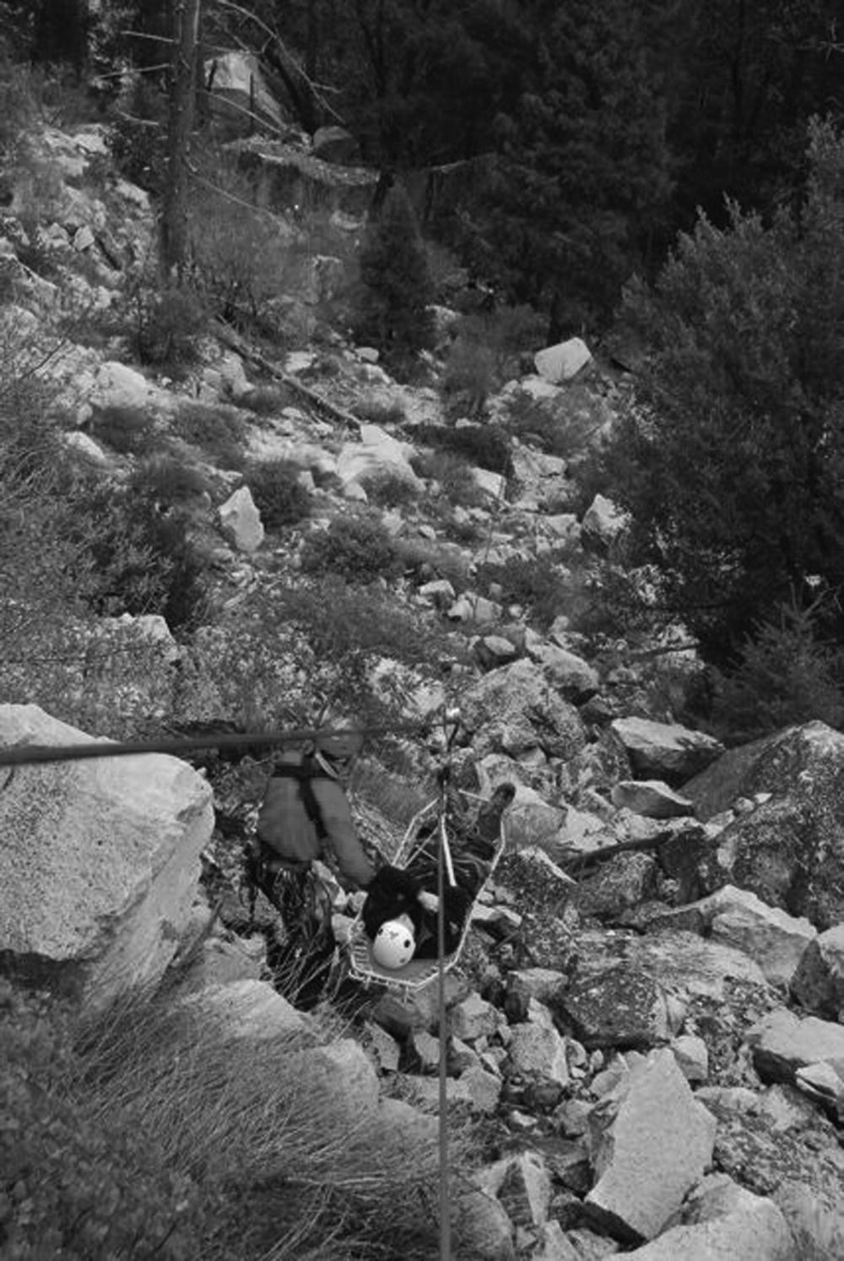
Figure 42.2 High-angle rescue.
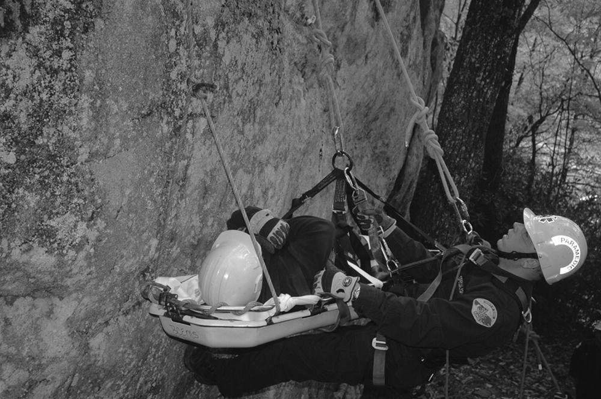
Figure 42.3 Cave/confined space rescue.

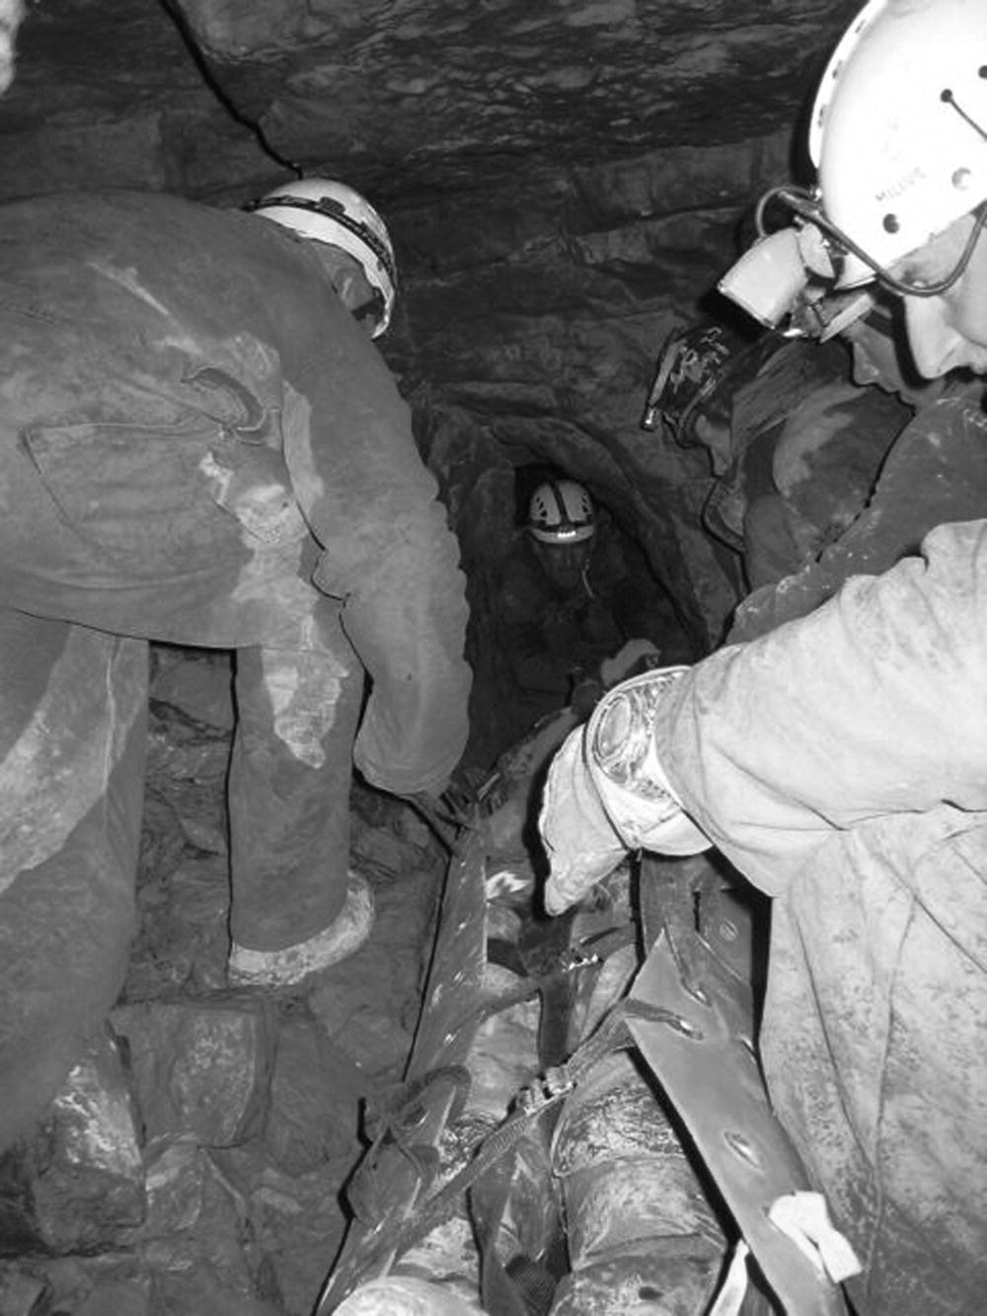
Although some authors define WEMS as any situation that involves a minimum 1–2-hour transport time, this definition does not encompass every WEMS experience. There may be situations that require specialized medical care prior to extrication or transport even if the area is near a roadside, such as a patient injured on the hill at a ski resort or a hiker in a large urban nature preserve. Due to the specialized skills required to manage these patients, the inability to get supplies to the patient easily, or a complex extrication without the aid of an ambulance, these situations must also be considered wilderness.
It is important to understand that WEMS is substantially more complex than the application of traditional medical training in a wilderness environment, and the indiscriminate application of traditional care and standards often proves to be dangerous to patients and/or providers in a wilderness setting.
Finally, it is important to draw a distinction between wilderness medicine and WEMS. Wilderness medicine is the broad field addressing the general care of patients in a remote, austere, or wilderness setting. Most often in popular dialogue and training paradigms, wilderness medicine assumes unexpected and opportunistic care. If, however, one specifically trains for a particular type of emergency medical response to a particular set of environmental challenges, joins a team that has specifically configured itself to provide medical care in a specific locality, and maintains a formal wilderness medicine certification to do so, then the care has entered the realm of WEMS. There are significant consequences to the differentiation of general wilderness medicine from specific wilderness EMS, not least of which are an expectation for increased professionalism, increased or more specific training for that particular environment, potentially increased equipment and familiarity with local emergency services, and by definition the probable establishment of a "duty to act" and different medicolegal expectations.
One good illustration of this difference is in the different didactic preparations. With a few exceptions, general wilderness medicine teaching focuses on the ad hoc use of materials at hand, which may or may not have been originally purposed for medical care. There is a recognition that minimal medical equipment may be available since medical care is only one consideration among many for recreational or professional trips. WEMS retains some of this ad hoc and improvisational spirit, but since the entire purpose of the WEMS operation is rescue and medical care, choosing the most appropriate equipment specifically for medical care, and absolute familiarity with that equipment, becomes paramount.
A more concrete example would be the response and medical care one would expect to be offered by a backcountry skier out for a day with basic wilderness medical training and a standard daypack who comes upon another skier with a broken leg and head injury in the remote backcountry. Then contrast the expectations of that caregiver with the expectations for the formal ski patrol unit that is dispatched to care for that same patient. This exemplifies the difference between general wilderness medicine and WEMS.
Other terminology frameworks include programs with similar themes of austere and resource-deficient care (wilderness, disaster, tactical, military, remote) under an umbrella definition of “operational medicine.” So, for example, the National Association of EMS Physicians (NAEMSP) and the National Association of State EMS Officials (NAEMSO) identify all EMS providers operating in remote or austere conditions as being “operational,” specifically citing ski patrols, wilderness search and rescue teams, and fast or open water rescue teams as well as tactical EMS and urban search and rescue teams [1]. Other global terms for this category of care include “austere medicine” or “resource-deficient medicine.”
Therefore, WEMS represents organized efforts wherein providers are assigned to specific geographic areas or missions with a specific duty to act. The purpose of WEMS is to provide care to an ill or injured patient in a wilderness setting while still recognizing that the providers are functioning within the defined health care system. It is the goal of WEMS to manage the patient in the field, extricate the patient, and transport to an acute care facility if needed. These goals are met with the concept that the patient should be receiving quality care with appropriate physician participation or oversight. The purpose of this chapter is to outline the structure of WEMS systems and define why and how health care systems that may need to provide wilderness care should consider developing or integrating formal WEMS programs.

History
Wilderness medicine is in some ways the oldest of the medical disciplines. The first time one human attempted to help another, with or without rudimentary tools made from the surroundings, could be considered the beginning of wilderness medicine. However, as a formal subfield of modern medical practice, wilderness medicine is very new, and WEMS is in its infancy.
The history of WEMS can be broadly divided into decades of evolution.
- 1940s–1950s: return of WWII 10th Mountain Division soldiers and establishment of the National Ski Patrol (NSP), probably the first non-military WEMS system [2,3]. The NSP’s first certification course was Winter Emergency Care, which evolved into Outdoor Emergency Care (OEC). The NSP’s OEC textbook is now in its fifth edition [4] and teaches WEMS skill sets and knowledge at a level exceeding the emergency medical responder curriculum but below the emergency medical technician level [5]. Although the program is administered by the NSP, it is designed to cover material for all wilderness environments, and can be used by WEMS providers in a diverse range of wilderness environments in addition to ski areas.
- 1960s–1970s: publication of Medicine for Mountaineering [6], one of the first wilderness-specific medical texts; establishment of first wilderness medicine/WEMS proprietary schools, such as Wilderness Medicine Outfitters in the west, Stonehearth Outdoor Learning Opportunities (SOLO) in the northeast, and Peter Goth’s NC Outward Bound-Linville Gorge Wilderness EMT courses in the southeast; development of many local search and rescue (SAR) teams [7–10].
- 1980s: establishment of “SOLO West,” the predecessor to the Wilderness Medicine Institute of NOLS (WMI-NOLS), and Wilderness Medical Associates (WMA). Other schools have proliferated, and for many decades such schools were the primary mechanism for obtaining wilderness medical training. Currently, over 100 different vendors or schools offer wilderness medical training, and over half a million individuals have received some sort of WEMS certification [9]. This early dependence on private schools is an important differentiation between WEMS evolution and that of other EMS subspecialties. The 1980s also saw the establishment of the Wilderness Medical Society (www.wms.org) and first publication of Paul Auerbach’s Wilderness Medicine [7], now considered the definitive textbook on wilderness medicine.
- 1990s: initial attempts at WEMS standardization. Development of Advanced Wilderness Life Support (AWLS) by the University of Utah, the first certification course generated by an academic institution, geared exclusively toward health care professionals, and marketed/taught outside the proprietary school model.
- 2000s: Stanford University established the first wilderness medicine fellowship. This decade saw the proliferation of academic programs, although most focused on wilderness medicine in general rather than WEMS. Examples of more rare WEMS-specific medical student/resident/fellowship programs include the UCSF-Fresno Wilderness Medicine/EMS fellowship [11] (UCSF-Fresno also has one of the very few residency programs with a program-wide focus on WEMS [12]); the University of Utah’s EMS/Wilderness Medicine fellowship; and the Carolina Wilderness EMS Externship, a uniquely collaborative operational and educational project involving a major university, a community health care system, a county EMS system, and a community college [13]. For paramedics, the University of Utah’s baccalaureate degree program in EMS has specific WEMS training in its Remote Rescue Training program. Western Carolina University established the first distance-learning WEMS paramedic baccalaureate program in 2007, but it was inactivated only a few years after successful implementation, a victim of budget cuts [8,14]. Other paramedic programs increasingly incorporate WEMS training into their traditional curricula. WMS and NAEMSP also endorsed the development of a specific Wilderness EMS Medical Director Course and associated curriculum, which is now offered annually at these organizations’ conferences. This decade also saw seminal historical events that dramatically altered our thinking about wilderness and austere medical care, including the 9/11 terrorist attacks of 2001 and Hurricane Katrina in 2005, and the growth of regionalization in wilderness medicine [15].
- Wilderness EMS is a field still defining itself, with new resources and programs appearing every year (please refer to the website for Box 42.1).

Box 42.1 Suggested wilderness EMS internet resources
- Adirondack Wilderness Medicine: www.adkwildmed.com
- Aerie School of Backcountry Medicine: www.aeriemed.com/
- Allegheny Mountain Rescue Group: www.amrg.info
- American Alpine Club (AAC): www.americanalpineclub.org
- American Mountain Guides Association (AMGA): www.amga.com
- American Safety & Health Institute: www.ashinstitute.org/wilderness.htm
- AMR Reach and Treat Team: www.summitpost.org/article/172226/amr-reach-and-treat-who-we-are-and-what-we-do.html
- Appalachian Center for Wilderness Medicine: www.appwildmed.org
- Appalachian Search and Rescue Conference: www.asrc.net
- APT Antincendio: www.aptgroup.it/eng/index.html
- Argentine Rescue & First Aid School: www.easpa.com.ar
- CDS Outdoor School: www.cdsoutdoor.org
- Cinchona.org: www.cinchona.org
- Crag Rats: www.cragrats.org
- Diploma in Mountain Medicine: www.theuiaa.org/mountain_medicine.html
- Divers Alert Network: www.diversalertnetwork.org
- Federal Emergency Management Agency (FEMA): www.fema.gov
- Front Range Institute of Safety: www.frisfirstaid.com
- International Institute for Sustainability in Emergency Services (iiSES): www.greenems.org
- International Society for Mountain Medicine: www.ismmed.org
- Landmark Learning: www.landmarklearning.org
- Médecins Sans Frontières/Doctors Without Borders: www.doctorswithoutborders.org
- Medic Response Safety: www.medicresponse.com
- MedicalOfficer.Net, Ltd: www.medicalofficer.net/
- Mountain Aid Training International (MATI): www.mountainaid.com
- Mountain Rescue Association (MRA): www.mra.org
- Nantahala Outdoor Center: www.noc.com
- National Association for Search & Rescue (NASAR): www.nasar.org
- National Cave Rescue Commission: www.caves.org/io/ncrc
- National Disaster Life Support Foundation: www.bdls.com
- National Disaster Medical System: www.oep-ncms.dhhs.gov
- National Ski Patrol (NSP): www.nsp.org
- National Speleological Society: www.caves.org
- North American Rescue Institute: www.soloschools.com/nari.html
- Professional Outdoor Medical Educators: www.wildernessmedicine.com/pomeschool
- Remote Medical International: www.remotemedical.com
- Rescue 3 International: www.rescue3.com
- Rescue Specialists: www.rescuespec.com
- Rigging for Rescue: www.riggingforrescue.com
- Stonehearth Outdoor Learning Opportunities (SOLO): www.soloschool.com
- UCSF-Fresno ParkMedic Program: www.fresno.ucsf.edu/em/parkmedic.htm
- Union Internationale des Associations d’Alpinisme (UIAA): www.uiaa.ch
- United States Coast Guard: www.uscg.mil
- United States Department of Defense: www.defenselink.mil
- United States National Park Service: www.nps.gov
- University of Utah Wilderness Medicine/AdventureMed: www.awls.org
- Vertical Medicine Resources: www.vertical-medicine.com
- Wilderness Emergency Care: www.wildernessemergencycare.com
- Wilderness EMS Institute: www.wemsi.org
- Wilderness EMS Medical Director Course: www.wemsmdcourse.com
- Wilderness Medical Associates (WMA): www.wildmed.com
- Wilderness Medical Society (WMS): www.wms.org
- Wilderness Medicine Institute of the National Outdoor Leadership School (WMI of NOLS): www.nols.edu/wmi
- Wilderness Medicine Outfitters: www.wildernessmedicine.com
- Wilderness Medicine Training Center: www.wildmedcenter.com/home.html
- Wilderness Safety Council: www.wfa.net
- Adapted from Hawkins SC. Wilderness EMS. In: Aehlert B (ed) Paramedic Practice Today: Above and Beyond. Philadelphia: Elsevier, 2008.

Current operations and epidemiology
Having generated data for many decades – longer than most WEMS systems have been in existence – the National Park Service has provided much of the best epidemiological information on WEMS operations. These data indicate that WEMS providers in national parks experience equal numbers of medical and traumatic EMS events (although more deaths are traumatic), and that the national incidence of EMS events is 46 per 1 million visitors [16]. However, this incidence may be misleading, as it includes many park areas that would not typically be considered wilderness. Other studies only focus on specific highly visited locations or specific wilderness activities. One useful study examined all incidents over a 3-year period in eight of the “most wilderness-type environment” national parks in California. This demonstrated an overall occurrence of 9.2 non-fatal events per 100,000 visits, with a mortality rate of 0.26 deaths per 100,000 visits. Men accounted for 78% of the deaths, with heart disease, drowning, and falls being the most common etiology [17]. Other ParkMedic data exemplify many of the different operational elements of WEMS, including non-transport rates of 77%, base hospital contact rates of 28%, and rates for ALS care of 10% (with 16% of these ALS patients not transported) [18].
These data amply demonstrate that WEMS providers have been working for decades in a very different operational environment than most traditional EMS authorities would recognize. As much as any other EMS subtype, WEMS argues for a redefinition of “prehospital” medicine” as “out-of-hospital” medicine, since the majority of patients in some WEMS systems receive all their care in the field and are not transported to hospitals.

Standardization
Despite growing academic and commercial attention, standardization of WEMS training and practice has not yet been achieved to the degree it has in other EMS specialties [19].
The Wilderness Medical Society (WMS) was founded in 1983 and serves as the professional society for wilderness medical practitioners. WEMS has been actively promoted by this organization and it has made some efforts towards WEMS standards. In 1991, the WMS proposed a model mechanism to develop a curriculum for wilderness prehospital emergency care (WPHEC) [20], with the intent of establishing a disciplinary standard for the WEMS field internationally [21]. However, this was not widely cited or implemented in subsequent commercial or academic courses, and the term “WPHEC” is no longer in widespread use. The WMS published minimum standards for wilderness first responder (WFR) certification in 1999 [22]. However, the maximum scope of practice may be the more controversial issue versus minimum curriculum standard. The WMS has also not yet defined the minimum curriculum or maximum scope of practice of wilderness EMTs (WEMT) or wilderness paramedics, which also is a potentially more controversial topic than WFRs.
Among communities that professionally require and utilize wilderness medical training, such as outdoor experiential schools, colleges, guiding organizations, and others, there is no industry standard regarding wilderness first aid (WFA) training and certification of outdoor adventure/education leaders [23], and there is even controversy among experts surrounding the de facto standards that do exist for WFA [24]. In 2013, leaders of many commercial wilderness medicine schools published a consensus document establishing minimum standards and scope of practice for WFA. However, as noted by the authors themselves, the document exclusively addresses first aid standards, not EMS responder standards, and sets a minimum, where a maximum scope of practice may be the more salient question. However, this bodes well for future initiatives establishing standardized or consensus standards and scopes of practice for true EMS certifications [25]. In addition, the establishment of minimum standards for WFA and WFR also satisfies the requirements of EMS Education for the Future, which promotes the idea that there is a single level of minimum competency for each level of EMS credentialing, and that those labeled as EMS providers (presumably including WEMS providers) should be able to demonstrate ability at or above that level.
Historically, NAEMSP Rural Affairs Committee has pursued important work on WEMS protocols and practice, establishing clinical guidelines for delayed or prolonged transport involving spine injury [26], dislocations [27], wound care [28], and cardiopulmonary arrest [29]. However, no new WEMS clinical position statements have appeared since 1993. In 2010, NAEMSP released a position statement on medical direction of operational EMS (including WEMS) [1]. This statement affirmed that WEMS programs and providers often require specialized skills, should function within and not outside the mainstream health care system, and should function with oversight from an appropriately trained, certified, and credentialed medical director. The position statement and an associated resource document [30] address medical director and system standardization, but neither specifically addresses certification or scope of practice standardization except to say that it is multifactorial and all applicable regulations must be followed.
The American College of Emergency Physicians (ACEP) and the Society for Academic Emergency Medicine (SAEM) have formed wilderness medicine sections that have implicit interest in WEMS, especially as practiced by physicians, but no standardization positions have yet been formally taken by these groups.
Wilderness EMS also accounts for many of the field health care providers and organizations who sometimes, despite meeting all apparent criteria for being EMS providers, operationally fall outside EMS supervisory processes such as medical oversight, standardization, and regulated scope of practice. These may include some ski patrols, lifeguards, SAR teams, and wilderness guides, among others. The National Ski Patrol’s OEC program, which is now commercially marketed as an all-seasons and all-environments wilderness medicine certification, has been particularly notable in this regard [4]. There is at least one instance of a state specifically defining OEC practitioners as first aid providers regardless of their scope of practice, thus potentially bypassing EMS regulatory oversight [31,32]. On the other hand, there is at least one instance of a state specifically declaring OEC as an EMS certification, thus explicitly putting it within the EMS oversight system [33]. The interface of all these WEMS agencies and teams with traditional EMS systems can be a subject of both local and national debate and negotiation [31,34,35].

Scopes of practice

New scope of practice model
The National Highway Traffic Safety Administration published EMS Education for the Future: A Systems Approach in 2000 [36] and The National EMS Scope of Practice Model in 2005 [37]. These were further refinements of a national standard for prehospital care promulgated by the 1996 EMS Agenda for the Future. The conceptual basis includes the application of the scope of practice of each of the four “levels” of EMS providers in all locations of the United States. Although these documents do not contain standards or sections addressing WEMS specifically, these concepts are still quite relevant to WEMS. Quite often in a wilderness event there may be a variety of levels of providers involved with the management of a patient. In addition, there may be times when a patient is managed by an EMS provider at the EMR or EMT level without the assistance of a provider at the level of AEMT or paramedic. While this suggests that scope of practice might need to be expanded in these circumstances, in a WEMS setting such expansion should be done only with appropriate indirect medical oversight well in advance of any anticipated need, and with the approval of the local and state EMS regulatory authority.
According to the National EMS Scope of Practice Model, “… state regulations must be clear as to the extent to which the State’s EMS scope of practice applies to EMS personnel functioning in these non-traditional roles and settings. The employers of EMS personnel working in non-traditional roles and settings must also be aware to what extent the person’s State EMS license permits or prohibits such activities” [37]. This scope of practice issue is two-sided: the state needs to understand the requirements of the austere and wilderness environment, and the providers and provider organizations need to understand that the state has regulatory authority.

According to the National EMS Scope of Practice Model, “… state regulations must be clear as to the extent to which the State’s EMS scope of practice applies to EMS personnel functioning in these non-traditional roles and settings. The employers of EMS personnel working in non-traditional roles and settings must also be aware to what extent the person’s State EMS license permits or prohibits such activities” [37]. This scope of practice issue is two-sided: the state needs to understand the requirements of the austere and wilderness environment, and the providers and provider organizations need to understand that the state has regulatory authority.

Levels of WEMS providers

Wilderness first aid (WFA)
In general, the WFA provider is someone who has limited training or experience in wilderness medicine. The typical WFA course is about 16–24 hours in length [21] and is intended to provide the individual with basic first aid knowledge as it applies to a remote or austere environment. WFA-certified individuals may be part of an organized WEMS system in the capacity of search and rescue, but are generally not intended to be the medical component of a formal wilderness rescue. This is more often a “general knowledge” certification that would be utilized in Good Samaritan circumstances. The wilderness first aider may also be a member of a local Boy Scout troop or a private citizen who happens upon someone in need. In 2013 a consensus panel primarily composed of wilderness medicine schools published a statement establishing minimum standards and scope of practice for WFA [25].

Wilderness first responder (WFR)
The WFR is the basic provider level serving in an organized WEMS system. There is also a growing standard for guided wilderness trips (e.g. rafting, climbing, and others) to have a guide certified to this level. WFR courses are generally about 80 hours in length [21]. The WFR is trained to recognize potential life-threatening injury and stabilize the patient for transport out of the wilderness environment. At times, the WFR may be trained to administer life-saving medications such as epinephrine, oxygen, and glucose under appropriate medical oversight. The WFR may also be trained in protocols that include dislocation reductions, selective spinal immobilization, and termination of resuscitation. Although new EMS terminology would suggest that this should become wilderness emergency medical responder (WEMR), this has not yet been embraced, and this level of responder is universally still referenced as a WFR. As noted earlier, in 1999 the WMS Curriculum Committee published minimum course content guidelines for a WFR curriculum [22].

Wilderness emergency medical technician (WEMT)
The WEMT course is approximately 150 hours long and usually adds to WFR training by including more advanced techniques in manipulation of dislocations, administration of medications, and all components of traditional EMT training. Despite the absence of a standardized curriculum, the curricula of at least three of the major schools (WMI, WMA, and SOLO) have been found to be similar enough that they will recertify each other’s students. As the majority of WEMS students are trained via the curricula from these three schools, an ad hoc comparison can be made between EMT and WEMT curricula, and when analyzed, that difference has been characterized as “vast” [9]. In general, the wilderness modules appended to these WEMT curricula involve an additional 48–80 hours of training beyond standard EMT curricula [9].

Wilderness paramedic
Commercial training companies, who generally train and certify at the WEMT level, do not generally recognize the wilderness paramedic as an independent certification level. However, numerous systems field paramedics who operate as wilderness paramedics. In general, the wilderness paramedic is able to administer medications with a similar scope of practice as the urban paramedic. In addition, some WEMS systems train providers at this level in procedures for prolonged care, such as the insertion of Foley catheters for urine drainage and nasogastric tubes for gastric decompression.

Wilderness physician
The wilderness physician is able to provide necessary care and advanced medical decision making within the limitations of the surrounding environment. Wilderness physicians may receive special training through fellowship programs and/or special courses such as the WMS's conference courses, proprietary professional school curricula such as Wilderness Upgrade for the Medical Professional, Wilderness Advanced Life Support, Wilderness Medicine for the Professional Practitioner, Remote Medicine for the Advanced Provider, or other similar coursework. As noted earlier, AWLS certification is available from AdventureMed, who license numerous instructors around the world to teach this course. The Wilderness EMS Institute has historically offered a Wilderness Command Physician course, although this has not been offered recently. In addition, wilderness physicians may also be tasked with providing medical oversight for other WEMS providers. In light of this, NAEMSP and WMS have jointly endorsed a new program, the Wilderness EMS Medical Director Course, which provides training for physicians involved as medical directors or medical advisors for WEMS systems [38]. In addition, numerous fellowships now exist in EMS (with a very few, as noted earlier, specializing further in WEMS). As board-certified and fellowship-trained EMS physicians begin to enter the workforce, it would be expected that field care at the physician level, including wilderness physicians, would continue to rapidly expand and improve.

Emergency medical dispatchers and telemedical providers
As telecommunications capabilities expand further into wilderness regions, the capability grows for remote medical care via telephone. It is worth noting that reliable 3G mobile phone coverage was established on the summit of Mt Everest, the highest point on Earth, in 2010. Emergency medical dispatchers (EMDs) may more frequently serve as the first point of contact with the subjects themselves for wilderness rescues. This puts a new emphasis on the importance of medical training for EMDs that includes novel protocols such as wilderness medical care. EMDs and other telecommunications services can provide life-saving wilderness medical instructions. For example, the most important intervention in the case of cardiac arrest from drowning or lightning strikes is immediate cardiopulmonary resuscitation (CPR), a skill that EMDs are uniquely prepared to facilitate via telephonic instruction, potentially hours before the first on-scene WEMS responder arrives.
Some countries are also embracing novel telecommunications strategies to address austere and WEMS environments of care. In Bhutan, a Himalayan country in the unique situation of developing an EMS system within an entirely new health care infrastructure, the decision has been made to consolidate much of their field medical care in a central “health help centre” (HHC), created in 2011 [39]. The HHC serves not only as a national public safety answering point, but also as a centralized source for telephonic medical care, potentially at the physician level. This addresses the reality that, outside the capital city, most of the country’s evolving emergency medical system has characteristics of a WEMS system (>85% of the country is forest, jungle, or mountain, including the highest unclimbed mountain in the world), but excellent and nearly universal mobile phone coverage. This makes it easier and faster to have individuals call in for EMS consultation and care (essentially creating a national WEMS system), before dispatching a limited number of EMS personnel (<100).

Medical oversight

Direct medical oversight
The process of direct medical oversight for WEMS operations can be quite difficult. Although it may be ideal to have the medical director or an EMS physician in the field with the EMS providers, this is typically not feasible. In addition, due to the reality that WEMS operations are often remote, it may be impossible to contact a physician by radio or cell phone.
Despite the challenges of direct medical oversight for EMS providers in the wilderness setting, there is still a need for close physician involvement with WEMS operations. Therefore, EMS agencies that will be involved with WEMS operations should work with physicians who are familiar with their work. The challenges of WEMS are unique and the physician who has experience only in the more traditional urban EMS setting will typically not be able to provide adequate input to the management of a patient in the wilderness environment. Physicians who will be involved with direct medical oversight of WEMS operations should have appropriate experience and participate in field training exercises with EMS providers. They are encouraged to participate in actual rescue operations.

Indirect medical oversight
Indirect medical oversight is the cornerstone of medical direction for WEMS systems. Mountain rescue data suggest that at least 95% of rescues are performed without physicians present [9]. Because it is often difficult for WEMS providers to reach direct medical oversight in real time, it is important to have regular educational sessions for special field assessments and protocols.
Although written protocols may seem too rigid for the wilderness environment, well-designed written protocols can largely eliminate the need for direct medical oversight. The key to developing wilderness protocols is to allow for a certain amount of flexibility in the application of the protocols by the EMS providers.
Because the case volume for WEMS operations is typically not as high as in the urban EMS setting, it should be possible to develop a program for regular case review. Case review can be the foundation for continuing educational activities and a rigorous quality improvement program.

Operations
Organized wilderness rescue can be quite complex. The most efficient method to manage the complexity is to apply a systems approach; hence the need for the development of WEMS systems. The organized rescue will often involve multiple agencies and personnel, each with their own areas of expertise. Although it may seem cumbersome to involve multiple agencies, the variance in levels of expertise is often quite important to a successful rescue. In a large-scale search there may be a need for individuals with expertise in high-angle or avalanche rescue and people with experience working with horses or snowmobiles (Figure 42.4). Large-scale searches will often require complex communications and logistical support for procurement of supplies and food. The best way to manage all of the different agencies and individuals that may be needed for a successful search is to use the incident command system (Figure 42.5). An example of the structure of a WEMS incident command is shown in Figure 42.6.

Figure 42.4 Snow rescue.

Figure 42.5 Incident command apparatus.

Figure 42.6 Wilderness EMS incident command.
In addition to the operational concerns of maintaining command and control of the multiple agencies that may be involved in a WEMS event, there are legal, financial, and ethical concerns that should be considered. Many large-scale WEMS events will involve both paid and volunteer EMS personnel. Regardless of the costs of personnel, a search may require significant financial resources. Although the party that will ultimately be responsible for carrying the financial weight of a search will vary by jurisdiction, certainly it is advisable that each jurisdiction plan for this prior to an event.
Fundamentally, a primary consideration of any WEMS event is finding the balance between rescuing the injured person and making sure that all involved with the event are not placed in undue danger. One study of SAR operations in New Hampshire analyzed 321 incidents and found a 2.5% rate of rescuer injury [40].

Protocols
Wilderness EMS is emerging as a subspecialty in EMS that requires different approaches, protocols, and medical oversight. Any austere environment challenges the feasibility, practicality, and safety of traditional EMS protocols. There also may be major communication problems. Protocols that allow EMS professionals to care for patients in prolonged care environments must be designed with sound foresight and training. Development of such protocols has engendered a number of debates.
First, some authorities have suggested that nothing about WEMS is sufficiently different to require separate standards, or that too much regional variation exists to establish national standards [41]. In 2001, Goodman et al. argued that mortality rates would not be expected to change as a result of upgrading WEMS operations [42]. However, each of these perspectives has been forcefully and directly repudiated in subsequent WEMS analysis [41].
The need for ALS, or equipment-intensive BLS such as automated external defibrillator (AED)-assisted BLS, has been heavily debated. Many WEMS operations benefit most significantly from outstanding BLS rather than ALS skills. As noted earlier, in some WEMS systems, only 10% of calls require ALS intervention [15]. This potentially calls into question the need for ALS in the first place, or its appropriateness in the context of skill retention with low-frequency usage. However, evidence also suggests that less than 50% of calls in the most urbanized cities in the United States require ALS care [43]. In addition, in some WEMS systems, providers keep skills active by also working in higher-volume systems when not working or volunteering on a WEMS team. Most importantly, to those patients who do critically need ALS interventions that may be life-saving in a remote setting, the fact that it is a low-frequency intervention is irrelevant. Some consensus guidelines are starting to appear regarding a standard of care and service expectation. For example, the International Commission for Mountain Emergency Medicine has concluded that all mountain rescue teams should have AED availability [44]. All WEMS systems must evaluate the type of ALS care that is being provided, its necessity, and its cost to the system versus its benefit to the patient.
Wilderness EMS protocols are generally developed at the state level. Current practice demonstrates a mosaic of practices, ranging from states like Maryland [33] and Alaska [45] that have explicit WEMS protocols, to states like Maine that recognize the proprietary WEMS certifications of particular schools [46], to states like North Carolina that approve specific protocols on a county case-by-case submission basis [47], to many states that have no WEMS provisions whatsoever.
Although WEMS is usually considered to be an extension of traditional EMS operations, multiple examples exist where protocols and practices first appearing in the WEMS environment helped drive changes in traditional EMS protocols. NAEMSP position statements first appeared in 1993 suggesting selective spine immobilization for remote/rural/wilderness patients [26], and protocols for this were taught in WEMS courses for many years before it became the subject of heavy scrutiny in traditional EMS. Other examples of WEMS driving traditional EMS operations include the development of the original prototype of our current incident command system by wildland fire teams.
The following are areas of focus of the major WEMS protocols that deviate from traditional EMS protocols and that are fairly consistent throughout many states’ and schools’ protocols and in national WEMS dialogue. It is worth noting that the first four are the same as those originally identified by NAEMSP in 1991 and 1993 position papers. However, despite their presence in the medical literature for two decades or more, some of these operationally specific protocols are still available to WEMS providers in only a few systems and remain controversial. This is particularly true for spinal motion restriction, joint reduction, and epinephrine availability for anaphylaxis.

Wound care
Special training is needed to manage wounds over extended periods of time to maintain function and avoid infection. This goes well beyond the teaching of traditional EMS that generally deals only with bandaging to control bleeding and transporting to the closest emergency department. In wilderness settings, protocols should address wound irrigation and ongoing wound assessments. Sometimes impaled foreign bodies have to be removed, as they may limit evacuation and increase infection risk. For situations with prolonged extrication, there may be utility in having protocols for the administration of antibiotics for prophylaxis or treatment of wound infection. Control of bleeding with well-applied direct pressure is still a key principle.

Termination of resuscitation (TOR)
If CPR has been performed in the setting of a cardiac arrest in the wilderness, it is helpful to give guidelines to out-of-hospital providers to enable them to cease resuscitation efforts. WMS practice guidelines indicate that CPR may be discontinued if there is no response after approximately 30 minutes [48], even if there is no monitor to demonstrate a non-organized rhythm, because there is virtually no chance of survival in the wilderness setting if return of spontaneous circulation (ROSC) has not occurred by that time. In 2011, NAEMSP similarly endorsed the concept that providers and medical directors, using evidence-guided methodology, could develop TOR protocols in non-traumatic cardiopulmonary arrest [49]. NAEMSP’s recommendation is that TOR protocols for non-traumatic cardiopulmonary arrest should be based on the determination that an EMS provider did not witness the arrest, there is no shockable rhythm identified, and there is no ROSC prior to EMS transport [50]. The “BLS TOR rule” developed by Verbeek et al. [51] demonstrates a sensitivity of 100% for identifying survivors and a negative predictive value of 100% for identifying non-survivors, with follow-up studies including rural regions showed a positive predictive value of 99.5% for death and specificity of 90% for recommending transport of survivors.
These are compelling data for TOR in the wilderness setting, where additional risks exist for providers performing CPR which must be measured against the putative benefit of continuing that CPR. Special considerations need to be made for patients with hypothermia, lightning injury, and drowning, but WEMS care of these patients without rapid evacuation to definitive care and without rapid ROSC is generally futile. Transforming a mission from rescue to recovery may be difficult for some rescuers, but the risk to rescuers of performing prolonged CPR in a wilderness setting outweighs the potential benefit.

Joint reductions
These protocols are generally not taught in traditional EMS courses, because patients with dislocations are easily taken to a hospital where x-rays can confirm a diagnosis and practitioners can reduce them in a controlled setting. In the wilderness, a shoulder dislocation can make it difficult for someone to self-extricate, but with training the WEMS provider at even the most basic levels may be able to successfully reduce a shoulder dislocation, allowing the patient to evacuate himself or herself [52]. This reduces the risk to the patient and caregivers while, most importantly, still providing good patient care. Other joint reductions that are often taught are digits and patella. Most of these protocols are very specific to reducing dislocations caused by indirect trauma so as to minimize the manipulation of fractures.

Spinal motion restriction
Spinal immobilization is a very common procedure performed in the urban/rural EMS system, and although selective spine immobilization is now being more broadly accepted in traditional systems, almost every patient injured by blunt trauma with a significant mechanism of injury is still immobilized. In wilderness settings, however, placing someone on a backboard can drastically change the scope of a rescue/evacuation, with markedly increased potential for risk to both the patient (in the form of pain, agitation, respiratory compromise, local perfusion loss, and development of pressure sores) [53] and rescuers (in the form of significantly increased operational complexity, physical labor for movement, possibility of secondary trauma, and longevity of operations). Selective spine immobilization and spinal motion restriction protocols are typically based on the same criteria that have become the standard for physicians deciding whether or not to order radiological studies on patients with potential spine injuries. These criteria have been validated in the EMS environment [54,55] and are an important tool for WEMS providers.
In 2013, both NAEMSP and the American College of Surgeons Committee on Trauma adopted the position that the benefit of long board spinal immobilization is largely unproven. They both recommend that the utilization of backboards for spinal immobilization should be judicious, so that the potential benefits outweigh the risks [53]. Some authorities make the case that no patient should ever be immobilized on a backboard in the WEMS environment unless needed for short-term extrication purposes rather than long-term transport.
In the wilderness environment in particular, there may be additional risks to immobilizing a patient, particularly if this may render him or her less able to avoid unexpected environmental risks. In a tragic case in Texas, a patient (who had been ambulatory for 10–15 minutes prior to this action) was immobilized onto a backboard in the middle of an intersection. A vehicle subsequently veered into the intersection, striking the immobilized patient but not the EMS personnel who were able to flee the danger [56]. Even more likely analogues are apparent in a wilderness setting, involving flash floods, avalanches, or other unexpected environmental dangers, as well as simply the danger of a patient being dropped or control lost in precipitous environmental conditions like steep trails or near water. Any immobilization done in or around water requires particular attention to the necessity of immobilization given increased environmental risk, and continuous control of the patient to ensure that the airway is above water. Indeed, in swift water rescues where a rescuer is taking direct in-water control of a patient, subsequent loss of control of that patient can be construed as negligence, a principle which is not only axiomatic in swift water rescue training but which also has legal precedent [57].

Anaphylaxis and severe asthma
This protocol primarily deals with the administration of epinephrine in life-threatening anaphylaxis and respiratory failure from asthma. Many guide services now require WFRs to carry epinephrine on long remote trips. Concerns have been raised about inappropriate administration of epinephrine causing significant side-effects in an older patient population with known or possibly unknown cardiac disease, as well as medicolegal issues with providers at the WFR or WFA level administering this prescription medication. However, most experts in the field, including the WMS, NAEMSP, and a wilderness medicine consensus panel convened in 2008 to address this question, have concluded that the benefits of treating life-threatening asthma and anaphylaxis with epinephrine by properly trained individuals at all levels of EMS providers outweigh the possible risks [58–60]. Despite this, when last studied, only 12 states currently allow first responders/emergency medical responders to carry epinephrine [61]. Other states put restrictions on EMT use of epinephrine that limit its actual availability, even if permitted for use, such as requiring it only be administered via expensive and short-lived commercial autoinjectors [62]. Interestingly, 17 states require that epinephrine be carried by EMTs, speaking to its perceived importance [61]. Studies have concluded that BLS providers correctly identify anaphylaxis and use epinephrine 95% of the time when compared to a physician review standard [63], and that their administration of epinephrine is safe [64,65].
In addition to the administration of epinephrine, it may also be advisable for WEMS providers to have protocols for the administration of albuterol multidose inhalers and prednisone for the treatment of both anaphylaxis and acute asthma. Wilderness protocols may also address the use of histamine blockers such as diphenhydramine for the treatment of anaphylaxis.
Communication in the WEMS environment is sometimes very limited or non-existent. In 2006 a robust debate appeared in the WEMS literature regarding protocol philosophy in the context of communication. One side argued for implementation of explicit, specific protocols and online direction; the other contended that well-trained providers could improvise, needed guidelines rather than strict protocols, and would rarely require online direction for consultation in difficult cases [8,66,67]. This mirrors similar, earlier debates in the traditional EMS community regarding paramedic autonomy and strict versus loose requirements for online direction.
Ultimately, a consensus has evolved that EMS protocols requiring the provider to contact medical oversight for advice and approval, or that attempt to predict every WEMS operational situation explicitly, are not feasible in the WEMS setting. In the wilderness setting, many of the traditional communication forms often do not work. Even satellite phones and other sophisticated communication devices frequently fail. In the WEMS setting it is necessary to have a “standing order” set of written protocols, and some recognition that WEMS providers need to have a higher degree of problem-solving and clinical decision-making ability in their field operations due to autonomy and operational complexity. As with any protocol authorizing EMS providers to perform skills, and especially those that promote some degree of autonomy in decision making, there should be a quality improvement program that assures that the training corresponds with proper medical decision making and that the decisions being made are sound.
Wilderness EMS medical directors must also consider the development of protocols and operational practices that are unique to wilderness environments. These include when to stop wilderness searches, how to build incident command-compatible operations that maintain command-and-control and appropriate medical care in the face of operations where the number of volunteers may exceed the number of formal responders, and many others.
Future areas of potential protocol expansion could include new pain medication modalities including intranasal fentanyl or oral opioids, field administration of agents previously limited to hospital use such as snake antivenin, and other innovations.

Wilderness EMS-specific extrication, treatment, and transport equipment
Wilderness medicine is often characterized as the provision of medical care with little or no availability of the medical technologies typically seen in health care. However, in some cases WEMS actually has access to (and must be familiar with) patient care equipment not available to hospital-based providers or traditional EMS providers. These can include tools such as:
- Gamow bags for altitude illnesses
- rescue helicopters capable of high-altitude/tactical/technical pick-off rescue operations, including short- and long-haul patient extrication and sometimes patient transport
- Stokes baskets for high-angle and technical rescues
- rope and rigging equipment for various environments including cave, water, and high-angle
- atypical motorized and non-motorized transport platforms like boats, off-road ambulances [68], toboggans, rescue sleds, Mule Litter Wheels, and ATVs.
An interesting consideration regarding mechanized rescue vehicles is that formal
wilderness areas in the United States ban motorized traffic. While this would seem to present an obstacle to rescue operations, in general, ethicists have suggested that preservation of human life takes priority over preservation of wilderness areas [69].

Survival skills and capability for autonomous operation
Wilderness EMS providers must be trained (and when appropriate/available, certified) to safely operate in their particular technical environment. Recognized certifications exist for many of the realms of WEMS including technical high/low-angle, swift water, cave, avalanche, dive, etc.
To a greater degree than traditional EMS providers, WEMS personnel must be prepared to operate autonomously and without the assumption that they will have constant access to medical oversight, back-up services, or additional resources. This may require not only additional training but also potentially additional equipment to safely operate within their particular environment. For backcountry operations, this could include map and compass and navigation skills and the corresponding equipment. For swift water rescue this could include rescue-specific personal flotation devices equipped with bailout options and swift water-appropriate helmets. For ski operations this can include cold weather gear, navigation skills in alpine/snow environments, and avalanche awareness. Many of these environments will have minimum levels of training and equipment without which no health care provider should enter the environment or attempt to deliver systematic (non-Good Samaritan) care. In addition, in many cases WEMS providers must have a fitness level and skill set appropriate to the operational environment that exceeds that of the general public or of traditional EMS providers.
Team and provider safety take on added importance in the austere and resource-deficient environments in which WEMS is often practiced. The illness, injury, or loss of a team member can have catastrophic effects on patient care and overall operations far beyond what would be experienced in a similar scenario in a traditional EMS environment. It is thus critical for both providers and administrators that appropriate steps are taken prior to deployment to ensure adequate training, certification, equipment, and fitness for the operational environment in which a team is delivering care.

Challenges to WEMS systems

Paramedic shortage
The Committee on the Future of Emergency Care in the United States Health System has expressed a perceived shortage of qualified paramedics in traditional EMS systems [70]. It has been speculated that this will likely cause further stress on WEMS as a subspecialization [8].

Volunteerism
In the United States, many if not most WEMS providers are volunteers [16]. The sustainability of this approach is increasingly in question. Since the establishment of EMS, regulations and requisite certifications, along with corresponding training time and expenses, have skyrocketed from almost none to the complex regulatory environment we work in today. These time and money costs may become unsustainable for unpaid volunteers, many of whom also have full-time jobs elsewhere. This is similar to rural EMS, where time constraints are one of the most cited reasons for departure from a volunteer EMS system. In general, after a spike around the 9/11 terrorist events, the United States has seen a steady decline in volunteerism [71,72], with particularly dramatic declines in volunteer fire/rescue numbers (often the source of WEMS providers) [73]. This may have dire consequences for WEMS, which relies disproportionately on volunteerism for activities such as ski patrols, SAR teams, technical rescue teams, and mountain rescue teams.

Ranger shortage
The National Park Service also has a critical ranger shortage [8]. There appears to be waning interest in employment as a park ranger, and about 50% of rangers specializing in law enforcement (which includes SAR and EMS) must retire between 2010 and 2015 under federally mandated age guidelines [74].
Another challenge to ranger staffing is reassignment based on changing federal priorities following the terrorist attacks of 2001. In 2004 the National Parks Conservation Association released a report citing millions of dollars in fee receipts diverted for increased security requirements, with a system-wide shortfall of $600 million annually [75].
A concerning disconnect between ranger staffing and attendance has been present for decades: visits to NPS parks have increased by more than 60 million people, but the number of permanently commissioned rangers dropped by 16% and the number of seasonal rangers dropped by 24% during this same period [75]. This represents an ominous trend for WEMS care. A recent analysis of SAR operations determined that without the presence of NPS personnel responding to SAR incidents, one in five of those requesting SAR assistance would be a fatality [76].

Physician shortage
Wilderness EMS suffers as much as (or more than) other branches of EMS from a dearth of field physicians. As noted earlier, over 95% of mountain rescues are performed without a physician present [9], with the majority performed without direct medical oversight [8]. This is less often the case in Europe and parts of Asia, where physicians are often heavily involved in mountain rescue and other wilderness rescue operations. A reinvestment on the part of physician-level providers in WEMS field operations would be appropriate, and is being actively promoted by many physicians active in WEMS [30,31,38].

Funding
As with other elements of rural EMS and volunteer rescue services, inadequate funding is a continual challenge for WEMS teams. Many pursue strategies similar to rural EMS agencies (fundraisers and other direct appeals). Grant funding may be available but is extremely limited, in terms of both numbers and duration. Some teams obtain governmental funding. For example, most helicopter-based rescues involve state or federal assets and these operations are rolled into preexisting training budgets at no additional taxpayer cost, contradicting the myth that these are extremely expensive operations for the government to run. However, examples of non-profit helicopter-based WEMS/rescue services do exist, and funding for them may be extremely tenuous. For example, abrupt discontinuation of fuel and maintenance funding from the federal government in 2013 has required the Snohomish County (Washington) Search & Rescue Helicopter Rescue Team, a long-standing non-profit helicopter WEMS/rescue team, to turn to other sources for funding or discontinue its operations [77].

Questions regarding appropriateness of wilderness rescue
Interestingly, the appropriateness of systematic wilderness rescue itself has been questioned. Some argue that the absence of formal medical care and rescue availability is part of the appeal of wilderness activities, and that individuals venturing into these areas should be self-sufficient and capable of treating and rescuing themselves [16].
Further questions have been raised regarding payment for services rendered. Unlike most EMS operations in the United States, most rescues and WEMS medical care are usually either provided on a volunteer, uncompensated basis or by the government [8]. (This is in contrast to Europe, where the standard is to charge for services rendered, with a consequence being that most individuals and groups purchase rescue insurance [16].) In large part, this uncompensated model is due to a concern that individuals injured or ill and in jeopardy in a wilderness environment will delay calls for help due to fear of cost.
Also, despite the fact that state and national parks have no specifically mandated “duty to rescue,” such authorities do have an obligation to protect the safety of participants in their regions, which is often extended to rescue and thus uncompensated medical care. In some areas that are considered at particularly high risk, a prospective rescue fee is sometimes levied on visitors. For example, a $150 fee was required of climbers attempting Mt McKinley in 1995 to defray rescue costs. Although some felt this was appropriate and argue for expansion of such policies, others feel it inappropriately restricts access to public areas and disproportionately singles out certain sports that have not necessarily been demonstrated to be higher risk or more expensive in aggregate. For example, in 2001 only 5% of rescues involved climbers; the remaining 95% did not pay fees to defray rescue costs involving their activities [78], despite the fact that Alaskan Coast Guard rescues in aggregate are orders of magnitude more expensive than climbing rescues in aggregate [79]. The National Park Service, the US Coast Guard, the Mountain Rescue Association, the American Alpine Club, and most SAR authorities do not support levying individual bills for mountain, SAR, or coastal rescues [80–82]. Rare exceptions do exist, such as Telluride County, Colorado, where rescues may be billed to individuals who are pursuing “high-risk recreational pursuits” [78].
Finally, “no-rescue areas” have been described where, upon entering, “people put life and limb at risk while society condones and presumably enforces a requirement not to assist those in need.” Areas cited as examples of this include the moon landing, surely the epitome of a wilderness environment where no medical care would be available, or early mountaineers venturing above 8,000 m (26,247 ft). As rescue operations have become planned even in space and extreme high-altitude environments, it begs the question as to whether “no-rescue areas” still exist today [69]. Certainly remote areas have been cited in the literature where no organized rescue services exist and where rescues or WEMS services would need to be launched remotely or even from another country, such as the Brazilian Amazon east of Manaus and other extremely remote areas with no local or regional EMS rescue infrastructure whatsoever [83].

Conclusion
Although there are some fundamental principles that apply to all EMS systems, it is clear that WEMS is its own subspecialty of EMS. WEMS requires specialized training and protocol development to meet the challenges presented by situations in which EMS providers have to manage patients in potentially adverse conditions. It is the expectation that, over time, the subspecialty will continue to grow and these principles will be embraced by all EMS systems that have the potential need for the management of patients in a wilderness setting.

References
1 National Association of EMS Physicians and National Association of State EMS Officials. Medical direction for operational emergency medical services programs. Prehosp Emerg Care 2010;14(4):544
2 Johnson D. Episode 93: WEMS. MedicCast Live Podcast on November 18, 2007. Available at: www.mediccast.com/blog/2007/11/18/wilderness-ems-and-episode-93/
3 10th Mountain Division History. US Army. Available at: www.drum.army.mil/AboutFortDrum/Pages/hist_10thMountainHistory_lv3.aspx
4 McNamara EC (ed). Outdoor Emergency Care, 5th edn. Upper Saddle River, NJ: Pearson, 2012.
5 Constance BB, Auerbach PS, Johe DH. Prehospital medical care and the National Ski Patrol: how does outdoor emergency care compare to traditional EMS training? Wilderness Environ Med 2012;23(2):177–89.
6 Wilkerson JA, Moore EE, Zafren K (eds). Medicine for Mountaineering and Other Wilderness Activities, 6th edn. Seattle, WA: The Mountaineers, 2010.
7 Auerbach PS (ed). Wilderness Medicine, 6th edn. Philadelphia: Elsevier Mosby, 2012.
8 Hawkins SC. Wilderness EMS. In: Aehlert B (ed) Paramedic Practice Today: Above and Beyond. Philadelphia: Elsevier, 2008, pp.597–614.
9 Hubbell, FR. Wilderness emergency medical services and response systems. In: Auerbach PS (ed) Wilderness Medicine, 6th edn. Philadelphia: Elsevier Mosby, 2012, pp.674–86.
10 Hubbell FC. 20 Years! and Counting … Wilderness Medicine Newsletter. Prin Pract Ext Care Resc 2007;20(1):2.
11 UCSF-Fresno. UCSF-Fresno wilderness medicine/EMS fellowship. Available at: www.fresno.ucsf.edu/em/wilderness/
12 UCSF-Fresno. Emergency medicine. Parkmedic program: resident involvement. Available at: www.fresno.ucsf.edu/em/parkmedic/resident.html
13 Hawkins SC. The Carolina Wilderness EMS Externship. American College of Emergency Physicians EMS-Prehospital Care Section Newsletter, September 2011.
14 Western Carolina University. Emergency Medical Care, BS. Available at: http://catalog.wcu.edu/preview_program.php?catoid=25&poid=2774&returnto=search
15 Hawkins SC, McGinnis H, Visser P. Organizing wilderness medicine on a regional scale. Wilderness Environ Med 2008;19:305–9.
16 Declerck MP, Atterton LM, Seibert T, Cushing TA. A review of emergency medical services events in US national parks from 2007 to 2011. Wilderness Environ Med 2013;24(3):195–202.
17 Montalvo R, Wingard DL, Bracker M, et al. Morbidity and mortality in the wilderness. West J Med 1998;168:248.
18 Johnson J, Maertins M, Shalit M, Bierbaum TJ, Goldman DE, Lowe RA. Wilderness emergency medical services: the experiences at Sequoia and Kings Canyon National Parks. Am J Emerg Med 1991;9(3):211–16.
19 Russell MF. Wilderness emergency medical services systems. Emerg Med Clin North Am 2004;22(2):561.
20 Wilderness Medical Society Pre-hospital Committee. Wilderness pre-hospital emergency care curriculum. J Wilderness Med 1991;2:80.
21 Liffrig JR, McStay CM. Wilderness medicine education. In: Auerbach PS (ed) Wilderness Medicine, 6th edn. Philadelphia: Elsevier Mosby, 2012, pp.2085–104.
22 Lindsey L, Aughton B, Doherty N, et al. Wilderness first responder: recommended minimum course topics. Wilderness Medical Society Curriculum Committee. Wilderness Environ Med 1999;10(1):13–19
23 Welch TR, Clement K, Berman D. Wilderness First aid: is there an “industry standard”? Wilderness Environ Med 2009(20):113–17.
24 Bennett BL. Wilderness first aid: is it time to revisit course content? Wilderness Environ Med 2012;23(3):203–4.
25 Johnson DE, Schimelpfenig T, Hubbell F, et al. Minimum guidelines and scope of practice for wilderness first aid. Wilderness Environ Med 2013;24(4):456–62.
26 Rural Affairs Committee, National Association of EMS Physicians. Clinical guidelines for delayed/prolonged transport. III: Spine injuries. Prehosp Disaster Med 1993:8(2):176–8.
27 Rural Affairs Committee, National Association of EMS Physicians. II: Dislocations. Prehosp Disaster Med 1993:8(1):77–80.
28 Rural Affairs Committee, National Association of EMS Physicians. IV: Wounds. Prehosp Disaster Med 1993:8(3):253–5.
29 Rural Affairs Committee, National Association of EMS Physicians. I: Cardiorespiratory arrest. Prehosp Disaster Med 1991;6(3):335–40.
30 Warden C, Millin M, Hawkins SC, Bradley R. Medical direction of wilderness and other operational Emergency Medical Services programs. Wilderness Environ Med 2012;23(1):37–43.
31 Hawkins SC. The relationship between ski patrols and Emergency Medical Services systems. Wilderness Environ Med 2012;23(2):106–11.
32 Legislature of the State of Idaho, 61st Legislature. Senate Bill no. 1021, first regular session; 2011. Available at: www.legislature.idaho.gove/legislation/2011/S1021.pdf
33 Maryland Institute for Emergency Medical Services. Wilderness EMS protocols. Available at: https://www.miemss.org/home/LinkClick.aspx?fileticket=_SOv8_DBZC4%3d&tabid=106&mid=821
34 Busko J. Ski Patrol Medical Direction. Available at: http://skipatrolmedicaldirection.com
35 Van Tilburg C. Sidecountry rescue – who should respond to ski resort out-of-bounds rescues? Wilderness Environ Med 2010;21:100–2.
36 National Highway Traffic Safety Administration. EMS Education for the Future: A Systems Approach. Washington, DC: National Highway Traffic Safety Administration, 2000.
37 National Highway Traffic Safety Administration. The National EMS Scope of Practice Model. Washington, DC: National Highway Traffic Safety Administration, 2005.
38 Hawkins SC. Wilderness EMS medical director course. Wilderness Med 2012;Winter:24.
39 Yasuda M. Medical advice a dial away. Bhutan Observer, May 10, 2011.
40 Ela GK. Epidemiology of wilderness search and rescue in New Hampshire, 1999-2001. Wilderness Environ Med 2004;15:11.
41 Johnson, DE. Wilderness emergency medical services. Emerg Med Clin North Am 2004;22(2):525–38.
42 Goodman T, Iserson KV, Strich H. Wilderness mortalities: a 13-year experience. Ann Emerg Med 2001;37(3):279.
43 Williams DM. 2007 JEMS 200 City Survey: is the status quo acceptable? JEMS 2008;33(2):48–65.
44 Elsensohn F, Agazzi G, Syme D, et al. The use of automated external defibrillators and public access defibrillators in the mountains: official guidelines of the international commission for mountain emergency medicine ICAR-MEDCOM. Wilderness Environ Med 2006;17(1):64–6.
45 State of Alaska. Model Standing Orders and Treatment Protocols for EMT-1, EMT-2, EMT-3 and MICP, 2nd edn. State of Alaska: 2003.
46 Maine EMS. Prehospital Treatment Protocols. Available at: www.maine.gov/ems/documents/2013_Maine_EMS_Protocols.pdf
47 Hawkins SC. Burke County EMS Special Operations Protocols. Morganton, NC: Burke County Emergency Medical Services, 2007.
48 Forgey WW. Wilderness Medical Society Practice Guidelines for Wilderness Emergency Care, 5th edn. Guilford, CT: The Globe Pequot, 2001.
49 National Association of EMS Physicians. Termination of resuscitation in nontraumatic cardiopulmonary arrest. Prehosp Emerg Care 2011;15(4):542.
50 Millin MG, Khandker SR, Malki A. Termination of resuscitation of nontraumatic cardiopulmonary arrest: resource document for the National Association of EMS Physicians position statement. Prehosp Emerg Care 2011;15(4):547–54.
51 Verbeek PR, Vermeulen MJ, Ali FH, Messenger DW, Summers J, Morrison LJ. Derivation of a termination-of-resuscitation guideline for emergency medical technicians using automated external defibrillators. Acad Emerg Med 2002;9:671–8.
52 Ditty J, Chisholm D, Davis SM, Estelle-Schmidt M. Safety and efficacy of attempts to reduce shoulder dislocations by non-medical personnel in the wilderness setting. Wilderness Environ Med 2010;21(4):357–61.
53 National Association of EMS Physicians and American College of Surgeons Committee on Trauma. EMS spinal precautions and the use of the long backboard. Prehosp Emerg Care 2013;17:392–3.
54 Domeier RM, Frederiksen SM, Welch K. Prospective performance assessment of an out-of-hospital protocol for selective spine immobilization using clinical spine clearance criteria. Ann Emerg Med 2005;46(2):123–31.
55 Domeier RM, Swor RA, Evans RW, et al. Multicenter prospective validation of prehospital clinical spinal clearance criteria. J Trauma 2002;53(4):744–50.
56 Borrego v City of El Paso, TC #92-10222, County Court of Law No. 4, El Paso County, Texas.

