Chapter 45
Perimortem cesarean section
Christian Martin-Gill

Introduction
While the origin of the perimortem cesarean section is debated, the procedure is reported to have been performed in all cultures dating back to ancient times [1]. The term “cesarean section” is said to come from the performance of the postmortem section, dating back to 715 BC when Roman king Numus Pompilius decreed that no child should be buried within its mother [1,2]. This was first known as Lex Regis (the law of the king) and later translated into Lex Cesare (the law of Caesar), leading to the term cesarean section. This procedure was described widely through the Middle Ages to aid with baptism, and multiple royal and religious decrees reinforced the performance of postmortem sections. While initially performed to aid in burial, the procedure was later performed in an attempt to save the infant and mother [3]. Literature from the 1800s demonstrates a debate over the pros and cons of the procedure, and medical reports of infants surviving surface at that time [2]. Because of the high frequency of maternal mortality, as well as high rates of sepsis, dehydration, and hemorrhagic shock as the causes of maternal death, infants often died before the mother and survival following postmortem sections remained low for centuries [2,4].
Over time, the leading causes of maternal mortality in pregnancy have changed to trauma, cardiac disease, and embolism [4–6]. In these cases, the mother and infant are generally in good health until an insult results in maternal cardiac arrest. Thus, performance of a postmortem c-section could be more likely to result in birth of a live infant than described historically. The term perimortem cesarean section (PMCS) began to be used widely following a landmark literature review of postmortem cesarean section cases by Katz et al. [5] Of 269 cases reported from 1879 to 1985, 188 infants (70%) survived, a higher infant survival rate than previously considered. The majority of surviving infants (with timing records) were delivered within 5 minutes from death of the mother. All but one neurologically intact infant was delivered within 15 minutes. Katz et al. recommended performance of PMCS within 4 minutes of maternal arrest, with delivery by 5 minutes, in any case with fetal viability. This became known as the “4-minute rule” and remains widely referenced today [7]. A follow-up review of 38 cases between 1985 and 2004 supported this recommendation [4].

Potential benefits of perimortem cesarean section
The reasons for performing PMCS have changed over time. While first primarily performed for burial and religious reasons and later to attempt survival of the fetus who would otherwise meet certain death, cases of maternal survival after PMCS reveal the additional potential benefit of the procedure as part of maternal resuscitation. In a pregnant woman at term, the great vessels are compressed by the uterus, which leads to a reduction in cardiac output by two-thirds [1,2,4,7–9]. Considering that cardiopulmonary resuscitation (CPR) already produces a cardiac output that is only one-third of normal, chest compressions in a supine pregnant mother under the best circumstances produce a cardiac output that is 10% of normal. Emptying the uterus through PMCS alleviates compression of the inferior vena cava, improves venous return, and allows redistribution of uterine blood to other organs, which under normal conditions at term contributes up to 25% of cardiac output. Emptying the uterus also increases the functional residual capacity of the mother’s lungs, allowing for better oxygenation [1,10]. In combination, this may improve the effectiveness of CPR and lead to successful resuscitation of the mother after delivery of the infant.
In the landmark review by Katz et al., 12 cases were identified where there was sudden and often profound improvement in the mother’s condition once the uterus was emptied [5]. There have been multiple additional reports of maternal survival after PMCS, including 13 of 38 mothers discharged in good condition in Katz et al.’s follow-up review of PMCS cases [4]. Dijkman et al. reviewed all cases of maternal cardiac arrest in The Netherlands from 1993 to 2008 and found eight of 12 mothers who regained cardiac output after PMCS, though only two ultimately survived [11]. In none of these cases was PMCS performed within 5 minutes, and timing may have contributed to the ultimate outcomes. In another review of 94 PMCS cases, the authors determined that PMCS was beneficial to the mothers in 31.7% of cases, without demonstration of harm in any case [12]. Because of this potential effect on maternal resuscitation, it has been suggested that physicians should perform PMCS regardless of the gestational age or fetal viability, without delays to assess the status of the infant [11].

Performance of perimortem cesarean section in the field
Only a few cases of PMCS performed in the field have been reported in the modern medical literature. In all of these cases, PMCS was performed by a physician working as part of an EMS team. Kupas et al. reported the performance of a PMCS on a 39-year-old woman at 39 weeks gestation who suffered a myocardial infarction [13]. PMCS was performed by an emergency medicine resident functioning as a flight physician, along with a physician neighbor. Neither mother nor infant survived. Bowers and Wagner similarly described a 31-year-old woman at 37 weeks gestation who was involved in a motor vehicle crash into a building [14]. PMCS was performed by an emergency medicine resident as part of a physician/nurse flight team. Neither mother nor infant survived. Kue et al. reported the performance of a PMCS on a 21-year-old woman at unknown gestation involved in a motor vehicle collision [15]. PMCS was also performed by a flight physician, who first performed an ultrasound and determined there was no maternal cardiac activity, but there was fetal cardiac activity. CPR had been ongoing for over 25 minutes prior to PMCS and both mother and infant ultimately died. In each of these cases, cardiac arrest likely ensued for at least 25 minutes prior to PMCS, which may have contributed to the ultimate outcomes.
The performance of PMCS in the out-of-hospital setting involves a number of challenges not encountered in the hospital. PMCS is not commonly part of a nurse or paramedic scope of practice and the absence of a physician as part of an EMS team will severely limit the ability to perform this procedure, regardless of maternal or fetal outcome [14]. Therefore, even when medical oversight is contacted, performance of PMCS is almost certainly outside the nursing or paramedic scope of practice. At least one case of PMCS performed by paramedics has been reported in the lay press, and the appropriateness of the providers in performing the procedure was brought into question [16]. It is important for EMS medical directors and EMS providers to review regulations from medical control boards and state licensing bodies in order to develop policies and procedures for how to manage this rare field presentation.
On the rare occasion that a physician is present, resources in the prehospital setting may still be limited. Following PMCS, lack of sufficient personnel to resuscitate two patients may result in the need to cease resuscitation efforts on the mother in order to focus on resuscitation of the newly delivered infant. Furthermore, due to the rare in-field presentation of a pregnant woman in cardiac arrest, an EMS physician may not have adequate experience or training in performance of a PMCS. In these cases, if transport can be completed within 5 minutes of maternal arrest, one may consider delaying the procedure in order to transport the patient to a facility with the appropriate obstetrical and neonatal resources to manage this emergency. Similarly, transport teams without practitioners who are licensed to perform this procedure should be dissuaded from performing PMCS in the prehospital setting, focusing on rapid transport with ongoing resuscitation of the mother.

Indications for perimortem cesarean section
Performance of PMCS within 4–5 minutes of maternal arrest beyond 20–24 weeks gestation is widely supported for the potential survival of both the infant and the mother [1–5,7,10,13,17]. The fundus can be identified 2 cm or 1 fingerbreadth above the umbilicus for every 2 weeks past 20 weeks and many experts recommend PMCS for any gestation that is 2 fingerbreadths above the umbilicus (24 weeks gestation). Other experts recommend that maternal resuscitation incorporate a determination of the likelihood of fetal viability by Doppler, audible fetal heart tones, or ultrasonography prior to the performance of PMCS [15,18–23]. However, the value of performing these assessments versus potential delays to the time-dependent PMCS has been debated. There have been cases reported in the literature with good fetal outcomes in spite of no fetal heart tones being audible [10]. Also, both ultrasonography and Doppler may be difficult to perform concurrently with CPR, and the fetus may be experiencing a period of bradycardia during resuscitation that complicates assessment of fetal heart rate. Therefore, authors have argued that time should not be spent looking for fetal viability, as it only wastes time to performance of the procedure, decreasing the likelihood that it will be successful in saving the mother or baby [2,3,10,13]. Furthermore, the American Heart Association recommends that PMCS be considered after the 20th week of gestation, or for any obviously gravid uterus that is deemed clinically to be sufficiently large to cause aortocaval compression [24].
The “4-minute rule” may be challenging to apply in the out-of-hospital setting, as the patient is likely to be in cardiac arrest for longer than 5 minutes at the time that appropriate resources and providers arrive on scene. PMCS should still be considered in these situations, as many neurologically intact infants have survived after more than 25 minutes of maternal death [1,6,25–27]. In these or other cases where the mother is determined to not be viable, in-field ultrasound may have its optimal role when considering PMCS solely for the infant [15].

Education
Considering that most EMS physicians will never have the opportunity to perform a PMCS in the field, the hesitancy to perform this potentially life-saving intervention could be partly overcome by special training and education. Special courses have been developed to train physicians in maternal resuscitation in cardiac arrest, including the performance of PMCS. These include the Advanced Life Support in Obstetrics (ALSO), Managing Obstetric Emergencies and Trauma (MOET), and Advances in Labour and Risk Management (ALARM) courses [7,11]. In a study of the management of cardiac arrest in pregnant women over a 15-year period in The Netherlands, there was an increase from 0.36 to 1.6 PMCS procedures per year following the introduction of the MOET course [1,11]. It is intuitive that without adequate training, physicians would lack the capability and willingness to perform this procedure, especially in the resource-limited prehospital setting. Performance of PMCS should therefore be incorporated in the training of all EMS physicians who may encounter the need to perform this procedure in the field.

Procedure
As soon as maternal cardiac arrest is identified, resuscitation should begin immediately. While tilting of the mother to the left during CPR has been described, manual leftward displacement of the uterus may be more effective in relieving aortocaval compression [28]. This necessitates one provider focusing on displacement of the uterus, a resource that may not be available in the limited environment of the field setting. Two EMS providers may alternate providing chest compressions with providing manual displacement of the uterus. Defibrillation should be performed for the appropriate rhythms at the same dosages as other adults (Class I, Level C evidence) [24].
The PMCS is a relatively simple procedure, which can be performed with limited equipment [3,10,17,23,29–31]. Once a decision has been made to perform a PMCS, the operator should proceed without delay. A suggested list of equipment to be used in the out-of-hospital setting is provided in Box 45.1. During the procedure, CPR of the mother should continue to increase chances of survival for both the mother and baby.

Box 45.1 Recommended equipment for an out-of-hospital perimortem cesarean section

Essential equipment
Scalpel with No. 10 blade
Toothed forceps
Bandage scissors
Bulb syringe
2 umbilical clamps
Towels
Suction device with suction catheter
Packing gauze

Optional equipment
Antiseptic solution
2 medium-sized Richardson retractors
Bladder retractor
Foley catheter
Needle driver
No. 0 or No. 1 delayed-absorbable (e.g. chromic) suture on a large needle
A generous vertical midline incision of the abdomen has been described most commonly as the preferred method to gain rapid access to the peritoneal cavity [3,10,13,17,21]. In the gravid woman, the linea nigra runs in the midline of the abdomen and serves as a guide for the incision. The incision should run from pubis to umbilicus and should be carried down through the fascial layers. If needed for access, the incision may be extended to the xiphoid. Alternately, a Pfannenstiel incision, which runs horizontally just above the pubic symphysis, could be performed [14,21,31]. The operator should select the incision he or she is most familiar with to facilitate a rapid intervention. Once in the peritoneal cavity, two Richardson retractors may be used to provide access to the uterus and the bladder should be displaced caudally, either manually or with a bladder retractor (Figure 45.1). A distended bladder may be quickly drained with a Foley catheter. If time does not permit, a stab incision of the bladder can be made, which can be easily repaired if the mother is successfully resuscitated.

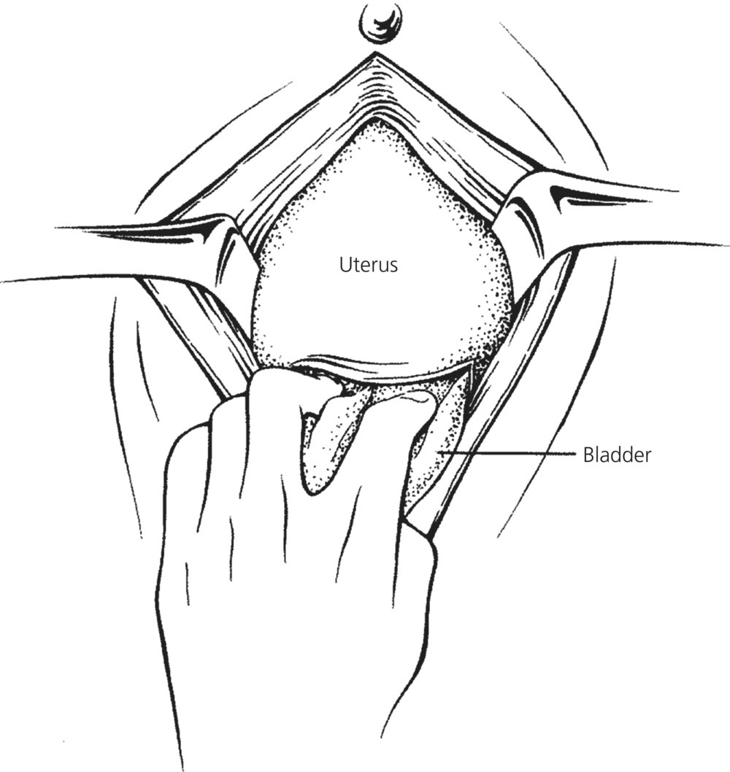

Figure 45.1 Cesarean delivery. Retraction of abdominal wall and displacement of bladder.
Source: Roberts JR and Hedges JR. Emergency childbirth. In: Clinical Procedures in Emergency Medicine, 4th edn, p.1139. Reproduced with permission of Elsevier.
Once the bladder has been retracted, a short vertical incision should be performed in the lower uterine segment, just cephalad to the bladder (Figure 45.2a). This incision is then extended cephalad using bandage scissors. The fingers of the operator’s free hand should be placed inside the uterus to lift the uterine wall and protect the infant as the incision is extended (Figure 45.2b). The incision should be long enough to allow rapid delivery of the infant. If the placenta is embedded in the anterior wall of the uterus, it should be transected while entering the uterus. Though this may result in a significant amount of blood loss, it will facilitate the rapid delivery of the infant.

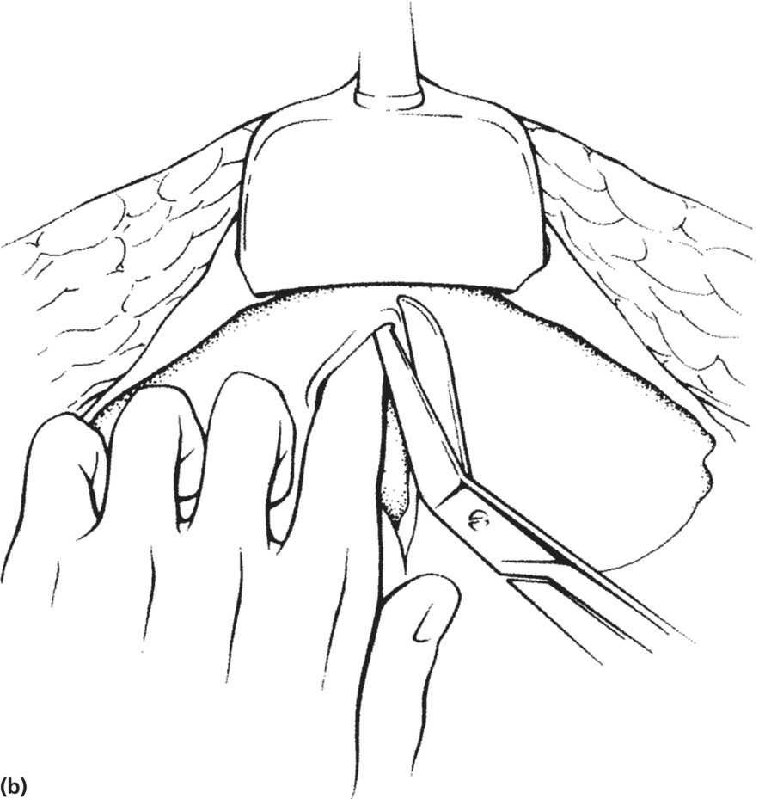

Figure 45.2 Cesarean delivery. (a) Small vertical incision made into the lower uterine segment. (b) Bandage scissors are used to extend the incision toward the fundus while the operator’s fingers shield the fetus.
Source: Roberts JR and Hedges JR. Emergency childbirth. In: Clinical Procedures in Emergency Medicine, 4th edn, p.1139. Reproduced with permission of Elsevier.
When the uterine incision is complete, all retractors should be removed to avoid injury to the baby. If the fetus is in a vertex position, the operator’s hands should be inserted into the uterine cavity between the fetal head and the pubic symphysis, and the head and shoulders should be elevated out of the incision (Figure 45.3). If the fetus is in a breech or transverse presentation or if the uterine incision is too high to adequately access the head, a feet-first delivery may be easiest.

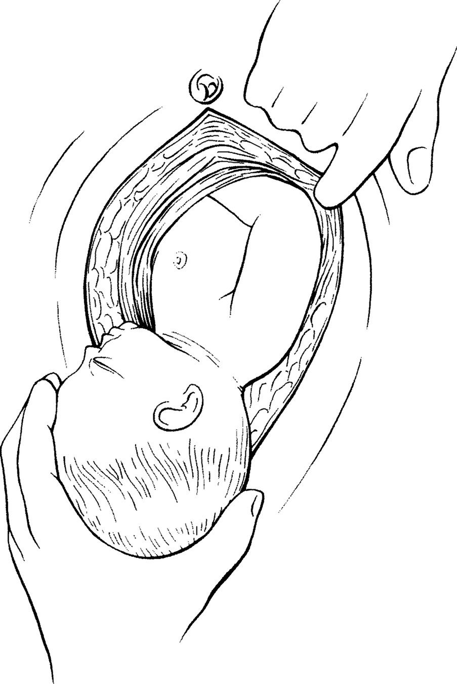

Figure 45.3 Cesarean delivery. Delivery of the infant from a vertex position.
Source: Roberts JR and Hedges JR. Emergency childbirth. In: Clinical Procedures in Emergency Medicine, 4th edn, p.1139. Reproduced with permission of Elsevier.
Once the infant is delivered, the mouth and nose should be suctioned with a bulb syringe and the cord clamped and cut while the infant is held at the level of the mother’s abdomen. The child should be assessed, cleaned, and warmed immediately. Resuscitation should ensue as appropriate. The uterus should be palpated to evaluate for the possibility of twins and the placenta may be removed if resources and time allow. Packing or suturing the uterus closed will decrease bleeding if maternal circulation is restored. The uterus may be sutured with No. 0 or No. 1 delayed-absorbable sutures using a continuous locking one-layer closure. Direct pressure may also be applied to the mother’s aorta, minimizing bleeding from the pelvic vessels and limiting the functional volume of the patient.

Ethical and legal considerations
The decision to perform a PMCS may invoke ethical and legal concerns. On one hand, there may be concern that the provider could be charged with battery for performing PMCS if consent is not obtained. On the other hand, failing to perform PMCS would result in near-certain death for the infant and mother. Since PMCS was described in 1986, no physician in the United States has been held liable for performing a PMCS, even when this was against the wishes of the mother’s family [2,10,29]. However, at least two cases have been identified where a lawsuit was brought against physicians and hospital staff for failure to perform a PMCS [2]. Even if PMCS is successful, a concern may be that the provider may deliver an infant who will have persistent neurological deficits. However, a case review of PMCS over 25 years identified no reported cases where an infant surviving beyond the early neonatal period had neurological disability [9], and multiple neurologically intact infants have survived following PMCS after even prolonged maternal resuscitation [1,6,25–27]. In addition to considering the potential benefits to the infant, one must also consider the risks to the mother. In this case, there is no maternal risk, as withdrawal of support will certainly result in death of both mother and fetus [1].
Ultimately, peer-reviewed resuscitation guidelines may provide the simplest recourse for the EMS physician in deciding whether to perform a PMCS. The American Heart Association recommendation is for the performance of PMCS in any case of maternal cardiac arrest when the gestational age is ≥20 weeks, regardless of fetal viability [24]. This is recommended to be performed within 4 minutes of the onset of maternal cardiac arrest if there is no return of spontaneous circulation (Class IIb, Level C evidence), but may be considered sooner in cases of obvious non-survivable injury, when the maternal prognosis is grave, and the resuscitative efforts deemed futile [24].
The emotional impact of performing PMCS in the field must be considered, both for the provider who performs the procedure and the rest of the EMS team who contribute to the resuscitation of mother and infant. The effect on any family or friends on scene must also be considered. Procedures should be in place to provide critical incident stress management to EMS personnel within 24 hours, with individual follow-up care determined on an individual basis [14]. Community resources may be sought to assist family members as well.

Conclusion
The out-of-hospital management of cardiac arrest in a pregnant patient is a rare and challenging event. Performance of perimortem cesarean section within 4 minutes and delivery within 5 minutes in pregnant patients beyond 20–24 weeks gestation are recommended to provide the highest likelihood of survival for both baby and mother. EMS physicians should be trained in performance of this procedure as they are most likely to be capable to perform it in the field. EMS systems should have established policies and procedures for this challenging situation and take into account state and local scope of practice for prehospital providers.

References
- 1 Fadel HE. Postmortem and perimortem cesarean section: historical, religious and ethical considerations. J IMA 2011;43:194–200.
- 2 Katz VL. Perimortem cesarean delivery: its role in maternal mortality. Semin Perinatol 2012;36:68–72.
- 3 Lanoix R, Akkapeddi V, Goldfeder B. Perimortem cesarean section: case reports and recommendations. Acad Emerg Med 1995;2:1063–7.
- 4 Katz V, Balderston K, DeFreest M. Perimortem cesarean delivery: were our assumptions correct? Am J Obstet Gynecol 2005;192:1916–20.
- 5 Katz VL, Dotters DJ, Droegemueller W. Perimortem cesarean delivery. Obstet Gynecol 1986;68:571–6.
- 6 Guven S, Yazar A, Yakut K, Aydogan H, Erguven M, Avci E. Postmortem cesarean: report of our successful neonatal outcomes after severe trauma during pregnancy and review of the literature. J Matern Fetal Neonat Med 2012;25:1102–4.
- 7 Engels PT, Caddy SC, Jiwa G, Douglas Matheson J. Cardiac arrest in pregnancy and perimortem cesarean delivery: case report and discussion. CJEM 2011;13:399–403.
- 8 Cardosi RJ, Porter KB. Cesarean delivery of twins during maternal cardiopulmonary arrest. Obstet Gynecol 1998;92:695–7.
- 9 Whitten M, Irvine LM. Postmortem and perimortem caesarean section: what are the indications? J R Soc Med 2000;93:6–9.
- 10 Page-Rodriguez A, Gonzalez-Sanchez JA. Perimortem cesarean section of twin pregnancy: case report and review of the literature. Acad Emerg Med 1999;6:1072–4.
- 11 Dijkman A, Huisman CM, Smit M, et al. Cardiac arrest in pregnancy: increasing use of perimortem caesarean section due to emergency skills training? BJOG 2010;117:282–7.
- 12 Einav S, Kaufman N, Sela HY. Maternal cardiac arrest and perimortem caesarean delivery: evidence or expert-based? Resuscitation 2012;83:1191–200.
- 13 Kupas DF, Harter SC, Vosk A. Out-of-hospital perimortem cesarean section. Prehosp Emerg Care 1998;2:206–8.
- 14 Bowers W, Wagner C. Field perimortem cesarean section. Air Med J 2001;20:10–1.
- 15 Kue R, Coyle C, Vaughan E, Restuccia M. Perimortem Cesarean section in the helicopter EMS setting: a case report. Air Med J 2008;27:46–7.
- 16 Chen DW. 2 Paramedics Face Inquiry Over Surgery in Emergency. New York Times, 1997. Available at: www.nytimes.com/1997/09/27/nyregion/2-paramedics-face-inquiry-over-surgery-in-emergency.html
- 17 Hauswald M, Kerr NL. Perimortem cesarean section. Acad Emerg Med 2000;7:726.
- 18 Brun PM, Chenaitia H, Dejesus I, Bessereau J, Bonello L, Pierre B. Ultrasound to perimortem caesarean delivery in prehospital settings. Injury 2013;44:151–2.
- 19 Gunevsel O, Yesil O, Ozturk TC, Cevik SE. Perimortem caesarean section following maternal gunshot wounds. J Res Med Sci 2011;16:1089–91.
- 20 Knobloch K. Re: Perimortem Cesarean section in the helicopter EMS setting. Air Med J 2008;27:152–3.
- 21 McDonnell NJ. Cardiopulmonary arrest in pregnancy: two case reports of successful outcomes in association with perimortem Caesarean delivery. Br J Anaesth 2009;103:406–9.
- 22 Morris JA Jr, Rosenbower TJ, Jurkovich GJ, et al. Infant survival after cesarean section for trauma. Ann Surg 1996;223:481–8.
- 23 Phelan HA, Roller J, Minei JP. Perimortem cesarean section after utilization of surgeon-performed trauma ultrasound. J Trauma 2008;64:E12–14.
- 24 Vanden Hoek TL, Morrison LJ, Shuster M, et al. Part 12: cardiac arrest in special situations: 2010 American Heart Association Guidelines for Cardiopulmonary Resuscitation and Emergency Cardiovascular Care. Circulation 2010;122:S829–61.
- 25 Awwad JT, Azar GB, Aouad AT, Raad J, Karam KS. Postmortem cesarean section following maternal blast injury: case report. J Trauma 1994;36:260–1.
- 26 Capobianco G, Balata A, Mannazzu MC, et al. Perimortem cesarean delivery 30 minutes after a laboring patient jumped from a fourth-floor window: baby survives and is normal at age 4 years. Am J Obstet Gynecol 2008;198:e15–16.
- 27 Lopez-Zeno JA, Carlo WA, O'Grady JP, Fanaroff AA. Infant survival following delayed postmortem cesarean delivery. Obstet Gynecol 1990;76:991–2.
- 28 Jeejeebhoy FM, Zelop CM, Windrim R, Carvalho JC, Dorian P, Morrison LJ. Management of cardiac arrest in pregnancy: a systematic review. Resuscitation 2011;82:801–9.
- 29 Strong TH Jr, Lowe RA. Perimortem cesarean section. Am J Emerg Med 1989;7:489–94.
- 30 Doan-Wiggins L. Emergency childbirth. In: Roberts JR, Hedges JR (eds) Clinical Procedures in Emergency Medicine, 4thedn.Philadelphia: W.B. Saunders, 2004, pp.1117–43.
- 31 Cunningham FG, Leveno KJ, Bloom SL, Spong CY, Dashe JS. Cesarean delivery and peripartum hysterectomy. In: Cunningham FG, Leveno KJ, Bloom SL, Spong CY, Dashe JS (eds) Williams Obstetrics, 23rd edn. New York: McGraw-Hill Medical, 2010, pp.549–55.

