Chapter 48
Cold exposure illness and injury
Jonnathan Busko

Introduction
Humans live in a wide range of environments. Below 82 ºF, a healthy naked human being can no longer produce enough heat to maintain body temperature [1] and requires protection from the cold. Cold illness and injuries are common and EMS physicians must be familiar with their epidemiology, presentation, and treatment to improve patient outcomes. Common cold injuries include hypothermia, non-freezing tissue injuries, freezing tissue injuries, and cold water immersion. These four processes account for the majority of cold-related EMS care.

Hypothermia

Definition
Hypothermia is a core body temperature below 95 ºF (35 ºC). Stages include mild hypothermia (90–95 ºF/32–35 ºC), moderate hypothermia (82–90 ºF/28–32 ºC), and severe hypothermia (below 82 ºF/28 ºC). Measuring a “true” core body temperature can be a challenge in the hospital, let alone in the prehospital environment, and individual physiological responses to cold can vary widely. From a practical perspective, hypothermia is best defined from a physiological standpoint: cold stress exceeding the body’s ability to produce sufficient heat to maintain body temperature [2]. The stages can then be based on clinical presentation and a patient’s ability to self-rewarm if the cold stress is eliminated (Table 48.1). In this approach, the core temperature is adjunctive but the clinical picture guides the provider’s actions.
Table 48.1 The stages of hypothermia can be defined based on the clinical presentation, and the ability of the patient to self-rewarm if cold stress is removed.

Clinical presentation | Ability to self-rewarm | Likely temperature
Mild hypothermia
Shivering, general loss of fine then gross motor function with progressive loss of intellectual function and development of confusion | Good initially but limited as temperature decreases | 90–95 ºF/32–35 ºC
Moderate hypothermia
Loss of shivering, progressive vulnerability of the heart to atrial fibrillation, and progression of confusion to unconsciousness | Poor progressing to none | 82–90 ºF/28–32 ºC
Severe hypothermia
Muscular rigidity, loss of detectable vital signs, progressive cardiac vulnerability to ventricular fibrillation due to rough handling with progression to spontaneous ventricular fibrillation, coma | None | Below 82 ºF/28 ºC

Types
From 1999 to 2011, there were on average 1301 deaths annually in the United States attributed to hypothermia [3]. While the classic image of hypothermia is the lost hiker huddled in the snow, EMS providers are more likely to encounter urban hypothermia, a multifactorial hypothermia resulting from cold exposure and some combination of medical conditions, medications, changes in temperature perception, substance abuse, inadequate nutrition, and inadequate social circumstances [4–7]. Urban hypothermia is a chronic disease and while the clinical presentation of hypothermia may precipitate the call for EMS and may well be the immediate life threat, it is rarely the only active disease process. It is often considered to be secondary hypothermia.
Wilderness or environmental hypothermia, by contrast, is primary hypothermia caused by exposure to cold stress that exceeds the body’s heat production capacity. It is either acute, as in immersion, or subacute hypothermia (over days), as seen in the inadequately prepared hiker in a cold (although not necessarily freezing) environment.

Mechanisms of thermoregulation
Humans maintain a core temperature within a narrow range of (95–100.7 ºF/35–38 ºC) for optimal metabolic functioning. Four mechanisms, radiation, conduction, convection, and evaporation, contribute to heat loss from the body; homeostasis is maintained by balancing these mechanisms against heat production.
Infrared radiation emission accounts for up to 40% of all heat loss. The greater the temperature difference between the individual and the environment, the greater the rate of heat loss [8]. This can occur even when the air temperature is warm if the surrounding environmental features (such as a cave or concrete structure) are colder.
Evaporation via sweating dissipates excess heat, with approximately 575 calories of heat lost for each cubic centimeter of evaporated sweat [8]. Unfortunately, this mechanism is just as effective at removing heat during periods of cold stress. Individuals who become wet will rapidly lose heat via evaporation in a cold environment.
In conduction, direct transfer of heat from one object to another, a colder object becomes an important source of heat loss for the recumbent ill or injured individual. The greater the area of uninsulated contact, the more heat is lost.
Convection, particularly combined with evaporation, also contributes to heat loss. The body heats a small local environment to minimize heat transfer. If this buffer zone is lost, the body is constantly reheating new air (or water) and heat losses increase dramatically. Moving air (wind) augments this effect. Heat loss is a function of the square of wind velocity so doubling the wind speed quadruples heat loss [8] up to a maximum speed of 40 mph (64 km/h), after which the air is moving too quickly to absorb heat [9]. This phenomenon is referred to as wind chill (Figure 48.1). Wind chill describes the rate of heat loss from exposed skin. This has implications for how urgently a rescue must be effected. Use of windproof garments or shelters eliminates the wind chill effect.

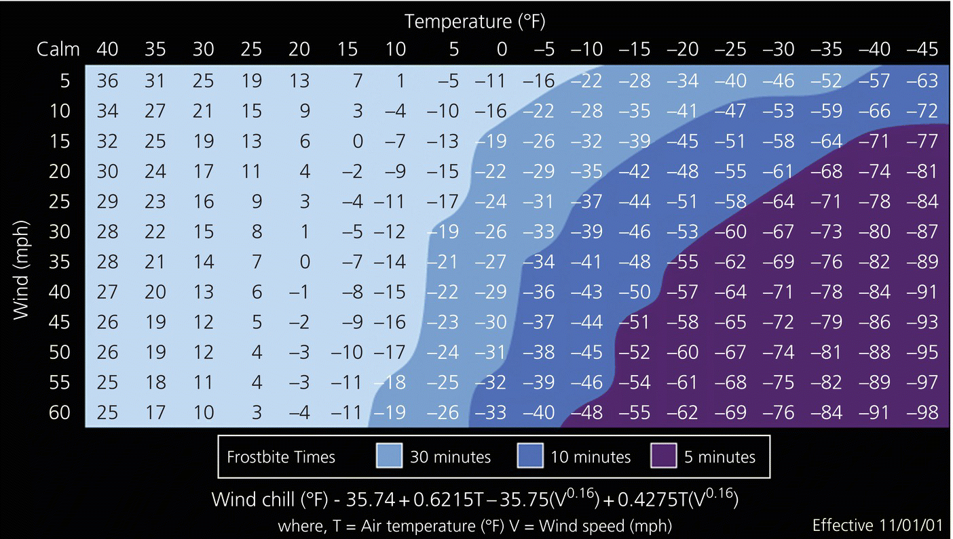

Figure 48.1 Windchill chart.
Source: www.nws.noaa.gov/om/windchill/
Two primary defenses guard against heat loss. First, in response to cold stress, there is a behavioral imperative to add additional layers of clothing and to seek sources of warmth [8]. The second defense is heat production. Any muscular activity produces heat. The body can uncouple heat production from useful activity via shivering [3]. While shivering will produce additional heat to counter cold stress, it will not prevent worsening hypothermia if the environmental conditions don’t change. Shivering should serve as a signal to take other actions to decrease the environmental cold stress. Performing useful activity that increases the chances of survival also generates heat and is the preferred method of muscular heat production.

Prevention
Preventing wilderness hypothermia requires recognizing cold stress and taking actions to decrease it. Sufficient calorie and water intake is crucial to allow effective metabolism and heat generation. Clothing that maintains a microclimate of trapped air, prevents heat loss though convection, and wicks moisture away through all the layers of the clothing decreases the risk of hypothermia. Avoidance of substances that promote vasodilation (e.g. alcohol) or that impair judgment and temperature perception (e.g. alcohol or illicit drugs) will decrease the risk of primary hypothermia.
Preventing urban hypothermia is a far more complex issue with public health and social welfare implications [10]. Programs such as the Low Income Home Energy Assistance Program likely decrease the incidence of urban hypothermia, as do homeless shelters.

Recognition
While classification based on core body temperatures is useful for research and statistical purposes [1,11–14], an individual’s performance at a given core body temperature can vary widely [15] and so the assessment and treatment should be based on clinical presentation (see Table 48.1).
In the early stages of hypothermia, a perception of being cold and a behavioral imperative to change or exit the cold environment will predominate. Unless sufficient heat is being developed from useful activity, the patient will shiver and may be mildly agitated. Loss of fine motor control follows. At this stage, if the patient has sufficient calorie reserves and is removed from the cold stress, he will be able to rewarm himself.
Left untreated, hypothermia will progress and symptoms will include confusion, slurred speech, loss of gross motor coordination, and loss of judgment. This stage is described as the “-umbles”: the patient stumbles, mumbles, grumbles, fumbles, and tumbles. Eventually as caloric reserves are depleted, shivering stops. At this point, the patient is no longer able to self-rewarm even if cold stress is eliminated.
The patient will progress to a state of unresponsiveness. Cardiac dysrhythmias occur, particularly atrial fibrillation. Metabolic demand decreases and the patient becomes bradycardic. As the myocardium becomes more irritable, the risk of ventricular fibrillation with minimal or no stimulation increases. Respiratory rate decreases and the patient may appear apneic.
Once the patient is comatose, effort must be focused on minimizing physical movements that could trigger ventricular fibrillation, including bumping, dropping, or otherwise physically stimulating the patient.

Treatment
Treatment of hypothermia depends on whether or not the patient is able to self-rewarm if the cold stress is eliminated. Therefore, the most important action is to eliminate the cold stress. This may be as simple as moving the patient to a heated ambulance. If a heated sheltered environment is not readily available, efforts to eliminate further heat loss include insulating the patient from the ground to prevent conduction, removal of wet clothing to minimize evaporation, and sheltering from wind to prevent convection. Although studies have evaluated mechanisms to decrease radiant heat loss [15], to date none have been particularly successful.
Once the cold stress is removed, an assessment must be made of the patient’s ability to self-rewarm. For the patient with mild hypothermia who still has adequate caloric and metabolic reserves (that is, still shivering or recently stopped shivering), elimination of cold stress and feeding the patient should be sufficient to restore normothermia [8,13,16].
For patients who are metabolically depleted and unable to self-rewarm, active interventions will be necessary. The historical dogma has been that out-of-hospital interventions are sufficient only to prevent further heat loss and are not adequate to restore normothermia. Such interventions have included heated IV fluids, heated (and preferably humidified) inhaled oxygen, application of heat packs or heated water bottles to the neck, axilla, and inguinal creases, and rescuer/patient skin-to-skin contact [8,17,18]. More invasive procedures such as warm water irrigation of the stomach, bladder, peritoneal, and pleural cavity as well as heated dialysis and cardiopulmonary bypass have been reserved for the hospital setting [8,19,20].
Over the last decade, research has demonstrated that effective prehospital interventions exist. These include a 600 W heater with a soft rewarming blankets (a forced warm air full-body blanket) [21,22], 600 or 850 W heater with rigid torso cover [21,23], and charcoal vest forced hot air heaters (Figure 48.2) [21]. Of these devices, the charcoal heater is the only one that does not require electricity beyond a D-cell battery to run the fan, is light enough that a single rescuer could carry two, and is inexpensive. On the other hand, it does use a flame source to generate heat (burning charcoal) and therefore poses a risk when used with oxygen. All of these devices have been demonstrated to attenuate afterdrop (the tendency for the core temperature to drop even after the initiation of rewarming) and to actually rewarm the patient. If EMS agencies and providers function in an environment where hypothermia is prevalent, acquisition of at least one of these types of devices should be considered. Avoid immersion in warm water as this increases mortality [15].

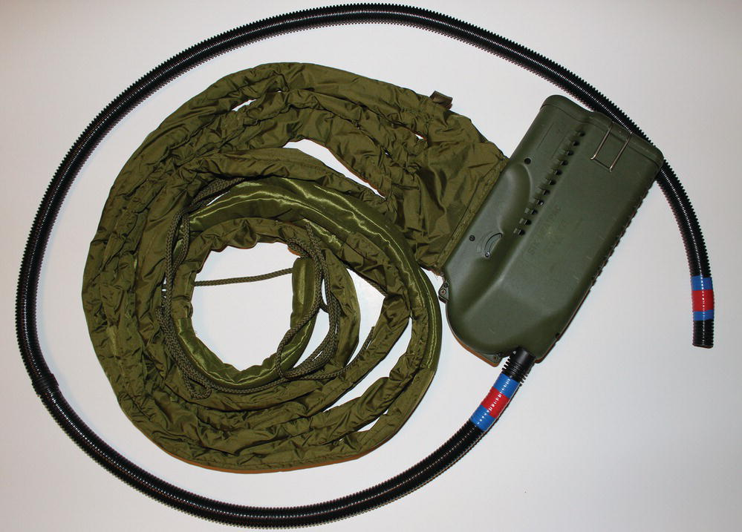

Figure 48.2 Charcoal vest. Charcoal inserts are burned in the body of the device and a small fan blows warm air through the green tubes that are wrapped around the patient’s torso. The black tube carries exhaust away.
Source: Jonnathan Busko. Reproduced with permission of Jonnathan Busko.

Disposition
Due to concomitant medical and social issues, the patient with urban hypothermia must be transported to an emergency department for further evaluation.
For the patient with primary hypothermia in a wilderness setting, the disposition is less clear. A patient with mild hypothermia who recovers to normothermia may not need evacuation if changes can be made to the patient’s clothing system or to the route so recurrent cold stress is minimized. For the patient with moderate hypothermia, evacuation is mandatory with one exception. In the case of an expedition with provisions for active rewarming, the decision to evacuate the moderately hypothermic patient restored to normothermia is made in conjunction with the patient, the expedition leader, and medical support staff in the context of the risks of evacuation.
For the patient with severe hypothermia and signs of life, evacuation is mandatory. The method of evacuation must be such that the patient experiences as little unnecessary movement and as few bumps as possible. Evacuation may not be possible and in situ rewarming may be necessary.
The patient without signs of life presents a challenge. While the mantra “no one is dead until warm and dead” is always operative, it is not always practical. Rescuer safety is primary and while successful resuscitation of severely hypothermic patients has been reported, the risk:benefit ratio of the operation must be considered. In addition, there are indeed patients who are cold and dead. These include those with a core temperature less than 50 ºF (10 ºC), cold water submersion for greater than 1 hour, obvious fatal injuries, and frozen patients (i.e. ice formation in the airway or chest walls that are so rigid compressions cannot be performed [24]. Cardiopulmonary resuscitation (CPR) is difficult in the wilderness environment and effective performance during patient transport is impossible. Some experts recommend performing rewarming in place [8] while others recommend transporting without CPR if definitive care (any provider capable of providing effective active rewarming) is available within 3 hours [24]. Guidelines for defibrillation, CPR techniques, and medication administration vary widely [8,19,24] and the American Heart Association in 2010 noted a lack of research identifying optimal resuscitation techniques [25].

Non-freezing cold injuries
Non-freezing cold injury to the foot (trenchfoot or immersion foot) occurs with subacute exposure in cold but non-freezing conditions. The foot becomes macerated with vasomotor instability and anesthesia. Temperature affects the time to onset; for shipwrecked sailors whose feet are immersed in cold water, onset may take as little as 24 hours [26] while the minimum time to onset on land is 4–5 days [8].
Injury occurs from local maceration due to water exposure, cold-induced vasoconstriction, and circulatory compromise from excessively tight footwear and immobility [8,27]. Prolonged vasoconstriction leads to damage to the blood vessels and results in injury to the tissues they feed [28].
Non-freezing cold injuries progress through three phases. In the pretreatment (prehyperemic) phase, the limbs are blanched and yellowish white. Local edema may be present and the patient may complain of anesthesia, particularly as cold exposure progresses. Pain is rare at this phase [27]. In the urban setting, alcoholism and chronic homelessness may contribute to a complete non-awareness of this condition.
Once treatment is initiated, the patient enters the hyperemic phase lasting hours to weeks [28]. The vasoconstriction reverses and, due to vasomotor instability, the extremities become hot, red, swollen, and painful [29]. Blisters in this phase indicate more serious injury and gangrene may occur in the most severe cases.
The posthyperemic phase may be absent in mild cases or may persist for years after the injury. It is characterized by ongoing symptoms after the resolution of the hyperemic phase, including vasomotor instability, persistent cold sensitivity, and limb coolness. After periods of exertion, blistering, edema, and paresthesias may also reoccur [27]. This phase may last for years.
Clean, dry socks changed at least once and preferably twice a day will markedly decrease the risk of non-freezing cold injury. Avoiding immobility, taking breaks from the cold, wet environment, limiting activity to minimize sweating, and keeping the feet dry for 8 out of every 24 hours are important prevention techniques [27].
Remove the wet garments, keep the feet dry and elevated, and keep bedclothes from pressing on the feet [8]. Tissue rewarming is not necessary, but warming the core temperature (if necessary) while providing cooling with a fan to the injured area will markedly decrease pain, edema, and blistering [29]. Remember that the social and environmental conditions that predispose to trenchfoot also contribute to hypothermia.

Frostbite
Frostbite is a freezing injury to soft tissues. A combination of local (tissue-level) freezing temperatures and an inability of the body to produce or provide sufficient heat allows the tissues to freeze. Frostnip may precede freezing. Frostnip is a condition of superficial ice crystal formation without resulting tissue damage. Cyclic vasoconstriction and vasodilation in the extremities (known as the “hunting response”) may be present. This process, which occurs more in cold-acclimatized individuals, protects at-risk tissue from freezing. While it contributes to additional heat loss, cyclic rewarming permits greater dexterity in the hands, improving function in cold environments [30,31].
Environmental conditions that predispose to frostbite are the same conditions that predispose to hypothermia. Peripheral vasoconstriction may cause blood flow to the distal extremities to essentially cease [8]. The cold also induces vascular endothelial damage with plasma leakage.
With continued cooling, freezing occurs and extracellular ice crystals form. This leads to changes in local solute concentrations and intracellular dehydration. Additional injury comes from denaturation of lipid-protein complexes, toxic concentrations of intracellular electrolytes, thermal shock, and, in the event of rapid freezing (seconds to minutes), intracellular ice crystals [32]. However, tissue freezing does not necessarily result in permanent damage. Frozen cells are metabolically inactive and so cell death may not occur when the tissues are frozen. Instead, when rewarming occurs and the tissues become metabolically active, oxygen demand increases. The endothelial damage to the microvascular circulation that occurred during freezing now contributes to local thrombosis and watershed ischemia [8].
Early signs of incipient frostbite include a cold sensation, pain, and pallor. As freezing occurs, pain resolves and anesthesia ensues. The loss of sensation may be accompanied by a sense that the limb is clumsy or that the affected body part is absent. The tissue becomes paler. A noticeable progression of superficial to deep freezing occurs. The skin will begin to feel firm and non-pliable although the underlying tissues will be soft. Ultimately, the entire affected part becomes solid. In severe cases, purplish discoloration may occur.
Several grading systems have evolved. The best grading system is one that allows early and accurate prognostication of treatment resource requirements and prognosis. Unfortunately, the ideal system has not yet been developed [32]. For prehospital providers, a grading system of “degrees” based on findings after freezing and rewarming is commonly used. First-degree injuries are characterized by numbness, erythema, white or yellow plaques in the area of injury, and edema without tissue loss. Second-degree injuries add blisters surrounded by erythema and edema. In a third-degree injury, blisters are more extensive and contain blood. A fourth-degree injury involves the subcuticular tissues. It may be difficult to clinically distinguish fourth-degree from third-degree injuries in the immediate postrewarming period [32].
Prevention of frostbite includes preventing hypothermia so that peripheral circulation is maintained, avoiding constricting garments and boots (including too many layers of socks), and remaining active.
Treatment of frostbite is less about what to do and more about what not to do. The two key principles are to avoid thawing and refreezing the frozen part and preventing burns. Honoring these two principles, any appropriate treatment to rapidly thaw the tissue is acceptable, although controlled rewarming with warm water immersion of affected limbs remains the preferred treatment. While there is no additional benefit to rewarming a frozen part that has completely thawed, there is also no harm. If there is any doubt about whether the part is completely thawed, rewarming should be instituted.
Rewarming is best accomplished by treating the hypothermia to a core temperature of at least 93 ºF (34 ºC) and then completely immersing the frozen part in a warm water bath (99–108 ºF/37–42 ºC). All clothing, constricting bands, or items that would decrease peripheral circulation should be removed. The bath should be brought to the appropriate temperature without the part immersed to prevent scalds. Except when rewarming the bath, the part should remain fully immersed until the tissues become pliable and there are no further color changes. The temperature of the bath should be continuously monitored. Rewarming will typically take 30–60 minutes. Avoid massage of the injured part since this may increase local damage [8,32].
Although older guidelines based on the work of Baron Larrey cautioned against rapid rewarming [33], recent work has demonstrated the superiority of a rapid rewarming approach [34].
In a wilderness or uncontrolled environment, thawing of a frozen part should only occur if the following conditions can be met [8].
- The person will not need to use the frostbitten part for evacuation until healing is complete.
- The person can be kept warm during thawing and until healing is complete.
- Thawing can be completed in a controlled, uninterrupted manner with accurate temperature management of the rewarming bath.
If these conditions cannot be met, the extremity should not be thawed [32].
During rewarming, pain can be intense. Adjunctive parenteral narcotics may be necessary to control this pain. Additional therapies include thromboxane inhibitors (ibuprofen 400 mg PO every 12 hours), tetanus immunization as needed, and strict wound care of the injured part [32]. Antibiotics are indicated for any signs of infection [8]. Sterile dressings should be placed between the digits once they are thawed to decrease tissue adhesion. Unless another traumatic condition or an abscess exists, surgery is contraindicated until the extent of the tissue death is clear, often 3–6 months [32].

Cold water immersion
Cold water immersion (head above the water, as opposed to submersion or drowning with the head below the water) is immersion in water less than 77 ºF (25 ºC) [35,36]. In water below 77 ºF (25 ºC), no amount of exertion can maintain a normal core body temperature in an unprotected individual [37]. In water temperatures below 68 ºF (20 ºC), a variety of physical and behavioral responses create hazardous conditions that put the immersion victim at increased risk of death either from drowning or eventually from hypothermia.
In cold shock response, the first phase of cold water immersion, respiratory patterns change with hyperventilation and a gasp response predominating; unacclimatized individuals also lose breath-holding ability [38]. Breathing becomes erratic and the individual cannot entrain coordinated physical activity with the respiratory cycle. While this phase lasts only a few minutes, the victim may hyperventilate to unconsciousness, panic or aspirate water and, if not wearing a personal flotation device (PFD), may drown. A victim wearing a PFD can focus on controlling breathing and successfully survive the initial immersion.
If the victim recovers from the initial cold shock response, a period of approximately 10 minutes remains for useful activity [36] before loss of fine and gross motor function progresses to complete inability to perform any meaningful survival actions [39]. This phase is called cold incapacitation. Core temperatures may increase as significant peripheral vasoconstriction shunts blood centrally. For a victim without a PFD, this phase will typically conclude with drowning as the ability to maintain the head above water is lost. Useful actions that promote recovery or survival should be performed. However, unnecessary physical activity should be avoided as movement promotes heat loss at a rate greater than metabolic heat generation [40]. If the shore is sufficiently close (within 800 m) the victim may consider attempting to swim to shore [36]. While this decision should be made as soon as possible during the cold incapacitation phase, it should not be made lightly as the rate of cooling will increase and, if the swim attempt is unsuccessful, hypothermia will be accelerated [36].
After 30–60 minutes, the victim will begin to face a significant risk of hypothermia. Many factors influence the time to onset of hypothermia (body morphology, sea state, protective garments, exercise, shivering, and behaviors) [36]. Nonetheless, even if the victim becomes unconscious from hypothermia, as long as submersion can be prevented, the victim may not actually die from hypothermia for up to 2 hours [36].
Sudden death in the period immediately preceding rescue as well as in apparently recovered survivors of cold water immersion has been described up to 24 hours after rescue [36,41]. This occurs in approximately 20% of immersion victims [42]. Although no one cause has been identified, a number of factors such as afterdrop and return of cold, acidotic or alkalotic blood to the heart, catecholamine release, decreased hydrostatic pressure upon removal from the water, cold-dulled baroreceptor reflexes, increased blood viscosity, intravascular volume depletion, and decreased work capacity of the heart may explain why this happens [36,42]. Rescuers must make all efforts to keep cold water immersion victims horizontal, prevent unnecessary physical activity (including walking to an aid room or ambulance), and maintain vigilance for this potentially delayed lethal event [42].
Cold water immersion is a threat to rescuers and patients alike. First, and most importantly, anyone at risk for cold water immersion must wear a PFD and preferably protective insulating garments appropriate to the degree of risk. While each circumstance is unique, it is important for anyone immersed in cold water to remember and act based on the 1-10-1 rule [36]. Upon immersion, the victim has 1 minute to control ventilation and prevent panic. This is followed by 10 minutes of useful activity to either signal for rescue or improve the situation to increase the chances of survival and rescue. Finally, it will take approximately 1 hour until unconsciousness occurs due to hypothermia, so any actions taken in the first 10 minutes that result in rescue before 1 hour may well prevent death from hypothermia.

Conclusion
Cold illness and injury are common in the EMS environment. EMS physicians and providers must be familiar with their epidemiology, presentation, and treatment. Hypothermia, non-freezing tissue injuries, freezing tissue injuries, and cold water immersion account for the vast majority of cold-related EMS care. It is important for the EMS provider to understand the pathophysiology and treatment of these disease processes to improve patient outcomes.

References
- 1 Wilkerson JA , Giesbrecht GG. Baby it’s cold outside: basic human cold physiology. In: Giesbrecht GG, Wilkerson JA (eds) Hypothermia, Frostbite, and other Cold Injuries: Prevention, Survival, Rescue, and the Treatment. Seattle, WA: Mountaineers Books, 2006, p.11–22.
- 2 Ulrich AS, Rathlev NK. Hypothermia and localized cold injuries. Emerg Med Clin North Am 2004;22:281–98.
- 3 Xu J. Number of hypothermia-related deaths, by sex – National Vital Statistics System, United States, 1999–2011. MMWR 2013;61:1050.
- 4 White JD. Hypothermia: the Bellevue experience. Ann Emerg Med 1982;11:417–24.
- 5 Shields CP, Sixsmith DM. Treatment of moderate-to-severe hypothermia in an urban setting. Ann Emerg Med 1990;19:1093–7.
- 6 Collins KJ, Exton-Smith AN, Dore C. Urban hypothermia: Preferred temperature and thermal perceptions in old age. BMJ 1981;282:175–7.
- 7 Rango N. The social epidemiology of accidental hypothermia among the aged. Gerontologist 1985;25:424–30.
- 8 Wilkerson JA. Cold Injuries. In: Wilkerson JA, Moore EE, Zafren K (eds) Medicine for Mountaineering and Other Wilderness Activites, 6th edn. Seattle,WA: Mountaineers Books, 2010, p.272–89.
- 9 Wilkerson JA. Don’t lose your cool: mechanisms of heat loss. In: Giesbrecht GG, Wilkerson JA (eds) Hypothermia, Frostbite, and Other Cold Injuries: Prevention, Survival, Rescue, and Treatment. Seattle: Mountaineers Books, 2006, pp.31–7.
- 10 Hislop LJ, Wyatt JP, McNaughton GW, et al. Urban hypothermia in the west of Scotland. BMJ 1995;311:725.
- 11 Jolly BT, Ghezzi KT. Accidental hypothermia. Emerg Med Clin North Am 1992;10:311–27.
- 12 Hanania NA, Zimmerman JL. Accidental hypothermia. Crit Care Clin 1999;15:235–49.
- 13 Reuler JB. Hypothermia: pathophysiology, clinical settings, and management. Ann Intern Med 1978;89:519–27.
- 14 Hamilton RS, Paton BC. The diagnosis and treatment of hypothermia by mountain rescue teams: a survey. Wilderness Environ Med 1996;7:28–37.
- 15 Giesbrecht GG, Wilkerson JA: Too cool to breathe: evaluation and treatment of hypothermia. In: Giesbrecht GG, Wilkerson JA (eds) Hypothermia, Frostbite, and Other Cold Injuries: Prevention, Survival, Rescue, and Treatment. Seattle: Mountaineers Books, 2006, pp.38–56.
- 16 Shields CP, Sixsmith DM. Treatment of moderate-to-severe hypothermia in an urban setting. Ann Emerg Med 1990;19:1093–7.
- 17 Giesbrecht GG, Bristow GK, Uin A, Ready AE, Jones RA. Effectiveness of three field treatments for induced mild (33.0 °C) hypothermia. J Appl Physiol 1987;63:2375–9.
- 18 Giesbrecht GG, Sessler DI, Mekjavic IB, Schroeder M, Bristow GK. Treatment of mild immersion hypothermia by direct body-to-body contact. J Appl Physiol 1994;76:2373–9.
- 19 Danzl DF. Accidental hypothermia. In: Auerbach PS (ed) Wilderness Medicine, 6th edn. Philadelphia: Elsevier, 2012, pp.116–42.
- 20 Sultan N, Theakston KD, Butler R, Suri RS. Treatment of severe accidental hypothermia with intermittent hemodialysis. CJEM 2009;11:174–7.
- 21 Hultzer MV, Xu X, Marrao C, Bristow G, Chochinov A, Giesbrecht GG. Pre-hospital torso warming modalities for severe hypothermia: a comparative study using a human model. CJEM 2005;7:378–86.
- 22 Giesbrecht GG, Schroeder M, Bristow GK. Treatment of mild immersion hypothermia by forced-air warming. Aviat Space Environ Med 1994;65:803–8.
- 23 Giesbrecht GG, Pachu P, Xu X. Design and evaluation of a portable rigid forced-air warming cover for prehospital transport of cold patients. Aviat Space Environ Med 1998;69:1200–3.
- 24 Alaska Department of Health and Social Services, Division of Public Health, Section of Community Health and EMS. State of Alaska Cold Injuries Guidelines, 2003 version revised 1/2005.
- 25 Vanden Hoek TL, Morrison LJ, Shuster M, et al. Part 12: Cardiac arrest in special situations: 2010 American Heart Association guidelines for cardiopulmonary resuscitation and emergency cardiovascular care. Circulation 2010;122:S829–61.
- 26 Ungley CC, Blackwood W. Peripheral vasoneuropathy after chilling. Lancet 1942;2:447–51.
- 27 Imray CHE, Castellani JW. Nonfreezing cold induced injuries. In: Auerbach PS (ed) Wilderness Medicine, 6th edn. Philadelphia: Elsevier, 2012, pp.171–80.
- 28 Thomas JR, Oakley HN. Nonfreezing cold injury. In: Pandolf KB, Burr RE (eds) Textbook of Military Medicine: Medical Aspects of Harsh Environments, Vol 1. Washington, DC: Office of the Surgeon General, Borden Institute, 2002, pp.467–90.
- 29 Webster DR, Woolhouse FM, Johnson JL. Immersion foot. Am J Bone Joint Surg 1942;42:785–94.
- 30 Arvesen A, Rosén L, Eltvik LP, Kroese A, Stranden E. Skin microcirculation in patients with sequelae from local cold injuries. Int J Microcirc Clin Exp 1994;14:335–42.
- 31 Greenfield ADM, Shepard IT, Whelan RF. Cold vasoconstriction and vasodilatation. Irish J Med Sci 1951;309:415.
- 32 Freer L, Imray CHE. Frostbite. In: Auerbach PS (ed) Wilderness Medicine, 6th edn. Philadelphia: Elsevier, 2012, pp.181–200.
- 33 Larrey DJ. Memoirs of Military Surgery, Vol 2. Baltimore, MD: Joseph Cushing, 1814.
- 34 Mills WJ Jr. Summary of the treatment of the cold injured patient. Alaska Med 1973;15:56.
- 35 Marino F, Booth J. Whole body cooling by immersion in water at moderate temperatures. J Sci Med Sport 1998;1:73–82.
- 36 Giesbrecht GG, Steinman AM. Immersion in cold water. In: Auerbach PS (ed) Wilderness Medicine, 6th edn. Philadelphia: Elsevier, 2012, pp.143–70.
- 37 Sagawa S, Hiraki K, Youset MK, Knoda N. Water temperature and intensity of exercise in maintenance of thermal equilibrium. J Appl Physiol 1988;65:2413–19.
- 38 Giesbrecht GG. Keep your head up: cold water immersion. In: Giesbrecht GG, Wilkerson JA (eds) Hypothermia, Frostbite, and other Cold Injuries: Prevention, Survival, Rescue, and Treatment. Seattle, WA: Mountaineers Books, 2006, pp.57–67.
- 39 Ferretti G. Cold and muscle performance. Int J Sports Med 1992;13:S185–7.
- 40 Hayward JS, Eckerson JD, Collis ML. Effects of behavioral variables on cooling rate of man in cold water. J Appl Physiol 1975;38:1073–7.
- 41 Golden FSC. Problems of immersion. Br J Hosp Med 1980;23:371–83.
- 42 Golden F, Tipton M. Essentials of Sea Survival. Champaign, IL: Human Kinetics, 2002, pp.243–89.

Further resources
The cold water boot camp is a project to teach the public about the hazards of cold water immersion and to provide survival strategies for cold water immersion.
www.youtube.com/watch?v=J1xohI3B4Uc
www.youtube.com/watch?v=nwETEkmVAeE
www.youtube.com/watch?v=aowQ9bthgBQ

