Chapter 64
End-of-life issues
Aaron Case, Dana Zive, Jennifer Cook, and Terri A. Schmidt
Memento Mori – Remember Death!*[1]

Introduction
The EMS system was designed to respond to emergencies to prevent disability and untimely death. With the aging of the population, EMS resources are now frequently called for patients with serious, life-threatening illness and for patients at or near the end of life. Many patients may not want the potentially life-extending interventions that are directed by standard EMS protocols [2]. A Canadian study found that nearly 10% of cardiac arrest calls were for patients with a terminal illness. In 63% of these cases, there was either a verbal (by family) or written request for no resuscitation [3]. Similarly, a Washington state study found that families of dying, terminally ill patients often called EMS because “they didn’t know what else to do.” Fewer than 10% of those patients had state-recognized formal written requests to withhold resuscitation, but a protocol allowing verbal and informally written requests to withhold resuscitation resulted in a significant decrease in unwanted interventions [4]. In addition, the American Heart Association reports that roughly 360,000 out-of-hospital cardiac arrests (OHCA) occur annually, with 60% treated by EMS professionals.
The chance of survival from OHCA is generally poor [5]. Survival rates vary based on the presenting rhythm, with survival from ventricular fibrillation ranging from 11% to 25%,[6,7] and overall survival to hospital discharge for all presenting rhythms being much smaller, and in some systems approaching zero [8]. There is also evidence that patients who do not have return of spontaneous circulation in the field have a very low likelihood (0.4%) of survival to hospital discharge [9]. Thus, EMS professionals need to determine whether the OHCA patient desires resuscitation, and to compassionately interact with family in the aftermath of a death in the field.
The EMS physician must design protocols to determine which patients should have attempts at cardiopulmonary resuscitation (CPR), or other life-sustaining interventions, and those who should not. (See Figure 64.1 for an example of one such protocol.) Considering the goals and ethical principles of medicine while remaining consistent with applicable local laws and regulations, these protocols should take into consideration patient preferences as well as the likelihood that the interventions will benefit the patient. It is not reasonable to assume that every patient found in cardiac arrest should undergo attempts at resuscitation, nor that everyone for whom resuscitation was attempted should be transported to the hospital.

Figure 64.1 Example EMS palliative and end-of-life protocol.
Source: Selected portions of Metro Regional EMS Consortium Patient Treatmen Protocols 2014. Reproduced with permission of Clackamas County Emergency Medical Services.
The basic ethical principles on which modern medicine is founded include respect for patient autonomy, beneficence, non-maleficence, and justice [10]. Decisions about resuscitation are generally based either on the principle of respect for autonomy or on beneficence. Respect for patient autonomy requires honoring patient preferences for or against treatments, including advanced airway support, CPR, and transport to the hospital when those preferences are known. Based on both beneficence and non-maleficence, an intervention should not be performed if there is no chance that it will benefit the patient.
The American College of Emergency Physicians’ position statement stipulates, “All emergency medical services (EMS) systems should have a policy addressing their response to 'Do Not Attempt Resuscitation' (DNAR) orders and other advance directives …” and “If the patient's preferences regarding resuscitation are clear, they should be respected. Patient preferences to refuse resuscitative efforts can be communicated directly by the patient, or by an advance directive, a valid DNAR order, or by the patient’s legal representative. Unofficial documentation may be considered when determining patient preferences” [11].
The number of states authorizing out-of-hospital DNAR orders increased from 11 in 1992 [12] to 42 in 1999 [13]. As of 2002, most United States EMS systems did not have palliative care protocols [14]. In the last few years states have been implementing Physician Orders for Life-Sustaining Treatment (POLST) programs to document and honor patient preferences regarding both resuscitation and other life-sustaining treatments [15]. EMS agencies in King County, Washington, have developed protocols that allow EMS professionals to withhold resuscitation if the patient has a preexisting terminal condition and the patient, family, or caregivers indicates, in writing or verbally, that the patient did not want resuscitation [4]. This protocol allows EMS professionals to withhold resuscitation based on verbal information without physician consult. The authors interviewed involved EMS professionals and found that most report the decision to withhold to be easy, and that they do not receive objections or complaints about that decision.

Advance directives
An advance directive is a written document, completed by the patient when he or she has decision-making capacity, expressing future wishes and/or appointing a surrogate decision maker. (See Figure 64.2 to compare documents indicating patient preferences). Advance directives have not been as effective as people had hoped [16]. The two main types of advance directives are living wills and durable powers of attorney for health care. Since 1991, the Patient Self-Determination Act has required all hospitals that accept Medicare and Medicaid funds to provide information about and develop policies for implementation of advance directives. Although there has been an increase in advance care planning since then, in many cases advance directives are still lacking when patients are transferred to emergency departments (EDs) [17–20]. One study found that many ED patients have never thought about advance directives or prefer that families make the decisions at the time of an event [21].

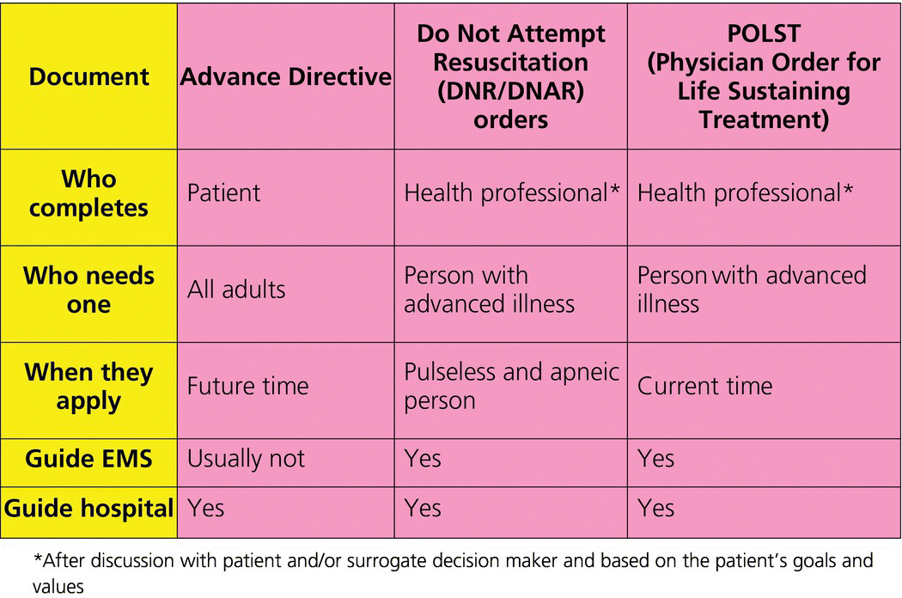
An expert panel has recommended that, “in the absence of signs of irreversible death, patient preferences regarding resuscitation should be the most important consideration of EMS personnel” [22]. EMS personnel need to make rapid decisions about attempting resuscitation for patients who are in extremis. Often the patients are unable to verbalize preferences about treatment and EMS professionals must make these time-critical decisions based on written instructions, when available. Unfortunately, written instructions are not always completed, or are unclear, which may be why systems such as King County now allow verbal statements.
One type of advance directive, the living will, expresses the wishes of patients regarding life-sustaining procedures in the event of conditions such as permanent coma or terminal illness. Living wills are theoretical documents that may state, for example, that the person would not want resuscitation if he or she is terminally ill, death is imminent, and resuscitation would only prolong the dying process. Because of these restrictive phrases, living wills are often difficult for EMS professionals to apply to decisions about specific life support measures [23,24] and in many cases health care providers do not follow them [25]. In at least one state, these documents explicitly do not apply except in a hospital or clinic setting [26], and one author has suggested that they may be misinterpreted as applying when they do not [27]. Living wills are not precise enough to predict all scenarios and consequently cannot outline appropriate guidance for all potential care situations [28,29].
Another form of patient-completed advance directive is the durable power of attorney for health care, which gives another person the authority to make decisions if the patient is unable to make decisions either temporarily or permanently. The person designated in the power of attorney becomes a legally recognized proxy decision maker. When a durable power of attorney exists, EMS protocols may allow the designated person to make decisions regarding the patient’s medical care. Immunity is generally granted to providers who carry out the proxy’s decision in good faith, but it is always wise to know local laws. Some states allow surrogates without a specific health care power of attorney to make decisions about resuscitation and end-of-life care for incapacitated patients, and others do not. Appointing surrogates who are aware of the patient’s preferences can be effective, as long as the surrogate and the documentation confirming their status can be found at the time of an emergency.

Do Not Resuscitate orders
Unlike living wills and health care powers of attorney, DNAR orders are written by health care professionals to indicate that resuscitation should not be attempted in the patient who is pulseless and apneic. A national survey of EMTs found that 89% of respondents were willing to honor a state-approved DNAR order and that 77% of those surveyed had local protocols for termination of resuscitation in the out-of-hospital setting [30]. Although DNAR orders only apply when the patient is pulseless and apneic, many primary care providers, who complete the orders for their patients, believe that they apply in other circumstances and that intubation and cardioversion are not appropriate in a patient with DNAR orders [31].
There is variability in honoring DNAR orders. One EMS study found that even with DNAR orders present, resuscitation was attempted 21% of the time [32]. Some states have had success with their DNAR programs [33] but problems remain. For example, some states use a DNAR bracelet program requiring EMS professionals to honor these DNAR orders and providing immunity from liability for honoring the order [34]. However, one study suggests that bracelet DNAR programs are used infrequently [24].
In addition, advance directives and DNAR orders may not be available when EMS arrive and often do not accompany patients to the ED [18,35,36]. On the other hand, there are EMS systems that allow responders to accept verbal requests from family to withhold resuscitation.
Out-of-hospital DNAR programs typically provide only orders about resuscitation with no guidance for patients who are breathing and have a pulse. It is often hard for out-of-hospital providers to know what interventions are appropriate for the seriously ill patient who is not in cardiopulmonary arrest but cannot speak for himself or herself and does not have a surrogate present. A recent study found that half of patients with DNAR orders wanted comfort measures only, but half wanted higher levels of care [37].

The Physician Orders for Life-Sustaining Treatment program
In 1991, a group of Oregon health care professionals and organizations, including EMS and long-term care providers, began development of the Physician Orders for Life-Sustaining Treatment (POLST) program (states use various names including POLST, POST, MOLST, LaPOLST). The goal of this program is to honor patient end-of-life care preferences by turning those preferences into medical orders that can be implemented as patients transition between multiple care settings, such as from home or long-term care to the ED [27,36,38–42]. POLST is intended for patients with serious illness or frailty. The POLST form (see Figure 64.3 for an example) is a brightly colored set of medical orders designed to be placed in a prominent location. It provides clear guidance for resuscitation as well as a range of medical interventions, in contrast to advance directives and DNAR orders. The form is divided into several sections, the first two of which are especially helpful in the emergency setting. The national POLST Taskforce oversees POLST initiatives and endorses programs. There are 43 states that have or are developing POLST programs and as of August 2013, 15 programs were endorsed by the National POLST Taskforce [15]. The National Quality Forum noted that, “Compared with other advance directive programs, POLST more accurately conveys end-of-life preferences and yields higher adherence by medical professionals” [43]. Communities have found that POLST is an effective means of conveying patient preferences [44].

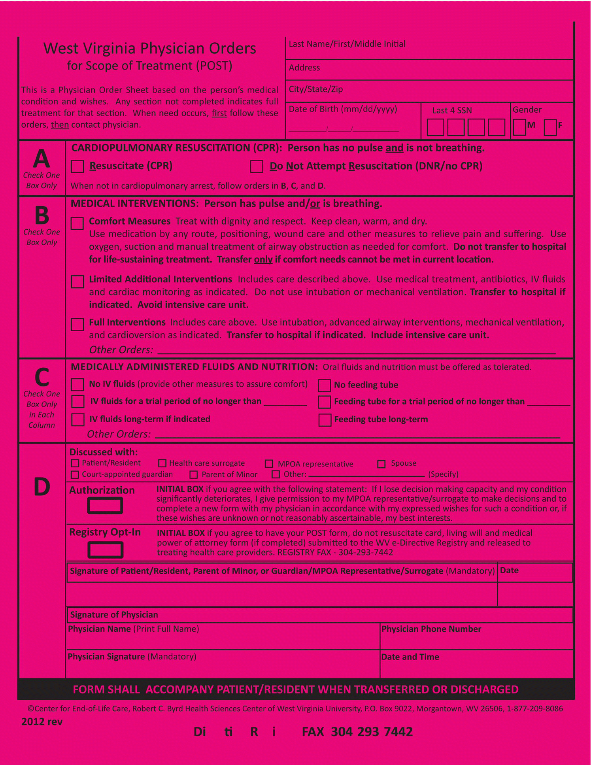

Figure 64.3 Example POST (POLST) form.
Source: West Virginia Physicians Orders for Scope of Treatment form. Reproduced with permission of West Virginia Center for End-of-Life Care.
States have begun to develop electronic registries to facilitate access to POLST forms. The first statewide POLST-only registry was initiated in Oregon in December 2009. Legislatively enacted, the registry accepts POLST forms signed throughout the state and provides access to verbal orders for EMS, emergency departments, and acute care units through a non-public 24/7 call center. The legislation enacting the registry also mandated submission of completed forms by signers unless patients opt out. By July 2013, the Oregon registry had received over 150,000 forms for nearly 90,000 Oregonians, and over 2,500 emergency calls [45]. The Oregon registry’s operations and patient matching algorithm have been found to limit release of “false-positive” matches [46] and also helped understand the EMS implications of the registry [47].
Several other states have developed registries or electronic mechanisms for accessing POLST forms or other documents like advance directives. In a 2011 report on behalf of the National POLST Paradigm Task Force, POLST registry efforts are outlined in seven states: California, Idaho, New York, Oregon, Utah, Washington, and West Virginia [48].
Studies indicate that POLST is effective in communicating patient preferences [38,49–51]. Studies in long-term care settings found that having a POLST form prevents unwanted life-sustaining treatments and hospitalization, and orders regarding resuscitation are typically followed, though medical intervention orders were followed less consistently [48,52–54]. One study surveyed a random sample of EMS professionals in Oregon to evaluate their experiences and attitudes regarding the use of the POLST form. Nearly three-quarters of respondents in this study had treated at least one patient with a POLST form, and in nearly half of the cases in which a POLST form was present, the EMS professionals used it to change the treatment plan, often avoiding interventions that the patient did not want [35]. Thus, the POLST paradigm is one model program for expressing patient preferences and helping EMS professionals to determine the best level of intervention for the patient.

Hospice and EMS
Hospice care focuses on the treatment of pain and other uncomfortable symptoms, as well as the patient’s emotional and spiritual needs. Hospice is a benefit of Medicare when a physician determines that the person likely has less than 6 months to live and the patient is no longer seeking curative treatment. In the United States, most hospice care is provided at home. A patient enrolled in hospice generally has a nurse who is on call 24/7, and is encouraged to call that nurse for any problem that arises. Nonetheless, patients or their families often call EMS in times of crisis. When they do, the hospice nurse can be a great resource. Contacting the hospice nurse can help to alleviate the patient’s and family’s distress and provide solutions other than transport to an ED.

Care of the grieving survivors
The responsibility of EMS professionals does not end with the death of a patient. Once a person is determined to be dead at the scene, the survivors who are present become our patients. The survivors may have both physical and psychological needs. When a person dies, the remaining spouse has an increased risk of death [55,56]. EMS professionals have a responsibility to inform family members of a death in a compassionate manner and to provide care and comfort to the survivors. Most survivors find EMS professionals to be supportive and are accepting of a death in the field without the need for transport [57] and families accept the non-transport of loved ones found in asystole [58]. A study of survivors found that the most frequently reported complaints concerned a lack of information and questions left unanswered [59].
Death notification can be stressful for EMS professionals [60]. A recent Canadian study found that paramedics find death notification stressful and think that they need more education in this area [61]. Deaths from violent crime, drunk driving crashes, or suicides, or the death of a child, increase the provider’s distress regarding notification [62]. A 2009 survey of EMS professionals found that only 48% felt prepared to communicate death to family [63]. A16-hour workshop based on the Emergency Death Education and Crisis Training (EDECT) program, with a 2-hour session on death notification, divided EMS professionals into three groups: long intervention, short intervention, and control. The authors found that after the training, 92% of those in the long intervention group felt that their training was adequate, compared with 43% in the short intervention group and 21% in the control group [64]. Although this study did not test whether or not death notification skills can be improved, it did show that education can improve EMS professionals’ comfort with death notification. A final study by these authors also suggested that behaviors can be changed [65]. One recent study of a 90-minute education model found that educating paramedics to use a structured communication model improved confidence and competence in delivering death notification [66].
Other studies have analyzed emergency physicians, the group most likely to become EMS physicians and medical directors. Most emergency physicians report that they have insufficient education on how to perform death notification [67]. A study of emergency medicine residents showed that role-playing increases their comfort with death notification [68]. Another study found that most respondents recommend that education on death notification be part of Advanced Cardiac Life Support courses [69].

Conclusion
Just as EMS medical directors have an obligation to ensure high-quality medical care by the EMS professionals that they supervise, they also have an obligation to ensure high-quality, compassionate, and medically appropriate end-of-life care. This includes protocols and education to determine when and when not to provide resuscitation and other life-sustaining treatments, often based on patient preferences, which are documented by various means. The POLST paradigm is a proven and growing method for communicating end-of-life wishes. Additionally, EMS professionals must provide support to the grieving survivors left behind.

References
- 1 Merton, T. The Wisdom of the Desert. New York: New Dimensions, 1960.
- 2 Innes G, Wanger K. Dignified death or legislated resuscitation? Can Med Assoc J 1999;161:1264–5.
- 3 Guru V, Verbeek PR, Morrison LJ. Response of paramedics to terminally ill patients with cardiac arrest: an ethical dilemma. Can Med Assoc J 1999;161:1251–4.
- 4 Feder S, Matheny RL, Loveless RS Jr, et al. Withholding resuscitation: a new approach to prehospital end-of-life decisions. Ann Intern Med 2006;144:634–40.
- 5 Go SA, Mozaffarian D, Roger VL, et al. Heart disease and stroke statistics – 2013 update: a report from the American Heart Association. Circulation 2013;127:e6–e245.
- 6 Warner LL, Hoffman JR, Baraff LJ. Prognostic significance of field response in out-of-hospital ventricular fibrillation. Chest 1985;87:22–8.
- 7 Bonnin MJ, Pepe PE, Kimball KT, et al. Distinct criteria for termination of resuscitation in the out-of-hospital setting. JAMA 1993;270:1457–62.
- 8 Dunne RB, Compton S, Zalenski RJ, et al. Outcomes from out-of-hospital cardiac arrest in Detroit. Resuscitation 2007;72:59–65.
- 9 Kellerman AL, Hackman BB, Somes G. Predicting the outcome of unsuccessful prehospital advanced cardiac life support. JAMA 1993;270:1433–6.
- 10 Beauchamp TL, Childress JF. Principles of Biomedical Ethics, 5th edn. Oxford: Oxford University Press, 2001.
- 11 American College of Emergency Physicians. Ethical issues of resuscitation. Ann Emerg Med 2008;52:593.
- 12 Adams J. Prehospital do-not-resuscitate orders: a survey of polices in the United States. Prehosp Disaster Med 1993;8:317–22.
- 13 Sabatino CP. Survey of state EMS-DNR laws and protocols. J Law Med Ethics 1999;27:297–315.
- 14 Ausband SC, March JA, Brown LH. National prevalence of palliative care protocols in emergency medical services. Prehosp Emerg Care 2002;6:36–41.
- 15 Available at: www.polst.org/
- 16 Castillo LS, Williams BA, Hooper SM, et al. Lost in translation: the unintended consequences of advance directive law on clinical care. Ann Intern Med 2011;154:121–8.
- 17 Lahn M, Friedman B, Bijur P, et al. Advance directives in skilled nursing facility residents transferred to emergency departments. Acad Emerg Med 2001;8:1158–62.
- 18 Jackson EA, Yarzebski JL, Goldberg RJ, et al. Do-not-resuscitate orders in patients hospitalized with acute myocardial infarction: the Worcester Heart Attack Study. Arch Intern Med 2004;164:776–83.
- 19 Llovera I, Mandel FS, Ryan JG, et al. Are emergency department patients thinking about advance directives? Acad Emerg Med 1997;4:976–80.
- 20 Llovera I, Ward MF, Ryan JG, et al. Why don’t emergency department patients have advance directives? Acad Emerg Med 1999;6:1054–60.
- 21 Grudzen CR, Liddicoat R, Hoffman JR, et al. Developing quality indicators for the appropriateness of resuscitation in prehospital atraumatic cardiac arrest. Prehosp Emerg Care 2007;11:434–42.
- 22 Abramson N, de Vos R, Fallat ME, et al. Ethics in emergency cardiac care. Ann Emerg Med 2001;37:s195–s200.
- 23 Partridge RA, Virk A, Sayah A. Field experience with pre-hospital advance directives. Ann Emerg Med 1998;32:589–93.
- 24 Danis M, Southerland LI, Garrett JM, et al. A prospective study of advance directives for life-sustaining care. N Engl J Med 1991;324:882–8.
- 25 Silveira MJ, Buell RA, Deyo RA. Prehospital DNR orders: what do physicians in Washington know? J Am Geriatr Soc 2003;51:1435–8.
- 26 Mirarchi FL. Does a living will equal a DNR? Are living wills compromising patient safety? J Emerg Med 2007;33:299–305.
- 27 Bomba PA, Vermilyea D. Integrating POLST into palliative care guidelines: a paradigm shift in advance care planning in oncology. J Natl Compr Canc Netw 2006;4:819–29.
- 28 Marco CA, Schears RM. Prehospital resuscitation practices: a survey of prehospital providers. J Emerg Med 2003;24:101–6.
- Perkins HS Controlling death: the false promise of advance directives. Ann Intern Med 2007;147:51–7.
- 30 Lerner EB, Billittier AJ, Hallinan K. Out-of-hospital do-not-resuscitate orders by primary care physicians. J Emerg Med 2002;23:425–8.
- 31 Iserson KV. A simplified prehospital advance directive law: Arizona’s approach. Ann Emerg Med 1993;22:1703–10.
- 32 Becker LJ, Yeargin K, Rea TD, et al. Resuscitation of residents with do not resuscitate orders in long-term care facilities. Prehosp Emerg Care 2003;7:303–6
- 33 Leon MD, Wilson EM. Development of a statewide protocol for the prehospital identification of DNR patients in Connecticut including new DNR regulations. Ann Emerg Med 1999;34:263–74.
- 34 Morrison RS, Olson E, Mertz KR, et al. The inaccessibility of advance directives on transfer from ambulatory to acute care settings. JAMA 1995;274:478–82.
- 35 Schmidt TA, Hickman S, Tolle SW, et al. The Physician Orders for Life-Sustaining Treatment (POLST) Program: Oregon emergency medical technicians’ practical experiences and attitudes. J Amer Geriatr Soc 2004;52:1430–4.
- 36 Dunn PM, Nelson CA, Tolle SW, et al. Communicating preferences for life-sustaining treatment using a physician order form. J Gen Intern Med 1997;12:102.
- 37 Fromme EK, Zive D, Schmidt TA, et al. POLST registry do-not resuscitate orders and other treatment preferences. JAMA 2012;307:34–5.
- 38 Dunn PM, Schmidt TA, Carley MM, et al. A method to communicate patient preferences about medically indicated life-sustaining treatment in the out-of-hospital setting. J Am Geriatr Soc 1996;44: 785–91.
- 39 Citko J, Moss AH, Carley M, et al. The National POLST Paradigm Initiative. J Pall Med 2011;14:241–2.
- 40 Abrahm JL. Advances in palliative medicine and end-of life care Annu Rev Med 2011;62:187–99.
- 41 Meier DE, Beresford L. POLST offers next stage in honoring patient preferences J Pall Med 2009;12:291–5.
- 42 Bomba PA, Kemp M, Black JS. POLST: an improvement over traditional advance directives. Cleve Clin J Med 2012;79:457–64.
- 43 Hammes BJ, Rooney BL, Gundrum JD, et al. The POLST Program: a retrospective review of the demographics of use and outcomes in one community where advance directives are prevalent. J Pall Med 2012;15:77–85.
- 44 Anonymous. A Framework and Preferred Practices for Palliative and Hospice Care Quality: A Consensus Report. Washington, DC: National Quality Forum, 2006.
- 45 Oregon POLST Registry. Available at: www.or.polst.org/registry#registry-information-for-healthcare-professionals
- 46 Olszewski EA, Newgard CD, Zive D, et al. Validation of physician orders for life-sustaining treatment: electronic registry to guide emergency care. J Am Geriatr Soc 2012;60:1384–6.
- 47 Schmidt TA, Olszewski EA, Zive D, et al. The Oregon physician orders for life-sustaining treatment registry: a preliminary study of emergency medical services utilization. J Emerg Med 2013;44:796–805.
- 48 Zive D, Schmidt TA. Oregon POLST Registry. Pathways to POLST Registry Development: Lessons Learned 2011. Available at: www.polst.org/wp-content/uploads/2012/12/POLST-Registry.pdf
- 49 Hickman SE, Nelson CA, Perrin NA, et al. A comparison of methods to communicate treatment preferences in nursing facilities: traditional practices versus the Physician Orders for Life-Sustaining Treatment Program. J Am Geriatr Soc 2010;58:1241–8.
- 50 Hickman SE, Nelson CA, Koss AH, et al. Use of the Physician Orders for Life-Sustaining Treatment (POLST) Paradigm Program in the hospice setting. J Pall Med 2009;12:133–41.
- 51 Hickman SE, Nelson CA, Moss, AH, et al. The consistency between treatments provided to nursing facility residents and orders on the physician orders for life-sustaining treatment form. J Am Geriatr Soc 2011;59:2091–9.
- 52 Tolle SW, Tilden VP, Nelson CA, et al. A prospective study of the efficacy of the physician order form for life-sustaining treatment. J Am Geriatr Soc 1998;46:1097–102.
- 53 Caprio AJ, Rollins VP, Roberts E. Health care professionals' perceptions and use of the medical orders for scope of treatment (MOST) form in North Carolina nursing homes. J Am Med Dir Assoc 2012;13:162–8.
- 54 Lee MA, Brummel-Smith K, Meyer J, et al. Physician orders for life-sustaining treatment (POLST): outcomes in a PACE program. Program of All-Inclusive Care for the Elderly. J Am Geriatr Soc 2000;48:1343–4.
- 55 Helsing KJ, Szklo M. Mortality after bereavement. Am J Epidemiol 1981;114:41–52.
- 56 Helsing KJ, Szklo M, Comstock GW. Factors associated with mortality after widowhood. Am J Public Health 1981;71:802–9.
- 57 Schmidt TA, Harrahill MA. Family response to out-of- hospital death. Acad Emerg Med 1995;2:513–18.
- 58 Edwardsen EA, Chiumento S, Davis E. Family perspective of medical care and grief support after field termination by emergency medical services personnel: a preliminary report. Prehosp Emerg Care 2002;6:440–4.
- 59 Merlevede E, Spooren D, Henderick H, et al. Perceptions, needs and mourning reactions of bereaved relatives confronted with a sudden unexpected death. Resuscitation 2004;61:341–8.
- 60 Norton RL, Bartkus E, Schmidt TA, et al. Survey of emergency medical technicians’ management of death in the field. Prehosp Disaster Med 1992;3:235–41.
- 61 Douglas L, Cheskes S, Fledman M, Ratnapalan S. Paramedics’ experiences with death notification: a qualitative study. J Param Prac 2012;4:533–9.
- 62 Stewart AE, Harris Lord J, Mercer DL. A survey of professionals’ training and experiences in delivering death notifications. Death Stud 2000;24:611–31
- 63 Stone SC, Abbott J, McClung CD, et al. Paramedic knowledge, attitudes, and training in end-of-life care. Prehosp Disaster Med 2009;24:529–34.
- 64 Smith-Cumberland TL, Feldman RH. EMTs’ attitudes toward death before and after a death education program. Prehosp Emerg Care 2006;10:89–95.
- 65 Smith-Cumberland T. The evaluation of two death education programs for EMTs using the theory of planned behavior. Death Stud 2006;30:637–47.
- 66 Hobgood C, Mathew D, Woodyard DJ, et al. Death in the field: teaching paramedics to deliver effective death notifications using the educational intervention “GRIEV_ING”. Prehosp Emerg Care 2013;17:501–10.
- 67 Schmidt TA, Tolle SW. Emergency physicians’ responses to families following patient death. Ann Emerg Med 1990;19:125–8.
- 68 Schmidt TA, Norton RL, Tolle SW. Sudden death in the ED: educating residents to compassionately inform families. J Emerg Med 1992;10:643–7.
- 69 Jones K, Garg M, Bali D, et al. The knowledge and perceptions of medical personnel relating to outcome after cardiac arrest. Resuscitation 2006;69:235–9.

Note
* In the 4th century AD, a group of monks lived as hermits in the deserts of Egypt, Palestine, Arabia, and Persia. These monks used memento mori as a common greeting.

