Chapter 20
EMS provider wellness
P. Daniel Patterson, Matthew D. Weaver, and David Hostler

Introduction
Emergency medical services personnel work in a unique environment and under exceptional circumstances. Work is spontaneous, unpredictable, and often dangerous. There is great diversity in patient age, size, sex, and presenting condition. Care occurs on the side of the road, in patient homes, and in environments that require creative solutions combined with care that is timely and appropriate. An EMS worker may provide routine, non-emergency care for one patient, and then respond urgently to a scene to provide care that is critical, timely, and life-saving. The occupation is rewarding and attracts many who are altruistic or seeking sensation and excitement. Concurrently, the setting and manner of care delivery can be dangerous with numerous hazards and threats to worker wellness and safety. Common hazards and threats include operation of a motor vehicle (often by inexperienced and excitable providers), violent patients, poor general health status, stress, burnout, chronic health effects from shift work, and sleep-related performance impairment. Exposure to blood-borne pathogens is a particular risk in this uncontrolled setting [1]. Many EMS providers are in poor physical condition and suffer from obesity and physical inactivity [2]. Leadership and medical oversight that are strong, objective, and visible may minimize threats and enhance EMS provider wellness.

Wellness of EMS workers
Wellness refers to the physical and mental well-being of the individual. Good sleep hygiene, regular physical exercise, and proper diets are required to maintain individual wellness. A well individual will suffer fewer chronic medical conditions and generally enjoys a higher quality of life and longevity. EMS providers should be physically fit and in good mental health to optimally perform their duties.

General health
Self-rated, global assessments of health status are commonly used to assess general wellness and well-being and predict risk of morbidity and mortality [3]. The rate of death among men and women who rate their health as “poor” is significantly greater than that of men and women who rate their health as “fair” or “good” [4]. After adjusting for age, the relative risk of death for men and women reporting poor health versus good health was 2.9, and for those reporting fair health versus those reporting good health was 1.6 [4]. Many EMS workers rate their health as poor and are thus at an elevated risk of early mortality. In a sample of 19,960 EMS workers, 1.8% rated their health as “fair/poor,” 75.5% as “very good/good,” and 22.7% as “excellent” [2]. In a separate study of >500 EMS workers, fewer than 10% rated their health status as “fair to poor,” 64% as “good,” and 27% as “excellent” [5]. These data are comparable to data from the National Health and Nutrition Examination Survey (NHANES 2005–2008) [6]. National estimates show that 17% of adults rate their health as excellent, 66% as very good or good, and <17% as fair or poor [6].

Body weight, tobacco use, and physical inactivity
Overweight and obesity, tobacco use, and physical activity are leading indicators of health and wellness [7]. There is no database of health indicators for all EMS workers but data from small studies provide a window onto the current status of EMS worker wellness. Data from the National Registry of EMTs show that nearly three-quarters (71.2%) of nationally registered EMS workers are overweight or obese, 17% currently smoke tobacco, and 75.3% fail to meet recommendations for physical activity [2]. In a convenience sample of 119 EMS workers in Pennsylvania, greater than 80% were classified as overweight or obese, and approximately 15% reported smoking tobacco [8]. A separate study involving 511 EMS workers affiliated with 30 diverse US-based EMS organizations revealed that 77.5% are overweight or obese and 15.5% smoke tobacco [5]. Data from the Behavioral Risk Factor Surveillance System (BRFSS) shows that the percentage of US adults who are obese (BMI >30 kg/m²) varies across states, with a mean prevalence of 24.6% (±3.0%) [9]. The mean percentage of US adults classified as physically inactive was 51.4% (±5.6%) [9]. Data from the National Health Interview Survey (NHIS) show that one in five US adults were considered current cigarette smokers during 2008 and 2010 [10].
The reversible conditions of obesity and smoking are significant risk factors for cardiovascular disease and place EMS workers at risk of future chronic disease conditions such as hypertension. Furthermore, the nature of EMS operations facilitates physical inactivity, which contributes to poor health and reduced longevity [11].

Work-related stress
Emergency medical services workers regularly care for patients who are at their moment of greatest need. These moments may involve critical illness or injury and result in stressful reactions by the patient, family members, other bystanders, or the care providers. Repeated exposure to critically ill or injured patients may lead to high levels of work-related stress and stress-related outcomes [12]. Work-related stress can be defined as “a process by which workplace psychological experiences and demands (stressors) produce both short-term (strains) and long-term changes in mental and physical health” [13]. There are numerous theories of stress and the effect/response in humans. A common underpinning of these theories is the belief that psychological stressors have mental and physical effects through a common set of physiological processes [13]. Data show that work-related stressors differ by occupation (e.g. white-collar versus blue-collar), and are affected by work characteristics such as hours worked, role ambiguity, interpersonal conflict, and other factors [14]. High levels of work-related stress can contribute to depressive disorders and poor mental health, physical disorders such as pain, job dissatisfaction, burnout, greater absenteeism, and poor work–family fit [14,15].
Stress among EMS workers has been a topic of research and discussion since the evolution of modern EMS in the 1970s [16]. Our understanding of stress and stressors in EMS remains imperfect, however, due to wide variations across studies that attempt to quantify the magnitude of EMS work-related stress. For example, one study of 658 EMS workers examined work-related stress using the Medical Personnel Stress Survey and determined that the mean survey score exceeded the cut-point for high work-related stress by 19 points [17]. More recent research of 34,340 nationally registered EMS workers showed that ~6% report work-related stress, 6% anxiety, and approximately 7% depression [18]. Studies of severe stress reactions show wide variation in the proportion reporting signs and symptoms of posttraumatic stress disorder (PTSD); however, the trend across studies suggests EMS workers report symptoms of PTSD with greater frequency than the general population [19,20].
Commonly reported stressors include high patient demand [21], shift work and job scheduling [22], medically unnecessary use of EMS resources by the public [23], poor relationships with administration and leadership [23], lack of public recognition, and perceived low pay/income [23]. The outcomes of chronic or acute stress among EMS workers include alcohol use [19], depression [24], burnout, and turnover [25]. While there are limited data on substance abuse among EMS workers, there is growing concern that many in the profession may be at risk.
Data from the Emergency Medical Services Agency Research Network (EMSARN) at the University of Pittsburgh School of Medicine’s Department of Emergency Medicine show that a large proportion of EMS workers are incapable of recognizing when stress is present. We have administered the EMS-Safety Attitudes Questionnaire to a group of EMS providers each year since 2010. Figure 20.1 highlights the proportions of EMS workers over time who responded positively (scored ≥75) to the domain of stress recognition. A small percentage of EMS workers report the ability to recognize when stress has a negative effect on their performance across all years and across a diverse sample of EMS agencies. Medical directors and supervisors may wish to invest in worker health and wellness programs that address recognition and treatment of worker stress.
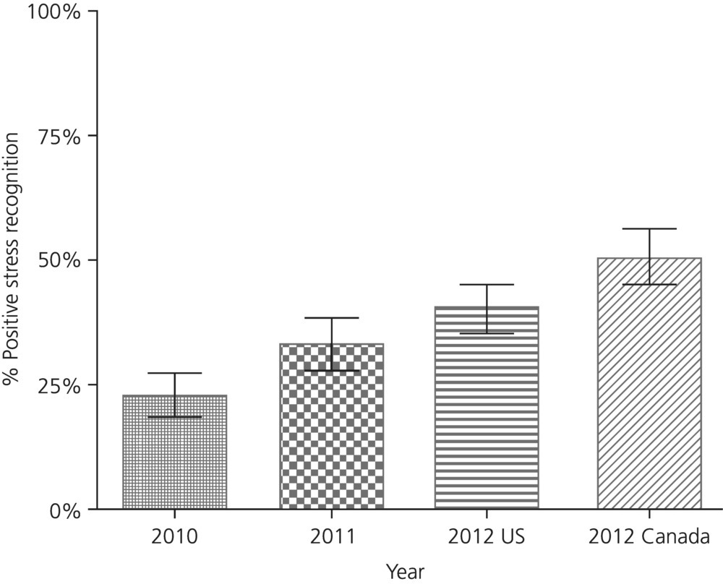

Sleep and fatigue
The National Sleep Foundation describes normal sleep for adults as 7–9 hours per sleep period. Inadequate sleep is defined as total sleep that is less than 7 hours [26]. Data from the National Health Interview Survey show that the mean amount sleep per night for the average employed US adult is 7 hours [27] yet one-third of US adults reports inadequate sleep [26,28]. Data from the Behavioral Risk Factor Surveillance System show that 31% of adults report inadequate sleep in the previous 24-hour period and approximately 11% in the previous 30 days [29]. Pirrallo and colleagues found that 70% of actively employed EMS workers report at least one sleep problem [30].
Shift workers such as nurses, physicians, and EMS workers are vulnerable to inadequate sleep due in part to work schedules that are non-traditional (e.g. 24-hour shifts, night shifts, rotating shifts). A recent study of hospital nurses showed that the mean amount sleep between scheduled shifts for both night and day workers was less than 6 hours per night [31]. A study of emergency physicians working in an academic medical center showed that short-term memory declined after day and overnight shifts and confirmed the high incidence of disturbed sleep among physicians [32]. Data from hundreds of EMS workers submitting data to the EMSARN consistently show that about half of these workers achieve less than 6 hours of sleep per sleep episode (Figure 20.2).
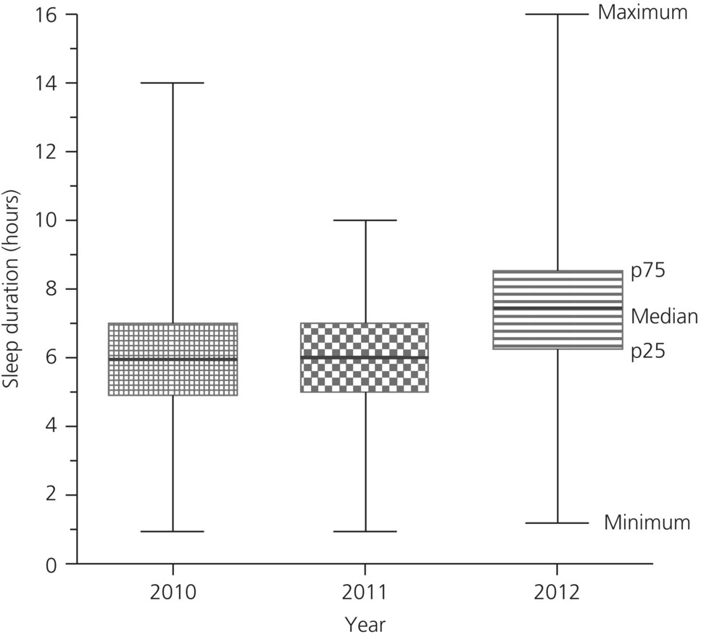
Figure 20.2 EMS worker self-reported median hours of sleep per sleep period across multiple years and diverse samples of EMS workers.
Total sleep hours is only one component of an individual’s overall quality of sleep. Sleep quality is a multidimensional concept that is most commonly referenced using seven domains of the Pittsburgh Sleep Quality Index (PSQI): subjective sleep quality, sleep latency, sleep duration, habitual sleep efficiency, sleep disturbances, use of sleep medication, and daytime dysfunction [33]. Scores on the PSQI range from 0 to 21 with scores ≥6 considered indicative of poor sleep quality [33]. Benchmarking data show that sleep quality scores among “healthy” controls are <3 and scores for persons diagnosed with depression are >11 [33]. Data from a convenience sample of EMS workers in Pennsylvania show a mean PSQI score of 9.2 (SD 3.7) [8]. Recent data from a nationwide sample of 511 EMS workers identified a mean PSQI of 6.9, with 60% of workers scoring ≥6 [5]. Sleep quality data have been collected annually since 2010 by the EMSARN. There is growing evidence linking characteristics of EMS worker sleep to negative outcomes, including a higher odds of sustaining a workplace injury (unadjusted odds ratio (OR) 2.3) [5] or ambulance crash [34]. Figure 20.3 shows that PSQI scores for most respondents exceed a score of 5 for all years, suggesting that sleep quality among EMS workers is habitually poor.

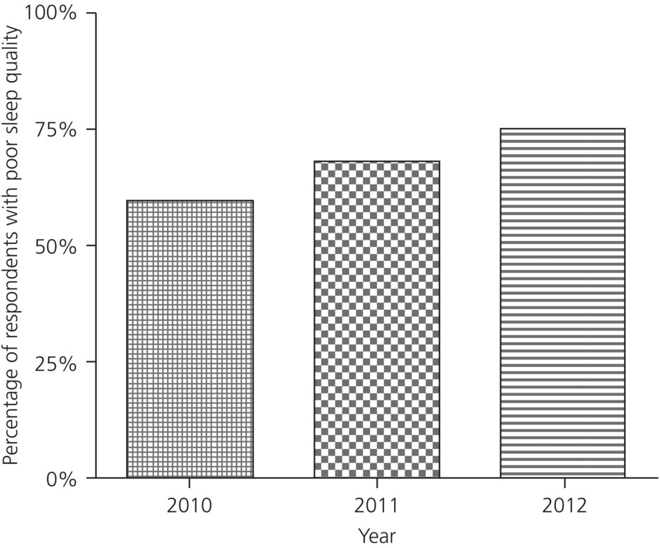
Figure 20.3 Percentage of EMS workers with poor sleep quality across years and diverse samples of US-based EMS workers and EMS agencies.
Daytime sleepiness is another common measure in sleep medicine, and the Epworth Sleepiness Scale (ESS) is used frequently to assess daytime sleepiness or sleep propensity [35]. The ESS scores range from 0 to 24 and scores ≥10 are often used to indicate excessive daytime sleepiness [35]. The proportion of US adults that report daytime sleepiness varies by demographic and work-related factors. Data from 5,173 older adults (mean age 66) show that ~16% of whites, 12.5% of Chinese, ~22% of African Americans, and 15% of Hispanics report excessive daytime sleepiness (ESS >10) [36]. Recent research involving 458 firefighters in the Midwestern US show that 25% scored ≥8 on the ESS [37]. Data from a sample of 1,854 nationally registered EMS workers show that 36% suffer from excessive daytime sleepiness (ESS >10) [30]. High ESS scores were associated with difficulty remembering protocols and tiredness-related difficulty in operating motor vehicles [30]. Sleepiness has also been linked to job satisfaction and intent to leave the profession in EMS workers [38].
Severe mental and/or physical fatigue may result from EMS workers not receiving the sleep and rest that they need. Fatigue refers to an “unpleasant symptom incorporating feelings of tiredness to exhaustion creating mental and physical conditions that interfere with the ability to function in a normal capacity” [39]. Fatigue is most often measured using self-report surveys but there is no recognized standard for fatigue assessment and the debate on how best to measure fatigue is ongoing [40]. Population-level data suggest that fatigue affects approximately one-third of US adult workers [41]. Self-reported fatigue varies by occupation and study sample. One-third (36%) of hospital-based nurses [31], 40% of truck drivers [42], and 75% of small-airline commercial pilots have reported acute or chronic fatigue [43].
Few studies have examined fatigue among EMS workers. A study of 221 EMS workers in the Netherlands showed that 10% of those answering the Checklist Individual Strength survey were classified as severely fatigued and at risk of sick leave or work disability [12]. A study involving a convenience sample of 119 EMS workers in western Pennsylvania showed that 44.5% reported severe mental and physical fatigue while at work using a modified version of the Chalder Fatigue Questionnaire [8]. A separate study involving 511 workers affiliated with 30 diverse EMS agencies showed that 55% reported severe mental and physical fatigue while at work [5]. Figure 20.4 includes multiple years of data from the EMSARN network and suggests that greater than half of EMS workers feel severely fatigued. Fatigue has been associated with an increased risk of injury (unadjusted OR 2.9), medical error or adverse event (unadjusted OR 2.3), and safety-compromising behaviors (unadjusted OR 4.9) [5].
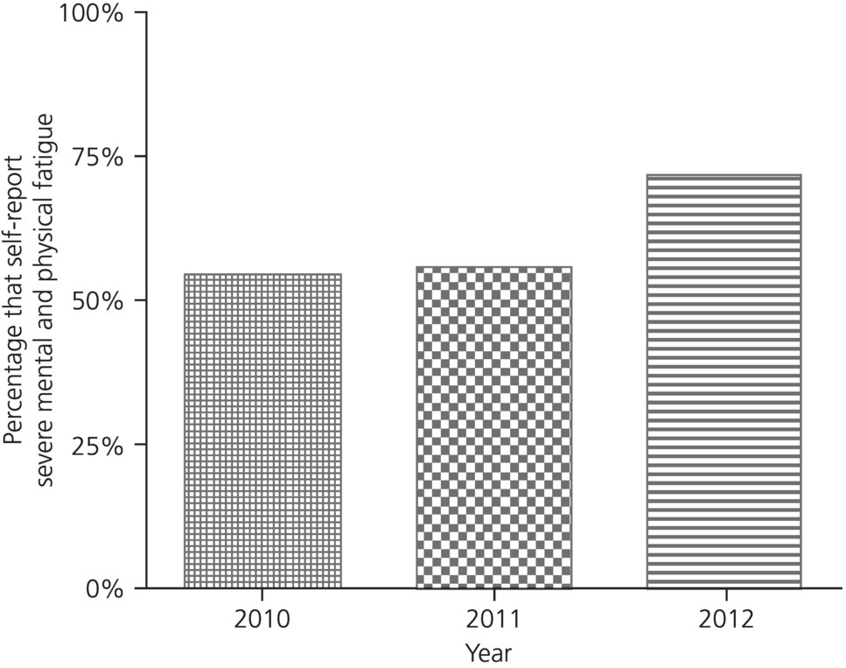
‘Figure 20.4 Proportion of EMS workers who self-report severe mental and physical fatigue while at work across diverse samples of US-based EMS workers and EMS agencies.

Shift work
The term shift work refers to “any arrangement of work hours other than the standard daylight hours” [44]. It is well established that shift work extending into the overnight and early morning hours disrupts the homeostatic and circadian mechanisms that regulate the human sleep/wake cycle [45,46]. Shift work has also been linked to degradation in performance, safety, and health [47–49].
There is no standard shift work schedule for EMS workers, and research on EMS shift work characteristics and patterns is limited. However, available data show that a large proportion of EMS personnel work long hours and multiple shifts. More than half work greater than 45 hours per week, most work 12- or 24-hour shifts, and 40% work more than 16 shifts per month [5,8,50]. A large proportion of EMS workers – as much as 80% – have additional employment and/or work a high number of overtime hours [51,52]. The long-term effects of shift work in the EMS setting have not been delineated, but recent research shows that retired shift workers have worse sleep quality in retirement than workers with no prior exposure to shift work [53].

Conclusion
The EMS worker, employer, and medical director share responsibility for achieving and maintaining wellness. The unpredictable nature of EMS work poses a unique challenge for work site wellness program implementation and maintenance. Wellness programs for EMS organizations will need to fit the unique needs and operations of each EMS organization. Employers will need to invest and devote resources – which are often limited – to work site health and wellness. Investment can lead to positive returns with improvement in worker health behaviors and a healthier workforce [54].
Despite the evidence in favor of work site health promotion, there are numerous challenges and barriers to program adoption, implementation, and maintenance in the EMS setting. Many EMS workers live and work with one or more chronic diseases. A high proportion of EMS workers are at risk of an acute injury or developing work-related chronic health problems through repeated exposure to stress, violence, blood-borne pathogens, physical exertion, etc. Employers, medical directors, and supervisors may not know what conditions to focus on and what to “let go.” The EMS worker may find it difficult to engage in a work site program given the unpredictable nature of EMS work and lack of protected time during work to participate.
Despite these challenges, there is widespread support and rapid growth in resources that EMS leaders can and should use to promote and protect the health and wellness of our EMS workforce [55].

References
- 1 Boal WL, Leiss JK, Ratcliffe JM, et al. The national study to prevent blood exposure in paramedics: rates of exposure to blood. Int Arch Occup Environ Health 2010;83(2):191–9.
- 2 Studnek JR, Bentley M, Crawford JM, Fernandez AR. An assessment of key health indicators among emergency medical services professionals. Prehosp Emerg Care 2010;14(1):14–20.
- 3 Idler EL, Benyamini Y. Self-rated health and mortality: a review of twenty-seven community studies. J Health Soc Behav 1997;38(1):21–37.
- 4 Burstrom B, Fredlund P. Self-rated health: is it as good a predictor of subsequent mortality among adults in lower as well as higher social classes? J Epidemiol Community Health 2001;55(11):836–40.
- 5 Patterson PD, Weaver MD, Frank RC, et al. Association between poor sleep, fatigue, and safety outcomes in emergency medical services providers. Prehosp Emerg Care 2012;16(1):86–97.
- 6 Zajacova A, Dowd JB. Reliability of self-rated health in US adults. Am J Epidemiol 2011;174(8):977–83.
- 7 2020 LHI Topics. Available at: www.healthypeople.gov/2020/LHI/2020indicators.aspx
- 8 Patterson PD, Suffoletto BP, Kupas DF, Weaver MD, Hostler D. Sleep quality and fatigue among prehospital providers. Prehosp Emerg Care2010;14(2):187–93.
- 9 Brock DW, Thomas O, Cowan CD, Allison DB, Gaesser GA, Hunter GR. Association between insufficiently physically active and the prevalence of obesity in the United States. J Phys Act Health 2009;6(1):1–5.
- 10 Schoenborn CA, Adams PF, Peregoy JA. Health behaviors of adults: United States, 2008–2010. Vital Health Stat 10. 2013;(257). Available at: www.cdc.gov/nchs/data/series/sr_10/sr10_257.pdf
- 11 Blair SN. Physical inactivity: the biggest public health problem of the 21st century. Br J Sports Med 2009;43(1):1–2.
- 12 Van Der Ploeg E, Kleber RJ. Acute and chronic job stressors among ambulance personnel: predictors of health symptoms. Occup Environ Med2003;60(Suppl 1):i40–6.
- 13 Ganster DC, Rosen CC. Work stress and employee health: a multidisciplinary review. J Manage 2013;39(5):1085–122.
- 14 Tennant C. Work-related stress and depressive disorders. J Psychosom Res 2001;51(5):697–704.
- 15 Roth SG, Moore CD: Work-family fit: the impact of emergency medical services work on the family system. Prehosp Emerg Care 2009;13(4):462–8.
- 16 Dutton LM, Smolensky MH, Lorimor R, Leach CS. Psychological stress levels in paramedics. Emerg Med Serv 1978;7(5):88, 90–4, 113.
- 17 Cydulka RK, Emerman CL, Shade B, Kubincanek J. Stress levels in EMS personnel: a national survey. Prehosp Disaster Med 1997;12(2):136–40.
- 18 Bentley MA, Crawford JM, Wilkins JR, Fernandez AR, Studnek JR. An assessment of depression, anxiety, and stress among nationally certified EMS professionals. Prehosp Emerg Care 2013;17(3):330–8.
- 19 Donnelly E. Work-related stress and posttraumatic stress in emergency medical services. Prehosp Emerg Care 2012;16(1):76–85.
- 20 Sterud T, Ekeberg O, Hem E. Health status in the ambulance services: a systematic review. BMC Health Serv Res 2006;6(1):82.
- 21 Boudreaux E, Jones GN, Mandry C, Brantley PJ. Patient care and daily stress among emergency medical technicians. Prehosp Disaster Med1996;11(3):43–8.
- 22 Cydulka RK, Emerman C, Shade B, Kubincanek J. Stress levels in EMS personnel: a longitudinal study with work-schedule modification. Acad Emerg Med 1994;1(3):240–6.
- 23 Brownstone JE, Shatoff DK, Duckro PN. Reducing stress factors in EMS: report of a national survey. Emerg Health Serv Rev 1983;2(1):35–53.
- 24 Revicki DA, Whitley TW, Landis SS, Allison EJ Jr. Organizational characteristics, occupational stress, and depression in rural emergency medical technicians. J Rural Health 1988;4(2):73–83.
- 25 Patterson PD, Probst JC, Leith KH, Corwin SJ, Powell MP. Recruitment and Retention of EMTs: a qualitative study. J Allied Health 2005;34(3):153–62.
- 26 Schoenborn CA, Adams PE. Health behaviors of adults: United States, 2005–2007. Vital Health Stat 10 2010;(245):1–132.
- 27 Lombardi DA, Folkard S, Willetts JL, Smith GS. Daily sleep, weekly working hours, and risk of work-related injury: US National Health Interview Survey (2004–2008). Chronobiol Int 2010;27(5):1013–30.
- 28 CDC: Unhealthy sleep-related behaviors – 12 States, 2009. MMWR 2011;60(8):233–8.
- 29 CDC: Perceived insufficient rest or sleep among adults – United States, 2008. MMWR 2009;58(42):1175–9.
- 30 Pirrallo RG, Loomis CC, Levine R, Woodson BT. The prevalence of sleep problems in emergency medical technicians. Sleep Breath 2012;16(1):149–62.
- 31 Geiger-Brown J, Rogers VE, Trinkoff AM, Kane RL, Bausell RB, Scharf SM. Sleep, sleepiness, fatigue, and performance of 12-hour shift nurses. Chronobiol Int 2012;29(2):211–19.
- 32 Machi MS, Staum M, Callaway CW, et al. The relationship between shift work, sleep, and cognition in career emergency physicians. Acad Emerg Med2012;19(1):85–91.
- 33 Buysse DJ, Reynolds CFr, Monk TH, Berman SR, Kupfer DJ. The Pittsburgh Sleep Quality Index: a new instrument for psychiatric practice and research. Psychiatr Serv 1989;28(2):193–213.
- 34 Studnek JR, Fernandez AR. Characteristics of emergency medical technicians involved in ambulance crashes. Prehosp Disaster Med 2008;23(5):432–7.
- 35 Johns MW. A new method for measuring daytime sleepiness: the Epworth Sleepiness Scale. Sleep 1991;14(6):540–5.
- 36 Baron KG, Liu K, Chan C, Shahar E, Hasnain-Wynia R, Zee P. Race and ethnic variation in excessive daytime sleepiness: the multi-ethnic study of atherosclerosis. Behav Sleep Med 2010;8(4):231–45.
- 37 Haddock CK, Poston WS, Jitnarin N, Jahnke SA. Excessive daytime sleepiness in firefighters in the central United States. J Occup Environ Med2013;55(4):416–23.
- 38 Blau G, Gibson G. Exploring the impact of sleep-related impairments on the perceived general health and retention of an Emergency Medical Services (EMS) sample. Career Develop Internat 2011;16(3):238–53.
- 39 Ream E, Richardson A. Fatigue: a concept analysis. Int J Nurs Stud 1996;33(5):519–29.
- 40 De Vries J, Michielsen HJ, van Heck GL. Assessment of fatigue among working people: a comparison of six questionnaires. Occup Environ Med2003;60(Suppl 1):i10–i15.
- 41 Ricci JA, Chee E, Lorandeau AL, Berger J. Fatigue in the U.S. workforce: prevalence and implications for lost productive work time. J Occup Environ Med 2007;49(1):1–10.
- 42 Arnold PK, Hartley LR, Corry A, Hochstadt D, Penna F, Feyer AM. Hours of work, and perceptions of fatigue among truck drivers. Accid Anal Prev1997;29(4):471–7.
- 43 Jackson CA, Earl L. Prevalence of fatigue among commercial pilots. Occup Med (Lond) 2006;56(4):263–8.
- 44 IARC, Working Group on the Evaluation of Carcinogenic Risks to Humans. Shiftwork. Lyon, France: International Agency for Research on Cancer, 2010.
- 45 Borbely AA. A two process model of sleep regulation. Hum Neurobiol 1982;1(3):195–204.
- 46 Daan S, Beersma DG, Borbely AA. Timing of human sleep: recovery process gated by a circadian pacemaker. Am J Physiol 1984;246(2 Pt 2):R161–83.
- 47 Caruso CC. Possible broad impacts of long work hours. Ind Health 2006;44(4):531–6.
- 48 Van Dongen HP, Hursh SR. Fatigue, performance, errors, and accidents. In: Kryger MH, Roth T, Dement WC (eds) Principles and Practice of Sleep Medicine. St Louis, MO: Elsevier, 2011, p.753–9.
- 49 Scott AJ. Shift work and health. Prim Care 2000;27(4):1057–79.
- 50 Brown WE, Dickinson PD, Misselbeck WJ, Levine R. Longitudinal emergency medical technician attribute and demographic study (LEADS): an interim report. Prehosp Emerg Care 2002;6(4):433–9.
- 51 Frakes MA, Kelly JG. Sleep debt and outside employment patterns in helicopter air medical staff working 24-hour shifts. Air Med J 2007;26(1):45–9.
- 52 Bauder B. Safety fears rise with city's use of overtime. Pittsburgh Tribune-Review, 2012.
- 53 Monk TH, Buysse DJ, Billy BD, et al. Shiftworkers report worse sleep than day workers, even in retirement. J Sleep Res 2013;22(2):201–8.
- 54 Goetzel RZ, Ozminkowski RJ. The health and cost benefits of work site health-promotion programs. Annu Rev Public Health 2008;29:303–23.
- 55 Sorensen G, Landsbergis P, Hammer L, et al. Preventing chronic disease in the workplace: a workshop report and recommendations. Am J Pub Health2011;101(Suppl 1):S196–207.

