Medical Command Physicians
Instructions for Setting Up Your TRAIN ACCOUNT

Link to site: https://www.train.org/pa/welcome
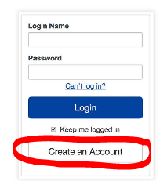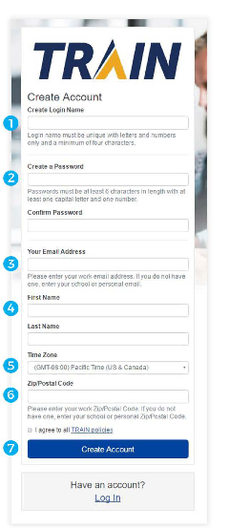
- Create a Login Name:
Prefer - Pa(certification number)
- Create a Password
- Enter email address that you used on your PA EMS Registry account
- Next enter first (full) and last name
- Select your time zone
- Enter your zip code, again must match the PA EMS Registry
- Check box that you agree to TRAIN policies.
- Click Create Account

Create an Account
If you do not have a TRAIN account, click on CREATE AN ACCOUNT

Once you have logged into TRAIN for the first time, you will see a notification that your profile is incomplete. This is shown because there remain unanswered fields in your profile. It is important to note that this profile status indication will display each time you log into TRAIN until your profile is completed. Additionally, you will be unable to register for courses until your profile is completed. To access your profile, click the 'Your Profile is Incomplete' notification link or click on your name in the top right corner and select "Your Profile.
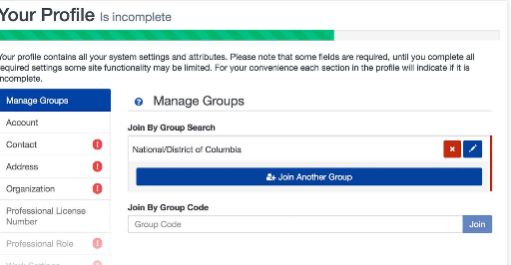
Medical Command Physicians Should Select ONLY the following Groups:
- Pennsylvania >YOUR COUNTY and then click on CONFIRM THESE SELECTIONS.
- Select a Functional Role – click on Other Public Health Profession (my functional role isn’t listed). Click on CONFIRM THESE SELECTIONS.
- Select an Organization, click on Other (my organization is not listed). Click confirm these selections.
- Click blue button that reads FINISH CREATING AN ACCOUNT.
- Click RED GO button.
You will be routed to your TRAIN HOME PAGE. You may have notifications that your profile is not complete. Click the link to the notification and complete areas that require information. Click on the RED ASTERIK in each group and fill in the missing data. Once all information has been entered you will be routed back to your Home Page where you can search for the courses you will need to complete. The classes you will need to complete are:
PA-EMS: Pennsylvania Medical Command Physician Course (All Modules)
PA-EMS 2017 Statewide BLS Protocol Update
PA-EMS 2017 Statewide ALS Protocol Update

