Volume 1

Chapter 11
Cardiac arrest systems of care
Bryan McNally, Paul M. Middleton, and Marcus Ong

Introduction
The original motivations for the development of EMS were to improve the care of patients suffering from major trauma and out-of-hospital cardiac arrest (OHCA). Physicians and resuscitation researchers often focus on patient-level perspectives of cardiac arrest care (e.g. specific drug agents or treatment algorithms). However, the most important factors determining OHCA survival involve the systems of community care.
The recognition that sudden cardiac arrest (SCA) survival depended on the time intervals from collapse to initiation of cardiopulmonary resuscitation (CPR) and to defibrillation spurred extensive EMS and public safety efforts to achieve faster response and earlier defibrillation. These efforts included the use of fire fighters and police officers as first responders, training EMTs to perform defibrillation, and strategic deployment of ALS units (systems status management). However, there were (and remain) inherent logistical limits to first responder speed.
The development of the automated external defibrillator (AED) led to the concept of public access defibrillation (PAD) [1]. The AED highlighted the critical importance of immediate bystander action in the management of cardiac arrest. Every EMS medical director, manager, and provider must recognize the importance of this principle. EMS responders and hospital staff have less impact on OHCA survival than bystander CPR and AED use [2]. OHCA survival when bystander CPR and AED are used may be as high as 33–50% [3–5].
The effect of bystander CPR or bystander AED happening early on in the chain of survival is described in Table 11.1. The data are from the Cardiac Arrest Registry to Enhance Survival (CARES) Program and are specific to those patients who have a witnessed OHCA and are found in a shockable rhythm.
Table 11.1 Number and percentage of persons who experience and those who survive a bystander-witnessed out-of-hospital cardiac arrest and are found in a shockable rhythm, by clinical characteristics, United States, 2005–2010
 | Experience |  | Survive
Characteristic | No. | (%) | No. | (%)
Who first initiated CPR?
Bystander | 2,076 | 49.0 | 696 | 33.5
9-1-1 responder | 2,164 | 51.0 | 580 | 26.8
Total | 4,240 | 100 | 1,276 | 30.1
Who first applied AED/monitor?
Bystander | 376 | 8.9 | 188 | 50.0
9-1-1 responder | 3,867 | 91.1 | 1,090 | 28.2
Total | 4,243 | 100 | 1,278 | 30.1
CARES 2005–2012
Optimal OHCA survival depends on a comprehensive community-based approach that includes collecting essential OHCA outcome data as part of a continuous quality improvement program to improve care. In 2004 only 13 of the 50 largest cities in the US collected meaningful OHCA outcomes. Today 45 of these communities collect OHCA outcome data [6]. Programs like CARES (https://mycares.net) and the Pan Asian Resuscitation Outcomes Study (PAROS) (www.scri.edu.sg/index.php/networks-paros) provide communities with the necessary tools to collect OHCA data in an ongoing efficient manner, allowing for benchmarking and gauging effectiveness in a real-world environment [4,7,8]. In King County, Washington, the Resuscitation Academy was created to help communities develop local quality assurance programs through a 3-day fellowship program designed specifically for EMS providers, administrators. and medical directors (www.resuscitationacademy.com/).
Implementation of this community systems-based approach is as important a role for EMS agencies as is training and preparing for their own direct patient care. This chapter provides an overview of the system-level considerations in cardiac arrest resuscitation and care. The other components of clinical cardiac arrest care are discussed in Volume 1, Chapter 12.

Epidemiology of cardiac arrest
The annual incidence of SCA in the United States is estimated at between 166,000 and 450,000 cases [5,9,10]. The reported incidence varies with the source of the data and definitions used. Precise epidemiological information is limited because the Centers for Disease Control and Prevention (CDC) does not consider OHCA a reportable disease [11].
Many cardiac arrests are due to ventricular fibrillation (VF) or ventricular tachycardia, but the proportion in a shockable rhythm on EMS arrival varies with the time from collapse to initial assessment. Studies based on hospitalized patients report a shockable rhythm in about 75% of cases, whereas EMS studies report figures ranging from 24% to 60% [4,12–17]. EMS data suggest that the rate of out-of-hospital VF/ ventricular tachycardia (VT) may be decreasing, but the overall incidence of OHCA is not [18–21]. However, studies with rhythms recorded by on-site defibrillators continue to identify VF/VT as the most common initial rhythm. VF/VT was the presenting rhythm in 61% of arrests in the Casino trial and 59% of the patients in the PAD trial [22,23].
The average survival to hospital discharge after OHCA is estimated to be between 5% and 10%,[4,24–27] but reported OHCA survival rates also vary widely. There are likely several reasons for this, including differing denominators, varying definitions of survival, and possibly true regional differences [24]. In the Resuscitation Outcomes Consortium composed of nine communities in North America, a five-fold difference in survival was found between sites [28]. Survival rates are highest in patients in whom the collapse is witnessed and the presenting rhythm is shockable. CARES data in 2012 (see Table 11.1) revealed a 37% survival rate for this subset of patients, which increased to 50% with use of an on-site defibrillator. Survival is lowest for unwitnessed and asystolic arrests.

Elements of a community cardiac arrest care system
The key elements of a community cardiac arrest care system include the following.
- Early recognition and calling for help.
- 9-1-1 dispatching and provision of bystander CPR instructions
- Bystander CPR
- PAD
- First responder BLS care, including defibrillation
- ALS care
- Postarrest care
- Participation in an OHCA registry and local quality improvement program
Emergency medical services directly provide only two elements of this chain. Thus, community-oriented approaches are essential in facilitating improved cardiac arrest survival. EMS medical directors and agencies cannot successfully care for victims of OHCA in isolation. They must work with the community to optimize all elements of care and should serve leadership roles in this effort.

Bystander recognition of arrest and calling for help
The most important first steps in cardiac arrest care are recognition of the event and summoning help. These actions require widespread public awareness of the existence of OHCA, how to recognize OHCA, and the importance of immediate action.
The methods for teaching laypersons the recognition of OHCA have evolved over recent years. Many studies have described the difficulty of and delays caused by laypersons attempting to feel for a pulse [29]. One showed that even trained EMTs were inaccurate in detecting the presence or absence of a pulse in patients undergoing cardiac bypass during open heart surgery [30]. Thus, current American Heart Association (AHA) guidelines advise that bystanders should call 9-1-1 and begin treatment for OHCA if the person has no movement and no regular breathing. Bystanders must not mistake agonal gasps for normal breathing [31].
Emergency medical dispatch (EMD) is essential in cardiac arrest care. Dispatch centers must quickly and accurately recognize potential cardiac arrest calls and promptly dispatch appropriate first responder and EMS units. Providing prearrival instructions for bystander CPR and AED use is another important EMD role. Dispatcher instruction in CPR improves the likelihood of the caller performing CPR [32]. The details and requirements for emergency dispatching systems are discussed in Volume 2, Chapter 10.

Bystander cardiopulmonary resuscitation
Bystander CPR refers to CPR performed by someone who was already present at or passing by the location of the patient. This contrasts with CPR performed by dispatched emergency responders. Bystanders have the earliest opportunity to provide CPR to the cardiac arrest victim. Multiple studies have demonstrated the survival benefit of bystander CPR as well as the increase in mortality with delays in CPR delivery [33,34].EMS medical directors and agencies should monitor and optimize the rate of bystander CPR in their communities [35]. Prior efforts have included community education about OHCA and the importance of CPR, increasing access to training, and teaching CPR in schools to develop a culture of bystander assistance.
When callers do not know CPR, the dispatcher should provide real-time instructions over the phone. Most current EMD protocols detail specific CPR instructions [36]. Growing evidence suggests that properly performed chest compressions are more important than ventilations [37–39]. Most emergency dispatch protocols now favor providing instructions only for chest compressions.
The AHA recommends that bystanders not trained in CPR and those trained but not confident or willing to perform ventilations should perform chest compression-only CPR until a defibrillator is ready for use (Class IIa) [37]. Unrecognized fatigue is common after just 1–2 minutes, so bystanders providing chest compressions should switch frequently [40].

Public access defibrillation
The most important cardiac arrest interventions for patients in VF or VT are early chest compressions and defibrillation. Although 70–80% of VF can be successfully converted to a perfusing rhythm if shocked within 3 minutes of VF onset, this success rate deteriorates rapidly with each additional minute [41]. Survival decreases 7–10% for each minute that passes before defibrillation [34] (Figure 11.1).

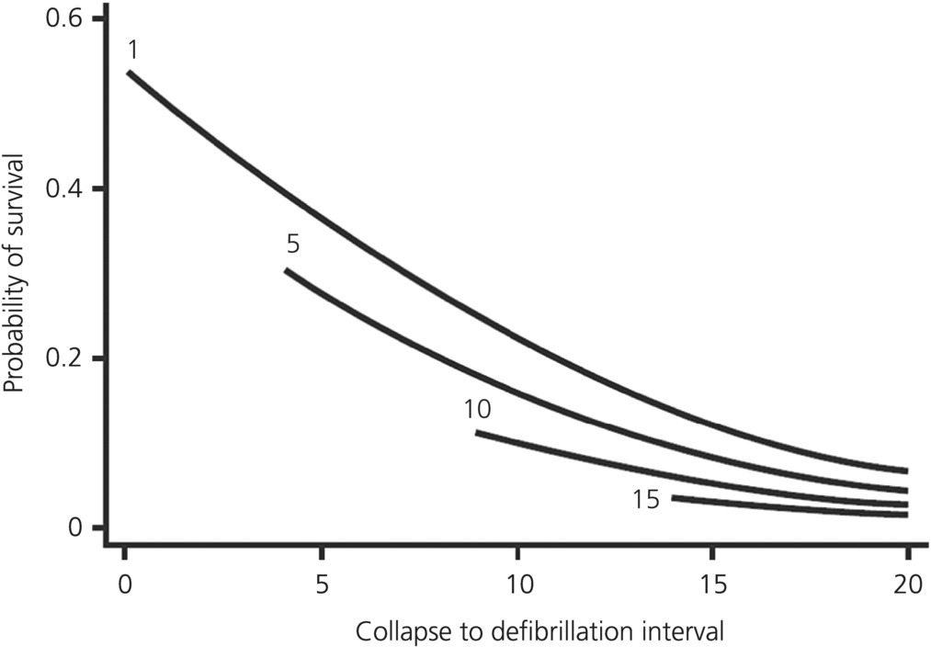
Figure 11.1 Relation of collapse to CPR and defibrillation to survival: simplified model. Graphical representation of simplified (includes collapse to CPR and collapse to defibrillation only) predictive model of survival after witnessed, out-of-hospital cardiac arrest due to VF. Each curve represents change in probability of survival as delay (minutes) to defibrillation increases for a given collapse-to-CPR interval (minutes).
Source: Valenzuela TD. Circulation 1997;96:3308–13. Reproduced with permission of Lippincott, Williams and Wilkins.
Automated external defibrillators provide lay bystanders with the ability to deliver rescue shocks. These devices were first used clinically in 1979 to recognize and deliver rescue shocks for VF and rapid VT [42]. AEDs are automated and simple to use with visual and audible instructions for operating the defibrillator and initiating CPR. They are relatively inexpensive and extremely safe; modern AEDs do not allow delivery of inappropriate shocks [43]. Most are equipped with memory modules that can record the entire resuscitation event, including continuous ECG and audio recording.
Defibrillators with CPR feedback use accelerometers embedded within chest defibrillation pads to measure depth and rate of compression, or use variations in chest impedance to reflect chest wall movements [44,45]. These devices are able to give verbal as well as visual prompts to cue the rescuer to speed up, slow down, or increase the depth of compressions or ventilations [46]. Such devices have been shown to improve the quality of CPR for out-of-hospital [47] as well as in-hospital cardiac arrest [46].
A variety of AED models are now available, ranging in sophistication and ruggedness. Some models are designed for minimally trained lay bystanders, and are available for consumer purchase without physician prescription.
There is strong scientific evidence confirming the efficacy of early first responder, bystander, and public access defibrillation. A trial which trained security personnel in casinos to recognize OHCA, start CPR, and use on-site AEDs achieved 53% survival from VF, and among patients shocked within 3 minutes survival was 74% [23]. AEDs have also been successfully used on aircraft and in the airport [48]. In the multicenter PAD trial, 993 high-risk locations were randomized to deploy or not deploy on-site AEDs. A response plan with identification and training of on-site responders was implemented at all sites. Survival was double at AED sites compared to non-AED sites [22]. Other reports also describe successful PAD programs [49].
One successful real-world example is Japan, where public access defibrillators have rapidly become more available since 2004 [50,51]. The cumulative number of public access defibrillators (excluding medical facilities and EMS institutions) increased from 9,906 in 2005 to 297,095 in 2011 [52]. From 2005 to 2007, the proportion of bystander-witnessed VF/VT arrests who received public access defibrillation increased from 1.2% (45/3841) to 6.2% (274/4402) [50]. The latest data show that over 40% of cardiac arrests in public places like train stations and sports facilities received shocks with public access defibrillators.
The observation that a majority of OHCA events occur in residential settings raised interest in home deployment of AEDs. This concept was evaluated in a large, multicenter, international trial of anterior wall myocardial infarction survivors who were not candidates for implantable cardiac defibrillators [53]. A related innovation is the wearable cardioverter-defibrillator, which combines a long-term ECG monitoring system with an AED [54].
Locations at high risk can be identified using public health surveillance tools such as registries that collect standardized data on OHCA. Cardiac arrest locations can be analyzed using geographic information systems and spatial epidemiology methods to identify and target high-risk neighborhoods within a community [55,56]. These should have emergency preparedness and response plans that include AED deployment [57–59]. These areas may include airports, fitness centers, large workplaces, arenas and convention centers, and even jails. AED deployment and response plans should include registration with dispatch centers, development of a notification system to alert on-site responders, selection and training of responders, and deployment of appropriate AED and other rescue equipment. Equipment maintenance, annual response plan review, and quality improvement incident reviews are essential components of an effective PAD program. Smartphone apps are also available which can show the location of the nearest AED during an emergency. These can be integrated into local response systems.
There is an important opportunity for local EMS agencies and medical directors to assist public and private sites with implementing PAD programs. Several websites and publications provide detailed suggestions for PAD program development [60–72].

First responder and Basic Life Support care
Before the advent of PAD, medical directors sought ways to shorten the delays to initial defibrillation.One solution was to equip first responders with AEDs because these individuals could often reach a cardiac arrest victim faster than an ALS ambulance. The first important report of this concept involved firefighterfirst responders in King County, Washington, in 1989 [73]. Police first responders in Rochester, Minnesota, and suburban areas near Pittsburgh, Pennsylvania, also successfully used AEDs [19,74,75]. These programs demonstrated benefit even if the first responders arrived only 2 minutes before EMS. Cardiac arrest survival was 50% in Rochester, Minnesota, after introducing a police AED program [75,76]. The use of motorcycles in urban settings to reduce response time has also been described [77].
The OPALS study specifically evaluated the effect of optimizing time to defibrillation by BLS responders, with a goal of having a defibrillator-equipped vehicle on scene within 8 minutes of 9-1-1 call receipt in 90% of calls. Increasing the proportion of responses that met the 8-minute standard from 77% to 92% improved survival to hospital discharge from 3.9% to 5.2% [78]. A subsequent analysis found that increasing time to defibrillation was associated with decreased survival [1] (Figure 11.2). These observations further underscored the greater importance of bystander action in facilitating additional survival.

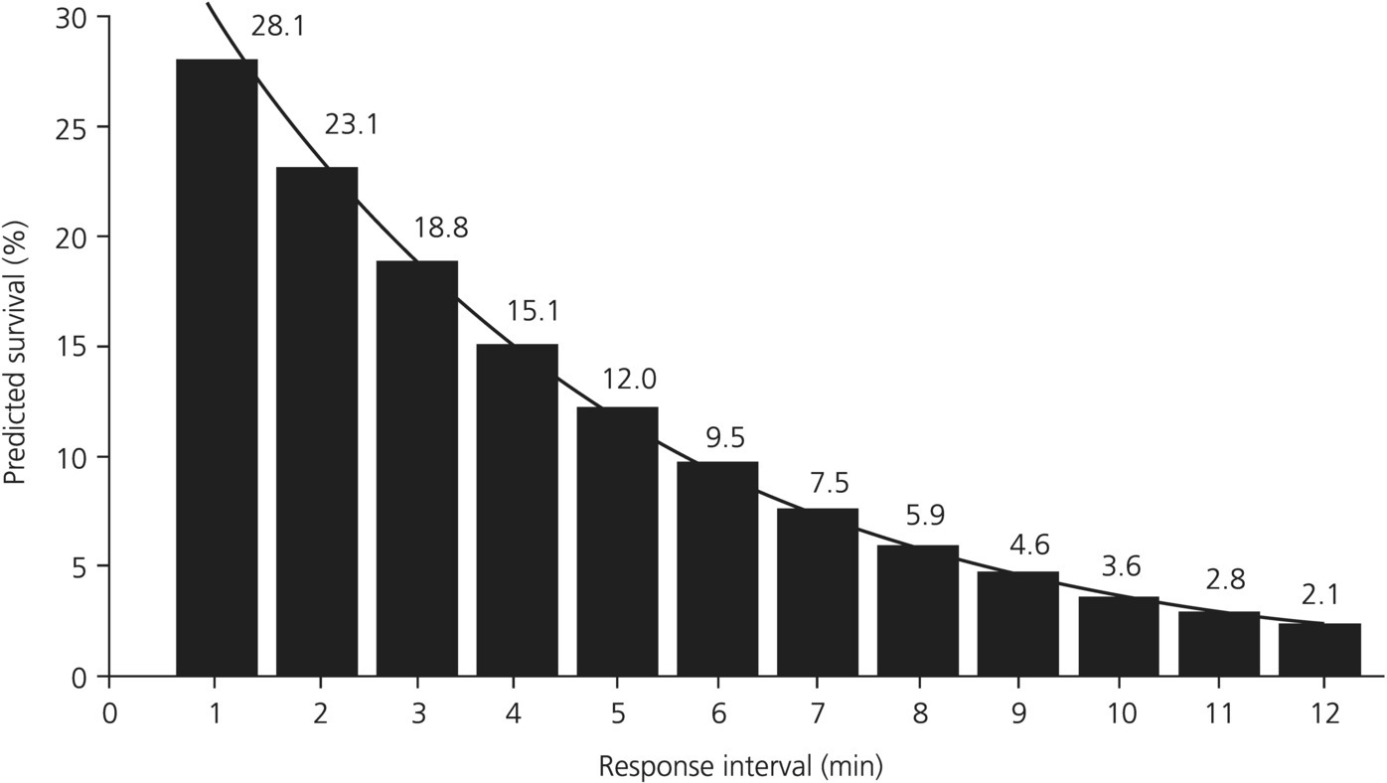

Figure 11.2 Predicted survival versus defibrillation response interval.
Source: De Maio VJ. Ann Emerg Med 2003;42:242–50. Reproduced with permission from Elsevier.
Performing high-quality, continuous chest compressions is another important role for first responders. There is increasing evidence of the role of high-quality chest compressions in improving defibrillation success [79–81]. Research indicates that the quality of CPR is vitally important [54,80], especially rate, depth, and reducing prolonged interruption of chest compressions, as interruptions result in less cycle time and lower coronary perfusion pressures [74–77]. Use of multiple first responders (teams of four or more) to allow for closely supervised BLS has also been advocated as “high-performance CPR.” Also, use of mechanical CPR has been recommended, especially if transport with ongoing CPR is needed, for example in BLS ambulance systems [78].

Advanced Life Support care
Although traditionally viewed as the cornerstone of cardiac arrest care, the limited effectiveness of traditional ALS interventions in cardiac arrest is increasingly being shown. In the OPALS study, which added ALS care to previously optimized first responder defibrillation, ALS care did not further improve cardiac arrest survival [2]. In other words, early CPR and defibrillation had greater effects on cardiac arrest survival than advanced airway management or drug administration.
In the systematic and comprehensive evidence review undertaken for the production of the International Liaison Committee on Resuscitation (ILCOR) guidelines in 2010, many ALS interventions previously accepted as routine were found to be supported by little good-quality evidence. ILCOR Consensus on Science authors stated that there were no data to support the routine use of any specific approach to airway management during cardiac arrest, and elaborated on concerns that extended attempts to insert an endotracheal tube may lead to harmful interruption of chest compressions [82].
They concluded that there was insufficient evidence to define the optimal timing of advanced airway placement during cardiac arrest, and also stated that supraglottic airway devices may be considered by health care professionals trained in their use as an alternative to bag-valve-mask ventilation during CPR. Cricoid pressure was not recommended for use in cardiac arrest, whereas waveform capnography was. A lack of evidence supporting many ALS pharmacological interventions was emphasized, including vasopressors, atropine, steroids, fibrinolytics, and fluids during cardiac arrest, with placebo-controlled trials being called for; calcium and sodium bicarbonate were not recommended [82].
Since 2010, studies have continued to show that advanced airway management during cardiac arrest appears not to benefit patients. A prospective, population-based study in Japan involving 650,000 out-of-hospital cardiac arrest patients showed that any type of advanced airway management was independently associated with decreased odds of neurologically favorable survival compared with conventional bag-valve-mask ventilation [83].
If dispatched, ALS personnel may play a supervisory role on scene, taking part in team leading to ensure that required interventions are made by basic-level responders. ALS providers also have advanced skills and resources that may be helpful in select scenarios (e.g. treating a tension pneumothorax or a hyperkalemia-induced cardiac arrest).
Recent changes in cardiac arrest guidelines based on this evidence have simplified the management of cardiac arrest, highlighting the preeminence of BLS measures such as immediate bystander chest compressions, and the use of AEDs by bystanders whether or not previously trained, with ALS interventions being delayed until later in the course of the patient journey.
Of interest is that interventions considered to be most beneficial in the postresuscitation care phase, such as the induction of therapeutic hypothermia, have increasingly been trialled in the prehospital phase of cardiac arrest. It has been shown that prehospital cooling can be carried out safely and efficaciously [84–86]; however, survival benefit has not yet been convincingly demonstrated [87].

Postresuscitation care
Postresuscitation care and in-hospital postarrest therapies are an important factor affecting OHCA survival and subsequent functional outcome [79]. Significant morbidity and mortality after OHCA are due to cerebral and cardiac dysfunction in what has been termed the “postcardiac arrest syndrome” [80]. Despite initial coma after OHCA, subsequent neurological recovery can be influenced by in-hospital postarrest treatments [81,87,88].
Despite these advances, many medical centers do not provide standardized postarrest care [89] for reasons including a sense of futility, staffing, cost, expertise, and resources [90–93]. This is despite published recommendations on postarrest care including implementation and barriers to implementation and guidelines for cardiac resuscitation systems of care [94,95].
Regionalized postresuscitation care has been proposed, with “cardiac arrest centers” equipped and staffed to provide guideline-based therapies such as targeted temperature management, 24-7 postcardiac arrest percutaneous coronary intervention, and extracorporeal membrane oxygenation (ECMO). An example of a state-wide regionalized system of postarrest care was implemented in Arizona in 2007 [96].

Role of the medical director
Stewart commented, “Without dedicated medical leadership, the EMS system of a community flirts with mediocrity” [97]. The medical director plays a pivotal role in community systems of cardiac arrest care. It is the medical director’s responsibility to ensure that all components of the system are in place. The importance of medical director involvement cannot be overemphasized. In Houston, the increase in VF survival from 0% to 21% over a 5-year period was attributed to the hiring of a full-time EMS medical director [65].
Indeed, Williams et al. [98] showed significant variation in EMS scope of practice with varying involvement of a medical director, and Greer et al. [99] showed that EMS agencies with paid medical directors or agencies with medical director interaction with EMTs in the preceding 4 weeks were more likely to have prehospital cardiovascular procedures in place.

Training and equipment
Cardiac arrest resuscitation requires timely and accurate execution of interventions. Because of the multitude of simultaneous tasks, cardiac arrest resuscitation requires a carefully coordinated team effort, potentially between rescuers from different agencies. EMS personnel should regularly train for cardiac arrest situations to determine the most efficient ways to carry out protocols. When possible, such training should involve the first responders who may also respond to these incidents. Recent studies of medical emergency team training in simulation settings demonstrate the importance of teamwork and assigned roles [100,101].
One systematic review described a lack of well-designed studies examining the retention of adult ALS knowledge and skills in health care providers [102] but commented that the available evidence suggests that ALS knowledge and skills decay by 6 months to 1 year after training, with skills decaying faster than knowledge. Simulation has been shown to be superior in the development and maintenance of skills in cardiac arrest management, and another large systematic review [103] showed that non-simulation intervention, learner satisfaction, and process skill outcomes favored simulation over non-simulation teaching, and commented that simulation-based training for resuscitation is highly effective, particularly if employing strategies such as team/group dynamics, distraction, and integrated feedback.
Team training, particularly using simulation, is potentially even more important since the 2010 ILCOR and American Heart Association guideline changes to cardiac arrest processes, as cardiac arrest management involves strategies such as charging while chest compressions are continuing, which despite having been shown to be highly effective in decreasing non-CPR periods, causes anxiety among providers about injury due to defibrillation. Another recent study [104] showed that charging during compressions was underutilized but was associated with minimal risk to patients or rescuers.
Emergency medical services personnel must possess the equipment necessary to carry out cardiac arrest resuscitation. Key resuscitation equipment includes monitor-defibrillators, airway management tools, vascular access equipment, and appropriate medications. Cardiac monitors that record and provide real-time chest compression feedback are preferable, as are monitors that are able to use dynamic filtering to remove compression artifact and reveal underlying rhythms, although it must be remembered that accelerometer-based compression feedback devices overestimate chest compression depth when performed on soft surfaces [105].
In addition to intubation equipment, airway management tools should include capnography and alternative airway devices such as the Combitube™, King LT airway™, or iGel™. In addition to standard IV catheters, EMS crews should also carry rapid-access vascular tools such as intraosseous devices. Medical directors should provide regular training on the use of all equipment to ensure that personnel can operate them efficiently. Even in busy systems, many personnel may not perform these various skills or use specific equipment for months at a time.

Optimizing system design
Medical directors should play a key role in developing the system design for cardiac arrest care. One potential intervention is to optimize the positioning of EMS and other resources to match areas with the most cardiac arrests. Geographic mapping systems can play an important role, illustrating not only the distribution of cardiac arrest cases throughout a community but also variables such as the preferred placement of AEDs [106,107]. The OPALS study reduced cardiac arrest response and defibrillation times by moving first responders closer to areas with many cardiac arrests.
Some have touted the advantages of system status management, a formal system of continuously redeploying units based on current and anticipated use [108]. Others suggest that skill dilution occurs with too many ALS personnel; these experts recommend using fewer ALS personnel in a tiered response fashion [108,109]. A Scottish study [110] reported on an initiative to more fully formalize the roles of senior EMS personnel, who are known to be able to contribute characteristics essential to high-quality resuscitation including non-technical skills such as resuscitation team leadership, communication, and clinical decision making in a second tier, expert paramedic response to OHCA.

Hospital liaison
There is growing awareness of the importance of postresuscitation care, which formally constitutes the final link in the chain of survival [111]. Care initiated in the field may prove fruitless if not continued in the hospital. The medical director should work closely with receiving hospitals to ensure continuity in cardiac arrest care, and targeted interventions and care algorithms initiated in the field should be continued in the hospital. For example, when determining the receiving hospital facility, EMS agencies that induce hypothermia after cardiac arrest in unconscious survivors should consider if the receiving facility will continue this therapy [112–116]. Studies are currently being performed which use a system-based approach in an attempt to integrate therapies which may have synergistic effects, and which are likely to show codependence in outcome. These are typified by the CHEER study, which aims to treat cardiac arrest patients with mechanical chest compressions and cool them to 33 °C in the prehospital setting, place them on ECMO at the hospital, transport them to the interventional cardiac catheter laboratory for angioplasty, then maintain hypothermia for 24 hours [117].
Davis et al. demonstrated that diverting postarrest patients past the closest available hospital to a tertiary care center did not worsen outcomes [118]. Future work should consider if regionalization of care and transfer of these patients to specialty facilities improves outcomes as it does for victims of major trauma [119–122]. Regional systems of care have improved both provider experience and patient outcomes, for those with ST-elevation myocardial infarction and with life-threatening traumatic injury. A Japanese cardiac arrest registry of 10,000 OHCA patients transported to critical cardiac care hospitals showed improved 1-month survival compared with those patients transported to hospitals without specialized cardiac facilities [123]. Compared with historical controls, survival to hospital discharge in the Take Heart America Program [124], a regionalized system of cardiac arrest care in Minnesota, improved from 8.5% to 19%, driven by a dramatic improvement in survival after admission to intensive care from 24% to 51%. This program is based on optimization of prehospital care including EMS and community training, while establishing transport and treatment protocols with three dedicated cardiac arrest centers providing therapeutic hypothermia, interventional coronary artery evaluation and treatment, and electrophysiological evaluation. However, a similar relationship between survival or neurological outcome and presence of a coronary catheterization laboratory or the volume of patients received was not seen in an analysis from CARES data [125].

Quality improvement program
A prerequisite for improving cardiac arrest resuscitation quality is the collection of performance and quality data. Medical directors should implement quality inspection and assurance programs to ensure the delivery of high-quality cardiac arrest care. Commonly collected cardiac arrest quality data include treatment time intervals such as call to dispatch, dispatch to scene arrival, arrival to patient side, and call to first defibrillation. Another important measure is CPR performance. Monitors now permit the medical director to evaluate the depth, rate, and interruptions of chest compressions delivered throughout the entire episode [126,127].
The Utstein style for reporting of cardiac arrest data attempts to provide some common denominators for comparing resuscitation rates among various systems [128]. EMS services should adopt standardized data collection methods that allow for uniform reporting and benchmarking capability.

Conclusion
Improving survival from OHCA requires a comprehensive community systems approach. No single component, including EMS, can improve cardiac arrest survival independently. EMS agencies must assume a leadership role in promoting, developing, and implementing this systems-based approach.

