Chapter 12
Emergency care regionalization
Raymond L. Fowler

Introduction
Regionalization of emergency medical care has become the rule over the last few years. A complex process from a clinical and a political perspective, the desired result of these efforts is improved patient care in those areas addressed by these efforts [1]. The Institute of Medicine in 2006 promoted regionalization as a means of improving patient outcomes and reducing costs [2].
Indeed, regionalizing specialty referral centers improves patient outcomes. For example, solid evidence exists that regionalized systems of care for trauma patients significantly improve patient outcomes [3–13]. Similarly, studies also demonstrate outcome improvements for victims of ST-elevation myocardial infarction (STEMI) patients in many systems [14–17].
The design of the system is vital to its success, and that success is highly dependent upon the ability of the designers to examine the entire system of emergency patient care. The design of a regionalized system of care – across the spectrum of clinical presentations – must focus on every aspect of the patient’s complex journey through the emergency medical care system, identify any “weak links,” and target these areas for improvement.
The need for regionalization may not be fully understood by individuals who do not understand the intricacies of the entire emergency medical care system, even though many of them work within the system. Many tend to operate within organizational silos, and thus integrating their work with other providers must begin by breaking down system barriers.

The emergency medical care system
The emergency medical care system in a nation is a broad network that encompasses the component EMS systems that make it up. The system encompasses the entire care pathway that the patient must traverse in the journey resulting from an out-of-hospital care activity, and all components of care of the Emergency Medical Care System Circle (Figure 12.1). In contradistinction, we typically speak of an EMS system as only the out-of-hospital component of the patient’s care.
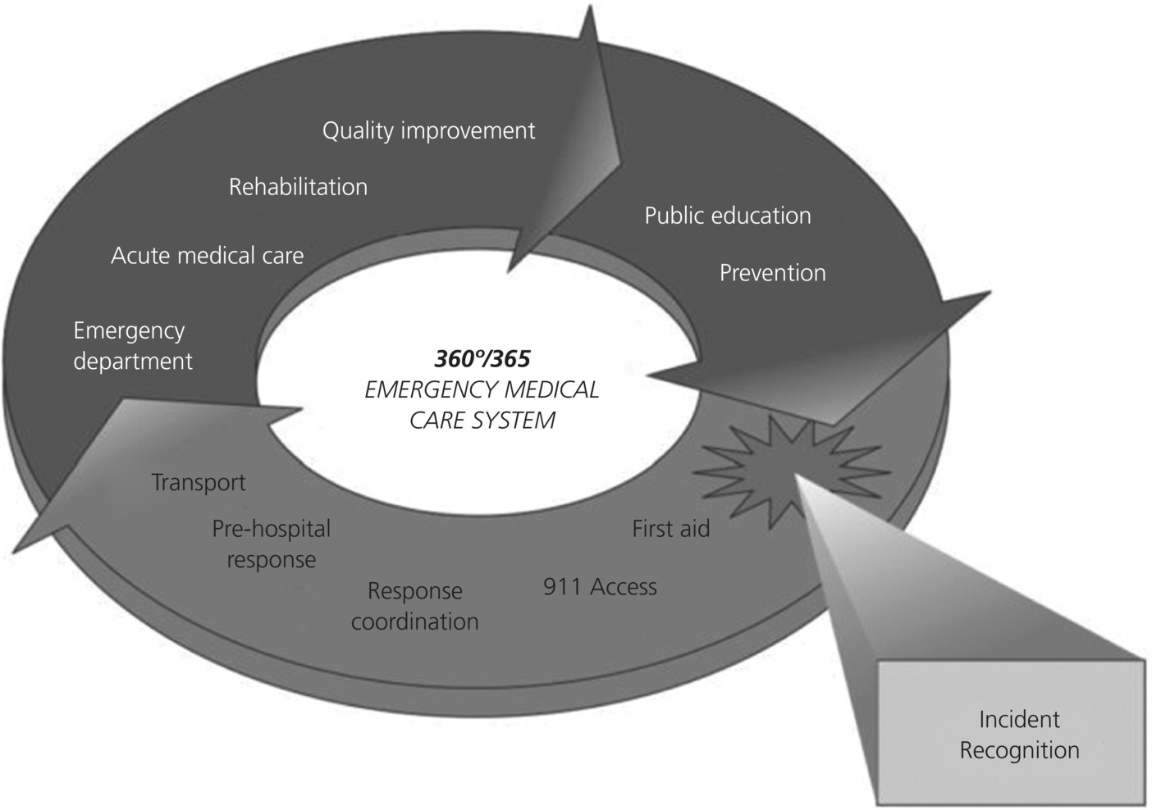

Figure 12.1 The emergency medical care system circle.
Source: Missouri Foundation for Health. Reproduced with permision of Missouri Foundation for Health.
The individual components of the emergency medical care system vary widely in their capabilities and responsibilities. For example, both ground and air response may be quite variable in clinical care abilities [2]. Hospitals may vary significantly in their abilities to care for severely ill or injured patients. Patients often require a high level of care that is unavailable at a local level to optimize outcomes. The early identification and “care mapping” for such patients form the basis of the need for an integrated, prospectively designed emergency medical care system through regionalization of medical care. EMS medical directors must be the leaders in bridging the many disciplines necessary for the creation and maintenance of a broad system, addressing actively the need to educate others on the entire spectrum necessary for system design and improvement. The importance of the EMS medical director in accepting this responsibility with a broad perspective cannot be overstated.
Success in efforts to regionalize facilities through categorization and designation has varied historically, first noted some 30 years ago as a pressing public imperative [18,19]. Only when all participants are committed to focus on the goal of improved patient care, across the spectrum of the variety of human clinical presentations, can the necessary system improvements begin to occur.
It is useful to consider an example of a case that might occur in an emergency medical care system on any given day.

A patient episode
The dispatcher in a seven-digit public safety answering point (PSAP), with no 9-1-1 number available, receives a call for emergency medical help. The caller tells the dispatcher that a child is choking and turning blue. The dispatcher in this rural setting, not trained in giving prearrival instructions, replies, “I’m sending someone right now!” A first responder unit and a transport ambulance are quickly dispatched. A total of 12 minutes is required from the initiation of the call to the initiation of care. Upon arrival of the EMS providers, the child is pulseless and apneic. The initial resuscitative efforts return a weak pulse. The transport ambulance arrives, and after a 20-minute scene time, their protocol is to transport to the nearest facility. The transport interval is 15 minutes.
The closest hospital facility is a low-volume ED that rarely cares for critically ill pediatric patients. Though the ED staff quickly gears up to provide the best care that they can, a lack of pediatric-specific equipment at the hospital delays definitive airway care and IV placement for the hypotensive, unresponsive child. A decision is made to transfer the child to a pediatric regional referral center. Elapsed time from arrival at this facility to the call for transfer is 40 minutes.
The pediatric tertiary center insists on sending its own transport team for the child and a 1-hour response time ensues. This interval is followed by a 45-minute scene time at the local hospital and a 50-minute transport time back to the tertiary center. The child is admitted to the tertiary care center’s pediatric intensive care unit, exhibits evidence of severe anoxic encephalopathy, and dies 3 weeks later.
The EMS medical director for the local emergency medical care system (EMCS) reviews this case and initiates the formation of an oversight body to improve the system. Quality improvement processes occur and each entity, from the dispatch agency to the transport team, concludes that it did the best it could have done at the time in this setting. The initial conclusion was that the outcome in this case was unavoidable and most unfortunate.
This assessment is of little solace to the child’s family. They realized that it was 12 minutes from the time of their call for help before their child was ventilated. They saw that it took 4 hours to get their loved one to a tertiary care facility. And they felt that if the original ambulance had turned right toward the pediatric hospital 30 minutes away instead of left toward the local hospital – at one crucial intersection – maybe the outcome would have been different.
How could regionalization have helped this child? The EMS medical director, looking at the entire spectrum of care provided to this patient, saw many areas for potential improvement that were then set before the oversight committee for consideration. The group saw that each component reflected individual “silos” that barely communicated. A process was initiated that examined every section and opportunity for care within the context of the whole system. Deficiencies were identified and proactive plans were made for maximizing that care on a regional basis, across the spectrum. The committee, led by the EMS medical director, set out to form a truly integrated emergency medical care system for the region.

Definitions
Regionalization is the formation of a coordinated system of care across a geographical area that combines all necessary components to optimize patient outcomes. This includes out-of-hospital components, in-hospital components, and public health components. The goal of the effort is both to facilitate the provision of quality patient care and to assure the overall economy of the system through utilizing appropriate resources within the region, coordinating overall care to focus on patient outcomes.
Categorization is the classification of facility capabilities against accepted standards. Categorization should be initiated before formal facility designation occurs.
Designation is the formal selection for patient referral and transfer by an organized body that has the authority to do so, typically both governmental as well as specialty designation bodies. A minimum set of standards exists for the various specialty designation areas that a facility must meet to become designated as a specialty receiving center.
The time-critical diagnosis system is the concept that a coordinated, integrated emergency medical care system can use to treat those diagnoses that are truly time critical. Clear evidence demonstrates that severe trauma, acute ischemic stroke, and STEMI outcomes can be improved by specialty care at regional referral centers designated by an accrediting body. The time-critical diagnosis concept seeks to avoid the creation of three separate systems (stroke, trauma, and STEMI) within a state or region, since the individual components of the system (EMS, local and regional hospitals, and various bureaucratic and oversight entities) play essential roles for all of these clinical cases. It is far more appropriate and cost-effective to coordinate all the critical cases within the emergency medical care system under a common banner of time-critical diagnosis. This allows resource sharing and coordination at many different levels and decreases duplication. Once formed, the combined time-critical diagnosis body has a significantly more powerful position in the political arena than do individual efforts.
Bypass is the decision to avoid transport of an out-of-hospital patient to a particular hospital facility when transport to a more distant facility will provide more optimal care. The decision to bypass the closer facility is made in the setting of clinical time-critical diagnosis cases in which care at the more distant facility – such as a stroke center, a STEMI center, a trauma center, a pediatric center – will most likely improve the patient’s outcome.
Diversion is an act taken by a hospital facility that informs field providers that transport to that facility should not occur. Diversion most commonly occurs when the patient traffic in the emergency department of that facility is of such a magnitude that additional EMS traffic could endanger either the current patients in the facility or the patient being transported. Diversion is commonly defined as an action that is allowed as a courtesy from the EMS medical director of that EMS system [20].

Historical background
In the past 70 years, the US military made most of the advances in the care of critically injured patients despite the fact that civilian accidental injuries occurred at an alarming rate [18]. Care of the severely injured in the military sector progressively improved through World War II and both the Korean and Vietnam conflicts, mainly through the prompt, judicious transport of the critically injured to centers specializing in trauma care. The lessons learned in the military sector, however, were slow to translate into the civilian sector.
In 1961, a “shock-trauma” unit was established at the University of Maryland to study shock in humans, followed by the first civilian trauma unit at Cook County Hospital in Chicago in 1966 [19]. This first trauma unit began promoting the concept of regionalization of trauma care in the civilian sector. The publication in 1966 of the far-sighted study from the National Academy of Sciences, Accidental Death and Disability: The Neglected Disease of Modern Society [21], was the seminal event that fostered the regionalization concept and modern civilian trauma care. The report detailed the problems within the medical care system of the day that contributed to the high morbidity and mortality due to trauma in the US. A few selected quotes from this 48-year-old report are useful to review today.
- “The general public is insensitive to the magnitude of the problem of accidental death and disability.” (page 5)
- “Local political authorities have neglected their responsibility to provide optimal emergency medical services.” (page 6)
- “Emergency departments of hospitals are over-crowded, some are archaic, and there are no systematic surveys on which to base requirements for space, equipment, or staffing for present, let alone future, needs.” (page 6)
- “Fundamental research in shock and trauma is inadequately supported.” (page 6)
- “Under medical leadership, national forums should be conducted at the highest levels on all subjects important to total emergency care from the time of receipt of an injury through rehabilitation.” (page 6)
- “Very few communities provide sufficient financial support for adequate ambulance services.” (page 13)
It is useful to look at the progress made in the emergency medical care system era today, and to examine the steps that were required to produce many of the positive results that have been seen. Congress paid attention to the report and began to address some of these shortcomings by directing funding into the Department of Transportation (see Volume 1, Chapter 1). Late in the 1960s and early into the 1970s, the conceptual design of a “systems approach” to trauma and emergency medical care began to emerge in some areas of the country. Programs emerged that targeted specific types of patients such as cardiac, trauma, burns, and spinal cord injuries. Illinois founded the first regionalized system in 1971 [22]. The Emergency Medical Services Act of 1973, signed into law by President Nixon, funded a nationwide shift from funeral home-based ambulances to a professional system of response and transport. A major goal of that federal grant program was regional EMS systems development on a national scale [23,24].

Categorization and designation
As the EMS Systems Act became implemented, it quickly became apparent that a system of categorization of hospital capabilities was needed so that other health care providers – both out-of-hospital and transferring emergency departments – would be better informed about optimal referral of patients.
The need for standards for specialty referral centers was quickly seen to be necessary. Trauma centers needed specialty teams ready to perform key interventions up to and including major surgery at all hours. Stroke center and STEMI center accreditation emerged, providing the requirements that these centers must be able to administer appropriate therapy to promote restoration of blood flow promptly. Indeed, as trauma became recognized as an emergency of critical injury, the care of stroke and heart attacks became recognized as “acute vascular emergencies” requiring prompt specialty care.
Formal designation of facilities by authorized bodies has followed. This designation process ensured that the categorization of facilities was accurate and that minimum standards were being met. In states that did not mandate those minimum standards, care was often found to be mediocre when compared to a formal process, though it was also found that any attempt at organization was better than no system at all [3–13,25,26]. Regionalization has followed the process of designation, requiring growth and change on the part of EMS providers. Enactment of state and/or municipal laws and regulations provides authorization for lead agencies to oversee processes within the emergency medical care system. For example, in New York State in 1998, facilities in half of the EMS regions were categorized based on guidelines established by the State EMS Council without formal state authority [27]. Since there was no legal authority to designate facilities, the process relied on voluntary participation that was uneven in some regions and non-existent in others [28].
Absent an authorized lead agency to carry out the process of oversight, it is important for the EMS physician to know that the risk of legal challenges against an emergency medical care system might increase. Designation often creates de facto monopolies by restricting the number of facilities allowed to participate within a given system, by requiring that certain standards of care be met prior to participation [29]. For example, the state of Texas (Administrative Code 157.133) requires that acute stroke patients be transported to the nearest comprehensive stroke center (CPC), primary stroke center (PSC), or secondary stroke center (SSC). If a PSC or CSC is within 10 minutes of the nearest SSC, the stroke patient will be directed to the PSC or CSC since more comprehensive care will be available at that center. In the absence of explicit authority, the designation process may be impeded by physicians, hospitals, or other special interest groups.
Initially, system planners did not adequately address the need for explicit authority to designate trauma centers. Compounding this shortfall was the lack of federal funding for upgrading hospital facilities. Individual hospitals were expected to make costly improvements on a voluntary basis [18]. Since it was assumed that designation of trauma centers would promote the development of the regionalized emergency medical care system, attempts were made in the 1970s to organize such systems around trauma center development [30]. When federal EMS systems funding effectively ended in 1982, program initiatives and necessary legislative changes became the responsibility of individual states. Those responsible for developing or managing EMS systems found that in the absence of both federal money and legal authority, plans for regionalization through facility designation commonly failed.
Many of the specialty referral center problems were caused by a relaxing somewhat of the originally strict criteria recommended by the American College of Surgeons and the development of Level II trauma center designations. The competition for designation as Level II centers among smaller community hospitals, and the litigation from this action, effectively halted development of the designations process altogether in many areas [31,32].
Concern regarding adverse economic effects (mainly the loss of patients) by those institutions not designated occasionally resulted in resistance by hospital administrators and physicians to both categorization and designation. It was noted that fewer than 10% of all trauma patients actually required trauma center care, and thus the actual loss of patients from non-designated hospitals was modest [18]. These same concerns are evident more than two decades later in the discussions about categorization and designation for acute ischemic stroke and STEMI. However, increased competition among facilities that have geared up for multispecialty critical care has increased the desire among these facilities to have EMS patients with these conditions transported to their facilities. At this writing, in the county of Dallas, Texas, there are 15 facilities that receive emergency 9-1-1 EMS patient transports from within the county. All 15 have percutaneous coronary intervention capability and are certified chest pain centers. Also, at this writing, 13 of these facilities either are certified stroke centers or are in the process of application to become certified. Thus, the competition for EMS emergency patients with these two conditions in this geographical area is very high.
Lead agencies with appropriate empowerment are important to a stable emergency medical care system process, as they oversee the planning, implementation, and operation of these systems, generally in the absence of serious legal challenge [33–35]. System development is much more difficult absent statutory and regulatory authority facility designation, establishing of regionalization processes, and overall system design. A branch of government with legislative authority to designate is best suited to serve as the lead agency.
This authority may assume many different forms besides an actual government unit. For example, Colorado and Pennsylvania utilize independent foundations for trauma center designation. The county of Dallas, Texas, worked with a non-profit organization and local foundation funding to create a county-wide network for the management of patients with acute coronary syndrome. Together with the American Heart Association local chapter, the University of Texas Southwestern, and local EMS agencies and hospitals, a grant was obtained from the W.W. Caruth Foundation to support the funding of a county-wide program – the “System Onset to Arterial Reperfusion” project – for the management of patients with acute coronary syndrome. All hospitals and EMS agencies participated in the project, together with the Regional Area Council. Of note, this was not a “designation process” but a voluntary process with funding to support common patient care protocols, training, and data tracking and analysis. The effectiveness of such an approach has not yet been fully determined, however, and should be observed carefully by system medical directors in other states. Whatever format is chosen, there must be a clearly defined body that has responsibility and authority to ensure an effective system.
Unauthorized designations expose agencies to antitrust liability. Explicit statutory authority affords the greatest protection against exposure to risk of liability for violation of the Sherman Act when limitations are made on the number of medical facilities used by a system [36]. In Huron Valley Hospital Inc. v. City of Pontiac, the court held that, “[State] regulatory actions within the gambit of valid legislation … are exempted from the antitrust laws under the ‘state action’ defense.” Proper authorization to designate granted to an agency that enforces state policies through activities closely supervised by state officials would not violate antitrust laws. However, anything short of properly constituted authority may fall foul of federal law.
To avoid such antitrust problems, the proper authority must perform hospital designation [37]. Although the law is unsettled nationally, it would appear that, in the absence of definitive court decisions or express legislative authority, governmental agencies with “implied” powers may be considered to be outside the scope of the antitrust laws [37].
The more recent development of effective stroke and STEMI acute therapy has again raised these same issues but within different groups. A few states have already developed classification standards for these categories of care on a legislative level, typically referring to national standards established by organizations such as the Joint Commission. Early on, some hospitals “self-designated” themselves as “stroke centers” or “cardiac centers” without objective review against established criteria, very similar to the formative days of the trauma system where hospitals rushed to self-designate as “trauma centers.” However, self-designation did not produce the expected clinical outcome improvements for trauma patients. Absent the development of specific criteria from the Joint Commission for the designation of stroke and STEMI centers, it is more than likely the same process might have repeated itself.

Public Law 101-590
The concept of regionalization and its ability to improve patient care is not new. The enactment in November 1990 of the Trauma Care Systems Planning and Development Act (PL 101-590) provided for the establishment of a federal trauma systems program [38,39]. This Act was intended to assist the local and regional planning efforts for trauma system development by breaking down some of the barriers to effective organization that were noted during the 1980s. However, the 1990 Act, which was supposed to provide grants to states for planning, implementing, and developing comprehensive trauma systems, was not funded when enacted. In November 1991, funding that finally was authorized to implement a new federal trauma systems program for 1992 totaled only $5 million. This amount was well below earlier projections, which were as high as $75 million [40,41].
Public Law 101-590 had two primary goals. First, it was designed to remove the barriers and rectify the problems that in many parts of the country prevented timely and efficient development of a comprehensive emergency medical care system. Second, it provided incentives, including grants, to states and localities to establish coordinated regionalized trauma care systems that would enable severely injured individuals to receive timely and highly specialized care at designated trauma centers.
Passage of PL 101-590 ratified the widely held belief that regionalized trauma systems reduced death and disability from trauma. Regionalized trauma care systems were models of health care delivery that could coordinate and integrate prehospital services and hospital resources to assure that optimal care was provided to traumatically injured patients. The 1990 legislation specified that such systems must identify and designate trauma centers with specialized physicians and equipment immediately available on a 24-hour basis. Also required were methods to identify severe trauma victims in the prehospital phase and to ensure that all major trauma victims were transported to trauma centers.
Public Law 101-590 addressed the issue of authority, effectively diminishing the threat of legal challenges to development and implementation of designation schemes. However, while the threshold issue of legal authority to designate was resolved, the financial burden caused by the large numbers of uninsured or indigent patients brought to designated facilities, compounded by inadequate reimbursement rates, still presented a great barrier to regionalization [40,41].
Progressive elements of PL 101-590 are found in the authorization of the Secretary of Health and Human Services to:
- establish an information clearinghouse to disseminate information on the experience of state and local agencies with respect to trauma care system development and operation
- establish an Advisory Council on Trauma Care Systems to conduct needs assessments on a country-wide basis
- establish funding for research and programs that seek to improve rural EMS.
By early 1993, progress was being made in each of those areas [34].
Unfortunately, enthusiasm has been greatly tempered by an economically constrained environment in which this legislative action has been able to attract only token funding. Ultimately, funding for this trauma program was lost in the mid-1990s.
Funding authorization returned in 2001 and again in 2007 with passage of the HR 727-Trauma Care Systems Planning and Development Act amendments, but the level of funding to be provided was unclear at that time. Unfortunately, the need for this type of system development remained poorly understood at all levels, the appropriations process failed to support the bill’s intentions, and funding remained elusive. Once again, the support for regionalization of care slipped from fiscal federal support back to the state and local level.

Simultaneous processing
Contrasted with the typical means of provision of emergency medical care (“sequential processing”), a key concept in the design of any regionalized system is “simultaneous processing.” A typical emergency call occurs in this manner.
- A call is made to 9-1-1.
- An ambulance responds.
- An assessment is made and treatment started.
- The patient is transported to the ED, admission information is gathered, and the assessment is repeated.
- After the ED examination, diagnostic tests are done.
- A provisional diagnosis is made, and a treatment plan is developed.
- Specialty consultants are called to the ED, if needed.
- Admission or discharge occurs.
Thus, in the usual world of EMS, evaluation and management are performed in a sequential fashion of “First A, then B, then C.” If a transfer from one hospital ED to another must occur – as is often the case with seriously ill and/or injured time-critical patients – this sequential process has even more steps added.
Early in the development of trauma systems and trauma care, it was noted that this sequential process often resulted in excessive delays for severely injured patients whose care was of a time-critical nature. In the earliest days, the trauma team was activated only after the patient had been examined in the ED. Out-of-hospital assessment and classification of injury severity (through the field trauma classification process) made it possible to move care forward and have the trauma team respond at the same time as the patient was being brought to the ED – an early example of simultaneous processing.
“Moving care forward” means that providers are performing tasks earlier during the sequence of care that typically were only performed by a higher-level health care provider later in the sequence. As in the above example, paramedics became authorized to give “trauma alerts,” an activity that was previously only in the purview of physicians. Significant time savings resulted between symptom onset and definitive care. It is a key component of simultaneous processing (Figure 12.2).
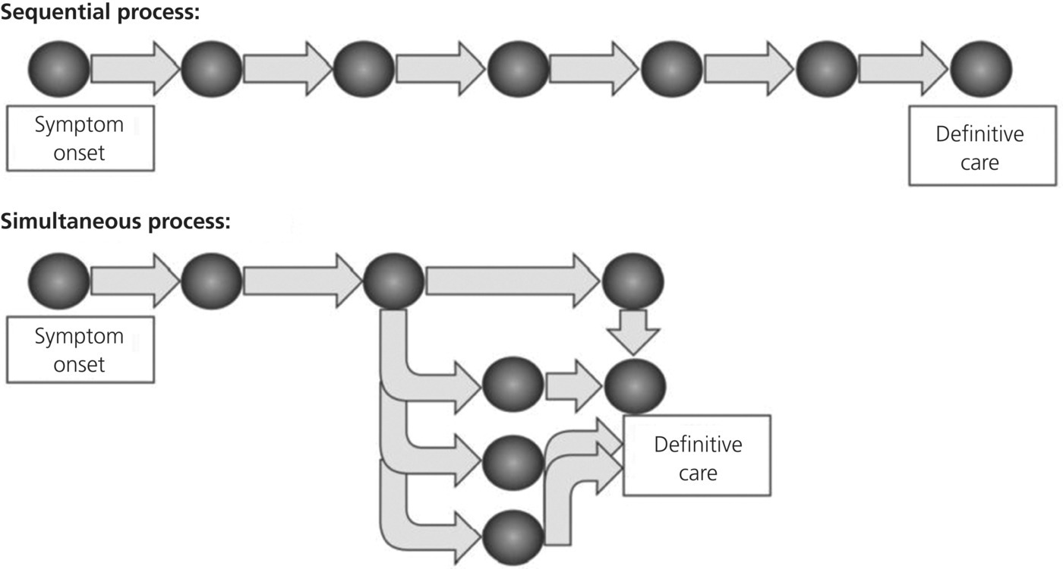

Figure 12.2 Sequential versus simultaneous process.
Source: William Jermyn. Reproduced with permission of William Jermyn.
Today that concept expands into field activation of stroke teams and cardiac catheterization labs. This authorization for activation by field personnel allows the simultaneous activities of catheterization lab (or stroke team) response while the patient is being transported to the hospital. Through this simultaneous activation of processes, vastly improved treatment of these conditions has occurred. Indeed, in 2013, the American Stroke Association stated, “Stroke care quality improvement should be an ongoing process for every hospital. One example of this process improvement is to shorten the door-to-needle time to <60 minutes. For every 15-minute reduction of door-to-needle time, there is a 5% lower odds of in-hospital mortality” [42].
The design of any regionalization system must account for this important concept to decrease the time elapsed from symptom onset to definitive care. In the future, with the assistance of programs such as advanced automatic crash notification and helicopter early launch programs, simultaneous processing should come under the purview of the modern 9-1-1 telecommunications center to continue to enhance patient outcome.

Outcomes
At present, three major diagnoses are considered “time-critical” emergencies: severe trauma, acute ischemic stroke, and STEMI. In these clinical scenarios, early identification through field evaluation to an appropriate (though not necessarily closest) facility, combined with appropriate treatment, can dramatically affect morbidity and mortality. Thus, outcomes can be directly affected by planning for “the right care, at the right place, in the right time.” Other clinical diagnoses, such as patients with postcardiac arrest return of spontaneous circulation, sepsis, and asthma, may join these time-critical conditions as efforts to maximize outcomes within integrated systems become increasingly standardized.
Achieving such a level of integration is a formidable task. Despite the common goal of helping the patient obtain the best available care, each of these levels may possess potential issues that may not produce a highly coordinated response.
- PSAP call takers may not be part of a 9-1-1 system, or may be primarily engaged in other public safety work and not trained, certified, or allowed to perform formal emergency medical dispatch.
- Initial responders such as law enforcement and fire service agencies may be more attuned to rapid, limited intervention.
- Local EMS policies may only provide for the transport of the patient to the nearest available community hospital, and a return to local readiness as soon as possible.
- Air ambulance providers may be engaged elsewhere, potentially depriving other time-critical patients of air transport to appropriate facilities.
- Community hospitals may have unclear guidance as to what patient work-up is required at that facility before transfer to a higher level of care to avoid a potential violation of the Emergency Medical Treatment and Active Labor Act.
- Regional referral centers may express concern that the caseload of patients referred to that facility by outlying facilities is too high.

Trauma
Research measuring the outcomes of a patient population that was treated within a trauma system compared to those treated outside a trauma system began early in trauma system development. Absent electronic patient registries, a tool was developed to measure these cases within the limitations of the data of the time. A panel of surgeons, blinded to the hospital and system, reviewed cases and determined if deaths were preventable, probably preventable, or not preventable [1,9,11,43,44]. These panels routinely found that care within trauma systems with a rigid specialty referral center designation process was best. Such a system design, using outside site review teams, was compared with both “no system” and a “self-designation” system, where a hospital performed the review process and designated itself according to various published standards. Patient outcomes were found to be best with external review and designation [3–13].
These differences were sometimes quite dramatic. For example, the classic study by West, Trunkey, and Lim compared the San Francisco area, which had a formal designated trauma system, with Orange County, CA, which had no formal designated trauma system [13]. West et al. found that only one of 92 deaths was deemed potentially preventable in the San Francisco system. In distinct contrast, 11 of 30 Orange County deaths were deemed clearly preventable and another 11 of 30 were deemed potentially preventable. They estimated that a formal system in Orange County could result in as much as a 73% decrease in non-central nervous system (CNS)-related deaths and a 28% decrease in CNS-related deaths. In a follow-up, Cales [6] studied the same Orange County area several years later, comparing outcomes from before and after a regionalized trauma system was implemented. He found that potentially preventable deaths fell from 34% to 15%, a 56% relative decrease. Thus, formal, rigorous, external site review processes can improve the performance of hospitals already designated as trauma centers [25]. Even rural Level III facilities have improved outcomes, even after transferring the patient [40].
At all levels of care it has become widely accepted that a regionalized system of care for the trauma victim is desirable. The overall reduction in preventable mortality is probably in the 50% range and the reduction in time to disposition falls from 54% to 7% [10,11]. The question then arises: Does the same logic apply to other time-critical diseases, and can we realize the same improvements in care?

Stroke
“Stroke networks” are relatively new, and data are now accumulating of abundant improvements in overall quality of care [45–47]. Improved outcomes for patients with acute ischemic stroke and for hemorrhagic stroke have been shown when patients are treated within a designated stroke center system [48,49]. Organized stroke systems decrease mortality. As mentioned above, emphasis on the management of acute ischemic stroke has become fully stressed within facilities that have been certified as either primary or comprehensive stroke centers. The rapid identification of victims of acute ischemic stroke who are appropriate candidates for fibrinolytic therapy is now an area of intense focus. Given the widely accepted statistic that some 2 million brain cells are dying each minute in these victims, there is now strong impetus to treat at least 50% of eligible patients with fibrinolysis within 1 hour of arrival to a stroke center [42]. It is now fairly clear that the benefit in improved morbidity and mortality for these patients outweighs the risks of fibrinolysis, especially when these selected patients are treated within 90 minutes of symptom onset [50,51]. There are more data that suggest that adherence to rigorous fibrinolysis administration criteria can minimize complications and gain the mortality benefits delineated in the original study [52,53].
A critical area of focus in stroke management today is the identification of these patients by prehospital providers. Standardized patient examinations such as the Cincinnati, Los Angeles, Miami, and Melbourne stroke scales allow EMS personnel to provide a level of assessment that is reasonable to permit activation of stroke teams in the destination facilities. Indeed, “prenotification” of the stroke teams in the stroke centers is central to achieving the “50% of eligible patients treated within an hour of arrival” goal to which stroke centers are now being held [42]. Thus, within the regional system of care for stroke, EMS providers must have initial and ongoing training and appropriately tailored quality management systems that feed back onto their assessments.

Diversion and bypass
Diversion is a scenario in which an emergency receiving facility may decline to allow transport to that facility by EMS providers. This fact has been shown to be a “surrogate” for ED crowding [54]. Regardless of the cause, the effect of diversion is to potentially threaten patient care through prolonging the prehospital phase of the encounter. Diversion, in effect, is the pushing of emergency patients in ambulances away from a facility due to systemic problems within that hospital as regards patient flow.
It is extremely important for a hospital to have prospectively designed diversion criteria. Such a decision cannot be made by a tired emergency provider in the department, seeing a glut of emergency patients within that department, calling a medical control area to say that ambulances are diverted. For a hospital to close its doors to inbound ambulance traffic is for the hospital to declare that it can no longer participate in the emergency medical care system at that moment. Such a decision must be made according to strict criteria, approved by the medical director, and activated only in the setting of appropriate administrative oversight, together with the emergency medicine team in the ED [54].
Justifications can be made for diversion of certain types of inbound ambulance patients on occasion. If the trauma team at a Level I trauma center has received a number of critical patients, is in the operating room, and has hours more of potential surgeries waiting for care, then an incoming trauma victim may be better served if there is another appropriate trauma facility in the area that is not so overloaded. Similar considerations apply to stroke and STEMI victims in the settings of receiving hospital teams being already occupied – and vascular intervention laboratories already full – and patients may benefit from being transported to another appropriate facility.
Progressive EMS systems have abandoned the ambulance diversion process. Massachusetts implemented a moratorium on ambulance diversion in 2009 [55]. Their study showed, “according to pre-determined criteria, no clinically significant changes were found in any ED group in mean monthly volume, admissions, elopement, or length-of-stay for any patient disposition group.” They concluded, “no diversion was not associated with significant changes in throughput measures in ‘all,’ ‘high’ diversion, and ‘low’ diversion emergency departments.” Examples abound of similar processes, including Dallas and Fort Worth, Texas.
Finally, EMS physicians should consider carefully whether ambulance diversion should be allowed at all within the emergency medical care systems in which those physicians have influence. The patients in the backs of those ambulances are ultimately under the care of the indirect medical oversight physician: the EMS medical director. Diversion, then, must be a courtesy extended by the EMS medical director to the receiving hospital and should be considered in that context [56]. While proactive medical liaison efforts by the medical director can help pave the way for emergency medical care system progress in this area, the ultimate disposition of the patient nonetheless falls to the medical director.
As to the matter of “bypass,” the emergency medical care system structure must allow for transporting agencies that have identified patients falling into certain clinical categories to be mobilized to the appropriate facility for the condition. This ensures the most appropriate care for the acutely ill or injured patient. Streamlining care also avoids additional unnecessary testing – perhaps duplicative testing – and better oversight of overall system finance within the emergency medical care system. Cooperative agreements must be in place, and system guidelines must be developed prospectively.

ST-segment elevation myocardial infarction
Systems that deal with STEMI have shown significant improvements in patient care. Efforts abound to establish systems such as these. The entire state of North Carolina (flowing into bordering states) has been organized into the Reperfusion of Acute MI in North Carolina Emergency Departments (RACE) effort. While a 2007 report in JAMA failed to demonstrate any overall mortality improvement [17], ongoing maintenance and monitoring of this system demonstrate a state-wide effort allowing for a high level of coordination of care for these patients. Similar effort occurred in the Dallas, Texas, area [56], which is now being actively extended into the Dallas-Fort Worth metroplex of four counties. The Dallas data indicate an improvement in overall survival for STEMI patients during the study period from 4.6% to 1.9% [56].
An interesting public health dilemma continues to be noted across these systems of care, both for STEMI and for acute stroke. Some 50% of patients continue to “self-transport” to receiving facilities, a saddening point resulting in an increase in morbidity and mortality for these patients. The Dallas AHA Caruth effort found that, in spite of public education, the relative percentage of patients self-transporting to area hospitals did not change [56].

Payer/funding issues
Funding is a key factor in the overall operation of an emergency medical care system. Critical trauma, for example, has a poor history of reimbursement, while cardiac care may be relatively well reimbursed. This may foster competition for various hospital designations. A local private hospital may be a “chest pain center” and “stroke center” but its medical staff may decline to be involved with the trauma system on critical patients. Transporting agencies must be reasonably reimbursed for their work within systems, especially in the setting of longer transport costs. Indeed, the capabilities of each and every component within the emergency medical care system must be adequately funded to allow for the high efficiency necessary for such a complicated system to function properly.
In the new paradigm of time-critical diagnoses, “stabilization” at facilities without the capacity for definitive care may result in the delay of treatment and the worsening of outcomes. Gross et al. found that when a STEMI patient was stopped at an outside facility for “stabilization,” an average of 79 minutes was added to the patient’s eventual definitive care [14]. Notably, this was in a system that sought to decrease the time required to transfer by several means, including a “one-call system.” Furthermore, when they studied the subgroups, those patients who were delayed for “stabilization” had a 4.3% overall mortality, versus 0% for those who either walked into or were field triaged directly to a percutaneous coronary intervention center. These data argue forcefully against any delays in definitive care, and payers must apportion their reimbursement standards to accommodate the advances and concepts of regionalization.

The optimal emergency medical care system
Regionalization of emergency medical care is a “work in progress” within the overall spectrum of medical care. It is critical that ongoing assessment of the condition of the system and continuous improvement be made consistently. Several key concepts and tenets are useful in the management of such systems.
- A designated overarching agency must be identified that possesses the necessary legal authority to oversee the political and administrative processes needed for a regional system to succeed.
- An oversight committee must be established to allow for the input of expert stakeholders and to encourage their participation in the design and refinement of system processes. Common subcommittees include medical oversight, funding, public education, prevention, quality improvement, individual clinical committees (9-1-1, EMS, stroke, STEMI, trauma), and legislative.
- Organizational silos need to be acknowledged and resolved. Leadership focused on improving patient outcomes through decreasing the time from symptom onset to definitive care is the key to bridging the gaps between provider groups.
- Care must be “moved forward”, and providers must be able to perform at the appropriate level for the system. The most correct diagnosis should be made quickly in time-critical cases, with a proper triage and destination decision being made. Prehospital personnel must be able to activate the appropriate receiving facilities and personnel. Prehospital personnel must be trained to recognize and make appropriate destination decisions and must be given consistent feedback regarding their field decisions.
- EMS medical directors have to ensure that their personnel appropriately identify stroke and STEMI candidates while avoiding “overtriage” when possible. For example, a prehospital provider should find that an altered patient with stroke-like symptoms was, in fact, a hypoglycemic diabetic who, when treated, regained stable clinical status. To have given prehospital stroke notification for such a patient would have been an “overtriage.”
- It is important for EMS medical directors to monitor their systems for overtriage decisions and to minimize those instances where possible through initial and continued education based upon quality improvement benchmarks.
- A functional quality management system is vital to the success of a modern emergency medical care system, providing an integration of all members of the network into a coordinated quality management process. An aggressive data collection process that encompasses all components of the system is critical. This data collection process allows analysis and effective quality improvement of the entire system so that “weak links” in the chain may be identified and improved. Benchmarking standards within the system facilitate facility performance within the overall quality management process.
- Clear protocols are needed at every level within the emergency medical care system to allow for early identification, moving care forward, simultaneous processing, and field triage of patients to the correct destinations.
- Incorporation of the traditional public health roles of public education and prevention as integral parts of the overall system is essential. This necessitates a working relationship with non-traditional partners and brings an enlarging audience to our daily work.
- Designation of specialty receiving centers should be done in a structured, formal fashion using outside review teams.

Conclusion
The formation of emergency medical care systems will continue to grow as regions identify methods of improving the quality of patient care while searching for ways to make the system function in a fair and economical manner. Data are compelling now that for time-critical clinical conditions, patients benefit from such organized systems of care, which are also helping keep down the rising cost of medicine. It is clear that pressure to demonstrate quality of care will drive the destination of medical development.
Referral facilities will continue to promote their programs, yet field providers must triage patients appropriately to protect all members of the EMCS team. EMS medical directors are therefore uniquely positioned to coordinate activities within the EMCS, gaining understanding of the many viewpoints of all participants.

