Chapter 13
EMS–public health interface
John P. Serra and Christopher A. Kahn

Introduction
The World Health Organization defines public health as all organized measures used to prevent disease, promote health, and prolong life among the population as a whole. In contrast to this definition, the National Highway Traffic Safety Administration (NHTSA) defines EMS as a response that is activated by an incident causing serious illness or injury, focusing on emergency medical care for the patient(s) [1]. Despite the clear differences in these definitions, EMS and public health share numerous commonalities. Arguably, modern-day EMS was born after the 1966 Institute of Medicine report Accidental Death and Disability: The Neglected Disease of Modern Society [2]. The white paper, as this publication is commonly known, concludes by stating that bolstering the EMS system as a whole would decrease morbidity and mortality, leading to improved public health.
Following the publication of the white paper, federal funding flowed into cities, allowing EMS systems to rapidly grow in both form and function in the United States and around the world (see Volume 1, Chapter 1). Thirty years later, in 1996, a refreshed vision for EMS was formulated in the publication by NHTSA and the Health Resources and Services Administration (HRSA) titled The EMS Agenda for the Future [3]. Federal funding supported the creation of this document, with the intent for it to be used by public and private organizations in planning for the future design of the growing EMS system. Within this document were numerous statements encouraging EMS and public health to strengthen their collaborations for the benefit of the community:
Emergency Medical Services [EMS] of the future will be community-based health management that is fully integrated with the overall health care system. It will have the ability to identify and modify illness and injury risks, provide acute illness and injury care and follow-up, and contribute to treatment of chronic conditions and community health monitoring. This new entity will be developed from redistribution of existing health care resources and will be integrated with other health care providers and public health and public safety agencies. It will improve community health and result in a more appropriate use of acute health care resources. EMS will remain the public's emergency medical safety net.
In 2000, Dr Mohammad Akhter, then American Public Health Association Executive Director, challenged the National Association of EMS Physicians to work more closely with the public health community. Shortly after that challenge, the EMS and Public Health Roundtable was formed, bringing together leaders and practitioners in prehospital care and public health. The Roundtable provided a forum for prehospital and public health discussion, with the goal of developing guidelines to foster collaboration. During the Roundtable, many examples of prehospital public health efforts were identified, with injury prevention efforts at the forefront. The final meeting of the Roundtable, in August 2001 in Washington, ended with the intention of promoting demonstration EMS and public health projects and developing joint education and training efforts [4].

Understanding public health
Public health is composed of many subfields including environmental health, health care policy, occupational medicine, epidemiology, biostatistics, disaster planning, health promotion, and EMS. Two subfields require further elaboration here regarding overlap with EMS: epidemiology and health promotion/needs assessment.

Epidemiology
Epidemiology is “the study of the occurrence and distribution of health-related states or events in specified populations, including the study of the determinants influencing such states, and the application of this knowledge to control the health problems” [5]. The foundation of epidemiology was constructed by Dr John Snow, a physician in London during the cholera outbreak in the 1850s. By creating a dot map of over 500 cases of cholera by known address, Dr Snow discovered the common source of cholera was water retrieved from the Broad Street pump. Using this information, Snow was able to convince the parish counselors to disable the pump and soon thereafter, the cholera cases in that region subsided. The science of epidemiology rapidly outgrew its origins in disease outbreak monitoring to encompass chronic disease and injury. From ideal response times in emergencies [6,7] to elderly EMS utilization [8–10], epidemiology encompasses the backbone of public health research and thus research in the field of EMS.

Health promotion and needs assessment
Health promotion is the process of enabling people to increase control over their health and its determinants, and thereby improve their health. Prior to beginning an intervention in promoting health, the researcher must first identify the deficiencies of health in the study community. Performing a community needs assessment represents one way of identifying health priorities in a community. Just as every individual’s needs vary, those needs within individual communities fluctuate over time. For example, public education on sunscreen is important in all communities, but remains a greater health priority in the southern United States. The reverse may be the case for hypothermia precautions. Preparation of a community needs assessment occurs on the local level. Some of the information typically available in community needs assessments includes employment, emergency department utilization, EMS responses, home ownership, disease incidence, crime, social services, parks and recreation, transportation, etc. For an example of a needs assessment, see the link to Dare County in North Carolina (www.darenc.com/health/docs/CommHlthAsst2013.pdf).
In 2011, to highlight the importance of the topic of community needs assessments, the Centers for Disease Control and Prevention (CDC) convened a panel of over 50 subject experts to discuss best practices. Non-profit hospitals have been the greatest supporters of these assessments in the past. The Patient Protection and Affordable Care Act has ensured their support will continue into the future. Non-profit hospitals under section 501(r) of the Internal Revenue Code are required to perform community needs assessments every 3 years to maintain tax-exempt status (www.irs.gov/Charities-&-Non-Profits/Charitable-Organizations/New-Requirements-for-501(c)(3)-Hospitals-Under-the-Affordable-Care-Act). In addition, many community health care centers and non-profit organizations (such as the United Way) also perform community health assessments. This CDC gathering focused on the effect hospitals have on our communities. However, when considering partners for EMS public health initiatives, hospitals remain an important starting point. While the content of community needs assessments varies from state to state and county to county, seeking these documents remains an excellent first step in determining deficits within the community. However, in the report from the CDC conference, Dr Paul Halverson (then with the Arkansas Department of Health) warns that one should consider how interhospital competition negatively interacts with the desire to improve the health of patients and communities.
I think it is not a given that hospitals want to come together and share accountability. It’s not necessarily one of the things that comes natural. They are competing for patients. They are competing for physicians. They are competing for scarce resources. And then we ask them to come together and share. It’s not something that they do naturally.[11]
When considering priorities in the community, one can also start with the Department of Health and Human Services (DHHS). Since the initial publication of Healthy People 1979, the DHHS has repeatedly set the country’s public health objectives using 10-year benchmarks. The program not only sets the objectives but also challenges communities to collaborate to meet the goals. Healthy People 2020 launched in 2010 with overarching goals to promote high-quality lives and freedom from preventable health states while removing disparities from all groups [12].
An example of a process that communities and individuals have benefited from is injury prevention. The white paper in 1966 focused on these issues. In 1970 Dr William Haddon, Jr. developed the Haddon Matrix (Figure 13.1). This theory was specifically developed for crash data and stated that any crash required three factors: a host (human factors), an agent (vehicle), and environmental factors (often a fourth category of social factors is added). These factors are broken up into precrash, crash, and postcrash categories. While Dr Haddon’s theory was developed for vehicular crash data, it has been used successfully over the years in a multitude of other public health problems. An example of how to apply the Haddon Matrix to public health questions can be reviewed in EMS Provider and Patient Safety During Response and Transport: Proceedings of an Ambulance Safety Conference(http://informahealthcare.com/doi/pdf/10.3109/10903127.2011.626106) [13].

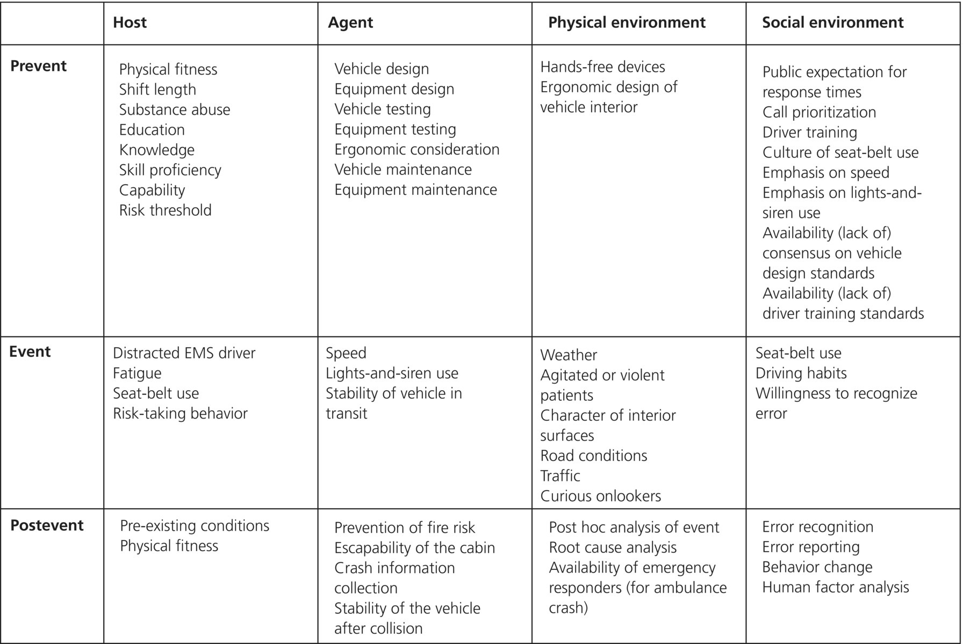
Figure 13.1 Example of Haddon Matrix.
Source: Brice 2012 [13]. Reproduced with permission of NAEMSP.

Programs highlighting the public health and EMS intersection
It has been said that EMS is the intersection of health care (specifically emergency medicine), public health, and public safety (Figure 13.2). Examples of successful programs in public health that share an intersection with EMS and/or public safety include:
- seat belt use and buckle-up programs
- child car seat installation and parent training
- bystander CPR
- Vial of Life
- bicycle helmets
- elderly falls prevention
- mass influenza vaccination programs
- blood pressure/cholesterol screenings
- frequent user case management
- serial inebriate case management

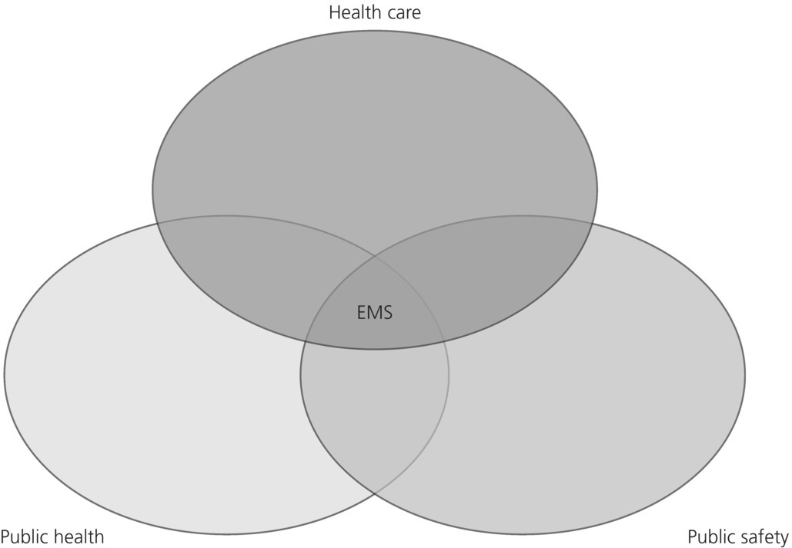

Figure 13.2 Prehospital care at the intersection of health care, public health and public safety.

Surveillance and databases
Surveillance is the collection of data about a community to monitor disease or health status [14]. Prehospital information contributes to case reporting by collecting information from individual EMS calls, grouping those calls into similar incidents, and then analyzing for trends to help in disease monitoring and surveillance in a community. Prehospital data have frequently been used in injury prevention efforts via surveillance. The Crash Outcome Data Evaluation Set (CODES) links prehospital motor vehicle crash data to hospital and discharge data [13]. CODES describes the cost of motor vehicle crashes for those not using seat belts, and characteristics of different sets of drivers such as teenagers or older drivers. The effect of policy changes, such as primary seat belt laws or graduated licensing, can also be monitored through database surveillance [15].

The Cardiac Arrest Registry to Enhance Survival (CARES) represents another excellent example of public health surveillance in prehospital medicine. This registry was developed in 2004 as a joint collaboration between the CDC and Emory University with the goal of evaluating out-of-hospital cardiac arrest (OHCA) data across the United States. The registry uses an Utstein-style template to track cardiac arrests based on location, presenting rhythm, return of spontaneous circulation, and Cerebral Performance Category scores at discharge from the hospital. Many cities, counties, and even entire state organizations have joined the CARES registry since inception since 2004, which now includes over 40 sites [16]. The data available from CARES assist communities in identifying areas for improvement and best practices in OHCA. For example, while bystander CPR has been considered integral in the chain of survival for OHCA, analysis of CARES data first confirmed the survival benefit that bystander CPR added.

Emergency medical services data can also be used for the surveillance of respiratory illness. In New York, symptoms of influenza-like illness have been used in monitoring respiratory illness in correlation with emergency department illness [17]. The European Emergency Data project [18] also utilizes an EMS-based surveillance system. The objective of the project is to employ EMS data to assist in health status monitoring, early warning, prevention, and benchmarking.

The evolving National Emergency Medical Services Information System (NEMSIS) has begun to provide greater opportunities for the coordination of prehospital care with public health efforts on national, regional, and local levels [19]. NEMSIS was developed from initial discussions involving NHTSA, HRSA, and NASEMSD in 2001 with the goal of standardizing prehospital information collection; the first dataset appeared in 2003. The standardized data elements number well over 500 today as version 3.0 of the project continues to evolve. In 2013, Wang et al. published a review of NEMSIS data describing over 7 million EMS responses in the United States to analyze response incidence type and outcome, clinical impression, patient characteristics, location type, time of day, and response mode. These data will become more granular in nature as more locations submit data to NEMSIS and more variables become available for analysis [20].

Immunizations and prehospital care
Immunizations are another example of prehospital public health activity with great potential. Walz et al. [21] suggested in their 2003 article that paramedics could be a tremendous resource for bioterrorism and disaster response through vaccine administration. Paramedics receive training in the science and practice of intramuscular injections, pharmacology, and response to emergencies such as allergic reactions (as might occur with certain immunizations). The potential role and challenges for EMS participation in vaccinations aer detailed in this paper.
Also in 2003, Mosesso et al. [22] reported on the MEDICVAX Project in Pennsylvania, describing the training and deployment of paramedics providing influenza vaccinations. The MEDICVAX program demonstrated the ability to cost-effectively deliver vaccinations to populations that had not been as effectively reached through the traditional system.
In 1999, the Chicago Housing Authority reported on its Pediatric Immunization Program (PIP) that extensively trained outreach workers in the recommended pediatric vaccination scheduling of the American Academy of Pediatrics and Advisory Committee for Immunization Practices. These outreach workers possessed a high school level of education and personal knowledge of the neighborhoods in question [23]. Over the 3-year period of the project, in children 19–35 months at the time of enrollment, complete immunization rates increased from 27% to 50%. EMS providers could be trained in the vaccination schedule in a similar manner, thus representing an additional resource to reach into the community to improve vaccination rates.
Vaccinations by non-traditional health care practitioners hit the limelight during the H1N1 influenza season of 2009. The increased incidence and virulence along with significant media coverage of “the swine flu” overwhelmed both the vaccine supply lines as well as those capable of delivering the life-saving vaccine. During the outbreak of 2009, or just prior to the 2010 influenza season, most of the 50 states created new language in their protocols allowing paramedics to administer the vaccine under varying emergency situations. Overall, prehospital providers have developed the skill of vaccination along with the set-up of vaccination clinics in non-traditional settings, including the patient’s home. An added benefit of increasing administration of vaccination rates in prehospital and other health care workers also must be noted. Health care workers in 2003 were vaccinated for influenza only 36% of the time [24]. The 64% of health care workers who were unvaccinated were a potential source for influenza outbreaks in health care settings and the community. Health care sources can spread viruses such as influenza to patients and workers and affect staffing during critical outbreaks, as seen during the SARS pandemic in 2003 [25].

Community paramedicine and mobile integrated health care
A measure of the success of public health is the reduction in the burden of disease. Prevention, health promotion, and disease intervention are important means by which public health improves. Prehospital care has significant opportunities in these areas. Garrison et al. [26] noted in a review that prehospital provider counterparts in the fire and police services have been providing primary prevention for decades, through their successful efforts of fire prevention and decreasing drunk driving. In fact, fire prevention systems have been so successful that it is not unusual for the vast majority of a fire department’s calls to be for medical assistance. This fact highlights the need for reforming preventive efforts in the medical sector, and for integration of public health and EMS.
Attempts at EMS “expanded scope of practice” have included public health and prevention activities. The Red River Expanded EMS Project (E-EMS) [27], through increased training and protocols, sought to expand health care in a rural area. With the goal of reducing unnecessary transports to the hospital, E-EMS providers triaged patients into four categories: emergency transport, immediate physician consultation with treatment, referral back to E-EMS or other medical provider, and treatment via protocol alone. The E-EMS Project ended without reducing ambulance transports.
The Supporting Public Health with Emergency Responders (SPHERE) program in Seattle is targeting the secondary prevention of heart disease [28]. The EMS system is used to identify patients with high blood pressure and high glucose readings. The goal is to provide these patients with information and guidance on what to do about it. As EMS providers are called in many cases when prevention has failed, prehospital care may provide a unique opportunity to identify high-risk patients and initiate preventive interventions.
These two programs were some of the earliest to highlight the possibilities of expanding the mission of paramedics. Often referred to as community paramedicine (citing origins in rural underserved communities), programs across the country and around the world are seeking creative ways to utilize the unique skill set of paramedics and the natural infiltration EMS has into the cores of the communities they serve. More broadly, the term mobile integrated health care is used to describe an interdisciplinary network of health care providers, including home health, nurses, case workers, etc. These programs can function in many ways. Examples include patient education of chronic health conditions, outpatient follow-up and coordination, needs assessments, medication reconciliation, advanced treatment protocols, and management of high utilizers of EMS. The International Roundtable on Community Paramedicine (IRCP) was formed in 2005 in the first of what would become annual meetings to discuss best practices, training programs and mission statements and future visions. The IRCP remains a key stakeholder in the community paramedicine movement.
The expansion of the paramedic scope of practice faces many challenges. The primary mission of paramedics limits functioning independently, instead placing paramedic care under the medical oversight of a physician. Technology advancements in telemedicine are rapidly progressing and allowing improved oversight of community paramedics; however, providing physician coverage of the program remains a challenge (see Volume 2, Chapter 43).
Funding these initiatives, despite evidence of cost savings in the literature, has been difficult. Many EMS systems are hesitant to start programs, despite their benefit to the community, because of ever-shrinking budgets and funding streams [29]. Developing support and partnerships with key stakeholders and hospitals in the communities served by these programs has been slow to catch on in the United States. However, the increased accountability of hospitals for their patients after discharge, encouraged by the Affordable Care Act, has opened opportunities for engaging hospitals in support of these programs.

Conclusion
Public health significantly overlaps with many of the goals of an EMS system, improving the health of the individual by strengthening the baseline health of the community. Identifying the deficits and needs in an individual community remains the first step. Referring to previous needs assessments while drawing comparisons and contrasts to other localities can help determine the needs of a particular community. Developing improvement programs can be a daunting prospect, but basing plans on other successful community interventions can be a starting point. Once an improvement program is in place, core concepts of public health such as epidemiology will track progress of these programs. Mobile integrated health care programs, to include community paramedicine programs, are challenging the traditional role of paramedics and bringing the public health interface to the forefront of EMS. The future likely will bring EMS and public health even closer together, with the prospect of the Affordable Care Act driving accountability outside the hospital walls to the community.

Acknowledgment
The authors would like to acknowledge Joseph Sabato, MD and Kerry Bachista, MD for their contributions to the original version of this chapter in the 2009 edition.
demic in 2003 [25].

