Chapter 32
Blast injury
John McManus and Richard B. Schwartz

Introduction
A contemporary understanding of explosive injuries is essential for all out-of-hospital health care providers. Although most explosive injuries were previously encountered in austere and/or military environments, civilian attacks with explosive devices have now become more frequent due to the inexpensive nature and ease of access of explosive materials. In fact, the average number of bombings is five per day within the United States, with a total of 36,110 bombing incidents causing almost 700 deaths from 1983 through 2002 [1]. In the most recent explosive events on US soil in Boston, there were over 200 casualties [2]. Newer explosive devices used in recent attacks have resulted in casualties with severe combined penetrating, blunt, and burn trauma. In addition to terrorist bombings, accidental industrial explosions are also common. Although arson has not typically been included in the terrorist’s agenda, some explosive agents and materials used in attacks have flammable injury potential because terrorists typically aim their attacks at human beings directly. These explosive and burn types of injuries are not typically different from non-explosive burns; however, the severity and complexity of injury and/or number of burn patients are potentially greater in the former than in the latter. Burn injury and management will be discussed in Volume 1, Chapter 33.
The medical provider treating explosive trauma in the out-of-hospital environment is faced with many unique challenges. Some of these challenges include the possibility of multiple casualties, unsafe environment, lack of medical supplies, prolonged evacuation time and distance, and lack of sophisticated care that is the standard for trauma management in the urban environment. This chapter will cover the evaluation and treatment of explosive injuries in the out-of-hospital environment.

Explosive devices
Because of the current increased terrorist threat and occurrences in many countries, many types of explosive devices can now be purposefully or accidentally encountered by out-of-hospital personnel in the civilian environment. Multiple types of improvised and manufactured explosive devices exist and only a few will be discussed. Most accidental explosive injuries occur from handling or encountering mines, improvised explosive devices (IEDs), or unexploded ordnance (UXO), such as grenades and ammunition. In Afghanistan alone, the combined death and injury rate was 150–300 per month from accidental UXO even before the US conflict [3]. The most common, purposeful explosive injuries currently in combat operations are from IEDs, homemade devices that cause injury or death by using explosives alone or in combination with toxic chemicals, biological toxins, or radiological material. IEDs can use commercial or military explosives, homemade explosives, or military ordnance and can be found in varying sizes and containers, and with various functioning and delivery methods.

Blast injury
An explosion is caused by the rapid chemical conversion of a liquid or solid material into a gas with a resultant energy release. Low explosives (gunpowder) release energy slowly, by a process called deflagration. In contrast, high explosives release energy rapidly through a process called detonation, which involves the almost instantaneous transformation of the physical space occupied by original solid or liquid material into gases, filling the same volume within a few microseconds, thereby expanding under extremely high pressure. The highly pressurized gases compress the surrounding environment, generating a pressure pulse that is propagated as a blast wave. As a blast wave passes through the body, it causes damage by several different mechanisms. Patients injured from explosions usually suffer from a combination of blast, blunt, penetrating, and burn injuries. Injuries from explosives are divided up into categories (Table 32.1).

Table 32.1 Categories of explosive injuries
Category | Mechanism | Injury type
Primary | A form of barotrauma, unique to explosions, which causes damage to air-filled organs | - Blast lung  - Tympanic membrane rupture and middle ear damage  - Abdominal hemorrhage and perforation  - Globe (eye) rupture  - Concussion
Secondary | Trauma caused by the acceleration of shrapnel and other debris by the blast | - Penetrating ballistic (fragmentation)  - Blunt injuries (rapid deceleration)  - Eye penetration
Tertiary | Casualty becomes a missile and is propelled through the air, with typical patterns of blunt trauma | - Fracture and traumatic amputation  - Blunt chest and abdominal trauma  - Impalement  - Closed and open brain injury
Quaternary | All other explosion-related injuries, illnesses, or diseases which are not due to primary, secondary, or tertiary mechanisms | - Burns (flash, partial, and full thickness)  - Crush injuries  - Exacerbation of underlying conditions (asthma, angina, etc.)  - Inhalation injury
Quinary | The intentional addition of agents that may result in injury | - Radiation  - Chemical  - Biological (including suicide bombers with hepatitis or HIV)

Primary blast injury
As the blast wave passes through tissues of different density, disruption occurs and small particles of tissue and liquids are thrown into the air space. This phenomenon is called spall. Not surprisingly, the injuries from this pressure wave tend to occur at sites of a gas/tissue interface (e.g. sinus, lung, middle ear, or bowel) (Figure 32.1). Traumatic brain injury can also occur without other signs of head injury.

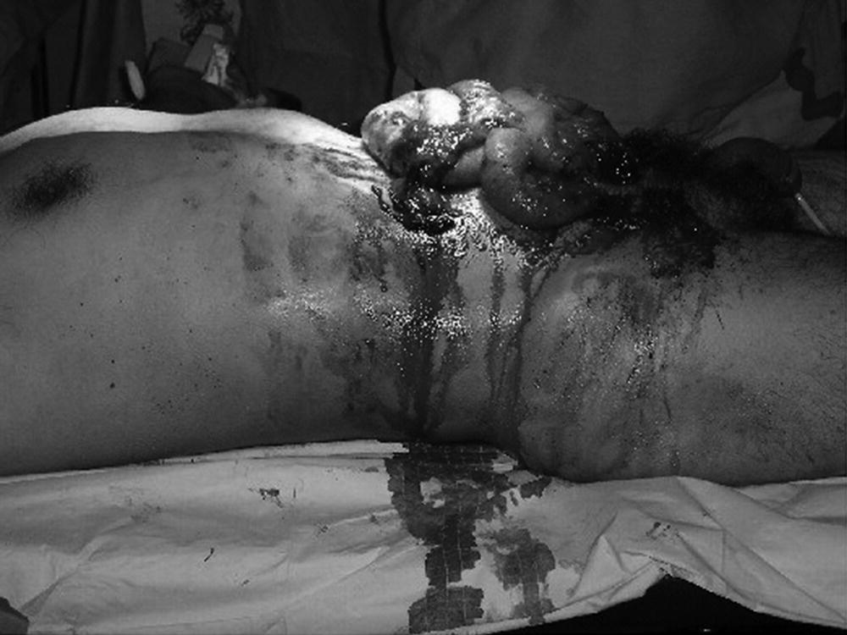

Figure 32.1 Example of an abdominal blast injury.
Source: Reproduced with permission of John McManus.

Secondary blast injury
Injury from projectiles or secondary blast injury represents the most common cause of trauma from explosive events and causes the most significant mortality and morbidity when the victim(s) survives the primary injury. Most improvised explosive devices have projectiles packed around them (e.g. nails, ball bearings) to increase the injury potential from secondary blast injury.

Tertiary blast injury
Tertiary blast injury results when victims are displaced by the blast wave and they become projectiles themselves. The resulting injuries may be severe and include a mix of blunt and penetrating trauma. In addition, structural collapse may contribute to the injuries under tertiary blast injury.

Quaternary blast injury
These are related to the thermal effect of the blast and exacerbation of existing medical conditions. Many primary, secondary, and tertiary blast injuries will be complicated by quaternary injury. Extensive burns, as well as exacerbation of medical conditions, may be related to explosions. The most common medical conditions affected are respiratory diseases such as asthma or chronic obstructive pulmonary disease; however, many other medical conditions may be exacerbated by explosive events. (It should be noted that some authors use the term “quaternary blast injury” to refer to injuries from a resulting structural collapse, included in this chapter as part of tertiary blast injury.)

Quinary blast injury
Quinary injury is related to the intentional addition of radiological, chemical, or biological compounds to the explosive device with the intent of exposing victims to the additional hazard. This has included the use of suicide bombers who are infected with infectious diseases such as human immunodeficiency virus (HIV) or hepatitis [4,5]. The possibility of biological contamination creates issues regarding postexposure prophylaxis (PEP). Recommendations for PEP by the Centers for Disease Control are summarized in Table 32.2. To determine appropriate actions in response to evaluation of casualties of bombings or other mass casualty events, health care providers should:
- assess individual exposure risk by categorizing the patient into one of three exposure risk categories that are numbered sequentially:
  - Category 1: penetrating injuries or non-intact skin exposures
  - Category 2: mucous membrane exposures
  - Category 3: superficial intact skin exposures without mucous membrane
- identify the appropriate risk category and pathogen-specific management recommendation(s)
- determine the appropriate action to take in response to management recommendations.

Table 32.2 Recommended postexposure management by risk category and specific pathogen
Risk category | HBV¹ | HCV² | HIV³ | Tetanus
Category 1: Penetrating injuries or non-intact skin exposures⁴ | Intervene | Consider testing | Generally no action | Intervene
Category 2: Mucous membrane exposures⁵ | Intervene |  | Generally no action | No action
Category 3: Superficial exposure of intact skin⁶ | No action | No action | No action | No action
1Hepatitis B virus.
2Hepatitis C virus.
3Human immunodeficiency virus.
4Penetration of skin by a sharp object that was in contact with blood, tissue, or other potential infectious fluid (i.e. semen, vaginal fluid, cerebrospinal fluid, synovial fluid, pleural fluid, peritoneal fluid, pericardial fluid, amniotic fluid, or any other visibly bloody body fluid or tissue) before penetration. Non-intact skin exposure is defined as contact ofnon-intact skin with any of these potentially infectious tissues or fluids.
5Contact of mucous membranes (i.e. eyes, nose, mouth, or inner surfaces of the gut or genital areas) with blood, tissue, or other potential infectious fluid (i.e. semen, vaginal fluid, cerebrospinal fluid, synovial fluid, pleural fluid, peritoneal fluid, pericardial fluid, amniotic fluid, or any other visibly bloody body fluid or tissue).
6Superficial exposure of intact skin (but not of mucous membranes) with blood, tissue, or other potential infectious fluid (i.e. semen, vaginal fluid, cerebrospinal fluid, synovial fluid, pleural fluid, peritoneal fluid, pericardial fluid, amniotic fluid, or any other visibly bloody body fluid or tissue).
Radiological contamination from “dirty bombs” has received a great deal of press attention. Screening for radiation should be considered for all potential terrorist bombings. If there is radiological contamination, although care of injuries takes precedence, patients should undergo appropriate decontamination and health care providers should wear appropriate personal protective equipment to avoid cross-contamination to themselves or others (see Volume 2, Chapter 37). These precautions also apply to potential chemical contamination. An overview of explosive-related injuries is listed in Table 32.3.

Table 32.3 Overview of explosive-related injuries
System | Injury or condition
Auditory | Tympanic membrane rupture, ossicular disruption, cochlear damage, foreign body
Eye, orbit, or face | Perforated globe, foreign body, air embolism, fractures
Respiratory | Blast lung, hemothorax, pneumothorax, pulmonary contusion and hemorrhage, arteriovenous fistulas (source of air embolism), airway epithelial damage, aspiration pneumonitis, sepsis
Digestive | Bowel perforation, hemorrhage, ruptured liver or spleen, sepsis, mesenteric ischemia from air embolism
Circulatory | Cardiac contusion, myocardial infarction from air embolism, shock, vasovagal hypotension, peripheral vascular injury, air embolism-induced injury
Central nervous system injury | Concussion, closed and open brain injury, stroke, spinal cord injury, air embolism-induced injury
Renal injury | Renal contusion, laceration, acute renal failure due to rhabdomyolysis, hypotension, and hypovolemia
Extremity | Traumatic amputation, fractures, crush injuries, compartment syndrome, burns, cuts, lacerations, acute arterial occlusion, air embolism-induced injury

Prehospital resuscitation and treatment
Specific recommendations for tactical, military, and mass casualty scenarios will be discussed in other chapters of this text. However, some of these treatment principles do overlap. In explosive environments, there is a significant increase in the number of penetrating traumatic injuries (e.g. gunshot, fragmentary, and blast propellant wounds) [6–8]. Because of the increased complexity and number of casualties and the possibility that civilian providers may be exposed to such, additional training and knowledge of the Tactical Combat Casualty Care (TCCC) guidelines are important for prehospital personnel. Although advanced trauma life support may be applicable to the emergency department management of trauma patients in both civilian and military hospitals, it was not created for out-of-hospital medicine. The three goals of TCCC are to treat the casualty, to prevent additional casualties, and to complete the mission, while maintaining provider safety [6,9].
Patients exposed to indoor blast are at risk of overpressure primary pulmonary blast injury. Patients with primary pulmonary blast lung are also at risk for arterial gas embolism (AGE). Gas from the damaged alveolus can pass directly into the pulmonary veins and enter the systemic circulation, leading to neurological or pulmonary compromise. Patients with potential pulmonary blast injury who rapidly decompensate after intubation should be considered to have developed AGE. Additionally, in patients with primary pulmonary blast injury, the pulmonary injury may be worsened by overaggressive fluid resuscitation. This must be balanced against the fluid needs for trauma and burn management.
Cervical spine (c-spine) injury must be considered in patients in explosive events. Tertiary injury and structural collapse are common mechanisms for injury. For rescuers, the risk of structural collapse and potential for secondary devices or other threats such as sniper fire must be weighed against the benefits of c-spine control. For patients with only penetrating injury, numerous studies have shown that high-velocity penetrating wounds do not result in occult spinal injury. If there is no clinical sign of spinal injury at the time of the initial insult, c-spine precautions do not need to be maintained in alert and awake patients [10]. For patients with blunt injury mechanisms, c-spine control should be performed when safe for the rescuer and patient.
In a mass casualty incident with blast and burn injuries, CPR should be withheld unless the injuries are the result of an electrical incident. An effort to identify and treat reversible causes (airway obstruction, tension pneumothorax, or hemorrhage) should be undertaken, after which the patient, if pulseless, may be declared dead based on local EMS protocol.

Medical oversight

Training
Practicing effective medical care in an environment involved with explosives (i.e. tactical environment) requires prehospital personnel to be well educated, trained, and equipped. Integrated “team” training allows the medical support members to understand their roles and to learn all aspects of tactical law enforcement operations and fundamentals on how to approach the tactical medical arena. Tactical competency-based guidelines have recently been published to guide the development of Tactical Emergency Medicine Support (TEMS) training curricula [11]. A project has been initiated by the Centers for Disease Control and Prevention to develop a nationally standardized curriculum for tactical medicine training. This project, using an expert panel and review of the scientific literature, refined the previously published outcome competencies and developed terminal and enabling training objectives to the competencies [11]. In addition, training curricula have been established, such as the National Tactical Officers Association’s Specialized Tactics for Operational Rescue and Medicine (STORM) for medics, operators, medical directors, and team commanders. These courses are based on the national TEMS curriculum and use the trainer methodology.

Hazardous materials
Incidents involving clandestine drug laboratories and weapons of mass destruction are also considerations in an explosive environment. Rapid decontamination must be taught and practiced by EMS teams because adequate decontamination is usually not available in the inner perimeter [12].

Forensic science
Basic knowledge of forensic science is important for recognition and preservation of evidentiary items. Documentation of wound and blood patterns should be done. All evidence should be collected appropriately and the chain of custody maintained [13].

Medical threat assessment
Medical threat assessment (MTA) is an important part of medical planning and should be integrated into operations involving response to explosive events. The MTA considers the potential medical threats that may confront the responders during EMS operations and develops the plan to mitigate and respond to the threats. Once the MTA is complete, a plan is then developed on the basis of the medical intelligence to address each possible situation, with the realization that the plan may change as the mission evolves.

Preventive medicine and force health protection
The maintenance of the EMS team’s health is an important aspect of an explosive response program. Poor health has been shown to directly correlate with poor job performance and mission failure.

Liability
Because special operations lend themselves to high litigation and possible disability, EMS providers need to ensure that they have proper malpractice and disability coverage for special events.

Conclusion
Explosive injuries present a significant challenge for the medical provider. Explosives are inexpensive and easy to make and use. EMS and hospital providers need to be prepared to confront these events if they occur. Basic ATLS principles should be modified for the possibility of prolonged evacuation times to definitive medical care, as well as the limited availability of medical supplies. The basics, however, remain unchanged with airway control, restoration of effective breathing, and hemorrhage control being the highest priorities. Once the secondary survey is completed, care can be undertaken with minimal wound debridement, copious irrigation, prevention of hypothermia, and early administration of antibiotics and pain medications to decrease morbidity and mortality.

References
- 1 Kapur BG, Hutson HR, Davis MA, Rice PL. The United States twenty-year experience with bombing incidents: implications for terrorism preparedness and medical response. J Trauma 2005;59:1436–44.
- 2 The Boston Marathon bombings: a post-event review of the robust emergency response. ED Manag 2013;25:73–8.
- 3 Butler FK, Holcomb JB, Giebner SD, et al. Tactical combat casualty care 2007: evolving concepts and battlefield experience. Mil Med 2007;172: 1–19.
- 4 Braverman I, Wexler D, Oren M. A novel mode of infection with hepatitis B: penetrating bone fragments due to the explosion of a suicide bomber. Isr Med Assoc J 2002;4:525–9.
- 5 Recommendations for Postexposure Interventions to Prevent Infection with Hepatitis B Virus, Hepatitis C Virus, or Human Immunodeficiency Virus, and Tetanus in Persons Wounded During Bombings and Similar Mass-Casualty Events – United States, 2008. Available at: http://emergency.cdc.gov/masscasualties/blastinjury-postexposure.asp
- 6 Mabry R, McManus JG. Prehospital advances in the management of severe penetrating trauma. Crit Care Med 2008;36:S258–66.
- 7 Eastridge B, Mabry R, Seguin P, et al. Death on the battlefield (2001–2011): implications for the future of combat casualty care. J Trauma Acute Care Surg 2012;73:S431–7.
- 8 Jaffe DH, Peleg K, Israel Trauma Group. Terror explosive injuries: a comparison of children, adolescents, and adults. Ann Surg 2010;251:138–43.
- 9 National Association of Emergency Medical Technicians. PHTLS: Prehospital Trauma Life Support, 7th edn. St Louis, MO: Mosby, 2011.
- 10 Ramasamy A. Learning the lessons from conflict: pre-hospital cervical spine stabilisation following ballistic neck trauma. Injury 2009;40:1342–5.
- 11 Schwartz RB, McManus JG Jr, Croushorn J, et al. Tactical medicine – competency-based guidelines. Prehosp Emerg Care 2011;15:67–82.
- 12 Born CT, Briggs SM, Ciraulo DL, et al. Disasters and mass casualties: II. explosive, biologic, chemical, and nuclear agents. J Am Acad Orthop Surg2007;15:461–73.
- 13 Carmona RH, Rasumoff D. Forensic aspects of tactical emergency medical support. Tactical Edge 1992;10:54.

