Chapter 37
Radiation and radiation injury
John C. White
The threat of use of radiological materials or nuclear weapons is at its highest point since the end of the Cold War. This chapter summarizes the environment, dangers, planning recommendations, and response techniques for EMS personnel when involved as providers or victims in a radiological or nuclear event. Selected resources are identified.

Radiation: definition and effects
Radiation consists of subatomic particles and electromagnetic waves that can interact with matter. Non-ionizing radiation causes excitement of atoms and molecular structures, and ionizing radiation can remove electrons from atoms and break interatomic and molecular bonds, including single- and double- strand breaks of DNA chains. Ionizing radiation has the capability to cause gross surface and subsurface damage, and incrementally impairs the ability of the body to repair those injuries. The latter effect, typically called a “radiation burn,” requires a different medical response than is typical for thermal burns [1].
Ionizing radiation materially damages the immune system, with permanence depending on radiation dose and probabilistic long-term effects, and requires a multifaceted care environment for injury and recovery.
Ironically, medical personnel, who have ample scientific training beyond that of the general public, are not immune to fear of the effects of radiation created by the entertainment industry. This was confirmed at a major “dirty-bomb” drill in North Texas in 2004 [2]. In that exercise, a large sports venue held 2,500 volunteers and the number of EMS personnel as would be present for an event with capacity of 275,000. State authorities secreted minor radiation sources, commonly available at sporting goods stores, on “trauma victims” with moulage wounds. When patients arrived at the 35 participating hospitals with varying levels of trauma, and hospital personnel detected the radiation sources, all closed temporarily (went to “divert” status) due to the presence of contamination. The local public health authority made a decision to require “contaminated” hospitals to continue to accept contaminated patients, because the authority had received radiation training a few weeks prior to the exercise. In a real-life scenario, fear of radiation can negatively affect operations due to reluctance of medical personnel to handle exposed or minimally contaminated patients. In addition, emergency facilities are likely to be overwhelmed with terrified but uninjured citizens.

Normal radiation environment
The human species developed in a radioactive world. Ionizing radiation from the sun, rocks, cosmic rays, and from naturally occurring radioisotopes in the environment has continually bathed all life on earth since life began. The background radiation level of the earth is actually less now than at the generally accepted date of Homo sapiens’ first appearance. Approximately 0.03% of the potassium on the earth is potassium-40 (K-40), a radioactive isotope with a half-life of 109 years, which decays while emitting powerful gamma rays. Since K-40 is ubiquitous, any foods that contain potassium are radioactive, and human bodies are radioactive as well. We live in a constant bath of ionizing radiation, and DNA strand breaks and radiation-generated chemically active free radicals result from this radiation. In addition, granite, which is widely found on the earth’s surface and used in buildings, contains small amounts of uranium, which generates many radioisotopes as it decays. Radon, a radioactive inert gas that accounts for over half the background radiation exposure in the United States, is a product of uranium decay. Ionizing radiation is simply everywhere in our existence. Excessive amounts of radiation are problematic because the physical re- pair mechanisms we have developed to cope with the background radiation on planet earth become over- whelmed.

Radiation threats
Although the Cold War has ended, the threat of nuclear weapons has not. A number of governments and terrorist organizations have clearly stated the intent to acquire and use such weapons as necessary [3]. In addition, the proliferation of radioisotope sources in medicine and industry has provided targets for terrorist organizations. A substantial effort is underway by responsible governments to protect and secure these sources, but it is possible that a determined group could acquire either a nuclear weapon or radioactive materials sufficient to cause massive destruction, or chaos and panic, with resultant societal disruption and significant expense. In addition, routine uses of radiopharmaceuticals in medicine involve transportation of smaller amounts [4]. Accidents happen and emergency medical personnel could easily be called on to treat accident victims or receive them at their facility. To understand this threat and grasp the effects of a detonation of a nuclear weapon in a city, it is useful to view Video Clip 37.1, produced by the US Defense Threat Reduction Agency (http://www.youtube.com/watch?v=nv_q8q6Z9_I).

Types of ionizing radiation
The main types of ionizing radiation are alpha, beta, gamma (and x-ray), and neutron. Each type has specific penetration, and therefore detection, characteristics. Figure 37.1 shows the penetrating capabilities of each in relation to human tissue.

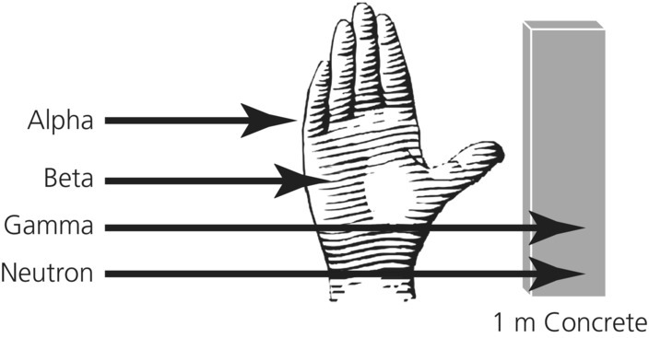
Figure 37.1 Relative penetration in human tissue of ionizing radiation.

What radiation does not do
Much has been made by the entertainment industry of the effects of radiation. Spontaneous immediate mutations, burns, and insidious unknown and scary effects are legion in movies, television, and novels. It is important to understand that immediate, dramatic mutations of anatomy do not occur, and that strange genetic anomalies are seen only in successive generations with large population-level doses. Radiation levels in the global environment were higher in the distant past due to naturally occurring radioactive elements, and recent atmospheric nuclear weapons testing raised the radiation background only slightly. The medical worker responding to a radiological incident may be exposed to a high-radiation environment for a short time, but the somatic effects should be similar to a short period of exposure to other physiological stressors such as heat, chemicals, or other repairable phenomena. Long-term effects of lower doses of ionizing radiation are generally probabilistic, and the immediate needs of a population exposed to radiological weapons or contaminants are evacuation, clean-up, and emergency care.

Resources for the responder
Since the emergency worker has a basic scientific education, understanding of the effects of radiation is somewhat easier to impart than to the general public. It is critical to remember that the effects of radiation are not magic, but are well understood after many years of scientific research. The emergency worker and emergency manager should identify trusted people in the facility or system who can provide accurate and useful evaluation of the risk and give concrete recommendations to ameliorate the radiation effects, while allowing the responder to perform duties. These resources – people whose livelihood depends on the understanding of radiation and its effects – are available in most communities, hospitals, and government entities. Immediate resources include nuclear medicine personnel who handle isotopes, detection equipment, and isotope clean-up on a daily basis, and are required to have detectors in their facility. Others immediately available include the facility’s radiation safety officer or radiological incident manager who have more in-depth knowledge of radiation detection and effects. Also, well-trained hazardous materials response personnel, who have extensive training and hands-on experience with detection equipment, may be available. They may also have detection equipment in mobile units. Well-trained incident management personnel with radiation training who have participated in local, regional, and national exercises, may also be available.

Resources in reserve
Management of a radiological incident requires understanding of the true threat to emergency personnel. An unreasoned response calling for immediate withdrawal of all emergency personnel to extreme distances is unwarranted and possibly negligent. Since fear of radiation is ubiquitous, a radiation specialist may be called on to provide guidance and reasoned response. Such person(s) may not be immediately available, but may be summoned or contacted. It is critical to note that radiation professionals are essential to response organizations when faced with a radiological response. In-depth under- standing of radiological science and knowledge of resources available can save time, money, and possibly lives.

Resources to contact
Every emergency service supervisor should have a list of immediately available contacts who can give concrete applicable advice and information to a responder. Techniques to protect a responder can be simple to implement with available equipment, and responders should be trained in these at every opportunity. Preparation for a radiological emergency is not necessarily an expensive, long-term process, but rather a matter of standard practice modified to fit an additional stressor. Reliable equipment to detect radiation is readily available, portable, and relatively inexpensive. Local medical use of isotopes requires knowledgeable personnel to handle, administer, and detect the isotope. Transportation requires drivers with an understanding of exposure limits and the materials that are being transported. In a massive incident, massive resources must be brought to bear, but immediate local response will be responsible in the first contact with any radiological threat. Local responders must be given clear and proper instruction and training in how to work with and around radiation. Many professional organizations, web sites, and agencies provide detailed information, such as Health and Human Services’ Radiation Emergency Medical Management website (http://www.remm.nlm.gov), and the U.S. Department of Energy, Oak Ridge National Laboratory’s Radiation Emergency Assistance Center/Training Site (REAC/TS) (http://orise.orau.gov/reacts/), which has expert assistance available year-round, 24 hours a day (call 865-576-1005, and ask for REAC/TS).

How to protect yourself
Exposure to ionizing radiation is a manageable risk. A basic understanding of the radiation environment and the dangers therein is your primary tool to manage how you and those you supervise can perform with minimal risk.
Radiation effects can be summarized simply by considering three elements of exposure.
- Irradiation: radiation enters and passes through the body as a field
- Contamination: radioactive materials collect on the outside of the body
- Internal exposure: radioactive materials enter the body
Each has different causes and effects.

Irradiation
Irradiation means that a person or an object is in a field of radiation, and the effects of that radiation can be reduced by the following three methods.

Time – obey the clock
Radiation effects are linearly cumulative. In a uniform field and at a steady distance, 10 minutes of exposure totals twice as much total effective dose equivalent as 5 minutes of exposure. It is important for emergency responders to understand the radiation field emitted by each victim. U.S. Environmental Protection Agency (EPA) guidelines for exposure of emergency responders are shown in Table 37.1.
Table 37.1 EPA emergency action dose guidliness
Dose limit
(Whole body) | Activity Performed
5rem (5.000  mrem) (0.05Sv) | All activities
10 rem (0.1Sv) | Protecting major property
25 rem (0.25Sv) | Life saving or protection of large populations
>25 rem (>0.25Sv) | Life saving or protection of large population,only by volunteers who understand the risks
rem, roentgen equivalent in man/mammal, a measure of exposure; Sv, Sievert. 1 rem = 10 milliSievert (0.01 Sv); 1 Sievert = 100 rem.
If a patient is emitting a radiation field of 100 millirem per hour (1 milliSv), the responder may spend 50 hours on that patient, or work on 50 patients for 1 hour each. For patients with higher radiation field readings, less time is allowed. Obviously, decontamination of the exterior of the patient can reduce the field, but if radioactive shrapnel is present in the patient, danger for surgical teams may exist.

Distance – radiation magic
Every person has at some time cupped his or her hand around a candle flame or come near a hot light bulb. At a short distance, the flame or bulb feels hot. At a 10 cm distance, the heat is greatly reduced, and at 20 cm may be imperceptible. This principle, known as the inverse square law, applies to ionizing radiation (Figure 37.2). Radiation received by any object decreases as the square of the distance from the source. So moving away from the patient, or staying at a distance if your immediate presence is not required for a procedure, dramatically reduces your dose. Combining distance and time planning can extend your time to work on an emergency patient, allow you to work on more patients, and increase the resources for responding to an incident.

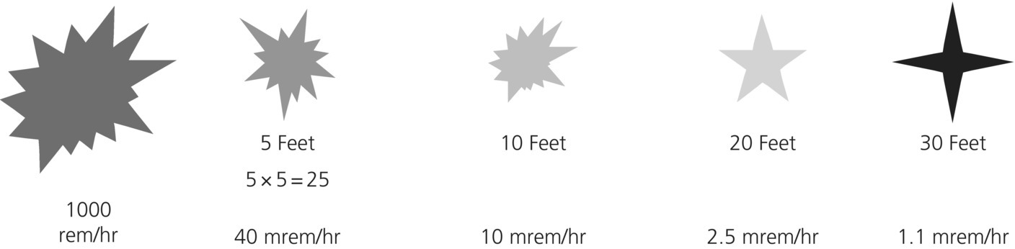

Figure 37.2 Distance causes decrease in radiation exposures exponentially.

Shielding – the thicker, the better
For most radiation sources, dense materials provide more shielding than light materials. Alpha particles will not penetrate skin or clothing or paper. Betas can penetrate approximately 1 cm of flesh, but are stopped by most firefighter protective gear. In the event of high-energy neutron radiation, quantities of plastic and water are required for shielding. Shielding against gamma ray penetration requires substantial quantities of concrete, lead, or water. But in an emergency situation, the person of your coworker, who is 90% water, may be something of a shield. So, standing behind a coworker when you are not needed at the immediate site can help lower your dose. Since shielding for many radiation sources is bulky, shielding is usually the least available tool for protection, unless the characteristics of a shield, such as a wall, are known.

Contamination
Radioactive materials that collect on the outside of a person (“contamination”) may be removed by simple mechanical means. Test data from people accidentally exposed to fallout from a nuclear detonation in the Pacific demonstrate that most of the material was re- moved by disposal of/changing clothing [5]. Recently released Army videos show effective “‘decontamination”’ of troops by using brooms to sweep materials from clothing, and describe sufficient reduction of exposures, which confirms that initial fallout or contamination is in sand-sized grains. (Broom Decon Segment Movie – Video Clip 37.2).
Exposed skin may be cleaned with any mechanical cleaning agent, such as soap and water or other surfactants or chelating agents. It is important to keep radioactives from gaining entrance into the body during the decontamination process. Exposed body surfaces such as hair, head, shoulders, hands, arms, and legs, and moist areas under clothing, should be treated as contaminated and washed with copious amounts of mechanical cleaning agent. Of paramount importance is prevention of ingestion of radioactives through any pathway, particularly the respiratory and gastrointestinal tracts. Note that unlike some materials, radiation cannot be “denatured” or “sanitized” by use of any chemical. Decontamination occurs only through mechanical removal.

Ingestion
The most dangerous exposure route by far is ingestion of radioactive materials. The materials ingested by inhalation, drinking, eating, or through a wound are translocated to specific organ systems, depending on the element, and significant damage can occur to the organ system. The body is an efficient physiological bioconcentrator of many elements, and does not discriminate between radioactive and non-radioactive elements. Iodine is preferentially taken up by the thyroid gland, calcium by the bones, sulfur by the liver and gonads, and so on. When an organ system takes a radioactive element into its physiologic pathway, the damage to that organ system can be amplified by the concentration in that system. For this reason, any emergency responder is advised to wear respiratory protection whenever the possibility of an airborne radioactive contaminant exists. The minimum protection used should be an N-95, R-95, or equivalent mask, but any reduction in the intake of radioisotopes is beneficial. Although there are now pharmaceutical intervention compounds that can remove certain radioactive elements from the body or block the initial uptake by an organ system, the preferential approach is clearly to prevent ingestion.

Effects on emergency personnel
It is difficult for patients presenting in an emergency to have enough radioactive material on their clothes or on their body to deliver a harmful irradiation dose to an emergency worker. Doses to response personnel are limited by regulation to certain specific levels. Be- low the upper limit of these levels, modern radiation science cannot detect somatic effects of radiation. There may be statistical chances of effects later in an individual’s life, but it is unlikely that a responder will suffer an effect. Table 37.2 summarizes the anticipated effects of radiation exposure.

Table 37.2 Signs and symptoms of radiation exposure
Source: summarized from Department of Veteran Affairs Pocket Guide, Terrorism with Ionizing Radiation General Guidance. Bethesda, MD: Armed Forces Radiobiology Research Institute, 2003.
Whole-body radiation from external exposure or internal absorption
 | Subclinical Range |  | Clinical, sublethal Range |  | Lethal Range
 | 0–100  rad | 100–200  rad | 200–600  rad | 600–800  rad | 600–3,000  ^{rad} | >3,000  rad
Nausea, vomiting | None | 5–50% | 50–100% | 75–100% | 90–100% | 100%
Time of onset |  | 3–6 hours | 2–4 hours | 1–2 hours | <1 hours | Minutes
Duration |  | <24 hours | <24 hours | <48 hours | <48 hours | Not available
Lymphocyte count | Unaffected | Minimally decreased | <1,000 at 24 hours | <500 at 24  hours | Decreases within hours | Decreases within hours
Central nervous system function | No impairment | No impairment | Routine task performance cognitive impairment for 6–20 hours | Simple and routine task performance cognitive impairment for >24 hours | Rapid incapacitation may have a lucid interval of several hours

The greater threat to an emergency response work- er is the possibility of ingestion of radioactive materials. It is critical that all emergency response personnel become accustomed to immediately donning an N-95 or greater respiratory protective mask when responding to an unknown situation. This may be difficult, since masks hinder communication, particularly for those who need to talk to victims, victims’ families, or numbers of persons. But the lethal ingestion dose for some highly unusual radioisotopes is relatively low. In the poisoning of the Russian agent Litvenenko, the estimated quantity of the polonium-210 delivered was less than a grain of salt [6]. And there are certain non-lethal but common isotopes such as iodine, routinely shipped on trucks in most cities, that should be suspected if any detection equipment shows a reading higher than background. Consequently, the inconvenience and communication hardship generated by the mask is far outweighed by the respiratory protection provided. In addition, if the worker or possible victim needs to drink liquids, a straw should be used to prevent washing contaminants from the lips into the body.
Radioactive materials for medical use in diagnostic tests are transported in low quantities through- out the world. Shipments occur daily in most major metropolitan areas. The quantities in these shipments are usually not an immediate danger to life and health, and there is ample documentation with each shipment. In the event of a terrorist attack to intercept a shipment, it would be difficult to acquire sufficient quantity of medical isotopes to cause significant harm. Most medical isotopes are of the short half-life variety, can be detected easily by radiation detection equipment, and are transported in well-marked vehicles. Iodine is used for medical activities, but dispersal of this isotope may reduce its effectiveness for injury. In the event of a transportation accident, detection equipment should be used prior to approaching the scene, emergency personnel should don masks, and information on the vehicle or shipment should be acquired as soon as possible.

Dirty bombs, exposure burns, and ingestion injury
The deliberate spreading of a radioactive material could happen in several ways. A radiological dispersal device or other means could spread isotopes over a large area by explosion or release. By definition, dispersing a radioactive material means that it is less concentrated; therefore, the radiation field is reduced by distance. The major medical effect of a “dirty bomb” would be the physical trauma associated with the bomb portion of the device. The medical effect of the radiation from such a device may actually be minimal, since it is difficult to deliver a harmful external dose with dispersed material. The danger would be from the ingestion of radioisotopes. It is certain that this type of incident would cause significant fear responses by a large number of citizens. During an incident in Goiania, Brazil, a city of 1 million people, four people died as a result of breaking open a radiotherapy capsule, and 249 persons were contaminated [7]. A number of persons presented with symptoms of radiation poisoning such as nausea and vomiting. Of those, none were contaminated. But 12% of the population showed up at a local soccer stadium to be checked for contamination. As with a radioisotope transport accident, the number of “worried-but-well” people who are fearful of the effects on themselves or their families could be orders of magnitude above the number of actual victims.
Trauma from the explosion of a dirty bomb could be significant, and the victims could be significantly contaminated. For this reason, it is recommended that any EMS personnel responding to an explosion of any sort, or receiving patients who have been affected by an explosion, immediately don masks. Ingestion could lead to significant internal exposure, and remedial pharmaceuticals may be required on an emergent basis. The use of radiation detectors by response personnel would be mandated, both in the field and in a receiving facility. Because the radiation environment could change rapidly, alarm-equipped detectors with reasonable pre-set levels would be useful. Radiation readings taken with calibrated equipment, typically carried by most fire department hazardous materials units, can determine the actual radiation field in the area, and access by emergency personnel can be planned. In the event of the presence of a radiation field, exposure limitations would be enforced. Unusual exposures could be allowed for specific personnel for life-saving and retrieval of injured persons in the radiation field.
A far greater hazard may be significant numbers of fearful citizens who feel the need to be “checked out” by competent medical staff, or who feel the need for decontamination. Medical facilities should be prepared for large numbers of citizens demanding attention if reporting of a traffic accident mentions associated radioactive materials. If there is a possibility of contamination, a simple means to deal with worried but well people would be to establish signage at a medical facility for people to decontaminate themselves while surrendering their clothing, and then donning paper gowns and being examined by trained professionals with radiation detectors. Per- haps the best recommendation to be made with a low possibility for contamination would be for persons who wish to be checked to stay home, remove their clothes and place them in a plastic bag, and then take a shower, put other clothes on, and bring the bag of clothes to a check station, which could be located at an area fire or police station or large gathering venue. An incentive for people to decontaminate them- selves would be that if they do, clearance by authorities is faster. Persons who need assistance with decontamination would proceed through a controlled decontamination stream, which would be much slower and monitored closely by response personnel. Materials required for this include heavy-duty plastic bags for clothing, recloseable freezer-strength plastic bags for valuables, and temporary clothing for decontaminated persons.
The financial effect of a dirty bomb might be significant in the short term, because of the need to clean the area for routine use. Natural phenomena such as weather may reduce the long-term effects of the isotopes, but uptake of biologically active isotopes such as iodine-131 (half-life of 8 days) or cesium-137 (half-life of 30 years) by crops and food animals could prolong the effects [8]. It is important that contaminated areas are controlled and adequately evaluated for realistic decontamination levels. Significant financial resources may be required to “normalize” an area for use. Without question, national resources would be brought to bear on control and clean-up of any area involved in such an incident.

Exposure burns
Exposure burns are generally caused by irradiation, that is, exposure to a radioactive source of activity sufficient to damage cells. This source could be a strong, concentrated “capsule,” or contamination of the skin over a significant period of time. The burn is not perceived by the individual at the time of occurrence, because humans are not equipped to directly perceive ionizing radiation. The effect of irradiation is to damage the ability of cells to regenerate, which presents at some time after exposure with symptoms similar to a thermal burn. Typically, the burn decreases in severity with distance from the point of exposure on the skin, but the burn can be extremely deep. An exposure burn does not present until weeks or months after the incident, due to the increasing failure of cells to regenerate. Examples are radiological burns from the x-rays during multiple cardiac catheterizations 18–21 months post-exposure, and a beta burn from an overnight exposure to a radioisotope thermoelectric generator 6 weeks post-exposure (see Figure 37.3).

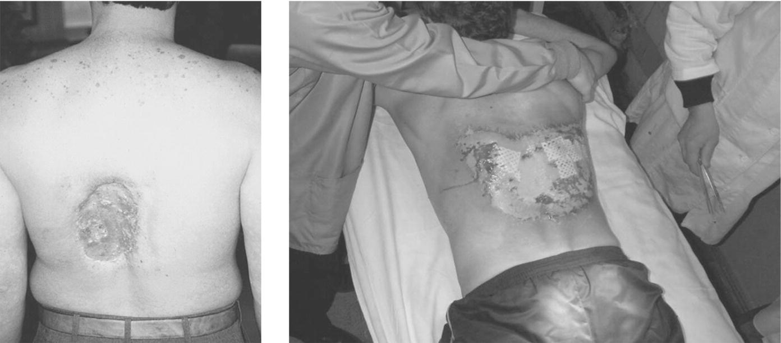
Figure 37.3 Radiation-induced skin injuries from fluoroscopy. Dodd B. The IAEA and the Control of Radiation
Sources. US Food and Drug Administration Office of Science and Technology, Center for Devices and Radiological Health. Presentation at Health Physics Society Conference, College Station, TX, April 2006.

Ingestion injury
The extremely dangerous effects of ingestion of radioactive materials were highlighted in 2006 in the case of Lieutenant Colonel Aleksandr Litvenenko of the Russian FSB (Federal Security Service, successor to the Soviet-era KGB secret police and intelligence organization). Litvenenko was poisoned with polonium-210, an alpha emitter with an extremely high specific activity (the ability of an isotope to produce radiation), while eating at a London restaurant. Polonium is a metal that binds to the heme portion of hemoglobin, so all tissues in Litvenenko’s body were bathed in high-level radiation. His death occurred 3 weeks after the ingestion.
Although the isotope in this quantity is rare and the ingestion deliberate, this incident should serve as a warning to be suspicious of the potential to ingest radioisotopes in an unknown environment such as responding to an explosion or treating patients who present to EMS personnel after an explosive or contamination event.

Nuclear weapons
The return of the threat of nuclear weapons has renewed many efforts to prepare for a catastrophic event. The effects of a nuclear detonation of any size would be significant, challenging the resources of any nation to respond. The uncertainty of the location of 50–100 “backpack nukes,” 1 kiloton weapons manufactured by the KGB for the Soviet Union [9], and the efforts by states such as Iran to develop weapons, along with the questionable reliability of certain nations that possess nuclear weapons, make a nuclear detonation in a city somewhere in the world more likely than not. The detonation of any nuclear weapon would produce destruction and injury in the immediate area and downwind threats due to fallout. In January 2013, the Institute of Medicine and the National Association of City and County Health Officials hosted a workshop on improvised nuclear devices. Several presentations were made by city, county, state, and federal agencies and private companies describing the effects and management of the detonation of a 10 kiloton device in a major city(www.iom.edu/Activities/PublicHealth/MedPrep/2013-JAN-23.aspx).

Blindness, burns, blast, and radiation
The detonation of a nuclear device produces a significant amount of radiation in the visible spectrum. The net effect of this phenomenon is a long-range flash that can permanently blind people who inadvertently look at the flash or at a reflection of the flash. Those who throw their arms in front of their eyes may actually see their bones through their flesh, and may still have permanent damage due to the physical response time for protective actions. The blink reflex takes approximately 200 milliseconds, which may be enough time for permanent injury from the light [10]. The thermal pulse generated by the detonation fireball, which produces energy in the infrared spectrum, comprises 35% of the energy from a nuclear detonation. Any surface exposed to a near-field thermal pulse will experience heat at a rate of 10 calories/cm2, which can cause spontaneous combustion [10]. Half of the energy generated by a nuclear weapon is expended in displacement of the atmosphere, which is the blast from the weapon. Atmospheric tests on buildings, steel ships, soil, hard rock, water, and all other physical structures demonstrate that there is little that can withstand a nuclear detonation. However, the range of such a blast is entirely dependent on the power of such a device, and the earth’s atmosphere provides a damping effect. Local buildings can perturb the effects of the radiation, thermal, and blast effects in such a manner that exposure and traumatic injury may vary substantially. Projectiles thrown by a nuclear blast can travel long distances. Last, the ionizing radiation produced immediately by the detonation comprises a relatively small proportion (5%) of the energy released. This so-called prompt gamma, or immediate release, is a high-energy pulse that irradiates any object according to the inverse square law. Shadowing by concrete structures can reduce exposure.
The remaining 10% of the energy released by a nuclear weapon is in the form of fallout, which is residual radioactive materials that are thrown into the atmosphere by the blast, and fall out of the atmosphere over a period of time. Initial fallout, which descends to earth in the first 24–48 hours, comprises 50%–70% of the total radioactivity from the detonation, and is comporised of a mixture of radioisotopes of relatively short half-life and high energy. This early fallout is extremely dangerous due to high radioactivity, and people should avoid exposure to this in any form. Sheltering-in-place at a point as far as possible from the external surface of a building is the primary means of protection, but should be augmented by air filtration [10]. Emergency responders are trained to immediately mobilize to enter the affected zone to save persons, but that training could cause those responders to become immediate victims or die later. Later fallout, which may descend over days or weeks, or may remain in the upper atmosphere for years, comprises 30%–50% of the radioactivity released. This occurs primarily in the form of small particles, and may be longer half-life isotopes with lower radioactivity. Respiratory protection is advised for anyone downwind of a detonation. For this reason, it is critical to know and understand the “wind rose” for your location. Knowing the direction of travel of the wind could mean the difference between life and death. If patients are received who have been in a fall-out area, or a patient is irradiated by a large source, use the Andrews lymphocyte nomogram to deter- mine the level of exposure (Figure 37.4).
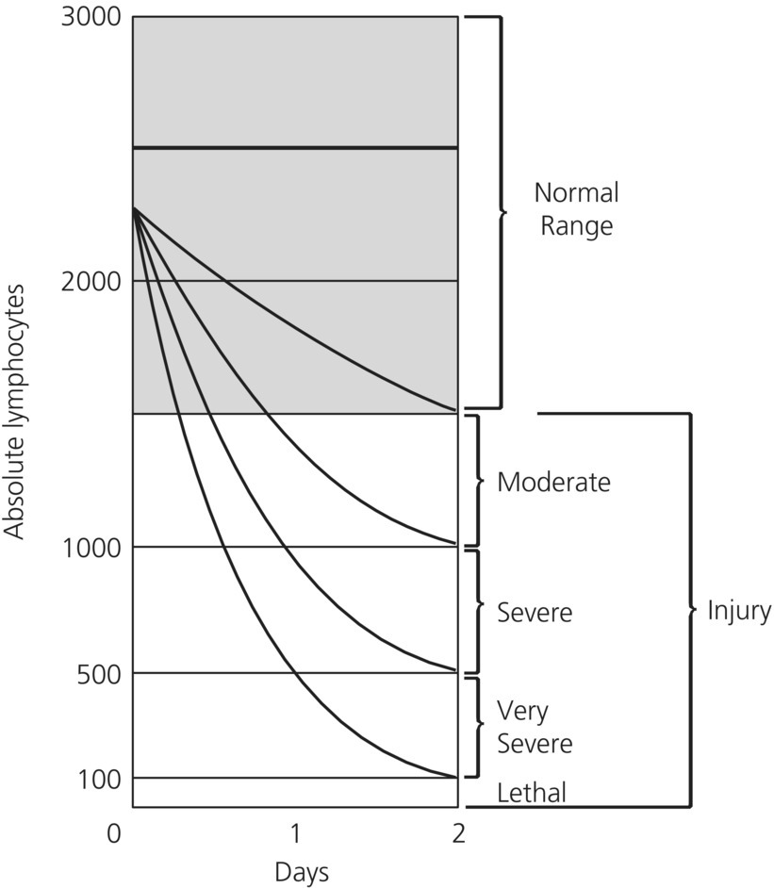

Figure 37.4 Andrews lymphocyte nomogram.
Source: Andrews GA, Auxier JA, Lushbaugh CC. The importance of dosimetry to the medical management of persons exposed to high levels of radiation. In: Personal Dosimetry for Radiation Accidents. Vienna: International Atomic Energy Agency, 1965.
Note that if a person is exposed to radiation, a major factor in his or her recovery is prevention of infection. In Figure 37.5, a general hemogram, shows maximum vulnerability at 30 days postexposure.
